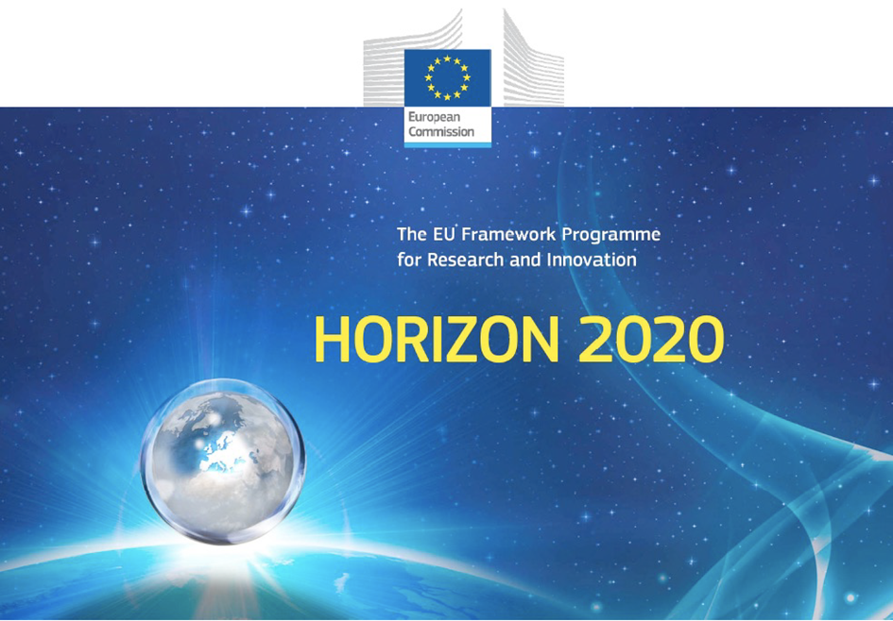

Horizon 2020 Work programme
Food Security, Sustainable Agriculture and Forestry, Marine, Maritime and Inland Water Research and the Bioeconomy
Call
H2020-FNR-2020: Food and Natural Resources
Topic name
FNR-16-2020: ENZYMES FOR MORE ENVIRONMENT-FRIENDLY CONSUMER PRODUCTS

FuturEnzyme:
Technologies of the Future for Low-Cost Enzymes for Environment-Friendly Products
Final ID: 101000327

26/11/2021
manuel ferrer
csic
Marie Curie n2, 28049 Cantoblanco, Madrid, Spain
ethics - EPQ - Requirement No. 4
D9.4

Document information sheet

Work package: | WP9, Ethics requirements
Authors: | CSIC (Manuel Ferrer, Patricia Molina)
Document version: | 1
Date: | 26/11/2021
Starting date: | 01/06/2021
Duration: | 48 months
Lead beneficiary: | CSIC
Participant(s): | CSIC, BSC, Bangor, UHAM, UDUS, IST-ID, CNR, ITB, FHNW, CLIB, Inofea, BioC_Chem, Schoeller, Henkel, Evonik, Eucodis
Dissemination Level: | Confidential, only for consortium's members (including the Commission Services)
Type | Ethics
Due date (months) | 6
Contact details: | Manuel Ferrer, mferrer@icp.csic.es

Summary

ETHICS - EPQ - REQUIREMENT NO. 4. Accomplishment of ethics related to environment protection and health and safety procedures. 4
1. Introduction 4
2. Mitigate the risks to the environment 4
3. MTA for biotic resource exchange 9
4. Authorisations for security level laboratories or GMOs utilisation 9
5. Occupational safety 9

ETHICS - EPQ - REQUIREMENT NO. 4. Accomplishment of ethics related to environment protection and health and safety procedures.

1. Introduction
This deliverable consists in the description and demonstration of the accomplishment of ethics related to:
- Information about the possible harm to the environment caused by the research and the measures that will be taken to mitigate the risks must be submitted as a deliverable. -
- Transfer agreements for biotic resource exchange
- Authorisations for relevant facilities (e.g., security classification of laboratory, GMO authorisation)
- Health and safety procedures conforming to relevant local/national guidelines/legislation, followed for staff involved in this project
As stated in article 34 of the Grant Agreement about Ethics and research integrity, FuturEnzyme partners are committed to perform their activities related to this project following ethical principles and the corresponding international, EU and national laws, always respecting the fundamental principle of research integrity.

2. Mitigate the risks to the environment
As stated in the Grant Agreement information about the possible harm to the environment caused by the research and the measures that will be taken to mitigate the risks must be submitted as a deliverable. - Copies of authorisations for relevant facilities (e.g., security classification of laboratory, GMO authorisation) must be kept on file (to be specified in the grant agreement) and submitted to the Agency upon request. - The applicant must demonstrate that appropriate health and safety procedures conforming to relevant local/national guidelines/legislation are followed for staff involved in this project. This information must be submitted as a deliverable. - If applicable, details on the endangered species and/or protected areas involved in the research, and the measures to minimise the impact of the activities must be submitted as a deliverable.
In relation to the above, while there are no other anticipated ethical issues that may arise in the proposal, risk management deserves few additional comments (see below):
The proposal involves the use of genetically manipulated microorganisms in the laboratory and in bench-scale tests or small fermentations of namely non-pathogenic E. coli, Pseudomonas, Burkholderia, Rhodococus, Thermus, Bacillus, Pichia, Rhodococcus, Haloferax, Aspergillus, and Streptomyces strains and series of isolates of microorganisms that are adapted to specific extreme marine environments considered as non-pathogenic. These isolates belong to the lowest category of risk i.e., are generally considered as safe and therefore do not require special facilities for their handling other than those common in standard microbiological and biochemical laboratory practice, and therefore no possible harm to the health and safety is foreseen. No risk associated to the biological materials is foreseen since these organisms will be used under conditions in compliance with EU regulations. The specific genes under analysis are not expected to give a rise to particularly toxic products and therefore pose no risk. All the transferred materials between Partners will contain environmental samples, as well as microbial cultures, fixed DNA or proteins/enzymes, which are not corrosive, toxic, explosive, radioactive or pathogenic and being completely non-hazardous for human, animals or environment (see D9.3). The samples will be provided to EU and non-EU partners for research use only within the frames of the proposed project (see D9.3). The project does not involve lab animal experimentation and raises no foreseeable ethical issues. This Project does not involve the release of the genetically modified organisms into the environment, and respects all international treaties dealing with the traffic of biological samples, and therefore no possible harm to the environment is foreseen.
In FuturEnzyme we are dealing with non-pathogenic strains and genetic constructs that require only a containment level 1: The requirements are the following:
Containment Level 1
Containment level 1 (CL 1) is used for work with low risk biological agents and hazards, genetically modified organisms, animals and plants. In the best case scenario, this level involves the following:
Local Rules and Risk Assessments
- There must be adequate policies, local rules, risk assessments, controls and standard operating procedures for the work.
- Managers and principal investigators are responsible for health and safety management, risk assessment and control.
- All workers and visitors have health and safety responsibilities.
- Risk assessments must be carried out where they are required including general risk assessments, COSHH, Biological COSHH and GM risk assessments.
- All workers and visitors must have adequate information, instructions, training and supervision.
- Managers and principal investigators must monitor activities to ensure risk assessments, controls and standard operating procedures are implemented and effective.
- Risk assessments, controls and standard operating procedures must be reviewed and amended where there are significant changes to the activity or risks.
- Managers and principal investigators must keep risk assessments, standard operating procedures and other important records.
- There should be adequate communication and cooperation between users of shared laboratories and facilities in relation to the hazards, risks and control measures required to protect health and safety.
- Key standard operating procedures and emergency procedures should be displayed in the laboratory.
- Safety Coordinators and Safety Advisers are available to provide advice and support on health and safety management.
Security and Signs
- Relevant safety signs should be placed on laboratory doors (eg biological hazards, chemical hazards, radiation hazards, containment level, flammables and gas cylinders).
- Safety signs which should be on laboratory doors for containment level 1 laboratories include (a) authorised persons, (b) biological hazards and (c) containment level 1.
- Laboratories should be locked when not in use or unoccupied.
- Access should be restricted to only authorised persons.
- Visitors and contractors must be adequately supervised.
- Access to laboratories must be controlled using suitable means (eg lock and key, swipe card, digital lock etc).

General
- Surfaces of benches, floors and walls should be impervious to water, easy to clean, resistant to acids, bases, solvents and disinfectants.
- Benches should be constructed of robust material (eg Trespa) using non-shrink sealants (eg Silicone or Epoxy resin).
- Adequate space and light should be provided for each worker.
- Procedures that produce hazardous or infectious aerosols must be adequately contained (eg equipment, safety cabinets, centrifuges, shakers etc).
- Microbiological safety cabinets should be used for work where hazardous or infectious materials aerosols could be produced.
- Centrifuges should have sealed buckets or rotor which can be opened inside safety cabinets.
- Fume cupboards should be used for work with hazardous chemicals.
- Laboratory ventilation and safety cabinets should be regularly inspected, maintained and tested usually at least every year.
- Lone working should be avoided but if there is no alternative then adequate controls must be used including supervision, active monitoring and the use of lone worker monitor/alarms.
- Avoid use of sharps unless really required and then adequate risk controls should be used.
- Avoid generating aerosols.
- Biological agents and hazards, genetically modified organisms, animals and plants should be safely and securely stored.
- Multiple containment should be used for storage of hazards.
- Biological agents and hazards and genetically modified organisms should be safely and securely transported.
- Multiple containment should be used for transport of hazards.
- Use suitable robust containers and label accurately for internal transport in and between buildings and where necessary use trolleys and spills kits.
- Use correct UN approved packaging containers, labels and protocols for external transport.
- Disinfect equipment and working surfaces after use where required.
- Do not store or consume food or drink in laboratory.
- Do not store outdoor clothes or bags in laboratory.
- Good personal hygiene practices are necessary in laboratories.
- Cover cuts and broken skin with waterproof dressings.
- Handwash sink with an emergency eyewash hose should be near to all exit doors.
- Taps should operate without being touched by hand.
- Soap and paper towel dispensers should be provided.
- Emergency eyewash hose should be provided which can be used for cleaning eyes, mouth or body in case of personal contamination by any hazards.
- Wash hands after completion of work activities and immediately after any contamination is suspected or handling hazardous materials.
Personal Protective Equipment
- Suitable laboratory coats should be used.
- Suitable gloves should be used where required.
- Suitable spectacles, goggles or face shields should be used where required.
- Specialist gloves can be used for specific biological, chemical and physical hazards (eg cut resistant Kevlar or chain mail gloves).
- Disposable clothing (eg overalls, overshoes, caps, gowns and masks) should be used where required.
- Boots, shoes, aprons, visors should be used where required.
- Gloves should be worn for all work with hazardous or infectious materials.
- Gloves should be used with care to prevent contamination of materials, surfaces and equipment.
- Gloves should be removed and disposed if they become contaminated.
Waste Inactivation and Disposal
- Waste should be properly labelled, safely handled, stored, transported and disposed.
- Waste should be properly inactivated using a validated means before disposal.
- Waste bags and sharps bins should not be overfilled.
- Dispose of waste safely using appropriate containers and correct waste route (eg waste bags or bins, sharps bins, hazardous or non-hazardous waste, biological, chemical or radioactive waste etc).
- Validation and monitoring of effectiveness is required to prove that inactivation method works.
- Effective disinfectants should be available.
- Disinfectants should be suitable for the biological agents and hazards, genetically modified organisms, animals and plants used in the work.
- Check manufacturer’s instructions and validation of effectiveness of disinfectants.
- Regular decontamination of surfaces of safety cabinets and benches is required.
- Autoclaves should be accessible in the building.
- Laboratory autoclaves should be inspected, maintained and tested at least every year.
- Validation of effectiveness is required for autoclaves using annual thermocouple testing of standard loads.
- Monitoring of effectiveness is required for autoclaves for every run by using either electronic probes and data recorders or printers, or using indicator strips, both of which need to be kept for records.
Emergency Procedures
- Emergency procedures should be prepared in advance for dealing with accidents and incidents.
- Emergency procedures should be determined in risk assessments and set out in standard operating procedures.
- Names and contact details of principal investigators, responsible persons and safety coordinators should be available in laboratory.
- First aid facilities should be provided.
- Workers must understand and be able to implement emergency procedures.
- Assess the accident or emergency before deciding and taking any action.
- Inform others of accidents and isolate the area or evacuate if required.
- Seek assistance and use PPE if required.
- Seek first aid and medical treatment if required.
- Individuals involved in serious incidents or where there is uncertainty should be referred or sent to hospital for clinical assessment and treatment.
- Decontaminate the work area or laboratory after an accident or emergency.
- Report accidents and emergencies immediately to supervisors, safety officers or managers.
- Report accidents and emergencies immediately practicable.
- Refer injured persons for an occupational health assessment where required.
Spillages and Releases
- Emergency procedures should be prepared in advance for dealing with spillages and releases.
- Emergency spillages and release procedures should be determined in risk assessments and set out in standard operating procedures.
- Instructions, spills kits and PPE should be provided.
- Instructions should be provided on laminated sheet near equipment where required.
- Notify other workers and isolate area (if required).
- Evacuate laboratory if risk of airborne infection.
- Allow aerosols to settle.
- Contain spillages with tissues or granules where required.
- Cover with suitable disinfectant liquid or granules where required.
- Allow sufficient contact time before clean up.
- Clean up debris gently and do not use a brush.
- Pick up broken glass carefully (eg forceps or swabs).
- Put debris in a suitable waste or sharps container for safe disposal.
- Disinfect contaminated surfaces and equipment.
Personal Contamination or Injury
- Remove contaminated clothing as quickly as possible and leave in laboratory.
- Remove contamination from skin, eyes and mouth by thorough washing with water.
- Minor cuts and small puncture wounds should be encouraged to bleed.
- Wash wounds with soap and water.
- Dress wounds.
- Use PPE if required when helping injured persons.
- Seek help where required including where relevant first aid or hospital.
- Emergencies should be sent straight to hospital and call ambulance if necessary.
- Explain incident and biological agents or hazards or genetically modified organisms to medical staff.
- Report all accidents immediately or as soon as practicable.
Information, Instruction, Training and Supervision
- Information should be provided to all workers on hazards, risks, control measures, monitoring, health surveillance etc.
- Instructions should be provided to all workers on actions and precautions to be taken, use, storage, transport, disposal, emergency procedures etc.
- Training should be provided to all workers on detailed and effective application of control measures etc.
- All workers must be adequately trained and supervised.
Copies of authorisations for relevant facilities (e.g., security classification of laboratory, GMO authorisation) are available and will be submitted to the Agency upon request.
In addition to the above, no environmental damage and health-related issues are anticipated neither while preparing enzyme formulations nor products. In the case of enzymes, partner EUC is an ISO 9001:2015 enzyme development and manufacturing company, and thus is aware of environmental, regulatory, and toxicity issues related to enzyme production; thus, all enzyme samples provided by EUC to project partners will be produced under ISO 9001:2015 quality standards. In addition, enzymes will be also immobilised by paertner INOFEA with a protective layer of silica, an abundant and safe natural resource respecting guidelines for circular design and avoiding any Registration, Evaluation, Authorization and Restriction of Chemicals (REACH)-restricted substance. In the case of products, three types of real-life products already in the market are going to be used, and thus requirements with regards to existing ethical, safety, environmental and regulatory barriers are known.

3. MTA for biotic resource exchange
Until now no biotic resource exchange has been produced among and within partners. In case this is the case, the corresponding material transfer agreements for biotic resource exchange will be prepared and will be at the disposal of the EU upon request.

4. Authorisations for security level laboratories or GMOs utilisation
Copies of authorisations for relevant facilities (e.g., security classification of laboratory, GMO authorisation) are available and will be submitted to the Agency upon request, as detailed in Section 3.

5. Occupational safety
In addition to the information stated in Section 2, information of health and safety procedures conforming to relevant local/national guidelines/legislation, followed for staff involved in this project.
Spain
- Ley 31/1995, de 8 de noviembre, de prevención de Riesgos Laborales
https://www.boe.es/eli/es/l/1995/11/08/31/con
- Prevención de riesgos laborales https://www.boe.es/biblioteca_juridica/codigos/codigo.php?id=37&modo=2&nota=0&tab=2
Italy
- Decreto Legislativo 81/08, “Testo Unico della Sicurezza sul Lavoro”,
UK
- Health and Safety at Work etc Act 1974
Germany
- The Joint German Occupational Safety and Health Strategy (GDA)
https://www.gda-portal.de/EN/Home/Home_node.html
Switzerland
- Bundesgesetz über die Arbeit in Industrie, Gewerbe und Handel (Arbeitsgesetz, ArG) vom 13. März 1964 (Stand am 1. Januar 2021
Portugal
- Occupational health and safety in Portugal
https://eportugal.gov.pt/en/cidadaos-europeus-viajar-viver-e-fazer-negocios-em-portugal/trabalho-e-reforma-em-portugal/seguranca-e-saude-no-trabalho-em-portugal
Austria
- ArbeitnehmerInnenschutzgesetz http://www.ris.bka.gv.at/GeltendeFassung.wxe?Abfrage=Bundesnormen&Gesetzesnummer=10008910
- Arbeitsstättenverordnung
- http://www.ris.bka.gv.at/GeltendeFassung.wxe?Abfrage=Bundesnormen&Gesetzesnummer=10009098
- VbA (Verordnung biologische Arbeitsstoffe)
- http://www.ris.bka.gv.at/GeltendeFassung.wxe?Abfrage=Bundesnormen&Gesetzesnummer=10009126)

In Table 1 are listed the persons responsible for occupational safety of the 16 organisations conforming the project, together with their contact.
Table 1. Contact/link of the Occupational Safety resposibles from the institutions conforming FuturEnzyme.
Partner | Name | email
CSIC | José María Caballero  Carolina García Rodríguez | josemaria.caballero@csic.es; prevencion@icp.csic.es  carolina.garcia@iqfr.csic.es
BSC | Octavi Monfort Samitier | octavi.monfort@bsc.es
Bangor | Michele Lake | m.lake@bangor.ac.uk
UHAM | Petra Grothe | arbeitssicherheit@uni-hamburg.de
UDUS | Andreas Palm  Marianne Otte  Magdalene Stosik  Kristina Rochel | andreas.palm@hhu.de  biologische-arbeitsstoffe@hhu.de  biologische-arbeitsstoffe@hhu.de  biologische-arbeitsstoffe@hhu.de
IST-ID | Rita Sá Costa | ritasacosta@tecnico.ulisboa.pt
CNR | Gianluca Sotis | gianluca.sotis@cnr.it
 | Mariella Genovese | maria.genovese@cnr.it
ITB | Lanfranco Masotti | presidenza@italbiotec.it
FHNW | Richard Wettmann  Désirée Zoller | richard.wettmann@fhnw.ch  desiree.zoller@fhnw.ch
CLIB | Dennis Herzberg | herzberg@clib-cluster.de
INOFEA | Anne Timm | anne.timm@inofea.com
BioC_Chem | Fabrizio Beltrametti | fbeltrametti@bioc-chemsolutions.com
Schoeller | Ruedi Kühne | ruedi_kuehne@schoeller-textiles.com
Henkel | - | https://www.henkel.com/resource/blob/20072/8eacb38ec1af3756149f679997d91a47/data/she-standards-2018-1-.pdf
Evonik | Diana Ljubas | diana.ljubas@evonik.com; https://corporate.evonik.de/en/responsibility/environment
Eucodis | Jan Modregger | modregger@eucodis.com

