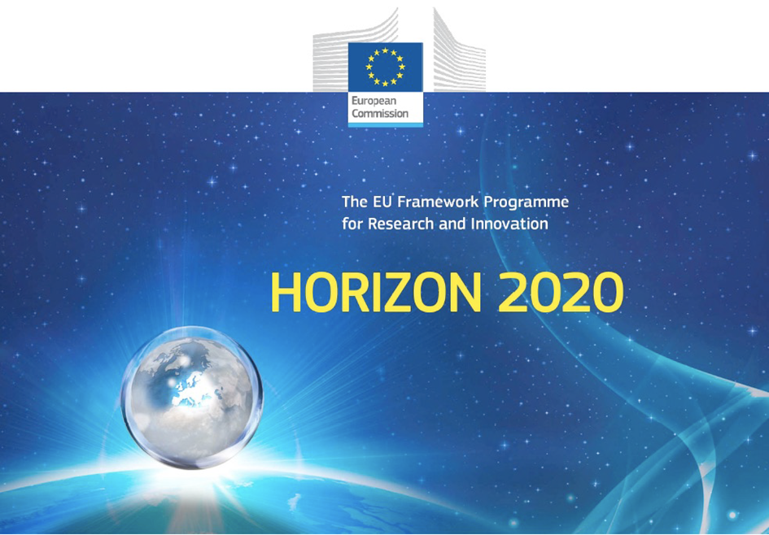

Horizon 2020 Work programme
Food Security, Sustainable Agriculture and Forestry, Marine, Maritime and Inland Water Research and the Bioeconomy
Call
H2020-FNR-2020: Food and Natural Resources
Topic name
FNR-16-2020: ENZYMES FOR MORE ENVIRONMENT-FRIENDLY CONSUMER PRODUCTS

FuturEnzyme:
Technologies of the Future for Low-Cost Enzymes for Environment-Friendly Products
Final ID: 101000327

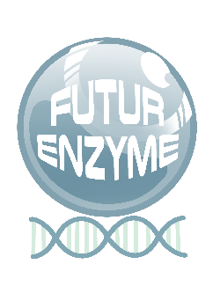
INSERT DATE
manuel ferrer
csic
Marie Curie 2, 28049, Cantoblanco, Madrid, Spain
First set of benchmark enzyme materials available
MS13

Document information sheet

Work package: | WP4, Small-scale enzyme production and characterisation
Authors: | CSIC (Manuel Ferrer, Patricia Molina)
Document version: | 1
Date: | XXX
Starting date: | 01/06/2021
Duration: | 40 months
Lead beneficiary: | UHAM
Participant(s): | CSIC, UHAM, Bangor, UDUS, IST-ID, CNR, FHNW, Bio_Ch, Eucodis
Dissemination Level: | Confidential, only for consortium's members (including the Commission Services)
Type | Report, materials
Due date (months) | 10
Contact details: | Manuel Ferrer (mferrer@icp.csic.es)

Summary
1
Document information sheet 2
Title 4
1.Title 1 (SCOPE of DELIVERABLE) 4
2. Title 2 4
3. Title 3 4
4. Title 4 4
5. Title 5 4

First set of benchmark enzyme materials available

1. Introduction
Report/material available – this milestone will attest the realisation of the first production batches of benchmark enzyme materials.

2.

3.

4.

