

*Horizon 2020 Work programme*

Food Security, Sustainable Agriculture and Forestry, Marine, Maritime and Inland Water Research and the Bioeconomy

*Call*

H2020-FNR-2020: Food and Natural Resources

*Topic name*

FNR-16-2020: ENZYMES FOR MORE ENVIRONMENT-FRIENDLY CONSUMER PRODUCTS

*FuturEnzyme:*

Technologies of the Future for Low-Cost Enzymes for Environment-Friendly Products

Final ID: 101000327

### 30/11/2022

Supramolecular engineering: first round completed

MS17

patrick shahgaldian

fhnw

Hofackerstrasse 35, CH-4132 Muttenz, Switzerland

## Document information sheet

|  |  |
| --- | --- |
| **Work package:** | WP5, Enhancing enzymes through innovative engineering |
| **Authors:** | FHNW (Patrick Shahgaldian, Ali Foroutan, M. Rita Correro) |
| **Document version:** | 1 |
| **Date:** | 30.11.2022 |
| **Starting date:** | 01/08/2021 |
| **Duration:** | 18 months |
| **Lead beneficiary:** | FHNW |
| **Participant(s):** | CSIC, INOFEA |
| **Dissemination Level:** | Confidential, only for consortium's members (including the Commission Services) |
| **Type** | Report |
| **Due date (months)** | 18 |
| **Contact details:** | Patrick Shahgaldian (patrick.shahgaldian@fhnw.ch) |

Summary

30/11/2022 0

Document information sheet 1

1. Introduction 3

2. Material 4

3.Methods 4

4.Results and discussion 5

5. Conclusions and next steps 7

6.References 8

Enzyme supramolecular engineering: FuturEnzyme lipase immobilization and shielding

## 1. Introduction

Lipase enzymes find a wide range of industrial applications. Their use in industrial processes is, however, often hampered by a limited stability under harsh conditions required in those processes. The main objective of the work summarized in this milestone report is to show the possibility to supramoleculary engineer enzymes selected by the project partners to markedly enhance their stability under process-relevant conditions. The proof of concept is carried out with one candidate enzyme selected by CSIC.

Enzyme immobilization onto solid supports (*e.g.*, silica particles) is a valuable approach to address enzyme stability and brings the additional benefit of allowing the biocatalyst to be retained for continuous operations. We have previously developed a synthetic chemical strategy that allows fully shielding immobilized enzymes in an enzyme-thin and soft organosilica layer at the surface of silica particles (SPs). We have demonstrated that this strategy allows for markedly enhancing the stability of the shielded enzymes against a series of stress conditions (*i.e.*, temperature, pH, chaotropes, proteases) [1,2].

Cyclodextrins (CDs) are cyclic oligomers of glucose composed of 6, 7 or 8 α-D-glucopyranose units. CDs display a truncated cone shape, delimitating a hydrophobic cavity, and decorated on both rims with primary and secondary hydroxyl functions. CDs have been shown to mimic the function of protein chaperones by controlling hydrophobic interaction with proteins’ hydrophobic residues [3].

In FuturEnzyme, FHNW, INOFEA and CSIC are working on enhancing the stability of enzymes, selected by the project partners by supramolecular engineering in tailor-made organosilica layers. Besides applying the method previously established by the partners to FuturEnzyme selected enzyme candidates, we expanded our approach of supramolecular engineering using designer cyclodextrin as protective layer’s building blocks. To that end, we produced a cyclodextrin derivative that can be covalently integrated within protective organosilica layers as schematically shown in **Figure 1**.

**Based on the results gathered by the partners and summarized in the present document, *Milestone 17_Supramolecular engineering: first round completed*, can be considered achieved.**

**Figure 1.** Schematic representation of Lip9 (green), immobilized at surface of a silica particle (dark grey) and shielded in a layer of organosilica (light grey) containing cyclodextrin macrocycles (blue).

2. Material

All solvents and chemicals were purchased from Sigma-Aldrich (Switzerland) and used without further purification. Protein assay dye reagent concentrate (BCA kit) was purchased from Thermo Fisher Scientific. Electron microscopy imaging was carried out using a Zeiss SUPRA® 40VP scanning electron microscope. Samples were prepared by spreading a volume of 2 µL of each sample on silicon wafer substrates and sputter-coating with a gold-platinum alloy (15 s at 15 mA). Micrographs were acquired using the InLens mode with an accelerating voltage of 10 kV. Particle sizes were measured on micrographs acquired at a magnification of 150,000 × using the ®AnalySIS software package. UV-Vis spectroscopy was measured using a Synergy H1 system (BioTek, Switzerland) in 96-well plates (Microplate 96 Well Half Area, Huber Lab, Switzerland).

## 3. Methods

***Cyclodextrin derivative synthesis –*** β-cyclodextrin (β-CD) (2 mmol) was dissolved in 20 mL dry dimethylformamide (DMF). 2 equivalents of 3-(triethoxysilyl)-propylisocyanate (TESPI) (4 mmol) were added and the reaction mixture was stirred for 12 hours at 80 °C under inert atmosphere. The mixture was consequently cooled down to room temperature. The addition of a volume of 50 mL of acetone caused the formation of a precipitate (CD-TESPI) that was thoroughly washed with acetone and dried under reduced pressure at 60 °C. Characterization of this product was carried out by means of 1H and 13C nuclear magnetic resonance (NMR) and high-resolution mass spectrometry. The synthetic route is shown in **Figure 2**.



**Figure 2.** Synthesis of a cyclodextrin derivative bearing tri-ethoxysilane moieties via the reaction of a primary alcohol of the cyclodextrin macrocycle (preferentially primary alcohols owing to higher reactivity) with isocyanate function to yield the corresponding carbamate.

***Enzyme immobilization -*** Silica nanoparticles bearing a limited number of amine functions at their surface (SP-NH2) were prepared using a procedure previously published [4]. A suspension of SNP-NH2 (3.2 mg/mL, 10 mL) was reacted with 40 µL of glutaraldehyde (25% in water) for 40 min at 20 °C. The reaction product was centrifuged (4000 rpm, 5 min), washed 3 times with Milli-Q water and resuspended in MES buffer (10 mM, 1.5 mM MgCl2). Next, the suspension of glutaraldehyde-modified SNPs (3.2 mg/mL) was reacted at 20 °C (1-hour, moderate magnetic stirring) with the selected lipase, namely Lip9 provided by CSIC. The immobilized enzymes so produced were collected by centrifugation (4000 rpm, 5 min). The liquid fraction was assayed to evaluate the enzyme immobilization yield (BCA assay). The pellet was resuspended in ammonium bicarbonate buffer (10 mM, 1.5 mM MgCl2).

***Organosilica shielding*** - The immobilized enzyme suspension (900 μl) was reacted with TEOS (2 µL) and CD-TESPI molecule (6.5 mg; 2:1 mol ratio, TEOS:CD-TESPI) and incubated at 10 °C for 1 hour with 400 rpm stirring. Subsequently, APTES (0.8 µL; 1:1.3 mol ratio, APTES:CD-TESPI) was added and the reaction was kept for another 90 minutes under the same conditions. Samples of 300 μl were collected every 30 minutes and washed with 10 mM MES buffer and cured for 12 hours at 20 °C.

***Activity measurements -*** Lipase activity was measured spectrophotometrically using *p*-nitrophenyl butyrate (p-NPB) as substrate at 410 nm. The reaction mixture contained immobilized lipase (0.3 mg) and 1 mM p-NPB in 50 mM Tris-HCl (pH 8.5).

## 4. Results and discussion

In order to produce a cyclodextrin derivative that can be integrated, in a covalent fashion, in organosilica, we decided to introduce a limited number of terminal triethoxysilane moieties in the macrocycle structure. This was achieved by reacting the primary alcohol functions of the native -cyclodextrin with stochiometric quantities of triethoxysilyl-propylisocyanate. The reaction of the isocyanate functions of the latter with hydroxyl functions of the CD yielded the corresponding carbamate bond. High-resolution mass spectrometry (**Figure 3**), MALDI-TOF, 1H and 13C NMR and infrared spectroscopy(not shown)confirmed the formation of both mono and di-substituted CDs.

**Figure 3.** HRMS characterization, the m/z values of 1404.48 and 1651.61 measured correspond to mono- and di-substituted derivatives respectively.

The enzyme immobilization on silica nanoparticles was evaluated by assaying the amount of protein remaining in the liquid fraction of the immobilization reaction mixture by means of the bicinchoninic acid (BCA) assay. The immobilization yield was measured to be as high as 90% (13 μg/ml; 4.1 μg/mg SNP).

Scanning electron microscopy characterization of the particles produced showed a successful layer growth reaction, with layer thickness values of 1.8, 3.6 and 6.0 nm after 30, 60 and 90 min of reaction duration, respectively. Representative micrographs are provided in **Figure 4**.

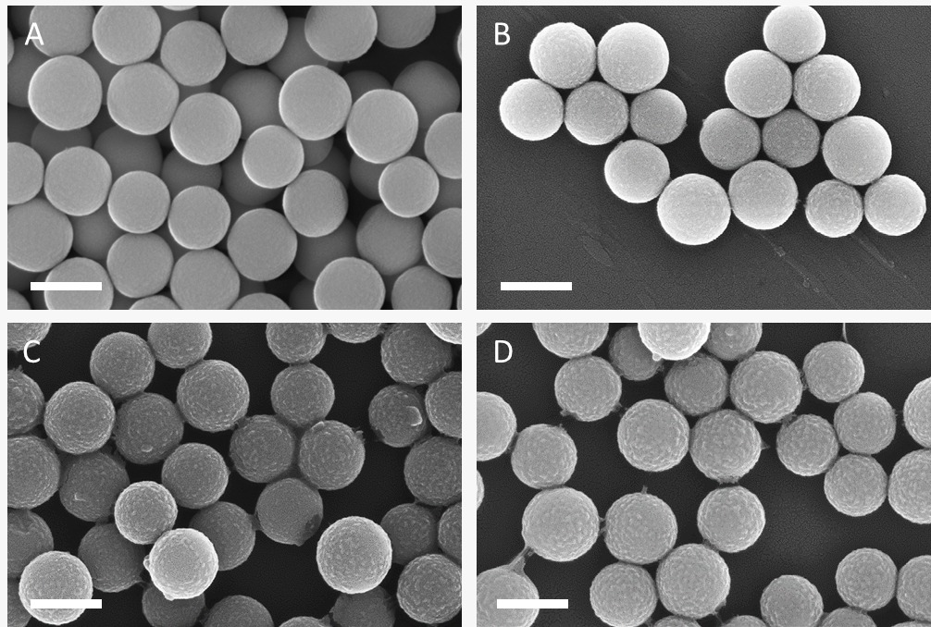

**Figure 4**. SEM micrographs of (A) bare SNPs (290 ± 20 nm diameter) and shielded enzymes after (B) 30 min, (C) 60 min, and (D) 90 min layer growth reaction duration yielding 1.8, 3.6, and 6.0 nm layer thickness, respectively. Scale bars represent 300 nm.

The enzymatic activity measurements carried out on the systems produced are presented in **Figure 5**; they show that the enzyme immobilization procedure did not affect the enzyme activity. Indeed, our results show that it allows immobilizing 86% of the total activity added in the reaction mixture. This suggests that the intrinsic enzyme activity is similar to that of its soluble counterpart. Interestingly, the enzyme embedded within the shield shows an increase in activity, with the highest value reached for the enzyme shielded in a layer of 3.6 nm (30 min of shielding reaction).



**Figure 5**. Enzyme activity measurements carried out on Lip9 immobilized at the surface of silica nanoparticles (time 0) and activity measured after increasing durations of layer growth reaction. All values are rationalized (%) with the initial enzyme activity added in the immobilization reaction.

## 5. Conclusions and next steps

Overall, this set of results demonstrate that the method of supramolecular engineering was successful when applied to the FuturEnzyme Lip9 enzyme. The work is underway to expand our approach to a larger number of enzymes selected by the project partners (decided at the last Steering committee meeting, 14 of November 2022) and to test the protected enzymes under stress conditions relevant for the applications targeted in the project. It is also noteworthy that one specific formulation has been tested in a detergent formulation; our preliminary results show a better activity retention with regard to the non-engineered enzyme.

## 6. References

1. Nagarajan, S.; *Appl. Biochem. Biotechnol.* **2012**, *168*, 1163-96
2. Giunta, C. I., *et al.*; *ACS Nano* **2020**, *14*, 17652-17664
3. Ma, F. H., Li, C., Liu, Y., Shi, L.; *Adv. Mater.* **2020**, *32*, 1805945
4. Correro, M. R., *et al.*; *Angew. Chem. Int. Ed.* **2016**, *55, 6285-6289*