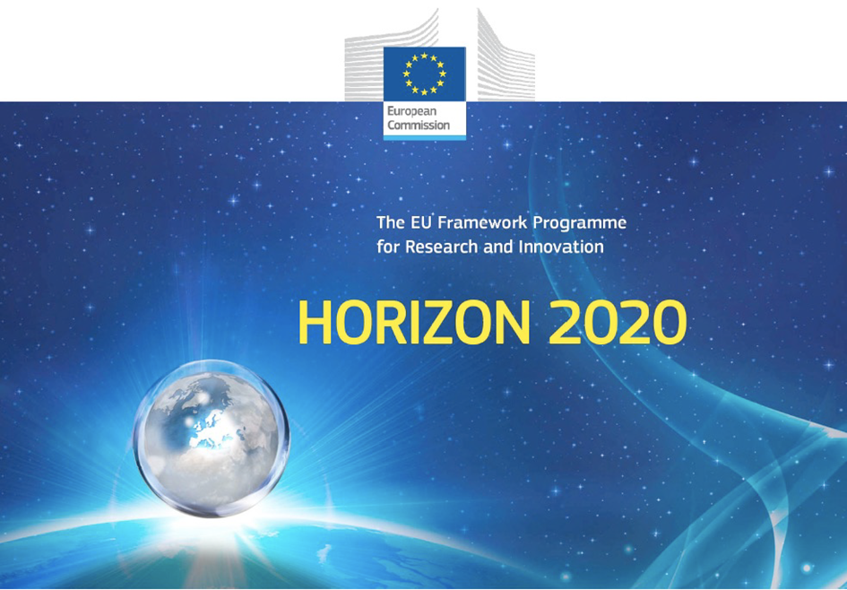

*Horizon 2020 Work programme*

Food Security, Sustainable Agriculture and Forestry, Marine, Maritime and Inland Water Research and the Bioeconomy

*Call*

H2020-FNR-2020: Food and Natural Resources

*Topic name*

FNR-16-2020: ENZYMES FOR MORE ENVIRONMENT-FRIENDLY CONSUMER PRODUCTS

*FuturEnzyme:*

Technologies of the Future for Low-Cost Enzymes for Environment-Friendly Products

Final ID: 101000327

### 30/05/2023

Michail yakimov

CNR

Piazzale Aldomoro 7, Roma 00185, Italy

Set of new bioresources to screen or sequence

D3.5

## Document information sheet

|  |  |
| --- | --- |
| **Work package:** | WP3, Activity-based bio-prospecting for enzymes |
| **Authors:** | CNR (Michail Yakimov) |
| **Document version:** | 1 |
| **Date:** | 30.05.2023 |
| **Starting date:** | 01.06.2021 |
| **Duration:** | 36 months |
| **Lead beneficiary:** | Bangor |
| **Participant(s):** | CSIC, Bangor, UHAM, UDUS, IST-ID, CNR |
| **Dissemination Level:** | Confidential, only for consortium's members (including the Commission Services) |
| **Type** | Other |
| **Due date (months)** | 24 |
| **Contact details:** | Michail Yakimov (mikhail.iakimov@cnr.it), Manuel Ferrer (mferrer@icp.csic.es) |

Summary

Set of new bioresources to screen or sequence 4

1. Scope of deliverable 4

2. New samples with enzymatic activities of interest by CNR 4

2.1. Set of new screened bioresources (isolates) to sequence 8

3. New isolates with enzymatic activities of interest by IST-ID 9

4. New fosmid clones with enzymatic activities of interest by Bangor 9

5. Detailed information of bio-resources newly sampled and generated 9

# Set of new bioresources to screen or sequence

## 1. Scope of deliverable

During the first report, a set of enzymes and microorganisms with relevant properties for study and application in the project were recovered. Both enzymes and microorganisms were retrieved from bio-resources generated in the framework of previous projects, or newly generated during the first reporting period. The list of bio-resources and their nature were extensively compiled in the Deliverable **D3.1** (submission, December 2022). During the first report, a set of enzymes and microorganisms with relevant properties were recovered from those bio-resources. However, in parallel to the work being carried out with these enzymes and microorganisms, we have continued to incorporate new bio-resources into the project in order to increase the diversity of the enzymes available for the project. In this Deliverable the list of newly retrieved bio-resources, particularly, new selected fosmid clones, microbial isolates and enrichments, and the enzymes they contain are briefly detailed. The sampling includes underexplored ecosystems such as hypersaline and alkaline sediments, microbial mats and water samples (**Table 1**).

**Table 1.** Brief description of the sampling sites visited in 2022-2023.

|  |  |  |  |  |
| --- | --- | --- | --- | --- |
| N° | Sampling site | Type of sample | Latitude | Longitude |
| 1A. | Solar salterns, Vietnam | Brine and sediments | 12°32'6.194"N | 109°12'49.752"E |
| 1B. | Solar salterns, Vietnam | Brine and sediments | 12°31'42.200"N | 109°13'23.167"E |
| 2A. | Salt Lake Elton, Russia | Brine and sediments | 49°09'08.942”N | 46°38'57.512”E |
| 2B. | Salt lakes Sol-Ilezk, Russia | Brine and sediments | 51°08'09.851”N | 54°59’22.505”E |
| 2C. | Salt and alkaline lakes, Kulunda, Russia | Brine and sediments | 52°15'16.549”N | 79°29’35.520”E |
| 3A. | Subglacial lake Enigma, Antarctica | Water and microbial mat | 74°25'42.061"S | 164°7'13.079"E |
| 3B. | Subglacial lake Enigma, Antarctica | Water and microbial mat | 74°25'46.740"S | 164°6’13.320"E |
| 4. | CaCl2-rich Don Juan Pond, Antarctica | Brine and microbial mat | 77°33’52.500”S | 161°10’23.300”E |
| 5. | Mt. Melbourne caves, Antarctica | Soil samples | 74°21'20.700''S | 164°41’12.600”E |
| 6. | Samouco salterns, Portugal | Brine and sediments | 38°44’13.100”N | 08°59’06.400”W |
| 7. | Menai Strait, Conwy River, UK | Wastewater | 56°25’36.701”N | 3°15’39.019”O |

## 2. New samples with enzymatic activities of interest by CNR

In June 2022, water and bottom sediments samples were taken from artisanal salt production fields and solar salterns of South Vietnam (Nha Trang province, Vietnam, **Figure 1**) and Portugal (**Table 1**). In addition, to search for extremely halo- and alkaliphilic prokaryotes during July-September 2022, samples were taken from three natural hypersaline and soda lake ecosystems (**Figure 2**, **Table 1**). During the astral summer (October 2022- January 2023), three members of CNR took part in the XXXVII Italian expedition to Antarctica. During this period, samples were taken from three extreme areas as a possible source of psychrophilic and chaotropic-resistant microorganisms. In total, more than 100 isolates were obtained and deposited in CNR culture collection, among which 5 bacterial and 6 haloarchaeal strains were chosen as potentially interesting candidates and sources of novel hyaluronidases and pectin lyases (**Figures 3-5**, **Tables 1 and 2**).

**Table 2.** Brief description of the HA-depolymerizing isolates.

|  |  |  |  |  |
| --- | --- | --- | --- | --- |
| Species | Strain | Isolation site | Isolation source | Genome sequenced |
| Eubacteria | | | | |
| *Pseudomonas fluorescens* | ENG#7 | Lake Enigma | Water column | TBD* |
| *Virgibacillus arcticus* | DJP025-6 | Don Juan Pond | Microbial mat | TBD |
| *Sutcliffiella horikoshii* | DJP025-6 | Don Juan Pond | Microbial mat | TBD |
| *Maribacter polysiphoniae* | MC3BIO2-51 | Mt. Melbourne cave | Soil sample | TBD |
| *Paracoccus sp.* | AB-hyl1 | Kulunda soda lake | Brine | TBD |
| Archaea | | | | |
| *Natronoarchaeum mannanilyticum* | H-hyl1 | Kulunda salt lake | Brine+sediments | YES |
| *Haloarcula hispanica* | KCL-HA5 | Sol-Iletsk lake *Razval* | Brine+sediments | YES |
| *Haloferax alexandrinus* | RMX81-HA22 | Sol-Iletsk lake *Razval* | Brine+sediments | YES |
| *Halomicrobium sp.* | SIV8XX | Sol-Iletsk lake *Razval* | Brine+sediments | TBD |
| *Halomicrobium sp.* | HArcel-Eu2 | Kulunda salt lake | Brine+sediments | TBD |
| *Natranaeroarchaeum aerophilum* | AArc-St1-1** | Kulunda soda lake | Brine+sediments | TBD |

* - TBD, to be done;

** - extremely high carotenoid content – suitability for production to be evaluated.

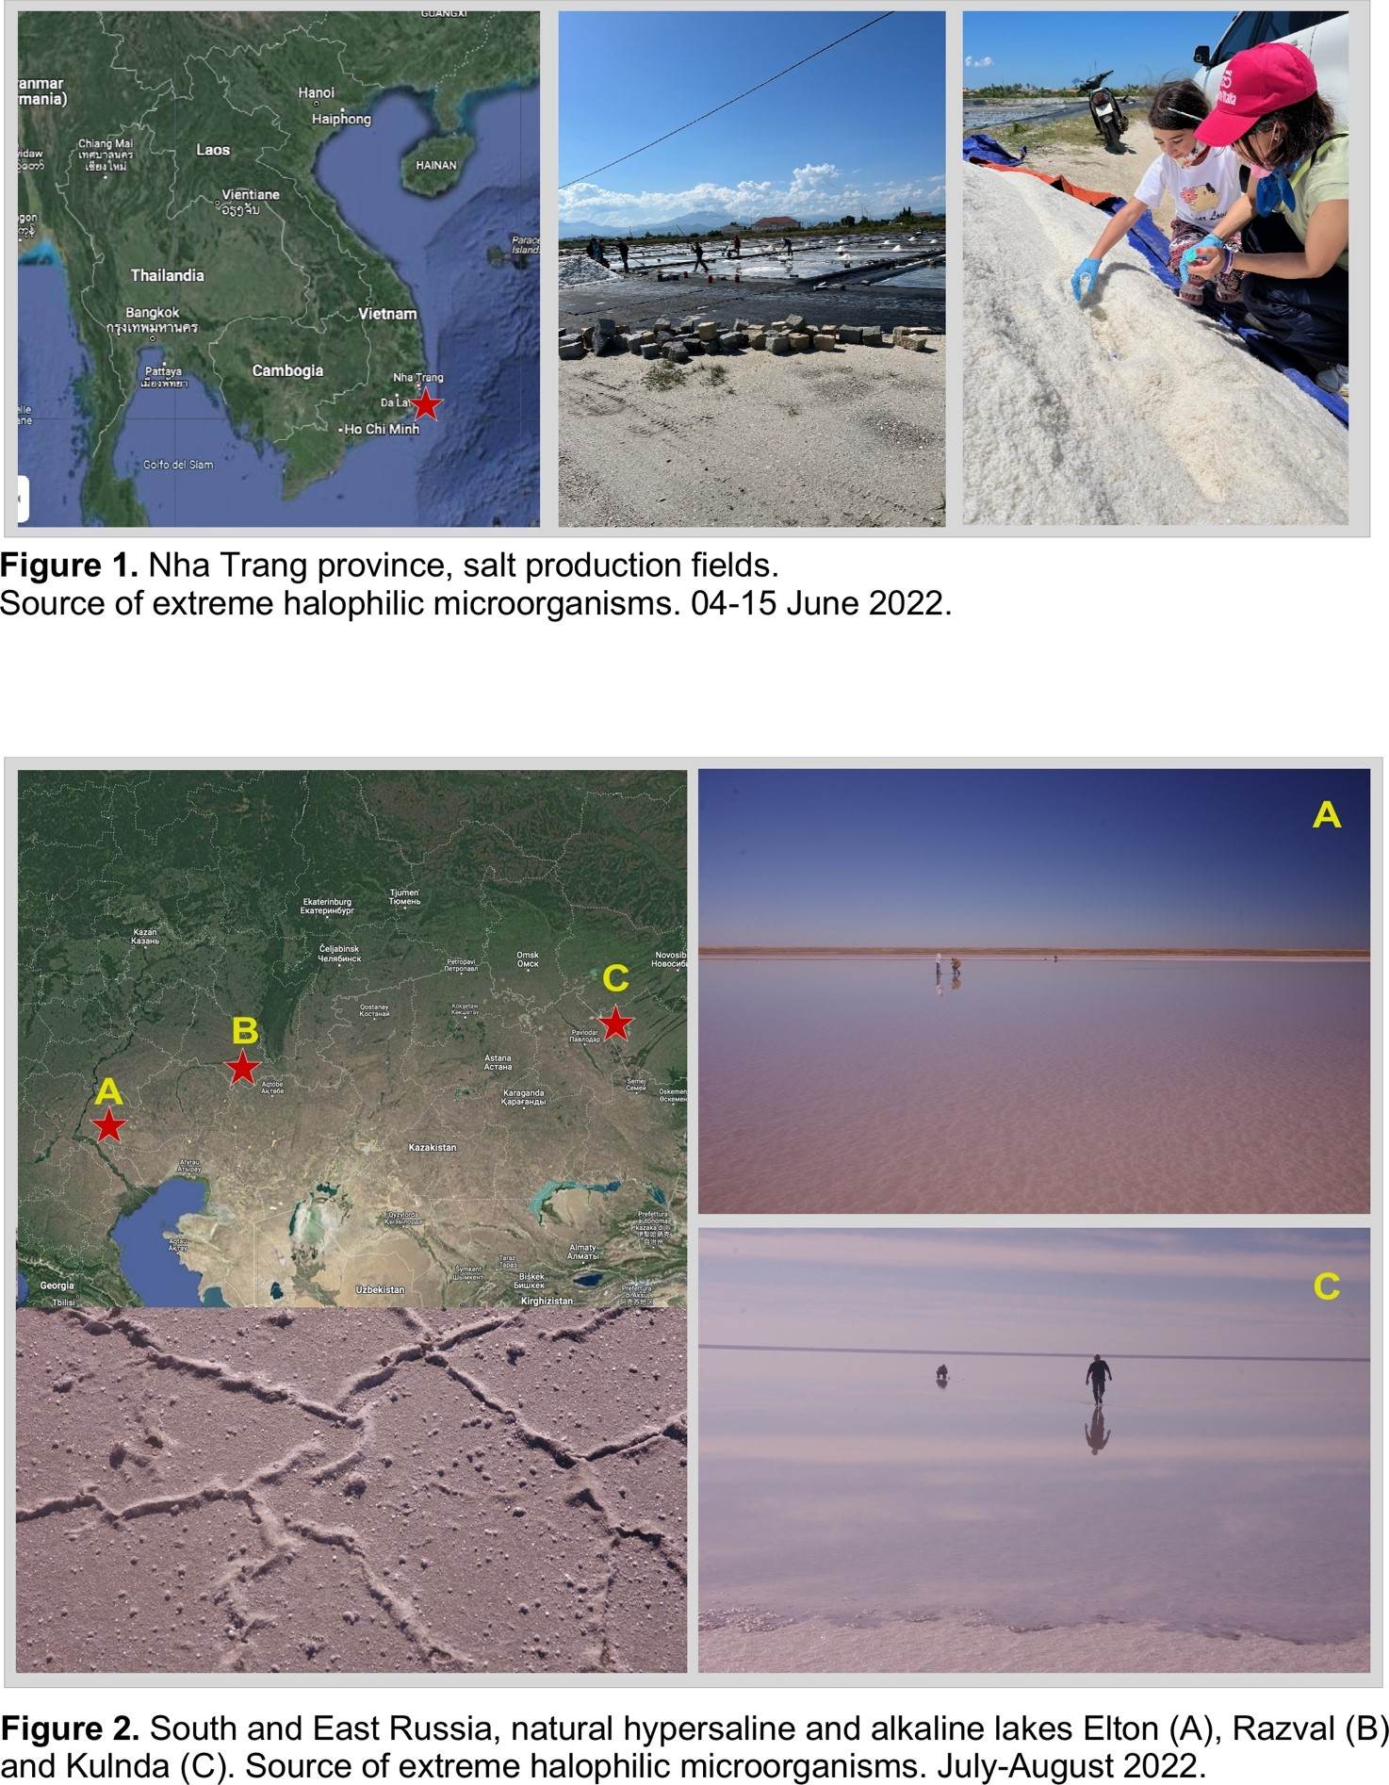**Figure. 1**. Nha Trang province (Viernam), salt production fields. Source of extreme halophilic microorganisms. 04-15 June 2022.

**Figure 2**. South and East Russia, natural hypersaline and alkaline lakes Elton (A), Razval (B) and Kulnda (C). Source of extreme halophilic microorganisms. July-August 2022.

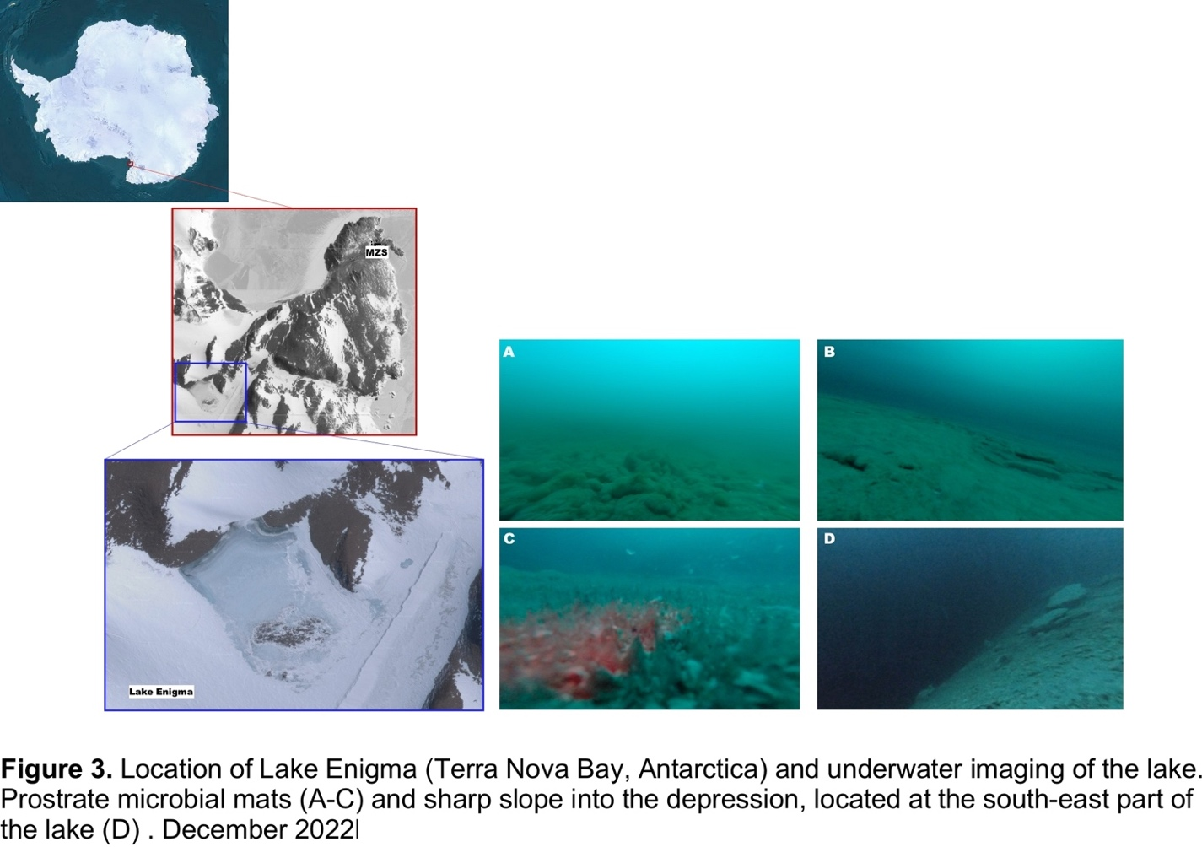

**Figure 3**. Location of lake Enigma (Terra Nova Bay, Antarctica) and underwater imaging of the lake. Prostrate microbial mats (A-C) and sharp slope into the depression, located at the south-east part of the lake (D). December 2022.

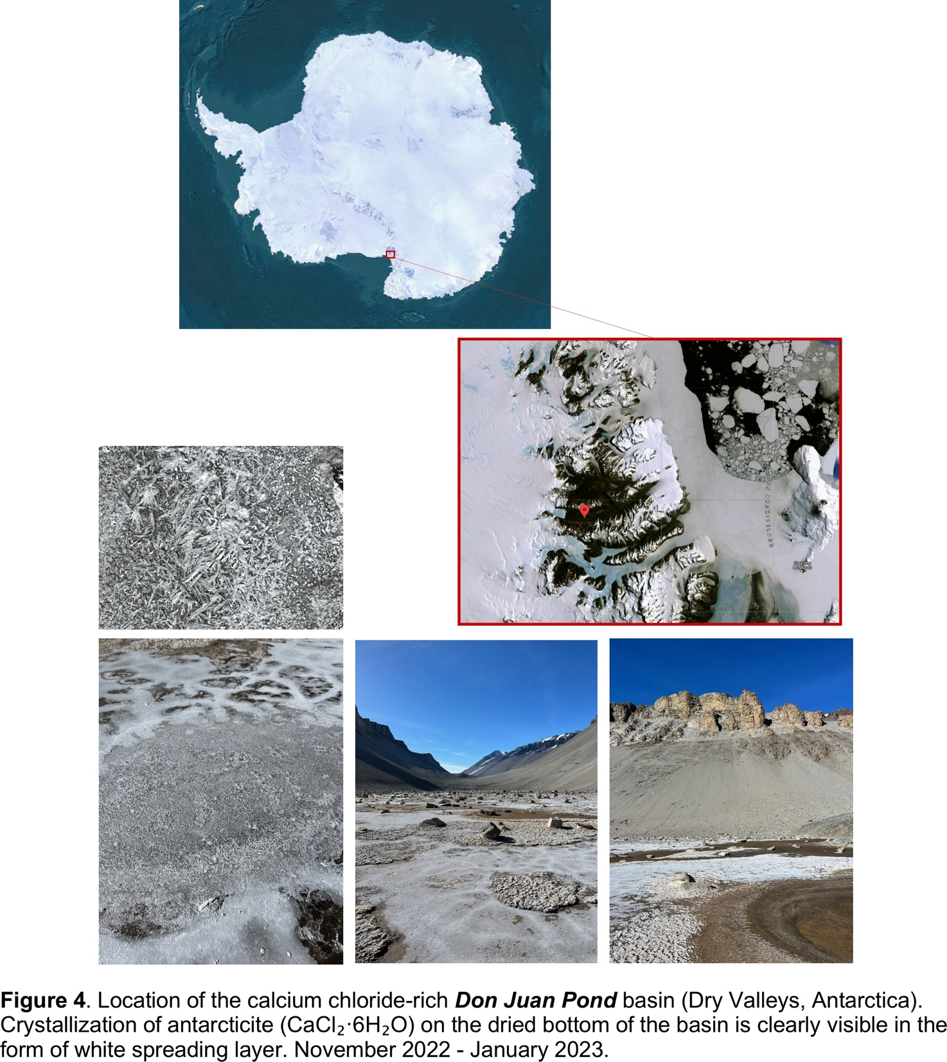

**Figure 4**. Location of the calcium chloride-rich Don Juan Pond basin (Dry Valleys, Antarctica). Crystallization of the antarctide (CaCl2 ·6H20) on the dried bottom of the basin is clearly visible in the form of white spreading layer. November 2022-January 2023.

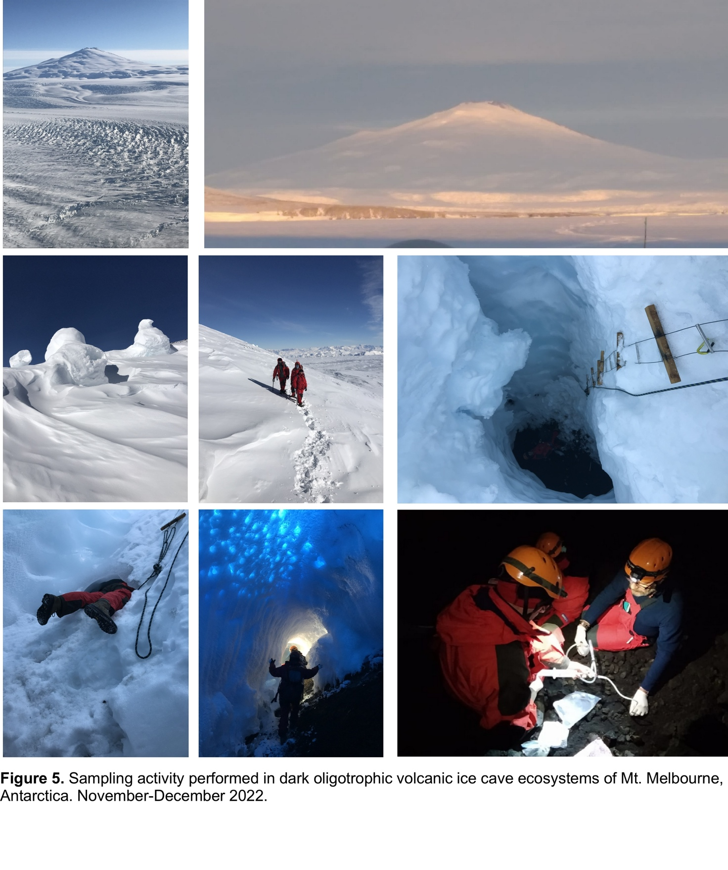

**Figure 5**. Sampling activity performed in dark oligotrophic volcanic ice cave ecosystems of Mt. Melbourne, Antarctica. November-December 2022.

### 2.1. Set of new screened bioresources (isolates) to sequence

As we mentioned above, during the FuturEnzyme project running (June 2021-May 2023), the CNR group (Italy) together with the IST-ID team (Portugal) devoted their activities to the isolation and initial characterization of both bacterial and archaeal strains, which have a high depolymerizing activity with respect to hyaluronic acid ([HA], polymeric state 50 KDa and 350 KDa). Based on initial test, performed with iodine staining of agar plates supplemented with HA (0.2%, w/v), a total of 11 isolates were obtained by CNR team (**Table 2**). Among them, the genomes of three isolates are already sequenced, assembled and analysed. The sequences of potentially interesting hydrolases/lyases are being analysed and currently the production of the corresponding synthetic sequences and production for validation tests (in the frame of WP4) is under progress.

## 3. New isolates with enzymatic activities of interest by IST-ID

Since November 2022, partner IST-ID added 15 new isolates to the list of strains to be screened for enzyme activities. They had been sampled in February 2022 from sea water from a rock pool, Guincho, Cascais, Portugal, and new isolates were retrieved after optimizing the conditions necessary for their growth in the laboratory. In addition, a series of samples collected in Samouco salterns, Portugal (**Table 1**), in September 2022, were subjected to enrichment in the laboratory using hyaluronic acid provided by partner Evonik (see Deliverable **D2.1**) as substrate, and isolates retrieved. The screening for lipase and esterase activity (see Deliverable **D3.2**) of all isolates allowed the identification of 26 isolates with activity, whilst the screening for hyaluronidases resulted in the identification of activity in 20 isolates.

## 4. New fosmid clones with enzymatic activities of interest by Bangor

Activity-based screening of clone metagenomic libraries (bio-resources available at partner Bangor) of Plant *Sorghum bicolor*, rhizosphere (Henfaes Research Station, Abergwyngregyn, North Wales) and Geothermal areas of the volcanic island of Ischia (Volcanic Island of Ischia; the Gulf of Naples, Italy) resulted in the selection of 29 fosmid clones, 16 with esterase activity, 3 with laccase activity, and 10 with amylase activity. DNA sequences of these selected fosmid clones were determined by Nanopore sequencing using the Rapid Barcoding kit. The bioinformatic analysis of the fosmid sequencing, plus a number of homology-based screens of genomes and metagenomes available at partner Bangor, allowed the identification of a total of 105 new enzymes, that included: 7 enzymes with peptidase activity, 48 with esterase/lipase activity, 2 with glycoside hydrolase activity, 14 with cutinase activity, 29 with laccase activity, 2 with catalase activity, 1 with peroxidase activity, and 2 with multicopper oxidase activity. Genomes screened include those from *Fervidobacterium riparium*, *Thermodesulfobium acidiphilum*, *Deferribacter autotrophicus*, *Carboxydocella thermautotrophica*, *Oleiphilus messinensis*, and *Thermoleophilum album* ATCC35263. Metagenomes screened included those from mesocosm experiments with Llanrwst waste water treatment plant (Menai Strait, Conwy River, UK, **Table 1**), to mention few from where a higher number of enzymes were retrieved.

## 5. Detailed information of bio-resources newly sampled and generated

The QR code belowdirects to the table containing detailed information of bio-resources newly sampled and generated since the beginning of the project, with the updates showed in the present deliverable (highligted in yellow). The different types of bio-resources are: new samples, new metagenomic clone libraries, new enrichment cultures, new shotgun metagenomes, and new isolates (including those with genomes sequenced). The table also contains information of the series of enzymes and microorganisms with activities of interest to the project identified by performing functional tests of the bio-resources available at month 2, and newly generated during the project. The table is available under the designation *Table D3.5_Bioresources_New for FuturEnzyme_25.05.2023)* at the FuturEnzyme web’s intranet (password needed), in the section *Shared data, Datasets*:

