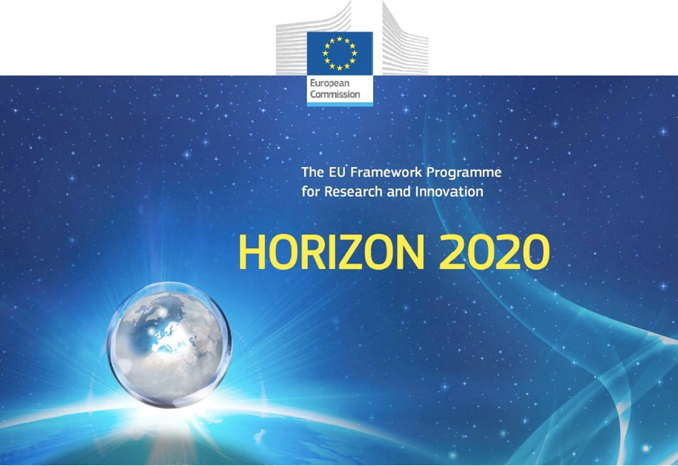

Horizon 2020 Work programme
Food Security, Sustainable Agriculture and Forestry, Marine, Maritime and Inland Water Research and the Bioeconomy
Call
H2020-FNR-2020: Food and Natural Resources
Topic name
FNR-16-2020: ENZYMES FOR MORE ENVIRONMENT-FRIENDLY CONSUMER PRODUCTS

FuturEnzyme:
Technologies of the Future for Low-Cost Enzymes for Environment-Friendly Products Final ID: 101000327

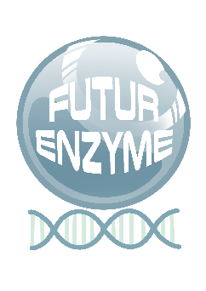
06/08/2021

QR BARCODING SYSTEM, AVAILABLE
DELIVERABLE NUMBER D4.1

MANUEL FERRER
CSIC MARIE CURIE 2, 28049 MADRID, SPAIN

Document information sheet

Work package: | WP4, Small-scale enzyme production and characterisation.
Authors: | CSIC (Manuel Ferrer, Patricia Molina)
Document version: | 1
Date: | 06/08/2021
Starting date: | 01/06/2021
Duration: | 40 months
Lead beneficiary: | CSIC
Participant(s): | CSIC
Dissemination Level: | Confidential, only for members of the consortium (including the Commission Services)
Type | Other
Due date (months) | 3
Contact details: | Manuel Ferrer, mferrer@icp.csic.es; Patricia Molina, patricia.molina@icp.csic.es

Summary
- Scope of Deliverable 4
- QR code generation 4
- Bio-resources prepared for Deliverable 3.1 4
- Material generated through the project 6
  - Deliverables including generation of QR code 7
- Other QR codes 8
Annex 9

QR barcoding system, available

Scope of Deliverable
To ensure the traceability of all materials and datasets within the lifetime of the project and beyond, while also guaranteeing that each material and dataset is legible and can be easily recognized and the information easily available now and in the future, they will be barcoded through a QR code. This is why this deliverable will consist in the design of a QR barcoding system to be applied by all partners that will be used for all bio- resources, enzymes and datasets to be generated in the project. The QR code will be readable with a mobile phone, and through it all information related to each material will be accessible. Information will include: the origin, identity and culture conditions of isolates, enrichments, clones and enzymes (native and engineered), the methods used to generate them, the cloning or synthetic system used, the host, the vector, the inductor, the antibiotic resistance, the origin of the sample (GPS coordinates, microbe, environmental sample, etc.), the laboratory and person implicated in the sampling, processing, isolation, production, purification, characterization, as well as all datasets linked to each material, etc.
This information will also be detailed in D8.4_Data Management Plan.

QR code generation
To generate every QR code, the free site www.qr-me.com will be used. This site was selected over others because it has no limit of scans, no limit of codes to be generated, and it is free. Moreover, by registration, the codes are dynamic, which is a very important feature since it allows to modify the file (usually a PDF) in case changes are needed or new data has to be added. Due to the big number of data to be generated along the 4-year project, this is very convenient, so new bioresources can be added to the file maintaining the same QR, avoiding the generation of thousands of QR codes which not only hurdles the management, but also can create confusion. Another advantage of this QR code generator site is that it allows to protect the files with a password if needed. It also allows to keep track of the number of scans per QR code. For all these reasons, and to the best of our knowledge, the mentioned site is the best for our purposes. The project manager will generate all the QR codes when needed and when material is ready and sent by the partners for this purpose. Every partner will keep a copy of the QR codes generated by their activities. All the codes will be kept by the project manager and will be available at the FuturEnzyme’s website repository.

Bio-resources prepared for Deliverable 3.1
For month 2, a deliverable (D3.1) compiling all the bioresources available from the partners was prepared. These bio-resources were established by previous FP7, H2020, EraNet and national-funded projects. The bio- resources comprised 7 different types of products: 1) enzymes available; 2) isolates available (not yet screened for enzyme activities); 3) isolates with genomes available; 4) metagenomic libraries; 5) enrichment cultures; 6) isolates with proven activity; and 7) shotgun metagenome sequences (all of them available at CSIC, UHAM, UDUS, BANGOR, CNR and IST-ID).
Below is a description of each type of bioresources. For every type, a PDF file was produced which was attached to a QR code. The data provided in these documents and the corresponding QR codes are:
ENZYMES AVAILABLE: ID enzyme; amino acid sequence; phylum or domain; genera, order or family; screen system; GPS coordinates; latitude; longitude; depth (m); source or source organism (short ID); type of habitat; cloning or expression system; activity.
1353 entries, representing highly diverse enzymes relevant to FuturEnzyme, available in expression systems, from single (meta)genomes; the enzymes have been isolated and characterized for purposes others than those in FuturEnzyme, and will be now screened with project-relevant substrates and conditions.

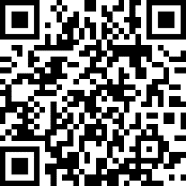

ISOLATES AVAILABLE: Sample ID/Sequence accession; strain name (original); status genome; corrected strain name; taxonomy ID; domain; phylum; class; order; family; coordinates; isolation site; source.
1387 entries, representing psychrophilic, mesophilic, thermophilic, hyper-thermophilic, thermo-acidophilic, alcaliphilic, extreme halophilic, obligate anaerobic and facultative (micro)aerobic sulphur-respiring microorganisms. The collection includes strains growing at temperatures from 0° to 92°C, pH from 1.5 to 10.0, salinity up to 490 g/L, and pressure up to 50 Mpa.
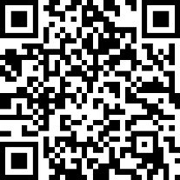
ISOLATES WITH GENOMES AVAILABLE: Sample ID/Sequence accession; sequence and length of the 16S RNA; taxonomic information if available (gene; domain; phylum; class; order; family).
197 entries, representing genomes from isolates representing lineages of (non)-extremophiles growing from 0 to 92°C, pH from 1.5 to 9.0, salinity up to 492 g/L, pressure up to 50 MPa.
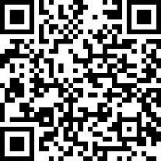
METAGENOMIC LIBRARIES: Libraries site/material; sampling date; GPS coordinates of the sampling site; number of clones and vector used to construct the library; GPS coordinates of the sampling site; accession number (if published); published in (journal); enrichment (substrate) or native community; further comments.
28 entries, representing DNA material from communities inhabiting extreme environments (low pH from 1.1 to 4.4; high pH of 9.3-9.6; high salinity from 200 to 490 g/L; pressure up to 300 MPa; temperature up to 98°C) and non-extreme environments, including contaminated sites (close to neutral pH, low to moderate salinity (up to 50 g/L), temperatures from 4 to 30°C, up to 10.1 MPa).
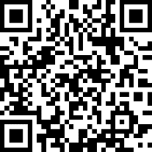
ENRICHMENT CULTURES: Starting material; sampling date; GPS coordinates; accession number; published in (journal); enrichment (substrate and medium); further comments including: sample ID; preliminary and validated strain (enriched) name; taxonomy ID; domain; phylum; class; order; family.
41 entries, derived from samples originated from multiple locations and representing enriched microorganisms of at least 16 different genera.
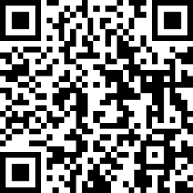

ISOLATES WITH PROVEN ACTIVITY: ID; activities tested: lipase 30˚C; lipase 37˚C; protease 30˚C; protease 37˚C; inulinase 30˚C; inulinase 37˚C; amylase 30˚C; amylase 37˚C; transaminase 30˚C; published (doi).
55 entries.
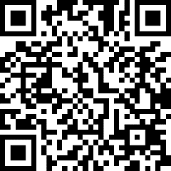
SHOTGUN METAGENOME SEQUENCES: Sample description; BioSample/BioProject; GPS coordinates. 61 entries, corresponding to at least 16 different types of extreme and non-extreme environments.
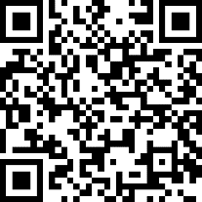

These QR codes are confidential and available within the FuturEnzyme consortium. In order to increase the security, they have been locked with a password (FuturEnzyme€01/06/2021). They will also be included in the private area of the FuturEnzyme website (www.futurenzyme.eu), in the section Shared material. This private area that serves as a repository for the project is accessible to the members of the consortium through user and password.

Material generated through the project
Besides this initial material, the new materials and datasets generated because of the project activities will also be attached to a QR code. In this sense, for every new bioresource (fitting in the any of the following categories: enzyme, isolate, metagenomic library, enrichment culture, shotgun metagenomic sequence) available along FuturEnzyme, a document will be filled using a excel template by the corresponding partner with as much information as possible. This information will include the name of the person responsible of the development and research on the corresponding material, institution and date. When the data is completed, it will be transferred to the project manager (patricia.molina@icp.csic.es) who will compile the information in an excel and word processor file (see Annex, Template for New Bioresources). The latter will be converted to PDF and assigned a QR code, which will be uploaded into the private area of the website. The files corresponding to QR codes for lists of bioresources will be periodically updated, since along the project, new ones will be continuously generated.
For every new bioresource produced and characterized along FuturEnzyme, a document will be filled using a word processor template (see Annex, Template for microorganism dataset and Template for enzyme and enzyme-immobilized dataset) by the corresponding partner with as much information as possible. This information will mandatory include the name of the person responsible of the development and research on the corresponding material, institution and date. When the data is completed, it will be converted to PDF file and transferred to the project manager (patricia.molina@icp.csic.es), who will create the QR code, and it will be uploaded into the private area of the website.
The partners will use the QR code to label the corresponding physical material (tubes, plates, etc.) so now and in the future, any person who makes use of the material can access to the related information. Each partner will keep a record with a list of all their QR codes, and the project manager will keep a list with the whole consortium’s. With this system, the traceability of the material is ensured, and heterogeneous labelling issues are avoided.

Since the QR code must be physically incorporated into different types of materials, e.g. vials, Eppendorf, etc., it is important to bear in mind that the QR code has to be stuck to a surface as flat as possible. When tubes are the containers of the material, the QR has to be tested after placed to check if the mobile phone can read it. If not, another QR can be added to the lid. For 2 mL tubes, the only option is to stick the QR code in the top of the lid (use a lid filler if it is hollow) (Image 1). To do that, the size of the printed QR code should be 0.8 x 0.8 cm. In case the mobile phone doesn’t read it, doing zoom should solve the problem.
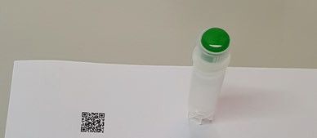
Image 1. Example of QR-coding a 2 mL tube. The size for the QR code to be printed is 0.8 x 0.8 cm. If the top of the lid is hollow, a lid filler can be placed to have a flat surface (a green lid filler is shown in the picture).

The QR codes created are dynamic, which means that in case any of the data in the PDF file generated for a material needs to be modified, the new one can be updated without changing the QR code.
As specified in the Grant Agreement, “each beneficiary must ensure open access (free of charge online access for any user) to all peer-reviewed scientific publications relating to its results” and “regarding the digital research data generated in the action (‘data’), the beneficiaries must: deposit (the data) in a research data repository”. This will be accomplished by using Zenodo (www.zenodo.org), in which a Community for FuturEnzyme has been created (www.zenodo.org/communities/futurenzyme/) and will be managed by the project manager. Each partner will upload their material/data/publications (there is possibility for embargo and restriction) and a QR code will be generated by the project manager to the corresponding URL when needed. This QR code will be used when convenient for the partners, for instance in posters, conferences, etc, and will be made available in the private area of the FuturEnzyme’s website.

Deliverables including generation of QR code
For the material derived of the activities of the deliverables below, a QR code will be generated following the guidelines specified in this document:
D3.3_Set of 100 best clones, 10 isolates, and 10 enzymes shortlisted for sequencing or transfer to WP2 D3.4_Sequence, activity, and stability datasets from best positive bioresources
D3.5_Set of new bioresources to screen or sequence
D3.6_Complete set of positive naïve screened enzymes and sequences and their datasets
D4.2_The FuturEnzyme Portfolio of 1,000 enzyme (recombinant/ native/biomimetic) material, obtained D4.5_At least 9 enzyme crystal structures
D4.6_The metadata on expression yield, activity and stability, available
D4.7_At least 180 enzymes (recombinant, native, biomimetic) with attractive properties, available D4.8_Set of high-performing multi-enzyme blends
D5.1_The shortlist of at least 18 enzymes nominated for engineering D5.2_Set of 18 mutants generated by genetic engineering
D5.3_Set of 4 PluriZymes with single activities

D5.4_Set of 3 multi-purpose PluriZymes
D5.5_Set of 18 improved enzymes by supramolecular engineering D5.6_Datasets of engineered variants
D6.2_Report on fermentation, DSP and activity verification for 18 PreLead enzymes D6.3_Best 9 Lead Enzyme Materials obtained at multi-gram/kg scale for real-life tests D6.4_Report on fermentation, optimization and verification for 9 Lead Enzyme Materials
D6.5_Safety, risk, and environmental evaluation sheet for 9 enzymes with premarket value, available D7.1_Report on small/ medium validation trials of 18 best preselected enzymes
D7.2_A leading liquid and a unit dose cap detergent product with new enzymes integrated D7.3_3-4 Enzymatically functionalised leading textiles in more than DIN A4 size
D7.4_A leading cosmetic formulation with an enzyme-based HA hydrolysis product integrated D7.5_LCA report of the 3 real-life products

Other QR codes
To date, other QR codes have been created:
FuturEnzyme’s website:
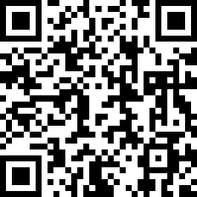
Scientific and patent search for enzymes used in detergents (password needed):
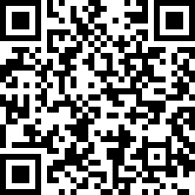
Scientific and patent search for hyaluronic acid enzymatic production (password needed):
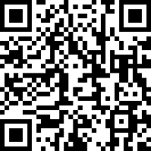
Scientific and patent search for producing features of interest by enzymes for textiles (password needed):
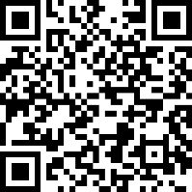
For any other material which can be useful to create a QR code, it will be generated, included in the website’s private area, and spread at convenience.

Annex
Templates for New Bioresources: Enzymes, Isolates, Metagenomic libraries, Enrichment cultures, and Shotgun metagenome sequences:
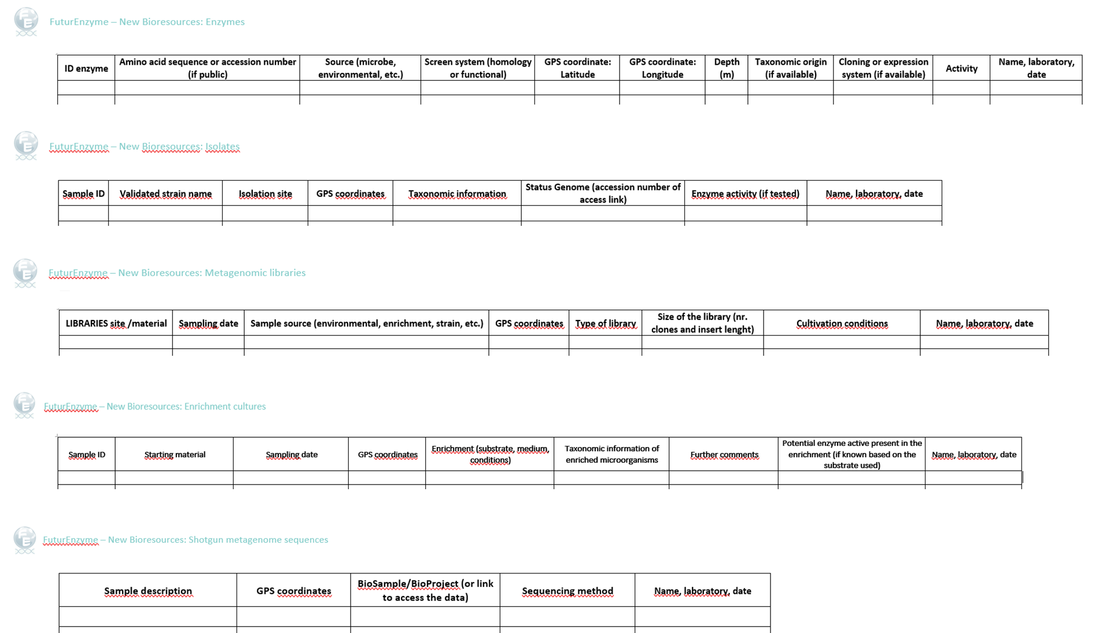

Template for Microorganism dataset:

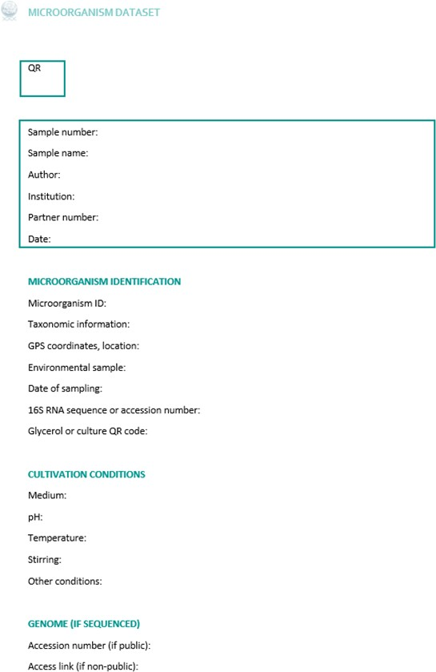

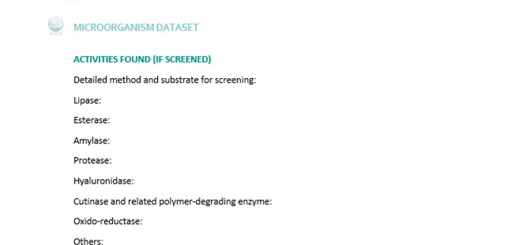

Template for Enzyme and enzyme-immobilized dataset:
