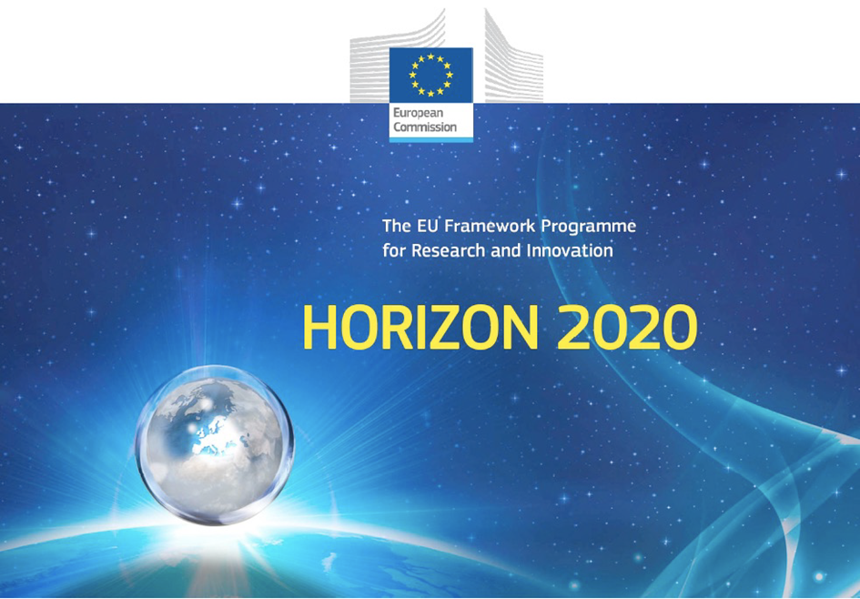

Horizon 2020 Work programme
Food Security, Sustainable Agriculture and Forestry, Marine, Maritime and Inland Water Research and the Bioeconomy
Call
H2020-FNR-2020: Food and Natural Resources
Topic name
FNR-16-2020: ENZYMES FOR MORE ENVIRONMENT-FRIENDLY CONSUMER PRODUCTS

FuturEnzyme:
Technologies of the Future for Low-Cost Enzymes for Environment-Friendly Products
Final ID: 101000327

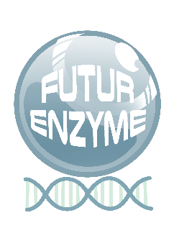
23/11/2022
manuel ferrer
CSIC
Marie Curie n2, 28049, Cantoblanco, Madrid, Spain
Initial-term external evaluation reports
D1.2

Document information sheet

Work package: | WP1, Management and Coordination.
Authors: | CSIC (Manuel Ferrer, Patricia Molina)
Document version: | 1
Date: | 23.11.2022
Starting date: | 01/06/2021
Duration: | 48 months
Lead beneficiary: | CSIC
Participant(s): | CSIC as main contributor and all partners for providing feedback and suggestions for implementation
Dissemination Level: | Confidential, only for consortium's members (including the Commission Services)
Type | Report
Due date (months) | 18
Contact details: | Manuel Ferrer, mferrer@icp.csic.es; Patricia Molina, patricia.molina@icp.csic.es

Summary

Initial-term external evaluation reports 4
1. Scope of Deliverable 4
2. Introduction 4
3. L. Crisigiovanni (Altroconsumo) -18 October 2022 4
3.1. Participants 4
3.2. The meeting 4
3.3. Annex 5
4. K. Niesel (Bayer AG), D. Daffonchio (KAUST), V. de Lorenzo (CNB-CSIC) - 20 October 2022 6
4.1. Participants 6
4.2. The meeting 6
5. J. Raj (PatentCo) - 02 November 2022 7
5.1. Participants 7
5.2. The meeting 7

Initial-term external evaluation reports

1. Scope of Deliverable
This deliverable will consist in a series of reports from the “Panel of External Advisory Scientists, Stakeholders, Policymakers and Consumers” in which experts judge the overall project success, both in terms of the quality of scientific results and the potential impacts during the first reporting period.

2. Introduction
In order to accomplish this deliverable, we met online with FuturEnzyme’s Advisory Board (AB) members. Since one meeting in which the five AB members were present was not feasible because of agenda issues, not even online, we held three separate meetings:
- 18 October 2022: Luisa Crisigiovanni (Altroconsumo, Italy, consumers’ organization).
- 20 October 2022: Víctor de Lorenzo (CNB-CSIC, Spain, academic scientific expert), Daniele Daffonchio (KAUST, Saudi Arabia, academic scientific expert), Ksenia Niesel (Bayer AG, Germany, company scientific expert).
- 02 November 2022: Jog Raj (PatentCo, Serbia company scientific and expert).
This division resulted convenient, since in this way we were able to adapt the presentation of the project, results and outcomes more focused on the expertise of the member/s of the AB in each meeting.
These meetings are crucial to develop with diligence the project. The AB role mainly comprises:
- To obtain access to a wider network of relevant organizations, platforms and influential individuals.
- To obtain feedback on FuturEnzyme activities and products to strengthen the societal impact and reach of FuturEnzyme.
- To judge the overall project success, both in terms of the quality of scientific results and the potential impacts.
- To assist in outreach and dissemination activities by distributing information related to FuturEnzyme.

3. L. Crisigiovanni (Altroconsumo) -18 October 2022

3.1. Participants
Affiliation | Name | Role in FuturEnzyme | e-mail
Altroconsumo | Luisa Crisigiovanni | Advisory Board member | luisa.crisigiovanni@euroconsumers.org
CSIC | Manuel Ferrer | Coordinator | mferrer@icp.csic.es
CSIC | Patricia Molina | Project Manager | patricia.molina@icp.csic.es

3.2. The meeting
The meeting was held online through Conecta CSIC platform, so we had the possibility to record it (available here), and it lasted around 1h 15’.
Manuel Ferrer, FuturEnzyme’s Coordinator led the exposition following a shared presentation focused of the consumers’ view with the following structure:
- The project: overall description
- Maximising exploitation of project enzymes, products, and knowledge
  - The website
  - The social media
  - Organization of events
  - Etc.
- Analysis of consumers’ behaviour
  - Literature analysis
  - Consumer survey
  - Etc.
Crisigiovanni saw interesting the possibility to cooperate in future projects as partners. Ferrer commented that he is planning in coordinating a new European project, so they will be in touch in this regard.
Crisigiovanni remarked the importance of adequate labelling of the final products, since our objective is to make them more sustainable and eco-friendlier. For consumers, consumers’ organisations and regulatory organisms, it is becoming every day more important to be able to have access to as much information of the formulations of the products as possible to exert their market surveillance activity. Precisely because of the increase in consumers’ interest for greener products, it is becoming a marketing claim to increase sells, so this information must be evidence based, green claims must be substantiated by facts and figures. Making the information of the list of ingredients available is essential for increasing transparency and avoiding greenwashing. Ferrer agreed, we will make this comment extensible to our industrial partners (Evonik, Henkel and Schoeller) and to the communication team within the project (CSIC and ITB).
She offered to send the articles published about the testing and surveys done related to detergents in a previous project called CLEAN (see Annex), so we can have an idea of the current situation in this regard. Ferrer answered that this information is highly valuable, and thanked Crisigiovanni for it.
That said, Ferrer commented that this labelling will not only be done at the final product level but also ensuring the traceability of all enzymes to be applied in the production process of the final products.
Crisigiovanni advised that we make clear to the consumers the impact of their decisions when choosing what they purchase, for instance, clothing. Messages such as “repair instead of buying again; wear a garment longer is greener; recycle, etc.” can be included in divulgative articles. Ferrer informed that we already try to deliver these ideas in our dissemination activities and that we will take this into account for future communication/dissemination processes. Crisigiovanni thinks that it can be interesting for both parts to use their European platform Euroconsumers - Consumer's Rights Organisation to produce an article related to our project and the new innovations we plan to make in daily-use products with a green vision. If we are interested, we can let her know in advance to organise it, for instance for next year. In addition, she can ask the experts and the content department, when they edit an article with a related topic, to evaluate the possibility to mention some of the project’s outcome . It is not sure that they can save a space for us, but it is worth trying.
Only in Italy, we can gain a reach of around 300 000 consumers plus the website visitors (around 40 million per year).
Ferrer invited Crisigiovanni to the 24-month meeting which will be held in-person in Hamburg (Germany) on 6-7 July 2023. ITB should finalise the subcontract agreement in order to carry out the activities that Altroconsumo is meant to perform for FuturEnzyme, such as an extensive consumers’ survey. It was delayed since such activities are planned for forward, but now it would be a good moment to formalise the agreement. In this sense we can make a closer cooperation. Even their environment experts can participate in some of FuturEnzyme’s events. Ferrer will ask about this situation to ITB so it can be clarified.
She remarked her availability to advise us as much as possible.
She also suggested that if needed we can reach out ICRT (International Consumer and Research Testing, a consortium of which Altroconsumo is partner, and that usually carry out independent testing) to assess the sustainability and eco-friendliness of the new products, but also the accessibility to the products in terms of price. This would be a different comparison than that made inside our consortium with benchmark products.
Crisigiovanni congratuled us for the nice and comprehensive explanation of our project and so up-to-date actions and outcomes. And with that, the call was dismissed.

3.3. Annex
Information sent by Crisigiovanni as support for FuturEnzyme’s consumers point of view
- Recent articles published on sustainability approach, textiles, cosmetics
Cosmetici davvero "naturali"? | Altroconsumo
- Outcomes on detergents composition and environmental claims
CCLEAN | Altroconsumo, CLEAN Project - How to know how ‘clean’ a detergent actually is | Euroconsumers
- Information on BeXt award (Euroconsumers Brands Award)
Euroconsumers announces nominees and agenda for the fourth annual BeXt awards | Euroconsumers

4. K. Niesel (Bayer AG), D. Daffonchio (KAUST), V. de Lorenzo (CNB-CSIC) - 20 October 2022

4.1. Participants
Affiliation | Name | Role in FuturEnzyme | e-mail
CNB-CSIC¹ | Víctor de Lorenzo | Advisory Board member | vdlorenzo@cnb.csic.es
Bayer AG² | Ksenia Niesel | Advisory Board member | ksenia.niesel@bayer.com
KAUST³ | Daniele Daffonchio | Advisory Board member | Daniele.Daffonchio@kaust.edu.sa
CSIC | Manuel Ferrer | Coordinator | mferrer@icp.csic.es
CSIC | Patricia Molina | Project Manager | patricia.molina@icp.csic.es
¹National Biotechnology Center - Spanish National Research Council, Spain
²Germany
³King Abdullah University of Science and Technology, Saudi Arabia

4.2. The meeting
The meeting was meant to be held online through Conecta CSIC platform, but external technical issues made it impossible. In case this happened, we had prepared an alternative online meeting link through Microsoft Teams, which worked. The inconvenient was that the meeting could not be recorded. The meeting lasted around 2h.
Manuel Ferrer, FuturEnzyme’s Coordinator led the exposition following a shared presentation more focused on scientific aspects with the following structure:
- The project: overall description
- Methodology and results
- Dissemination, Communication, Exploitation and Synergies

Ksenia Niesel
Niesel offered to cooperate also for the high scale enzyme production.
Niesel remarked the relevance of Nagoya’s protocol. She asked if all the partners will have access to the metadata (via chat). Ferrer was at the same time saying precisely that they will. Ksenia writes: “Predictive tools are the future”. She asked (chat) if we are focused on bacterial enzymes, at which we answered that we usually work with microbial enzymes.
After the project exposition by Ferrer, Niesel said that she will need more information of our outcomes: we will send her a report summarizing all the activities, actions, and results obtained so far, equivalent to the document for the first reporting period, but adapted to the AB.
She asked if we are using eukaryotic systems for expression processes, since otherwise we might be losing possibilities and yield. Ferrer answered that we usually begin with Escherichia coli, but we have a variety of other expression organisms, eukaryotic and prokaryotic, that can be further tested if needed.

Daniele Daffonchio
Daffonchio commented on the complexity and ambition of the project, and remarked its clear organization and the well thought out. He again highlights the relevance of the Nagoya Protocol. He wondered how we managed to search amongst the thousands of proteins we started looking for our hits, and the criteria we use (and keep on using) for selecting samples and the type of environmental source to search for the enzymes. Ferrer explains that for instance in the case of hyaluronidases, the experimental outcomes obtained in the project suggest that they are mostly found in microbes inhabiting salty environments, so that is where we looked for their sequences; in the case of textiles and detergents, we know the fatty acids that we want to transform, so we screened amongst the meta/genomes by homology. All the partners involved follow the decision-taking workflow, which will be detailed in the already mentioned report.

Víctor de Lorenzo
De Lorenzo wanted to know about the expression and production platform, since we might be putting too much effort in this aspect. The part about discovery, screening and improvement of enzymes is of high quality, innovative and cutting-edge, but the production steps are “old-style”, lacking innovation. Ferrer explained that we usually begin with E. coli, and if it does not work we can turn into other organisms such as Aspergillus, or even the cell-free expression system that our partners from UHAM have developed in the frame of the project. Other partners such as Eucodis or BioC_Chem Solutions have different expression organisms that are at the disposal of the partners. BioC_Chem is developing a method that will predict the culture media depending on the sequence and organism.
At this point, the call was dismissed.

5. J. Raj (PatentCo) - 02 November 2022

5.1. Participants
Affiliation | Name | Role in FuturEnzyme | e-mail
PatentCo | Jog Raj | Advisory Board member | jog.raj@patent-co.com
CSIC | Manuel Ferrer | Coordinator | mferrer@icp.csic.es
CSIC | Patricia Molina | Project Manager | patricia.molina@icp.csic.es

5.2. The meeting
The meeting was held online through Conecta CSIC platform, and the recording is available here. The meeting lasted around 1h.
Manuel Ferrer, FuturEnzyme’s Coordinator led the exposition following a shared presentation more focused on scientific aspects with the following structure:
- The project: overall description
- Methodology and results
- Dissemination, Communication, Exploitation and Synergies
Raj asked about what enzymes we plan to use for hyaluronic acid (HA) degradation. Ferrer answered that we already have some hyaluronidases showing promising performance. It is complicated to find those that cut the large molecule of HA is the precise size we are looking for. To search for this concrete activity, what we found more appropriate is to cultivate the prospect microbes in the presence on HA; the culture conditions are changed and then we screen for those microbes and cultivation conditions that yield specific size of HA we want to achieve. The positive microbes’ genomes are sequenced to identify the gene codifying for the enzyme that carries out the reaction. For the other project’s consumer products, the enzymes to focus on are mainly lipases for detergents (stain removal at low temperature), and lipases, laccases and monooxygenases for textiles (removal of acrylic acids and dyes). The rest of the mentioned enzymes during the presentation are secondary targets. Raj wanted to know if the enzymes are only for the 3 manufacturers in the project or other companies will be able to access some of these enzymes, at which Ferrer commented that he will explain this point later.
When dissemination and communication actions are showed, Ferrer commented that Raj attended at some of the online events.
Ferrer invited Raj to FuturEnzyme’s 24-month in person meeting (6-7 July 2023, Hamburg, Germany), to what he answered he is interested in attending, and they comment on the convenience of coming back to in person meetings when necessary. It was also expressed how the online meetings can be very effective since many partners do not have much time to travel, and so the communication is more fluent. This is important also since we have many actions ongoing with the other consortiums conforming the Cluster Enzymes for Greener Products (call FNR-16-H2020).
Regarding exploitation, Ferrer explained how the consortium manages transparency and traceability: by creating a QR code for every enzyme of interest that details all the relevant information such as the partner in charge, origin of the enzyme, sequence, expression system, activities, stability, etc. Ferrer comments that those enzymes that will not be appropriate for the objectives of the 3 industrial partners in the project will be made available outside the consortium. Eucodis for example offers the possibility to introduce those in their commercial portfolio as a kit or individual, and all the partners can offer them as they see convenient. The exploitation plan (deliverable 8.6) detailed a description of this pipeline.
We will send a report to all the AB members in December similar to the one for the first reporting period (November 2022, evaluation on 1 February 2023 in Brussels), but adapted to them. Raj expressed his general opinion about the project: it is complete, and well planned and designed. He will give further feedback when he receives the mentioned report.
Raj highlighted the importance of having a strict price control, and how maintain a low cost of the final product is essential. For instance, in PatentCo’s case, the product price is around 1-3€ per kg, so they do not have big profit margin.
At this point, the call was dismissed.
In a subsequent email, Raj made further comments:
- Regarding commercialization of enzymes and companies of interest: the path should be clearly defined. If you get interest from 2 or 3 companies, what will the group do? Who will own the IP? The website and social media are OK but the web site should be linked to enzyme producing companies e.g Novozymes, Advanced Enzymes, Dupont, etc…
- The work from this project should be presented in reputed congresses of different sectors, e.g enzymes, detergents, biochemistry, etc.
- Regarding application of enzymes in industry: the enzyme activity should be validated in industry processes and tested by labs in industry.

