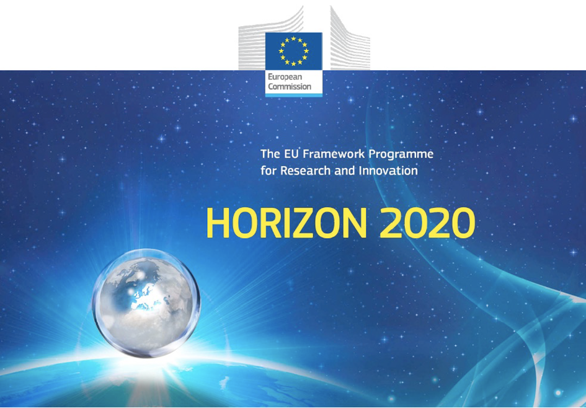

Horizon 2020 Work programme
Food Security, Sustainable Agriculture and Forestry, Marine, Maritime and Inland Water Research and the Bioeconomy
Call
H2020-FNR-2020: Food and Natural Resources
Topic name
FNR-16-2020: ENZYMES FOR MORE ENVIRONMENT-FRIENDLY CONSUMER PRODUCTS

FuturEnzyme:
Technologies of the Future for Low-Cost Enzymes for Environment-Friendly Products
Final ID: 101000327

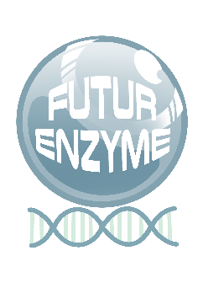
26/05/2023
Mid-term review
MS2
manuel ferrer
csic
Marie Curie 2, 28049 Cantoblanco, Madrid, Spain

Document information sheet

Work package: | WP1, Management and Coordination
Authors: | CSIC (Manuel Ferrer, Patricia Molina)
Document version: | 1
Date: | 31.05.2023
Starting date: | 01/06/2021
Duration: | 48 months
Lead beneficiary: | CSIC
Participant(s): | All
Dissemination Level: | Confidential, only for consortium's members (including the Commission Services)
Type | Report
Due date (months) | 24
Contact details: | Manuel Ferrer (mferrer@icp.csic.es); Patricia Molina (patricia.molina@icp.csic.es)

Summary

Mid-term review 4
1. Means of verification 4
2. Report available 4

Mid-term review

1. Means of verification
This milestone consists in preliminar series of brief reports from the “Panel of External Advisory Scientists, Stakeholders, Policymakers and Consumers” in which experts get a first impression about the overall project success, both in terms of the quality of scientific results and the potential impacts during the first 24 months.

2. Report available
Based on the information and reports gathered by the members of the Panel of External Advisory Scientists, Stakeholders, Policymakers and Consumer, and summarized in the Deliverable D1.2 “Initial-term external evaluation reports”, submitted 23.11.2022, we can consider Milestone MS2 be achieved. For details, see Deliverable D1.2.
That said, the next General Assembly Meeting will be organised in Hamburg on the days 6-7 July 2023 and the members of the Panel of External Advisory Scientists, Stakeholders, Policymakers and Consumer have been invited to participate. In person will assist Ksenia Niessel (Bayer AG), Luisa Crisigiovanni (Altroconsumo) and Jog Raj (PatentCo). On line will connect Víctor de Lorenzo (CNB-CSIC) and Daniele Daffonchio (KAUST).

