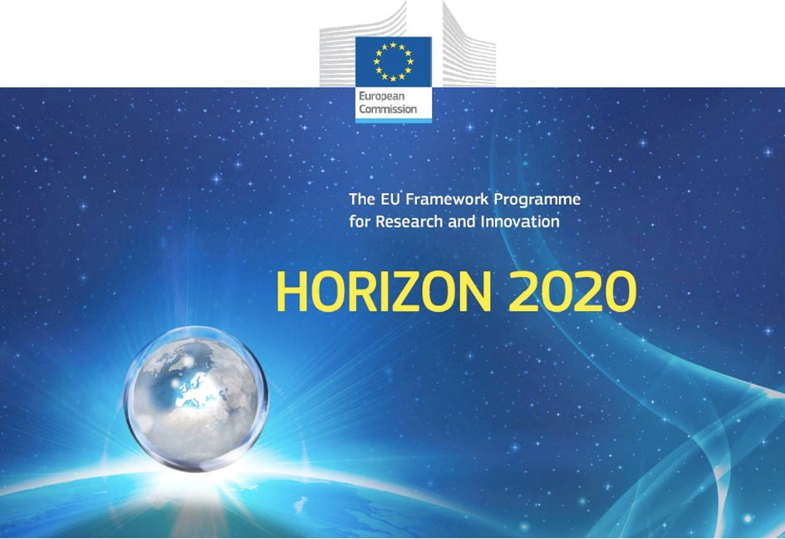

Horizon 2020 Work programme
Food Security, Sustainable Agriculture and Forestry, Marine, Maritime and Inland Water Research and the Bioeconomy
Call
H2020-FNR-2020: Food and Natural Resources
Topic name
FNR-16-2020: ENZYMES FOR MORE ENVIRONMENT-FRIENDLY CONSUMER PRODUCTS

FuturEnzyme:
Technologies of the Future for Low-Cost Enzymes for Environment-Friendly Products Final ID: 101000327

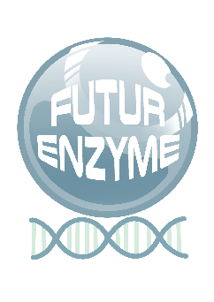
30/07/2021

PLAN FOR USING, COMMUNICATION, AND DISSEMINATING PROJECT INFORMATION AND KNOWLEDGE
D8.3

SARA DANIOTTI, ILARIA RE
CONSORZIO ITALBIOTEC
Via Gaudenzio Fantoli 16/15, 20138, Milan (Italy)

Document information sheet

Work package: | WP8, Communication, Dissemination and Exploitation
Authors: | Consorzio Italbiotec (Sara Daniotti, Ilaria Re) y CSIC (Manuel Ferrer, Patricia Molina)
Document version: | 1
Date: | 30/07/2021
Starting date: | 01/06/2021
Duration: | 48 months
Lead beneficiary: | Consorzio Italbiotec (ITB)
Participant(s): | ITB, CSIC and contribution by all other patners
Dissemination Level: | Confidential, only for consortium's members (including the Commission Services)
Type | Report
Due date (months) | 3
Contact details: | Ilaria Re, ilaria.re@italbiotec.it

Summary
Dissemination and Communication Plan 4
- Introduction 4
- Project overview 5
- Dissemination process overview 6
- Project Dissemination objectives 10
General objectives 11
Specific objectives 12
- Definition of the Strategy Plan 12
Target audience 12
Key messages of the project 16
- Execution of the Strategy Plan 19
Offline Communication tools 19
Online Communication tools 23
Events 32
- Dissemination and communication timetable 35
- Assessment of dissemination and communication activities 40

Dissemination and Communication Plan

Introduction

This deliverable represents the first version, developed at month 3, of the Communication and Dissemination Plan of the FuturEnzyme project, which defines the objectives, target audiences and users, tools, channels, and metrics for measuring the impact of these activities.

This plan is fundamental to set out a strategy to raise awareness of enzyme-based products' positive impact. It also ensures visibility and understanding of the project objectives, activities, and achievements by reaching the broadest possible audience of relevant stakeholders, strengthening the project's communication and dissemination effort. Furthermore, the plan describes the dissemination coordinator's internal communication procedures through liaison with the partners' contact points and the public relation strategy, how information and outputs are collected and communicated.

The strategy proposed is, therefore, intended at spreading the results from the project to the different target groups as well as at building links for further interaction and mutual cooperation with the target groups, engaging not only researchers and manufactures operating in the cosmetic, detergent and textile field, but also consumers, media and policymakers to ensure the actual applicability of the new products in real-life activities.

The communication strategy covers both the European and the regional/national level. The project website and online/printed communication materials about the project represent the primary source of information online for project results. Besides, FuturEnzyme takes advantage of the existing online communication channels, contacts, and consortium partners' networks and look for a broad spread of the project communications in sector magazines, open access journals, and the European Commission's online platforms. Project accounts on relevant social media (Twitter and LinkedIn) are fundamental to support communication activities, disseminating key outputs, and highlighting project workshops and webinars.

The strategy proposed also intend at maximising dissemination and communication impacts by favouring synergies with other projects funded under the same topic.

Consorzio Italbiotec (ITB) is the appointed partner for elaborating, implementing, and updating this document.

The deliverable is structured as follows:

- Project overview explains the context of the whole project in which the dissemination activities stand.

- Communication and dissemination process overview describes the dissemination process in terms of planning, executing, monitoring, and evaluating the impact of communication activities and defining responsibilities within communication activities.

- Project Dissemination objectives explain the strategy's general and specific objectives and define dissemination and communication levels.

- Definition of the Strategy Plan describes the main target groups for the dissemination work and the engagement framework (target actions and target key performance indicators) and the project's key communication messages and the visual identity strategy.

- Execution of the Strategy: description of dissemination tools and materials, which have already been developed or agreed to do. This includes online and offline communication tools, events

and other demonstration events, and a series of activities to maximise the impact of project results, including a customer survey and a product testing activity.

- Dissemination timetable: description of the action timetables and procedures, including the timing of dissemination deliverables and milestones.

- Assessment of dissemination activities: criteria to monitor the dissemination activities.

Project overview

FuturEnzyme: Technologies of the Future for Low-Cost Enzymes for Environment-Friendly Products

In a world facing major environmental threats, concepts such as environmental sustainability, green products, reduction of carbon emissions, and climate-neutrality are gradually increasing importance, becoming central not only in European, national, and local policies but also in citizens' behaviour and consumers' choices. In this context, enzymes undoubtedly play a central role as green catalysts operating efficiently at low energy needs and enabling novel functionalities. By tackling current technological limitations, FuturEnzyme will strive to develop a high-tech platform to generate new enzymes from 9 classes with enhanced performances for processes and products with markedly reduced environmental impacts. Using an innovative yet pragmatic and solution-oriented strategy, the enzymes developed will be used to improve real-life consumer products focusing on 3 market segments: textiles, detergents, and cosmetics. In particular, FuturEnzyme will develop economically viable products with greater sustainability and lower environmental impact (energy, CO2, water, toxicity) of production processes and/or with reduced environmental footprint during their use or end-of-life, while creating advantageous characteristics that included a higher level of functionality. FuturEnzyme will also bring to fruition the enormous potential of the developed enzymes for use as catalysts to faster yield greener, more valuable, and sustainable products in other market sectors.

In particular, the 48-months project FuturEnzyme pursues the following ambitious yet realistic objectives:

  - To develop the most advanced innovative solutions in a fast-track to market platform to discover, design, optimise and formulate enzymes of 9 classes that meet the key performance indicators of three market sectors (detergent, textile and cosmetic manufacturing), as well as producing valuable enzymes for use as catalysts in other market sectors. These solutions will include a smart machine learning platform, a sophisticated activity-based platform, novel systems for producing and characterising the selected enzymes, and novel engineering techniques.

  - To develop four real-life and solution-oriented products [1) enzymes; 2) detergents; 3) textiles; 4) cosmetics] that meet the requirements of manufacturers, society and citizens. For that, a platform for a sustainable supply of the best enzymes and enzyme-based strategies for the formulation of real-life consumer products, will be established.

  - To establish business opportunities in four sectors [1) enzymes; 2) detergents; 3) textiles; 4) cosmetics] aimed at sustainable and inclusive economic growth in order to enhance the competitiveness, innovation capacity, and sustainability of the EU industries and to open low-carbon market opportunities.

  - To ensure the market uptake of the enzymes, processes, and products developed as well as the uptake of the high-tech enzyme development platform through outreach and events towards science, society, and policy makers, aligned with the principles of Responsible Research and Innovation, FAIR, Open Science, gender equality and ethical principles.

Project duration: 48 months – From 1 June 2021 to 31 May 2025.

Dissemination process overview

Communication mechanisms for dissemination activities and communication between partners have been implemented.

Consorzio Italbiotec (ITB) is responsible for the Communication and Dissemination Plan elaboration and implementation and overseeing all dissemination and communication activities in collaboration with the project coordinator. However, all partners will be actively involved in communication efforts as ambassadors of the project, contributing to reach the goals specified in this strategy and ultimately, to maximise the impact of the project outcomes. The communication and dissemination plan will be evaluated on an annual basis for effectiveness and adjusted if needed, following inputs from the consortium, Executive Committee and the Panel of Scientific Advisory Board, Stakeholders, Policymakers and Consumers.

The Dissemination, Communication and IP Task Force, coordinated by ITB, represents the project organism in charge of coordinating effectively project-wide dissemination and communication to internal IP relevant issues and ensuring regularly liaise with appointed contact persons each of the partner institutions (Table 1).

Table 1. Contact persons for communication, dissemination and IP issues

Partner | Contact person: Dissemination, Communication, IP
CSIC | Patricia Molina: patricia.molina@icp.csic.es Manuel Ferrer: mferrer@icp.csic.es  Julia Sanz: xjulia@iqfr.csic.es  IP Department* (Sara Junco): s.junco@csic.es / patentes@csic.es Communication Department: g.prensa@csic.es
BSC | Víctor Guallar: victor.guallar@bsc.es  IP Department (Anna Escoda): anna.escoda@bsc.es / techtransferoffice@bsc.es)  Communication Department (Gemma Ribas): gemma.ribas@bsc.es / communication@bsc.es
BANGOR | Peter N. Golyshin: p.golyshin@bangor.ac.uk Olga V. Golyshina: o.golyshina@bangor.ac.uk Alexander Iakounine: a.iakounine@bangor.ac.uk  IP Department (Gareth Mayhead): gmayhead@bangor.ac.uk  Communication Department (Elinor Elis-Williams): e.elis- williams@bangor.ac.

UHAM | Wolfgang Streit: wolfgang.streit@uni-hamburg.de Jennifer Chow: Jennifer.Chow@uni-hamburg.de  IP Department (Sabine Baars): sabine.baars@uni-hamburg.de  Communication Department: medien@uni-hamburg.de
UDUS | Karl E. Jaeger: k.-e.jaeger@fz-juelich.de Stephan Thies: s.thies@fz-juelich.de Alexander Bollinger: a.bollinger@fz-juelich.de Rebecka Molitor: molitor@fz-juelich.de  IP Department (Claudia Niemann): niemann@zuv.hhu.de, contact through Karl E. Jaeger or Stephan Thies.  Communication Department (Achim Zolke): achim.zolke@hhu.de, contact through Karl E. Jaeger or Stephan Thies
IST-ID | Carla de Carvalho: ccarvalho@tecnico.ulisboa.pt  IP Department (Patrícia Lima): pi@tecnico.ulisboa.pt  Communication Department (Carla de Carvalho): ccarvalho@tecnico.ulisboa.pt
CNR | Michail M Yakimov: mikhail.iakimov@cnr.it IP Department: segreteria.uvr@cnr.it  Communication Department: segreteria.comunicazione@cnr.it
FHNW | Patrick Shahgaldian: patrick.shahgaldian@fhnw.ch Philippe F.-X. Corvini: philippe.corvini@fhnw.ch  IP Department (Marion Rutsche): marion.rutsche@fhnw.ch  Communication Department (Katja Gruenblatt, Pascale Rippstein): katja.gruenblatt@fhnw.ch / pascale.rippstein@fhnw.ch
Bio_Ch | Fabrizio Beltrametti: fbeltrametti@bioc-chemsolutions.com  IP Department (Fabrizio Beltrametti): fbeltrametti@bioc-chemsolutions.com  Communication Department (Fabrizio Beltrametti): fbeltrametti@bioc- chemsolutions.com
INOFEA | Anne Timm: anne.timm@inofea.com  Rita Correro: rita.correro@inofea.com

IP Department: none

Communication Department (Anne Timm): anne.timm@inofea.com
SCHOLLER | Roland Lottenbach: roland_lottenbach@schoeller-textiles.com Rainer Roesch: rainer_roesch@schoeller-textiles.com  Nazanin Ansari: nazanin_ansari@schoeller-textiles.com  IP Department (Rainer Roesch): rainer_roesch@schoeller-textiles.com Communication Department (Dagmar Signer): presse@schoeller-textiles.com
HENKEL | Christian Degering: christian.degering@henkel.com Susanne Wieland: susanne.wieland@henkel.com  IP Department (Sarah Dieckmann): vtp-in.vtp@henkel.com  Communication Department (Christian Degering): christian.degering@henkel.com
EVO | Hans Henning Wenk: henning.wenk@evonik.com  Monica Desiree van Logchem: moniec.van-logchem@evonik.com  IP Department (Meinolf Boettcher): meinolf.boettcher@evonik.com Communication Department (Lukas Notthoff): lukas.notthoff@evonik.com
EUC | Jan Modregger: modregger@eucodis.com  IP Department (Jan Modregger): modregger@eucodis.com Communication Department (Janna Frömbling): froembling@eucodis.com
ITB | Ilaria Re: ilaria.re@italbiotec.it  Sara Daniotti: sara.daniotti@italbiotec.it  IP Department (Ilaria Re): ilaria.re@italbiotec.it Communication Department (Ilaria Re): ilaria.re@italbiotec.it
CLIB | Tatjana Schwabe: schwabe@clib-cluster.de Tobias Klement: klement@clib-cluster.de  IP Department (Tatjana Schwabe): schwabe@clib-cluster.de  Communication Department (Annika Thamm): thamm@clib-cluster.de
*Person at the Institution to whom contact in order to discuss IP issues.

The Dissemination and Communication plan will also consider the best collaborative efforts regarding other projects funded under the same topic, with a view to maximise efficiency and impact, by favouring synergies and avoiding overlapping or duplication of activities. The collaboration will in particular ensure the efficient coordination of activities through, e.g. regular contacts and exchanges, sharing of information (where appropriate) and communication and dissemination of results. The coordinator of the project will ensure contacts with other projects through appointed contact persons each of the coordinators (Table 2).

Table 2. Contact persons for communication and dissemination of other funded projects

Project | Contact person
FuturEnzyme | Patricia Molina: patricia.molina@icp.csic.es Manuel Ferrer: mferrer@icp.csic.es  Julia Sanz: xjulia@iqfr.csic.es  Twitter account: @futurenzyme
Oxipro | Gro E. Kjæreng Bjerga (Norway <grbj@norceresearch.no>)  Twitter account: @OXIPRO_EU
Radicalz | Aurelio Hidalgo (<ahidalgo@cbm.csic.es>)  Twitter account: @RadicalZ_EU
Enxylascope | Carolina Peñalva (<carolina.penalva@aitiip.com>)  Twitter account: @enxylascope

The FuturEnzyme communication and dissemination process is structured in four parts:

- Definition of the Strategy Plan and Project performance indicators which includes key elements of the project communication and dissemination, such as target audience identification, setting of key communication messages, define the project performance indicator and identify proper communication channels.

- Implementation which includes the execution of project activities related to the communication deliverables and milestones.

- Assessment which includes the measurement and tracking of the progress of communication and dissemination activities as well as the evaluation of the effectiveness of the Strategy Plan and its updating during the course of the project. This step also relies on feedbacks and inputs from the consortium, Executive Committee and the Panel of Scientific Advisory Board, Stakeholders, Policymakers and Consumers.

- Project Lesson learned focused on bringing together any insights gained during the project that can be usefully applied on future projects. The major findings will be included in a final report.

This process is continually monitored, updated, and reported upon during the project.

DEFINITION
EXECUTION
Strategy Plan and
Performance indicators
Implementation
Dissemination
Process
Project lesson learned
Assessment
FINAL REPORT
MEASUREMENT
Figure 1. Communication and dissemination process overview

In addition to the above, in order to help the Dissemination, Communication and IP plan, the coordinator will prepare in the next 3 months a report related to the IDENTIFICATION OF THE STATE OF THE TECHNOLOGY in the three sectors relevant to the project. The objective of these reports is to locate that bibliography (both patent documents and non-patent literature) referring to the use of enzymes in the following applications:

- Hyaluronic acid production (breaking) processes, mainly in the field of cosmetics;

- Use of enzymes, mainly lipases, detergent compositions;

- Use of enzymes in the field of textile production/treatment.

In a potential second stage, as much information as possible will be extracted from the documents retrieved in the searches on the type and characteristics of the enzymes that have been described for these processes, the conditions of the procedures (amount of enzymes used, temperature, times, etc.), and on the companies behind these publications and developments together with their contact details. These reports will allow, among others:

- To be at the forefront of new inventions and developments in the three technological areas of interest, so that we will have the technical information regarding the processes that have been developed or are being developed in those areas of knowledge;

- To carry out a comparison with our own processes/products or the development of the same.

- To identify the main applicants/actors in the areas under study, which could be considered as potential companies of interest, licensees, partners interested in the technology or for disseminating and communicating project activities via social media – effort will be done to find their Twitter account in order to make massive promotional campaigns;

- To know the positioning of the technology, new trends, versatility, etc.

Project Dissemination objectives

This plan defines all the communication and dissemination activities that will be undertaken during the project to maximise project results. These activities are complementary to each other, but they are not the

same. The European Commission IPR helpdesk provides detailed information about this in the leaflet 'Making the most of your H2020 project'. The difference between dissemination and communication is explained as follows by the EC Research & Innovation Participant Portal Glossary:

Communication: "Strategically planned process that starts at the outset of the action and continues throughout its entire lifetime, aimed at promoting the action and its results. It requires strategic and targeted measures for communicating about (i) the action and (ii) its results to a multitude of audiences, including the media and the public and possibly engaging in a two-way exchange."

Dissemination: "Public disclosure of the results by any appropriate means (other than resulting from protecting or exploiting the results), including by scientific publications in any medium."

Dissemination and communication activities in FuturEnzyme are strictly interconnected and embedded in all project stages, yet different and not overlapping. Communication activities refer to a wider audience in order to promote the project and its results within the society and show the impacts and benefits of the research activities. On the contrary, dissemination activities aim at transferring knowledge and results to audience that may be interested in the potential use of the project results.

The activities will continue beyond the project-ending, therefore ensuring a long-term impact of the project and its research activities.

Dissemination and Communication activities will also be consistent with protecting generated IP (e.g. patent, product design) and further industrial application. Therefore, before any of these activities (publication, presentation) strict rules of prior notice to all partners will be applied, according to the EC guidelines, the Grant Agreement and the Consortium Agreement.

General objectives

The general objectives of FuturEnzyme Communication and Dissemination Plan are:

- Formalise all communication actions planned in the project framework to provide guidelines and to set out the key dates related to planned events and actions.

- Ensure that information is shared with appropriate audiences on a timely basis and by the most effective means.

- Provide a recognisable identity for the FuturEnzyme project.

- Define channels and communication messages according to the target audience needs.

- Maximising the impact of project results and research activities implemented during FuturEnzyme.

- Increase the general visibility of the project within the society.

- Establish and maintain mechanisms for effective and timely communication.

- Inform stakeholders of the progress of the development and encourage interactions between stakeholders.

- Coordinate all levels and types of communication to the project.

- Generate long-term benefits for the partners and the territory.

Specific objectives

The specific objectives of FuturEnzyme Communication and Dissemination Plan in relation to project activities are:

  - Encourage the application of technological solutions to raise competitiveness and maximise the potential and scientific excellence of manufacturing activities.

  - Encourage the attraction of new investments in the enzymes sector as a green catalyst to reduce the environmental impacts of commonly used products.

  - Ensure better exploitation of project results. This will encourage the transfer of the lessons of the project to other users, manufactures and policymakers.

  - Encourage the industrial exploitation of project products and research results.
  - Raise public awareness of the environmental impact of commonly used products.
  - Analyse consumers’ interests in the new enzyme-based products developed within FuturEnzyme project.

Dissemination and communication levels

The dissemination plan is divided into three strategic focus areas, so that the focus is based on where and when the effort of the dissemination is most needed and effective.

The strategic focus areas are:

  - Dissemination at Local level

  - Dissemination at National level

  - Dissemination at European level

- Definition of the Strategy Plan Target audience Scientific/academic community
The activities aimed at the scientific and academic community have the purpose of disseminating the project experience and results, while encouraging future research on eco-friendly enzyme-based products and therefore accelerating. By stimulating the scientific community's participation in the Open-Web-platform for enzyme search, these activities aim also at accelerating the process of identifying enzymes required by industries making new enzyme-based products more accessible to consumers.

This target group includes researchers, academics, and university students to reach the above-mentioned objectives and secondary and high school pupils to promote knowledge in the biotech sector, spreading awareness about pollution prevention and supporting the improvement of environmental responsibility.

Target actions:

- 100 scientific publications and research datasets (open access and public repositories).

- 2 science and policy briefings.

- 4 scientific workshops.

- 1 technical course.

- 25 scientific seminars.

- 2 training activities and 25 talks for secondary school students.

Once the decision to publish specific results has been reached and the IP issues preserved, the corresponding scientific publications and their research datasets will be deposited in Thematic and institutional Open Access repositories (Green will be the general rule). Open Science elements will be included in the project by the introduction of a Project Manager at the CSIC (Patricia Molina) and through the implementation of a “control channel” involving all partners but coordinated by the Project Manager. The “control channel” will ensure the open access deposition and release of all material related to the results. Data produced by any partner will be included in a publication and a repository only after their explicit permission. We will collect and ensure that all the scientific publications, and their associated research datasets, are deposited in the public repositories (e.g. bioRxiv, medRxiv, Authorea, ArXiv, Europe PudMed Central, Cogprints, Repec, Zenodo, OPEN Library, Recolecta, OpenAIRE, OpenDOAR, etc.) and identified with the name of the action, acronym and grant number, as well as the DOIs and permanent identifiers. All pre-prints of manuscripts will be submitted to repository within 3 months after acceptance. Below, some of the public repositories most used by partners are included.

Repositories most commonly used by Partners
DIGITAL.CSIC (https://digital.csic.es/) UPCommons (https://upcommons.upc.edu/)
Repository – PURE@Bangor (https://www.bangor.ac.uk/research-support/repository.php.en) JuSER (https://juser.fz-juelich.de/?ln=en/)
Zenodo (https://zenodo.org/)

Life Science Nord (https://lifesciencenord.de/de/) SOTIS (https://sotis.tecnico.ulisboa.pt/)
Protein data Bank (https://www.rcsb.org/)
NIH genetic sequence database GenBank® (https://www.ncbi.nlm.nih.gov/genbank/) PRIDE Proteomics Identifications Database (https://www.ebi.ac.uk/pride/) MetaboLights (https://www.ebi.ac.uk/pride/)

SMEs and industries operating in the biotech sector (also scientific and academic community)

This target group includes biotech firms, SMEs and large industries active in enzyme production for different application and industries that produce everyday products with a high environmental impact that could be reduced by using enzymes in their production. The involvement of this target group in FuturEnzyme activities aims to encourage the industrial dialogue about FuturEnzyme topics and support the improvement of environmental responsibility in the industry. Industries will be actively involved in international, EU, national, regional, and local events in which partners present new enzymes and technologies to reduce the environmental impacts of products to improve the speed to market of enzyme- based products and services and their future growth potential.

Target actions:

  - 2 online software
  - 2 news technical bulletins and understandable practice abstracts
  - 2 articles in scientific magazines
  - 1 conference
  - 3 online webinars
  - 3 patents

Consumers & policymakers

Policy events and briefs aimed at European, national and regional policymakers and events specifically aimed at consumers have the purpose of recognising that more efficient enzymes can have a positive impact on the sustainability of laundry homecare, textile and cosmetic products. Therefore, these events aim to spread awareness of the benefits of new, environmentally friendly ingredients and products among policymakers and consumers.

In particular, policymakers' events are focused on supporting environment-friendly products and policy issues that contribute to sustainable development and promote a dialogue about research funding policies integration.

Consumers will be involved in events such as seminars and workshop and they will also be also asked to participate in a consumer survey, to understand if they appreciate the new products and if they are willing to pay more for them, and in a product testing, to evaluate the applicability and the real preference of consumers in everyday situations.

Target actions:

  - 1 legacy leaflet
  - 2 consumer briefings
  - 2 articles in non-scientific magazines
  - 3 industry/market/consumer-driven workshops
  - 2 policy events (1 with other call-consortia)

  - 2 roundtables
  - 1 public event "EU Green Deal aligned to Rights, Ethics, Equality"
  - 1 Consumer survey
  - 1 Consumer product testing

Networks of other actors and EU linked projects

Disseminating and communicating the project outcomes in events organized outside the consortium and in which FuturEnzyme partners participate, will be key piece. In addition, bringing together linked EU projects in inter-consortia events will be fundamental to exchange good practices, transfer information, share ideas, results, LCA assessments and enzymes. Co-integrating enzymes of other consortia, in fact, may yield products of higher environmental quality and consumer acceptance. Therefore, the purpose of partners of EU linked projects is to find joint exploitable solutions to challenges and problems encountered during their respective projects.

Target actions:

  - 3 demonstration events in science festivals
  - 30 open days
  - 4 exhibitions and tours
  - 40 conferences and workshops presenting different EU linked projects
  - 40 social events
  - 2 inter-consortia networks that will include a policy event to create a transparent legal and policy framework in which to operate, exploit and disseminate synergies

Broad audience

The broad audience does not include one specific target audience, but all of them. It will be aimed at communicating about the project and disseminating project results by using different online tools, reaching specialised media, and organising events and other activities about FuturEnzyme to interact with stakeholders. The final purpose of these activities is to raise awareness about everyday sustainable practices, inform about FuturEnzyme products' advantages, and promote public responsibility of pollution prevention.

Target actions:

  - Social media strategy with at least 1000 notes on LinkedIn and Twitter.
  - 1 website freely open to public.
  - 5 visual identity guidelines, pictures, artistic animations.
  - 2 film, film footage, comic on environmental thematic.
  - Press strategy with at least 40 newspapers, radio and TV appearances.

Key messages of the project

The identification of key messages is essential to ensure the coherence of all communications produced about the project. Partners are encouraged to include the messages below in all communications about the project, as well as other messages that will be defined throughout the project and based on the results to be achieved.

Slogans

  - Driving a tomorrow’s greener Planet.
  - New Enzymes for Cooperative Bioeconomic Innovation.
  - Assisting consumers with products for a greener Planet.
  - Let’s contribute to a greener future we’re all inspired.
  - Let’s change the way we generate products with reduced environmental impacts.
  - Assisting society to accept and use greener and more innovative consumer products.
  - FuturEnzyme assists Europe to become the world’s first climate-neutral continent.
  - Go green with enzymes
  - Enzyming your world
  - Make the world green again
  - Go, enzymes!
  - Greening the world through enzymes
  - The future is enzymes
  - Enzymes for our future
  - Enzymes to the people
  - Enzymes to heal our Earth
  - Healing Nature with enzymes
  - Enzyming textiles
  - Enzyming detergents
  - Enzyming cosmetics
  - Enzymes have the power to green your world

  - Etc.

Project’s messages

  - FuturEnzyme is a project inspired by the major environmental threats the world is facing.
  - FuturEnzyme is a project inspired by future consumer habits and preferences.
  - FuturEnzyme positively impacts greenhouse gas emissions and global warming issues, by reducing water, energy and chemicals consumption, and carbon footprint.

  - Cooperatively designing the world’s most advanced technologies for disruptive smart enzymes with enhanced performances and reduced load to the environment.

  - Assisting the production of innovative and greener detergents, and bio-processed textiles and cosmetic ingredients, with improved sustainability, performance, and quality.

  - Cooperatively designing the enzymes of the future in line with future stricter environmental regulations, changes in consumer habits and preferences, and industrial objectives.

  - FuturEnzyme addresses the challenges of the COP21, the European Green Deal, the Sustainable Development Goals and the European Bioeconomy priorities.

  - FuturEnzyme addresses social challenges and promote the exchange between Academia and Industry and the consumers.

Figures on expected results

FuturEnzyme covers multiple activities from which multiple results are expected:

- Machine learning-based enzyme bio-prospecting;
- Bioinformatics and Sequencing for enzyme bio-prospecting;
- Activity-based enzyme bio-prospecting;
- Cultivation of novel microbes;
- Disruptive enzyme engineering approaches;
- Enzyme implementation through immobilisation and shielding technology;
- Beyond state-of-the-art multiple expression technologies;
- Biocatalysis;
- Bio-fermentation and downstream purification;
- Upscale/(Pilot) fermentation, production of industrial enzymes, and formulation;
- Production of detergents, and bio-processed textiles and cosmetic ingredients;
- Evaluating consumer acceptance for new innovative and greener products;
- Evaluating the environmental profile of the new enzyme-based products;
- Etc.

Figures will be produced to disseminate and communicate these activities and the outcomes. Figures on expected results include the following ideas:

- A figure that exemplifies how new enzymes can be integrated into products relevant to the project, how the consumers may use them and how the environment will benefit.

- A figure that exemplifies the benefits of integrating super-computers in the enzymes search for solving environmental threats.

- A set of figures showing the different types of environments and sampling sites from which new enzymes can be discovered.

- A set of figures exemplifying how enzyme parameters can be predicted, and to show how combining industrial feedback and academic knowledge, new enzymes for designing specific consumer products can be implemented.

- A set of figures showing how through genetic and supramolecular engineering high performance enzymes can be implemented.

- A set of figures through which to show how enzymes can be produced at large and how consumer products can be made.

- A set of figures showing to consumers how the addition of enzymes in everyday products can lower the environmental impact of these products.

- A set of figures representing how biology and green chemistry can join effort for greener solutions.
- A set of comic vignettes showing the whole process from an initial idea, to how to organize the search for new enzymes and how these can be produced and used based on circular economy criteria.

- A set of figures showing how our project can be linked to other funded projects to join efforts to bring benefits to the environment and to the consumers.

- A set of figures that summarize how the EU is and will be a key player in developing research towards a greener planet.

- A set of figures illustrating the diversity of microorganisms and enzymes (native and artificial) to be obtained.

- A set of figures that briefly summarise the innovative character of the products to be implemented.
- Etc.
Outcome measure: at least 14 images/figures representing major advanced achieved during the project.

Execution of the Strategy Plan

Offline Communication tools

Logo and graphical identity

A visual identity is composed of visual elements that will provide a tangible manifestation of the project identity and define how FuturEnzyme will be presented to the target audience. The FuturEnzyme graphical identity will include logo, fonts, colours, text, promotional materials, and templates for presentations, posters, and deliverables. The guidelines will assist the partners in designing and producing compelling communications both for web and printed material and contribute to developing a strong and recognisable FuturEnzyme brand. Therefore, it is important to follow the visual identity strategy since good use will help to consistently communicate and disseminate the project. Guidelines and templates will also save time and effort for the members of the consortium since no further design work will be necessary. These materials will be provided by CSIC and defined in detail in D8.2 "Visual identities guidelines".

Here, we report the logo of the project developed by CSIC. The logo exemplifies a crystal ball through which one can visualize how smart enzymes can be seen in the future.

At the time of the submission of this deliverable, the templates for deliverables and power point presentations have been prepared to be used for internal communications among partners. The same template for deliverables will be used to compile the minutes (to be produced by the Project Manager) of all internal project meetings.

Deliverable template:
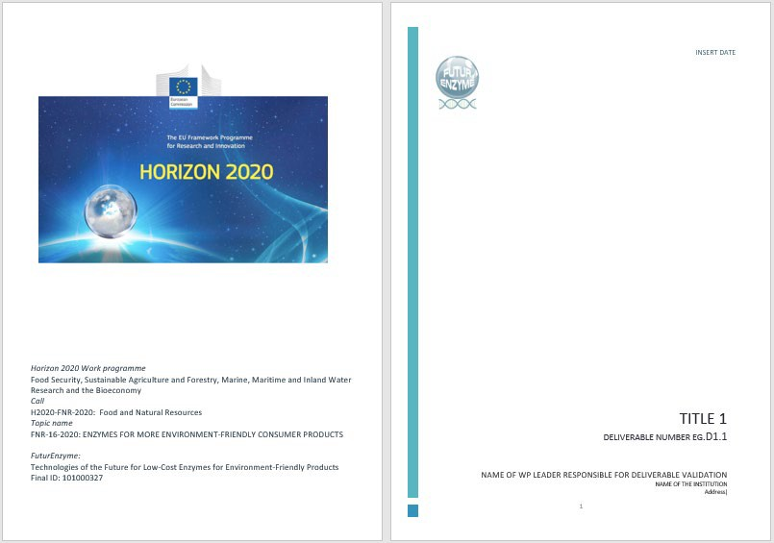
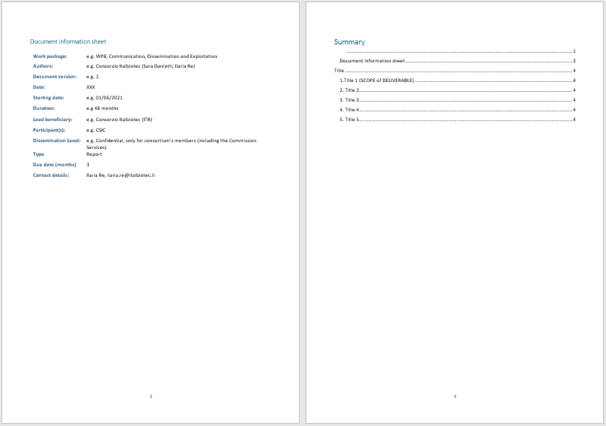

Power point presentation template:
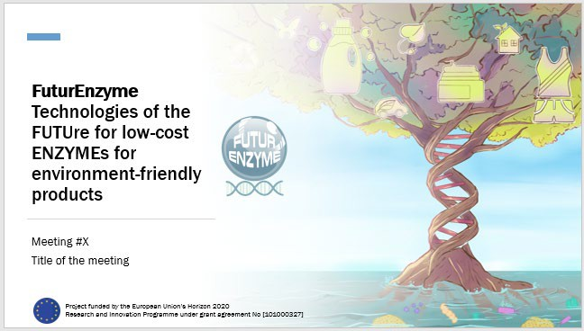
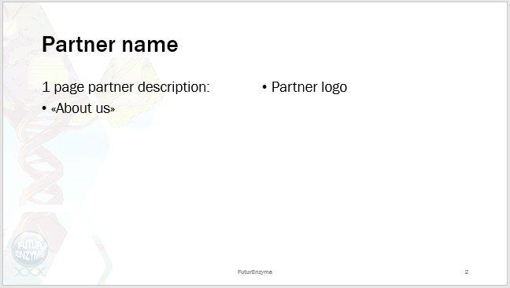

Outcome measure: 5 Visual identity guidelines, pictures, artistic animations, number of templates

Project leaflets, brochures and posters

The project leaflet (Factsheet) will contain the project logo and a summary of its goals and actions. It will be in different languages, 2 to 4 pages long and it will be distributed during the project events aimed at a broad public to communicate the potential societal benefits of the FuturEnzyme research. The PDF version will be uploaded on the website, widespread through the social network and distributed through a monthly newsletter.

Brochures will be created and distributed to the scientific and industrial community of stakeholders. They will explain the project objectives in a detailed way describing the concrete undertaken actions and expected results with the aim to exploit the outputs of the FuturEnzyme project.

Furthermore, two posters will be produced, one providing a scientific and technical overview of the FuturEnzyme project, for scientific conferences and trade fairs and the second one for general communication and disseminations events aimed at the general public and society. They will be in several sizes, such as A3 to A1 format and will be displayed at strategic points with the FuturEnzyme logo visible on these posters. The support from European Union’s Horizon 2020 will also be acknowledged in all communication materials by including Horizon 2020 logo.

Outcome measure: Project leaflet (~500 copies printed and ~ 2000 sent by newsletter), brochure (~200 copies), 2 different posters (200 copies in total).

Legacy leaflet and consumer briefs

The offline communication tools will include legacy and policy leaflets and briefs detailing the issues around using enzymes as ingredients for greener products and reducing the carbon footprint and waste productions. These leaflets will summarise key outputs of the project and recommendations on the use of enzyme-based products to reach both policymakers to impact environmental policy and consumers to raise awareness on the sustainability of everyday products.

In order to maximise the impact on consumers, two different consumer briefs will be distributed to inform about the output of the consumer survey and the product testing activities, both evaluating consumers' interest in the new enzyme-based products developed by the project. This material will be distributed during events, and the pdf version will be uploaded on the website, widespread through social networks and distributed through a monthly newsletter.

Outcome measure: 1 legacy leaflet, 2 consumer briefs (1 for the survey activity and 1 for the product testing activity), number of copies distributed (number of paper copies, number of copies distributed via online channels)

Press campaign

Media are always invited to all dissemination events in order to achieve maximum presence on news channels (including newspaper, radio and television). The event information will be given priority using the communication channels of the partners. Maximum spread will be given through the website, newsletters and social media related to the project.

Different press releases will be produced at pivotal moments of the project to maximise the exploitation of results. Press releases will be prepared in English and they will be available for the other partners via the online platform so that they can disseminate them within their networks. Partners can also translate the press release in their languages in order to reach their national public. Press releases will target biotech sector organisations, policymakers, consumers and specialised media. A template of press release of FuturEnzyme will also be available for partners' use. For joint press releases that include all consortium members, the CSIC

press office will be in charge of preparing the official press release that will be sent to the partners to be adjusted to their own needs.

Outcome measure: 40 newspapers, radio or TV appearances, readership numbers of these publications.

Publication in Scientific Journals and technical magazine

The Project partners cements the impact of their dissemination activities by preparing and publishing formal reports and scientific articles in open access, peer-reviewed journals. This ensures that FuturEnzyme will have a long-lasting impact beyond the project duration, particularly to the area's academic discourse. In order to guarantee the highest impact, about 8% of the documents are expected to be published in journals with an impact factor > 9.0, and 90% are expected to be published in journals with an IF between 3.0-9.0. Relevant journals for the publication of FuturEnzyme scientific articles could be: Nature, Nature Catalysis, PNAS, Nature Communication, ACS Catalysis, Angewandte Chemie, Computational and Structural Biotechnology Journal, Biotechnology Bioresources, Environmental Microbiology, etc. This list is not exhaustive but is simply meant to convey the breath of publication to which FuturEnzyme findings may be relevant. Once the decision to publish specific results has been reached and the IP issues preserved, the corresponding scientific publications and their research datasets will be deposited in Thematic and institutional Open Access repositories.

Furthermore, detailed technical reports will be produced and published in scientific magazines in order to reach SMEs and industries operating in the biotech sector, besides the scientific and academic activities, to ensure the exploitation of FuturEnzyme results.

A broader audience, including consumers and policymakers, will be addressed by the publication in non- scientific journals (e.g. the journal Ambienta, from the Spanish Ministry of Ecological Transition and the Demographic Challenge) of informative articles describing the project's objective and its main results, with a focus on environmental sustainability and green products.

All dissemination activities (articles in conference proceedings and journals) carried under FuturEnzyme project will use the following acknowledgement: “This paper is supported by European Union’s Horizon 2020 research and innovation programme under grant agreement No 101000327, project FuturEnzyme (Technologies of the Future for Low-Cost Enzymes for Environment-Friendly Products)”.

Major efforts will be done to perform dissemination activities in collaboration with other consortia, including, contribution in non-scientific and scientific journals, etc.

Outcome measure: 100 Scientific publications & research datasets (Open Access), 2 articles in scientific magazines, 2 articles in non-scientific magazines, journals impact factor, circulation of the publications, number of citations.

Online Communication tools

Platform for project meetings and conferences

A strong online communication platform (Conecta CSIC) has been established in order to effectively organize project-wide communications by partners. Conecta CSIC is the platform adapted from BigBlueButton by the CSIC’s Technology Arquitecture department. This service will be used for FuturEnzyme meetings. It was developed in February 2020 in sight of the urgent need for a videoconference system due to COVID-19 health emergency. With this service, one can easily organize different communication activities including:

- Meetings

- Video conferences

- Presentations

- Conferences

- Classes

Some advantages over the use of other platforms are:

- Authenticated access using CSIC’s credentials;

- Access to the participants through a specific URL that directs to specific “rooms” (avoiding downloads and registrations), which can be personalized;

- CSIC severs support the service and guarantee its performance;

- Independence of video conference service suppliers online;

- Coded communications;

- Protected content in CSIC’s infrastructures;

- No time limit.

The following tools are at the user’s disposal:

- Access to the meeting only by audio or audio/speaker

- Shared video

- Shared screen

- Public chat

- Private chats

- Shared notes

- Blackboard

- Recording of the sessions, available through a link

- Sharing of the recording via link

- Surveys

According to a consumption analysis (https://greenspector.com/en/which-video-conferencing-mobile- application-to-reduce-your-impact-2021/), BigBlueButton is one of the platforms with a lower Eq CO2 consumption.

Below are the links to the services and recordings for FuturEnzyme project:

- Link to Conecta CSIC: https://conectaha.csic.es/b

- Link to FuturEnzyme room: https://conectaha.csic.es/b/pat-1d3-guk-x6v

- Links to the meetings held so far:

  - KOM:

https://balanbbb.corp.csic.es/playback/presentation/2.0/playback.html?meetingId=631f9e2ae184 41fe3fb2ebb52cdd396582b046ef-1623136404906

https://balanbbb.corp.csic.es/playback/presentation/2.0/playback.html?meetingId=73c45220ca9d 919ea5a88862837074915e4db82d-1623140148516
  - Meetings for D2.1 https://balanbbb.corp.csic.es/playback/presentation/2.0/playback.html?meetingId=73c45220ca9d
919ea5a88862837074915e4db82d-1625124005812

https://balanbbb.corp.csic.es/playback/presentation/2.0/playback.html?meetingId=73c45220ca9d 919ea5a88862837074915e4db82d-1625043240403
  - Meeting for WP 2-4 https://balanbbb.corp.csic.es/playback/presentation/2.0/playback.html?meetingId=73c45220ca9d
919ea5a88862837074915e4db82d-1625468859806
  - Meeting for WP4-5 https://balanbbb.corp.csic.es/playback/presentation/2.0/playback.html?meetingId=73c45220ca9d
919ea5a88862837074915e4db82d-1626161837373

Project website

The website's primary function is to disseminate information about the project activities and results, its achievements, and scientific knowledge and list of publications. The website will contain general information of the project such as objectives, up-coming events (e.g. meetings, conferences, workshops, info days, …), photo gallery, videos, reports, information on the participants, links to correlated websites and projects, also including all communication materials (project leaflet, brochures, consumer briefs, link to publications, seminars invitations etc…) which will be open and easily downloadable for website visitors. The website will also contain a discussion forum where registered participants will post requests and open discussion threads interacting and exchanging ideas with Consortium members and project stakeholders.

We will also include a public, non-confidential questionnaire to interested industrial parties throughout the EU to deposit interest into enzyme families and communicate non-confidential requirements. After collecting all the information, a protocol to evaluate and summarize the outcome will be defined in order to define how our Project can help solving these requirements and also how we can adapt our strategies to take into consideration relevant needs.

Aside from providing factual and practical information about the project, the website will serve also as a secure central file exchange platform and a facility for internal communication and project management: therefore, a part of the website will be reserved as an internal workspace for the partners with the aim to share contacts, databases, reports and scientific materials, allowing a strong relationship between partners fitting the current COVID-19 situation and also reducing the environmental impact of extensive travel.

Commercially available or open-source products will be used for developing and maintaining the website (e.g. Project Place, Feng Office). The website will be in English and will be the central point of communication about news, events, progress, and the project results.

The user-friendly layout format will feature the project logo as to create a distinctive and recognisable identity for the publication. The site is also accessible via QR Code report on all materials produced by the project.

To drive traffic to FuturEnzyme’s website, the partners will provide a link to the project’s web on their organisation's webpage.

The first draft of the project website (www.futurenzyme.eu) was designed and circulated internally on 30/06/21 and is online since 26/07/2021. It was set up by CSIC and will be managed, maintained, and updated for the duration of the project and for at least 1 year after the completion of the project.

The following QR code was generated to be used whenever can be adequate by the partners. For instance, in posters, presentations, leaflets, etc.

The sitemap is structured as follows:

- Home: project challenge and general context;

- Objectives: specific project targets;

- Work Plan: project work packages;

- Project Meetings: regular Consortium/Project-related meetings;

- Partners: logo and link to partners' project website;

- Events: description of public events (workshops, courses, conferences, etc.) realised in the frame of the project; description of public events such as demonstration events, science festivals, open days, exhibitions, tours, conferences, workshops, and social events organized outside the consortium and in which project activities are presented

- News: media-gallery, promotion of events, news, press releases;

- Publications: scientific publications, divulgative publications, and patents; Other entries and sections of the webpage are:
- Networking and Links: (in Homepage) logo and link to other relevant European and national projects, European Commission H2020, Paris Climate Conference (https://unfccc.int/; https://ec.europa.eu/clima/policies/international/negotiations/paris_en), European Green Deal (https://ec.europa.eu/info/strategy/priorities-2019-2024/european-green-deal_en), Sustainable Development Goals (https://sdgs.un.org/goals), EU Policy relevant to FuturEnzyme (https://ec.europa.eu/jrc/en/research-topic/consumer-products; https://ec.europa.eu/programmes/horizon2020/en/h2020-section/food-security-sustainable- agriculture-and-forestry-marine-maritime-and-inland-water; https://ec.europa.eu/info/research- and-innovation/funding/funding-opportunities/funding-programmes-and-open-calls/horizon- europe_en), links to Equality Plans of the Partners (https://icp.csic.es/es/instituto/igualdad/; etc.), etc.;

- Advisory board: (in footpage) Scientific Advisory Board, Stakeholders, Policymakers, Consumer Organizations;

- Contact details: coordinators and partners;

- Social Media: LinkedIn, Twitter; including the webs and Twitter/LinkedIn accounts of other funded projects (e.g., @enxylascop; @OXIPRO_EU; @RadicalZ_EU) and also those of members of the Advirosy Board (e.g, @vdlorenzo_CNB (Víctor de Lorenzo), @JRJaswal (Jog Raj), @MedScienceCom (CIESM), @Altroconsumo (Altroconsumo), etc.).

- Intranet: internal repository for data storage, data and material exchange between partners, etc. This section has three main blocks:

  - Private area, which is the principal page that appears when login in, divided in four categories: private data storage (private data of partners with password access), shared data (data shared by partners, such as datasets), shared material (links, videos, documents, etc., shared by partners), and shared templates (those produced for reports, deliverables, etc).

  - All accounts: information of the partners and their members.

  - All profiles: information of the members who upload material.

- Visitors to website: overall number of website visitors;

- Slogans: (Home and others) the slogan or slogans we want to mention.

The website is supported by a statistical analyser to analyse website hits, page views, downloads and other important indicators to evaluate the website performance and impact.

The website will include several images that will also be used for other communication activities (such as social media posts and press releases). Five images have already been created by CSIC. These figures are Original Visual Identity Pictures created for FuturEnzyme.
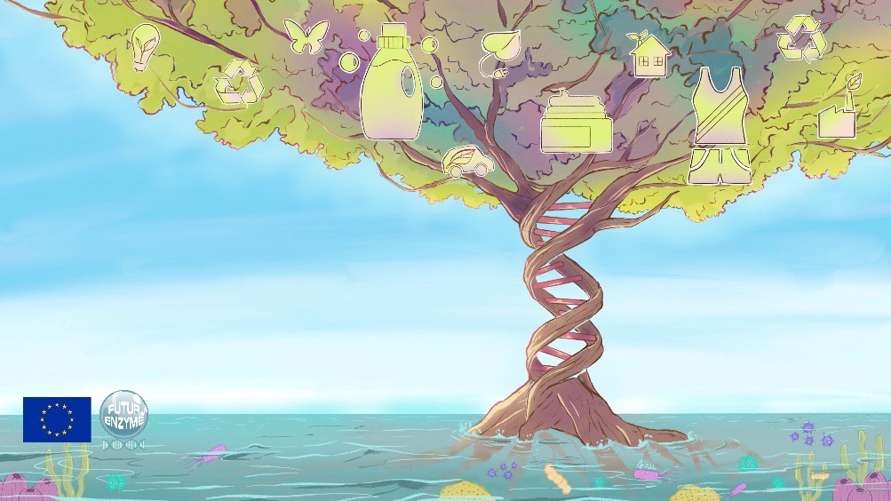
Image 1 - Enzymes for driving a greener planet for tomorrow: this image represents the expansive nature of FuturEnzyme. Based on natural DNA resources (depicted as the root of the tree) and applying to them new smart and advanced technologies, disruptive enzymes with enhanced performances and reduced load to the environment will be discovered, designed, optimised, supplied, and formulated, leading to innovative and greener detergents, bio-processed textiles, and bio-processed cosmetic ingredients. FuturEnzyme will also bring to fruition the enormous potential of enzymes via a novel, high-tech platform to yield other greener, more valuable, and sustainable products depicted as multiple branches of the tree.

Image 2 -Enzymes for driving greener detergents for tomorrow: this image is related to liquid detergents, showing a detergent from which we are going to remove chemical compounds by replacing them with enzymes. The consumer would use a new greener detergent with less or zero chemical additives in a washing machine, which would produce cleaner clothes. At the same time the washing machine would use less water and energy. In the image, the plants are climbing and growing around the clothes washed with the most ecological and innovative detergent made by FuturEnzyme, representing that the washing process is more eco-friendly. Sparkling around clothes represents the fact that the detergent not only cares for nature, but also leaves the clothes cleaner than a standard detergent.

Image 3- Enzymes for driving greener cosmetics for tomorrow: the following image show a cosmetic whose main ingredient is produced with zero-pollutants and which is beneficial for the environment because, in the production process, it avoids the use of toxic solvents and saves energy and greenhouse gases. At the same time, when using the new cosmetic consumers would have a better "look". Therefore, the image shows a user whose hair is part of the natural landscape, thus expressing that she/he is nature and that by using cosmetics to be produced in FuturEnzyme, she/he, in turn, takes care of both her/himself and nature.

Image 4 - Enzymes for driving greener textiles for tomorrow: this image is related to textiles, showing a sportswear that is going to be more innovative (for example, breathable or waterproofing, etc.) using compounds with lower toxicity and less energy during the production process. It shows a runner that, by wearing clothes created more ecologically and functionally by FuturEnzyme, leaves a trail of steps in which vegetation grows, symbolizing that wherever she/he runs, nature feels appreciated.

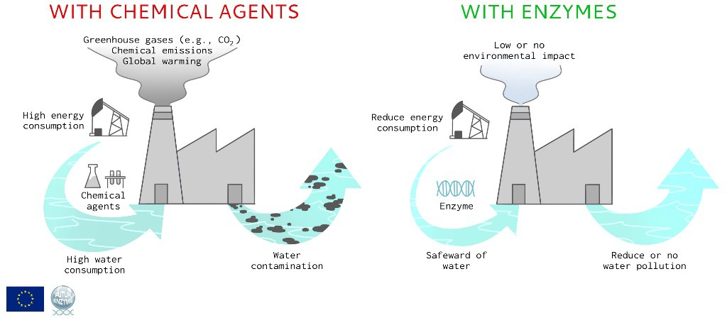
Image 5 - Advantages of enzymes vs. chemical agents for the development of more sustainable detergents, textiles and cosmetics. The image summarizes the high environmental impact of consumer products produced with chemical agents and how it can be considerably minimized with the use of enzymes following circular economy criteria.

Other images will be prepared and included on the website as the project progresses. These images will represent the main results of the project in a simple graphic form so that they are easily communicated to both the general and the specific public.

Outcome measure: website hits, page views, deliverable/document downloads, comments received, request for information received, number of specific webpages dedicated to the project on partners' website.

Newsletter and technical bulletins

ITB will develop a project newsletter that will be submitted at least every 12 months to disseminate information about the project (objectives, intermediate results, events), demonstration events, and any information related to the topics covered by the national project or worldwide. All newsletter produced will be freely downloadable from the website, even by non-registered users, and will also be distributed via social media as well as the clusters' (CLIB, ITB) members network. Users will also have the possibilities to subscribe to a mailing list to receive the newsletter via email. The newsletter will have a corporate identity with the site of the project.

Furthermore, the project's partners will also develop technical bulletins (at least 2 during the project) to ensure timely and uniform dissemination of technical information, guidelines and instructions. In particular, the technical bulletins or practical abstracts are intended to communicate a short summary of some practical information or recommendation that has been observed or developed during the research (e.g. recommendations on the amount of enzymes to decrease the environmental impact of detergent, or to save water and energy, etc.). These bulletins will be aimed at a technical and scientific audience.

Outcome measure: 1 publication every 12 month; ~ 2.000 signed up users, number of subscribers, number of technical bulletins, number of clicks and click rates.

Project videos

During the project lifecycle, a film footage and a comic will be developed by CSIC on the innovative research aspects and socio-economic potential of the FuturEnzyme project. The videos will be in English, include project logo and a clear reference to the H2020 financial support (credits at the beginning or the end include an explicit mention "With the contribution of the Horizon 2020: the EU framework programme for Research and Innovation"), have a duration of 15 minutes and adopt a user-friendly language, in order to explain the objectives, strategies and project impacts. Videos will be available on project website and they will be disseminated through social network campaigns on LinkedIn, Twitter and Youtube.

Outcome measure: 2 project videos, number of members/followers, network page views, video comments, mentions, feedback.

Social networking promotion

Social media will be in place to maximise the results of the project and stakeholder engagement. They will be used to communicate project news, important results, publicise events and webinars, and distribute the newsletter, leaflets, briefs, and brochures. Blogs will also be considered since they are a useful online tool to publicise project efforts and results and may be particularly effective in reaching particular industrial and academic sector. Emphasis will be put on Twitter and LinkedIn accounts, being the most extensively used for professional communications. ITB, with a strong collaboration of CSIC, has created a project account on each platform. Each partner is welcomed to repost the news on their accounts in order to reach a wide audience. ITB also prepared an editorial plan, planning to post at least twice on a month. The impact of project communications on social media will be regularly monitored and reported by all partners.

The FuturEnzyme accounts are the following:

  - Twitter: @futurenzyme
  - LinkedIn: https://www.linkedin.com/company/74295792

We are planning 5 massive social campaigns during the Project to improve the project visibility and increase the number of followers on both Twitter and LinkedIn. The first campaign will be launched after the website launch, aiming at both increasing the number of followers on project's social media accounts and encouraging users to convert to FuturEnzyme website.

Recommendations for social media communications:

  - Use reference to the project in all tweets/posts: #FuturEnzyme
  - Optional hashtags: #H2020, #Biotechnology, #ResearchImpactEU, #sustainability, #enzymes
  - Include a picture consistent with the posts content and always including the logo in one corner
  - Include a link to one of the pages of the FuturEnzyme website
  - Tag project partner accounts
Outcome measure: 1000 social media notes, number of members/followers, network page views, page comments, mentions, blog posts, blog post views, feedback, number of tweet engagement.

Online software

Two software will be made available, for enzyme bioprospecting and engineering. The first consists in a semi- automatic informatic tool to perform Hidden Markov models (profile HMMs) searches, to extract homologous candidate hits with only low or no similarity to already known proteins. The HHM program will be made user-friendly and available as an open source tool at the end of the project. The second consists in an online predictive web tool to search enzymes with manufacturers’ specifications, through the analysis of descriptors directly extracted from the sequences. One can generate a fast technique for mapping candidate sequences for those fitting to specific enzyme characteristics. These tools will be designed by UHAM and BSC, respectively, and will be shared freely with the community, through the FuturEnzyme web site. They will also be published in open repositories together with the other project results.

Outcome measure: 2 online software.

Events

Kick off meeting

The kick-off meeting was hosted by the coordinator CSIC on the 8th June 2021 and due to COVID situation it was an online meeting. It was aimed at the definition of the technical state-of-the-art at the different partners’ laboratories and the fine-tuning of the working plans. In particular, the meeting was divided into two sessions, according to the following agenda:
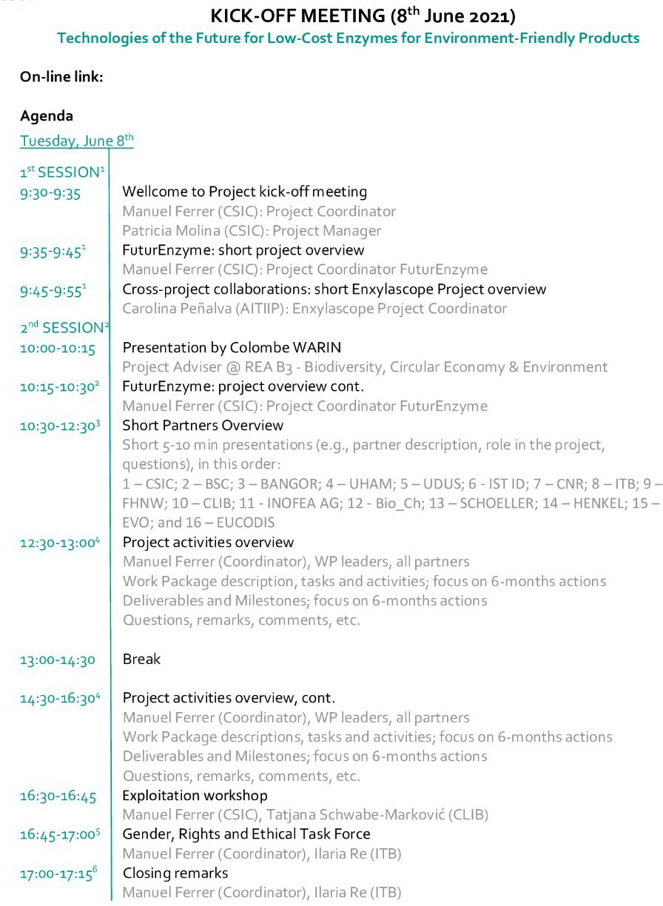

Open days and Stakeholder Workshops, Conferences, Training and Gender, Ethical and Rights events

The purpose of these events is to allow the project to be showcased as an example of best practice, demonstrating new methods to public authorities and multipliers. Additionally, running these regional events will also foster networking between relevant stakeholders, enabling knowledge transfer and sharing of experiences. These events will also include policy events and roundtables to discuss the potential of new enzyme-based products.

In order to maximise visibility and financial leverage, the project will focus on running events in connection with existing events, fairs, conferences and platforms already engaging relevant target audiences. Relevant events to carry out dissemination and communication activities along the project's execution will be selected once the project is running from the extensive lists of events tracked by the project partners.

Partners have already agreed to organize the following events:

- Series of 3 webinars "Enzyme for more environment-friendly consumer products" via online tools (month 12, 24, 36) involving the scientific community;

- 1 Consortia-wide industry-oriented workshop to evaluate market needs and provide training in the development and pitching of business ideas (month 12) aimed at a wider scientific public (consumers, end-users, policymakers, stakeholders, scientists, students);

- 1 Workshop and roundtable on "How to find enzymes that will serve the present and future industrial and consumer demands and habits" (month 24) aimed at a wider scientific public;

- 1 International biotech/bioeconomy conference (month 36) aimed at a wider scientific public;

- 4 Intra-consortium exploitation workshops to evaluate and discuss upcoming exploitable results of the project. These workshops will consist in 1-hour meetings after the annual general meeting.

Partners have already agreed to participate in the following events that reinforce our compromise with a society where ethics as well as gender equality, and rights whatever race, ethnic, and cultural and educational backgrounds are defended and integrated:

- 1 Public event, "European Green Deal Aligned with Rights, Ethics, Equality" (Madrid, in the frame of the International Day of Women and Girls in Science) involving the civil society; this event will be organized in the frame of the International Day of Women and Girls in Science.

Partners have already agreed to participate in the following events that reinforce our compromise with Responsible Research and Innovation and FAIR principles:

- 1 Workshop on RRI issues: how to take stakeholder and public views to direct R&D towards societal and market needs (month 24) aimed at a wider scientific public.

In addition, partners will participate in events organized outside the consortium and in which FuturEnzyme partners will contribute.

- 3 Demonstration events (in science festivals, etc.): prototypes

- 30 Open days

- 4 Exhibitions and tours (in science festivals, etc.)

- 40 Conferences and workshops

- 40 Social events

- 2 Inter-consortia networks

Outcome measures: at least 20 events organised by project members, minimum audience of 500-700 persons; also at least 100-120 events organized outside the consortium and in which FuturEnzyme partners will participate.

Inter-consortia network events

The FuturEnzyme consortium will organise several inter-consortia events bringing together linked EU projects in order to exchange good practices, transfer information, capitalise on results and support joint initiatives to proactively identify the challenges and problems encountered during their respective projects and find joint solutions that can be considered as potentially exploitable in synergy. In particular, these events will include:

- A series of webinars to present each project and explore potential synergies.

- 1 workshop (month 24) involving partners of the linked EU project supports exchange of good practices.

- 1 general meeting (month 36) with coordinators and key partners of other consortia to agree how to communicate the global activities undertaken to implement new greener products, evaluate synergies, sharing ideas, experimental results, results of the LCA assessments and consumer surveys, etc., with the final idea to evaluate whether enzyme-based products from different consortia could have better environmental footprint, product performance, and consumer acceptance to better define and supply the best enzyme candidates. We will strongly explore the possibilities that other consortia can use enzymes from the FuturEnzyme Portfolio, and vice versa.

- 1 joint inter-consortia policy event (month 44) with coordinators and partners from other funded projects to evaluate to what extent the projects' results contribute to realising the objectives of European policy initiatives and creating a transparent legal and policy framework in which to operate, exploit and disseminate synergies. Major findings during this event will be reported in policy briefs. The event will be open to the public and all partners from the related initiatives will be invited.

Outcome measure: number of linked EU projects identified, number of participants (per event), number of webinars organised, number of publications (policy briefs and reports).

Demonstration events

Science festivals, conferences and other relevant running events will allow project partners to participate in demonstration events with product prototypes. These events will be aimed at consumers and investors to stimulate interest in the new enzyme-based products, offering a tangible evidence of their properties and their environmentally friendly characteristics. They will also be an effective way to address specific product- related concerns.

Outcome measure: number of demonstration events (minimum 3), number of participants.

Training events

Different training events will be organised during the project to improve and promote the project activities and raise awareness of sustainability and environment-friendly products aimed at young researchers, university students, and school pupils. These events will be free and open to the general public. They will include technical courses and several scientific seminars and workshops aimed at the scientific and academic

community to encourage collaboration and exchange among young researchers to give them the chance to improve their skills, learn from senior scientists, and share their work in an international context. Furthermore, two training activities and 25 talks for secondary schools will be provided to raise awareness of the need for new sustainable products among young people.

Project participants have already agreed in organising the following events:

- 1 Workshop "Summer School on Metagenomics 2021" (month 12);

- 1 theoretical-experimental course on "Engineering enzymes for consumer products of higher environmental quality" (month 24);

- 2 Training events for 4th-grade secondary school pupils (month 36 and 48), which consists in few days visit of 4th-grade secondary school pupils to CSIC for getting contact of students with academic and industrial groups.

Outcome measure: number of schools/universities involved, number of students involved, number of events organised.

Final workshop/meeting

As mentioned above, a joint inter-consortia policy event (month 44) with coordinators and partners from other funded projects, will be organized. This meeting will evaluate to what extent the projects' results contribute to realising the objectives of European policy initiatives and creating a transparent legal and policy framework in which to operate, exploit and disseminate synergies. Major findings during this event will be reported in policy briefs. The event will be open to the public and all partners from the related initiatives will be invited.

Previous to the inter-consortia policy event, a final project meeting will be organized, aimed at providing an overall overview of project outcomes and achievements, as well as fine-tunning actions in order to prepare for the inter-consortia final event.

Dissemination and communication timetable

The communication plan will be developed according to the project outcomes available and the specific audiences to be targeted to ensure the best possible performance of the communication actions.

The following timelines include already confirmed deliverables, milestones and events for the dissemination and communication activities (WP8).

Deliverables

Deliverable Title | Lead beneficiary | Due Date (month)
D8.1 FuturEnzyme website  This deliverable will consist in an open website to assure communication towards the outside world, that will be maintained and regularly updated throughout the project. The website will serve as the main interface for distributing project information and results as elaborated in all WPs | 1-CSIC | 2
D8.2 Visual identity guidelines | 1-CSIC | 3

This deliverable will consist in a series of visual elements to create distinction and a strong visual identity for the FuturEnzyme project, as well as template for presentations, posters, and reports
D8.3 Plan for using, communication and disseminating project information and knowledge  This deliverable will consist in a report defining the strategy for effective communication and dissemination: guidelines, objectives, target audiences and users, tools, and channels, as well as the metrics for measuring impact | 8-ITB | 3
D8.4 Data Management Plan  This deliverable will describe the Data Management Plan (DMP), as a key element of good data management. The DMP will describe the data management life cycle for the data to be collected, processed and/or generated by the Horizon 2020 project FuturEnzyme. As part of making research data findable, accessible, interoperable and re-usable (FAIR), the DMP will include information on: 1. The handling of research data during & after the end of the project; 2: What data will be collected, processed and/or generated; 3: Which methodology & standards will be applied; 4: Whether data will be shared/made open access; and 5. How data will be curated & preserved (including after the end of the project). In addition to the above, the DMP will additionally include the Innovation and IPR Management Strategy of the project, main potential exploitation routes, the target groups (per project asset) that are potential end-users of the results, general terms of use and relevant IPR provisions, most promising joint exploitation plans for the whole consortium or specific groups of project partners, and the means and procedures for the exploitation of project’s assets and a clear action plan to this. | 1-CSIC | 4
D8.7 FuturEnzyme project leaflet and brochure  This deliverable will consist in a series of leaflet and brochure materials for disseminating and communicating Project objectives and outcomes for consumers & policymakers. This material will be available through the website | 8-ITB | 12
D8.8 Newsdigest, posters, bulletins  This deliverable will consist in a series of newsdigests, posters, and bulletins for disseminating and communicating Project objectives and outcomes for SMEs and industries operating in the biotech sector (also scientific and academic community). This material will be available through the website | 1-CSIC | 36
D8.9 Report on public, intraconsortium, and interconsortia 18-months events  This deliverable will consist in a report listing all public, intra-consortium, and inter- consortia events organized until month 18 with indication of assistance, outcomes, communication and dissemination efforts, etc. This material will be available through the website. Public events will include workshops, courses and other public events.  Intra-consortia events will include internally organized exploitation workshops, with indication of assistance, and outcomes. Upcoming exploitable results will be monitored in intra-consortium exploitation workshops by providing questionaries to partners, the results of which will be evaluated and summarized in this deliverable as a report. The exploitation workshops will consist in 1 h meeting after the general annual meetings. Questions will include at least the following: i) identification of potential users of the results inside or outside the consortium; ii) Identification of authors of a result (Should co-ownership be applied?); iii) which enzymes are interesting? (are they  published?; are there any genetic modifications that allow us to patent or protect | 4-UHAM (1-CSIC) | 18

them?; iv) If an interesting enzyme or results is found, which could be the next steps before publishing/protecting?; v) What additional steps would be needed so that the enzyme can be applied / manufactured industrially?; vi) do the enzyme/results has other applications different to those initially thought for the Project?; vii) Have we achieved the proposed objective of the Exploitation Plan?; viii) Is there something similar published or patented? Is the enzyme/result easy to copy?, etc. Inter-consortia events will include online and face-to-face meetings with partners of other consortia.
D8.10 Report on public, intraconsortium, and interconsortia 36-months events  This deliverable will consist in a report listing all public, intra-consortium, and inter- consortia events organized until month 36 with indication of assistance, outcomes, communication and dissemination efforts, etc. This material will be available through the website. Public events will include workshops, courses and other public events.  Intra-consortia events will include internally organized exploitation worshops, with indication of assistance, and outcomes. Upcoming exploitable results will be monitored in intra-consortium exploitation workshops by providing questionaries to partners, the results of which will be evaluated and summarized in this deliverable as a report. The exploitation workshops will consist in 1 h meeting after the general annual meetings. Questions will include at least the following: i) identification of potential users of the results inside or outside the consortium; ii) Identification of authors of a result (Should co-ownership be applied?); iii) which enzymes are interesting? (are they published?; are there any genetic modifications that allow us to patent or protect them?; iv) If an interesting enzyme or results is found, which could be the next steps before publishing/protecting?; v) What additional steps would be needed so that the enzyme can be applied / manufactured industrially?; vi) do the enzyme/results has other applications different to those initially thought for the Project?; vii) Have we achieved the proposed objective of the Exploitation Plan?; viii) Is there something similar published or patented? Is the enzyme/result easy to copy?, etc. Inter-consortia events will include online and face-to-face meetings with partners of other consortia. | 1-CSIC (2- BSC) | 36
D8.11 Report on public, intraconsortium, and interconsortia 48-months events  This deliverable will consist in a report listing all public, intra-consortium, and inter- consortia events organized until month 48 with indication of assistance, outcomes, communication and dissemination efforts, etc. This material will be available through the website. Public events will include workshops, courses and other public events.  Intra-consortia events will include internally organized exploitation worshops, with indication of assistance, and outcomes. Upcoming exploitable results will be monitored in intra-consortium exploitation workshops by providing questionaries to partners, the results of which will be evaluated and summarized in this deliverable as a report. The exploitation workshops will consist in 1 h meeting after the general annual meetings. Questions will include at least the following: i) identification of potential users of the results inside or outside the consortium; ii) Identification of authors of a result (Should co-ownership be applied?); iii) which enzymes are interesting? (are they published?; are there any genetic modifications that allow us to patent or protect them?; iv) If an interesting enzyme or results is found, which could be the next steps before publishing/protecting?; v) What additional steps would be needed so that the enzyme can be applied / manufactured industrially?; vi) do the enzyme/results has other applications different to those initially thought for the Project?; vii) Have we achieved the proposed objective of the Exploitation Plan?; viii) Is there something similar published or patented? Is the enzyme/result easy to copy?, etc. Inter-consortia events will include online and face-to-face meetings with partners of other consortia. | 8-ITB (10-  CLIB, 1- CSIC) | 48
D8.12 Short promo video/ comic | 1-CSIC | 24

This deliverable will consist in at least one short promo video and a comic to maximize the FuturEnzyme dissemination, exploitation and communication impact towards a broad audience. This material will be available through the website.
D8.13 Two divulgative/ promotional articles in scientific magazines  This deliverable will consist in two articles published in two non-Science Citation Index scientific magazines with broad audience among SMEs and industries operating in the biotech sector (also scientific and academic community). This material will be available through the website. | 1-CSIC | 40
D8.14 Report on public relation activities and events  This deliverable will consist in a report listing all public relation toolkits available to the consortium to support the implementation of the Dissemination and Communication Strategy, to raise awareness of the work, progress and achievements of the FuturEnzyme project (e.g. enzymes, processes, and products developed, and the high- tech enzyme development platform), and the positive societal implications of these.  The report will also summarize the visits/talks in secondary school and University, dialogues and face by face talks, assistance to open days, exhibitions and tours (in science festivals, etc.), scientific seminars, conferences and workshops and other social events to which consortium partners have participated. The report on the public inter- consortia event to be organized with consortia of other funded projects will be included. | 1-CSIC | 48
D8.15 Report on one consumer survey and product testing and brief  This deliverable will consist in a report and a brief summarizing the outcomes of the consumer surveys and product test performed in the project to understand the acceptability of the new enzyme-based products. This material will be available through the website. | 8-ITB (1- CSIC) | 48
D8.17 Science, Consumer, Policy Briefs: research focus  This deliverable will consist in a series of Science, Consumer, Policy Briefs through which to draft individual and common scientific, market, consumer, social, and policy advices within the consortium and in collaboration with other consortia. This material will be available through the website. | 8-ITB | 48
D8.21 Inter-consortia policy brief  This deliverable will consist in a Policy Brief through which to draft policy advices in which members of different consortia agreed. This material will be available through the website. | 1-CSIC (10-  CLIB, 8- ITB) | 48

Milestones

Milestone title and number | Description | Lead beneficiary | Due Date (month)
First version FuturEnzyme website (MS29) | Website accessible online. This milestone will attest the completion of the first draft of the website to | 1-CSIC | 1

 | be made available to the consortium for its evaluation.
Media package released (MS31) | Package on website. This milestone will attest the completion of the first set of the media package products | 8-ITB | 30

Already planned events

Event number | Event name | Due Date (month) | Where
1-3 | Series of 3 online webinars, "Enzymes for more environment- friendly consumer products" via online tools | 12, 24, 36 | Online
4 | Workshop, "Summer School on Metagenomics 2021" | 12 | Hamburg
5 | A consortia-wide industry-oriented workshop to evaluate market needs and provide training in the development and pitching of business ideas | 12 | Madrid
6 | Workshop on RRI issues (e.g., how to take stakeholder and public views to direct R&D towards societal and market needs) | 24 | Dusseldorf
7 | A theoretical-experimental course on "Engineering enzymes for consumer products of higher environmental quality" | 24 | Barcelona
8 | Workshop and roundtable on "How to find enzymes that will serve the present and future industrial and consumer demands and habits" | 24 | Madrid
9 | Inter-consortia workshop to support good practices exchange between participants | 24 | To be defined
10 | An international biotech/bioeconomy conference | 36 | Dusseldorf
11 | A public event, "European Green Deal Aligned with Rights, Ethics, Equality" in the frame of the International Day of Women and Girls in Science | 36 | Madrid
12 | Inter-consortia workshop focused on fostering the dissemination and exploitation of results of all projects/initiatives | 36 | To be defined
13-14 | 4° ESO+Company | 36, 48 | CSIC
15 | A professional event and roundtable on "Market Place and Policy" to show representatives of authorities, associations, policymakers, industries and end-users the FuturEnzyme results and products with pre-market value | 40 | Milan

16 | Inter-consortia policy event | 44 | Madrid
17-20 | Intra-consortium exploitation workshop | 12, 24, 36, 48 | To be defined

Assessment of dissemination and communication activities

In order to monitor the dissemination activities, ITB will create a form to report on organised events (including information on participants, content of the workshop, communication and dissemination and self- assessment) for project partners. These reports allow to evaluate the target groups reached and help to draft recommendations where necessary. Analysis of the reports on the dissemination events also allows to check whether planned schedules need to be adjusted or other types of activities are necessary.

The Dissemination Performance Indicators are set in order to assess the various dissemination tools outlined in relation to the stated objectives of the FuturEnzyme dissemination strategy. For this, it employs the following criteria:

Dissemination activity selection criteria
Appropriate | Suitable for a particular stakeholder segment
Effective | Capable of eliciting a strong response or call to action from the particular stakeholder segment.
Targetable | Capable of direction to a stakeholder segment
Economical | Disseminating the deliverable efficiently both operationally and technically without burdensome aspect or cost.
Measurable | Disseminating the deliverable efficiently both operationally and technically without burdensome aspect or cost.

Statistical analysis of the project website monitors the users' interest for the contents provided by the Google Analytics, providing to partners a guidance for further activities. In particular, the main indicators of interest are:

  - Page views: number of web pages requested and viewed by the user.
  - Visits or sessions: number of visits to the LIFE BIOREST website made by users.
  - Unique visitors: number of single users that have visited the site, net of duplications.
  - Time spent: time spent in minutes and seconds while navigating or viewing the pages of the site or using a digital application.

