Horizon 2020 Work programme
Food Security, Sustainable Agriculture and Forestry, Marine, Maritime and Inland Water Research and the Bioeconomy
Call
H2020-FNR-2020: Food and Natural Resources
Topic name
FNR-16-2020: ENZYMES FOR MORE ENVIRONMENT-FRIENDLY CONSUMER PRODUCTS

FuturEnzyme:
Technologies of the Future for Low-Cost Enzymes for Environment-Friendly Products
Final ID: 101000327

30/05/2023
victor guallar
BSC
Jordi Girona 31, BARCELONA 08034, Spain
FE_BSC_D5.3_Set of 4 PluriZymes with single activites
D5.3

Document information sheet

Work package: | WP5, Enhancing enzymes through innovative engineering.
Authors: | Víctor Guallar (BSC)
Document version: | 1
Date: | 30/05/2023
WP starting date: | 01/08/2021
WP duration: | 40 months
WP lead: | FHNW
WP participant(s): | FHNW, CSIC, BSC, Bangor, UHAM, UDUS, Inofea AG, Eucodis
Deliv lead beneficiary: | BSC
Dissemination Level: | Confidential, only for members of the consortium (including the Commission Services)
Type: | Other
Due date (months): | 24
Contact details: | Víctor Guallar (victor.guallar@bsc.es)

Summary

Set of 4 PluriZymes with single activities 3
1. Scope of Deliverable 3
2. Introduction: The PluriZyme concept 3
3. Methodology: How to develop a PluriZyme 4
3.1. System preparation 4
3.2. Binding site search 4
3.3. From binding site to active site 5
3.4. Refinement 5
3.5. Automation of PluriZyme design 5
4. Results: Successful designs of PluriZymes 6
5. Conclusions 9
6. References 10
Annex -QR codes 12

Set of 4 PluriZymes with single activities

1. Scope of Deliverable
This deliverable consists in the delivery of 4 PluriZymes with single activities. This deliverable is accompanied by a report detailing the methods used to generate such PluriZymes, the activities they support and the datasets describing their performances and stabilities. This information will be linked to the corresponding QR code associated to each enzyme, which will be made available in the internal FuturEnzyme repository (this deliverable version does not contain the QR codes, but they are included in the corresponding document available in FuturEnzyme’s web intranet).

2. Introduction: The PluriZyme concept
Enzyme engineering is the design and construction of new enzymes or the modification of existing ones with desired properties for specific practical uses. It has widely proven its importance in a vast number of applications, finding a significant recent increase in the number of studies in both academia and industry. Such an increase is largely based on the advantages of using proteins to catalyze reactions, mainly in the form of sustainable and greener alternatives to chemical catalysts. In addition, the constantly growing source of new enzymes derived from bioprospecting campaigns, along with their malleable nature, make them a very interesting raw material. In this sense, enzyme engineering aims to improve the performance of these natural catalysts in properties such as activity, specificity, and stability. A wide diversity of methodologies have been developed for the improvement of enzymes [1]. At the experimental site, a plethora of rational mutagenesis [2–5] and directed evolution [6–8] techniques have centered the attention. In the frame of the FuturEnzyme project we are interested, however, in the computational techniques for enzyme engineering, where we find several recent approaches, such as de novo design of active sites in protein scaffolds [5,9,10], artificial intelligence to find the best mutations to improve stability or a specific activity [11,12], or atomistic protein dynamics studies, using MD techniques [13–15].
Within the consortium, partners have recently introduced a different approach based on adding one or multiple active site(s) in an existing enzyme, a concept named PluriZyme [2,16,17]. Such an approach has the additional difficulty of keeping as intact as possible the native activity (see for example a recent nice review on this topic [18]). In this way, when adding an active site with the same activity as the wild-type one, it may improve the catalytic performance of the enzyme by increasing the activity and/or substrate scope [17-19]. On the other hand, adding an active site with a different activity allows for a single enzyme scaffold to perform a cascade reaction [19,20]. The PluriZyme concept goes in line with recent efforts in designing protein bearing multiple enzyme centers using different approaches: i) self-assembly of histidine-tyrosine peptides mimicking a catalytic microenvironment [21]; ii) using a noncatalytic protein scaffold (a lactococcal multidrug resistance regulator) resulting in two abiological catalytic sites [22,23]; iii) coupling of metal nanoparticles to gain catalytic properties [24-27]; iv) cofactor modification for a new host that incorporated both a mimic of NADH and a flavin analog [28].
The design of PluriZymes has been based on adding catalytic triads capable of introducing hydrolytic biochemistry [2,16]. The engineering effort resides on mutating amino acids (up to three although we do aim for reusing existing residues) to form a hydrogen-bonded catalytic triad, typically introducing serine, histidine, and aspartic acid or glutamic acid. Additional mutations might also be necessary to better accommodate the triad, to open the pocket, or to introduce an oxyanion hole. Importantly, using covalent suicidal inhibitors, we have been able to introduce additional activities other than hydrolysis, such as an oxidation one [19]. Inserting an extra active site allows having different chemistries in a single protein scaffold, reducing the costs and optimization of protein expression. Thus, PluriZymes could become part of the next generation of artificial enzymes, designed by artificial intelligence, that can have a wide range of applications, including those to be targated in FuturEnzyme.
Below, we summarize all PluriZymes developed up to date, emphasizing on best practices and behind-the-scenes of the engineering process. We also underline two of the most recent developments, designed for improving polymer degradation. Overall, we aim at providing the PluriZyme-making recipe so any lab with a bit of experience in computational modeling can reproduce their own designs.

3. Methodology: How to develop a PluriZyme
PluriZymes are proteins with more than one active site capable of enzymatic catalysis, where at least one of these has been designed by protein engineering. In this procedure, rational design plays a crucial role. The overall workflow for creating a de novo PluriZyme follows the steps summarized in Figure 1.
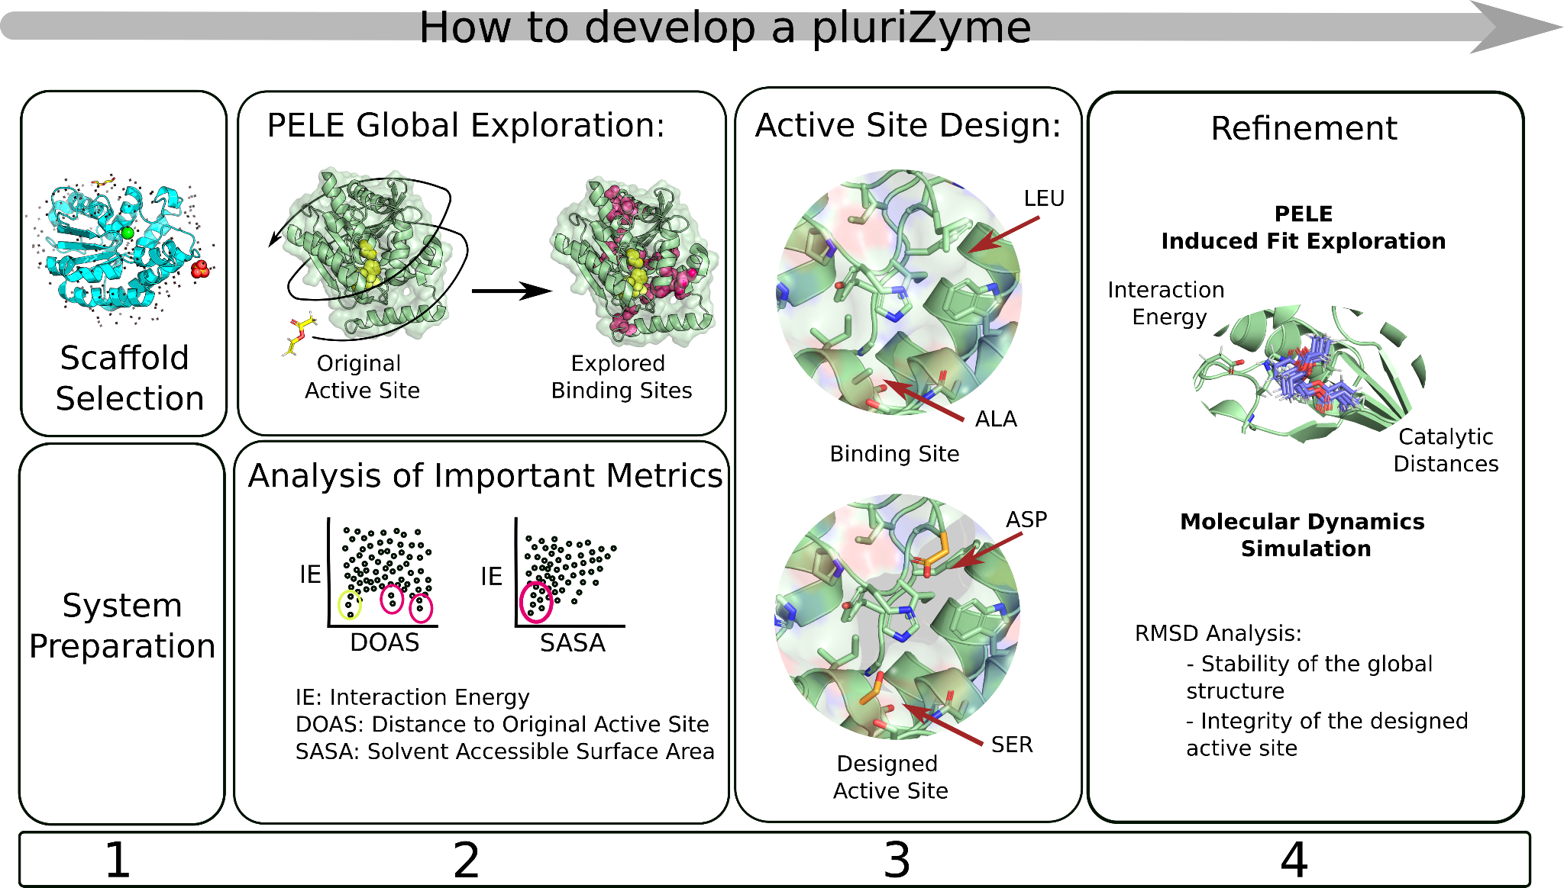
Figure 1. Workflow for the development of PluriZymes.

3.1. System preparation
The first step always consists of knowing the system to prepare it adequately: cellular location (membrane or soluble protein), number of system subunits, stability at different pHs and temperatures, cofactors, and modified or essential residues. The next step starts from a 3D protein structure that ideally comes from a resolved crystal or Nuclear Magnetic Resonance (NMR). We can also start from a model thanks to homology modeling and, more recently, to the breakthrough of deep learning structural builders, such as AlphaFold 2.0 [29]. Moreover, a model structure can add missing or omitted parts in the experimental structure. Finally, the hydrogen bond network should be optimized; we typically use Maestro's Protein Preparation Wizard [30] to correct the protonation states depending on the pH of interest.

3.2. Binding site search
The second step, since we want to design new active sites in a protein scaffold, involves selecting a substrate(s) to simulate the active site binding event. Once the substrate is selected, we prepare it with a quantum mechanics calculation in implicit solvent and obtain the ESP (electrostatic potential) charges with Jaguar [31]. Now that both the protein and the substrate are prepared, we perform the PELE (Protein Energy Landscape Exploration) global exploration [32] (also known as SiteFinder), aiming at identifying potential binding sites (other than the wild-type active site if we are dealing with an enzyme). PELE is our in-house Monte Carlo software capable of mapping complex intermolecular biophysical problems, such as global ligand migration, local induced fit, etc. [33]. As PELE uses implicit solvent models (OBC or SGB), it tends to close the protein because the system maximizes stabilizing contacts between residues. Therefore, adding a series of constraints to the initial structure is necessary, generally with a force of 5 kcal/(mol·Å²) every 5 or 10 residues. The metrics that most interest us at this point are the solvent-accessible surface area (SASA) of the substrate and the binding energy along the simulation. If we observe a local energy minimum, it might indicate that the substrate has found a binding site: a cavity throughout its exploration in which it could remain for a long time due to stabilizing intermolecular interactions. If we do not find a potential new binding site, we have to consider whether we want to continue working with the system by designing a binding site, by opening/enlarging some nascent cavity, for example. While we use PELE in our laboratory, other software capable of describing potential binding sites in an enzyme could be used at this point, such as a combination of docking and molecular dynamics [34,35] and even AI-based tools [36].

3.3. From binding site to active site
The third step involves the conversion of the binding site into an active site, involving amino acid mutagenesis to introduce a catalytic triad. When carrying out mutagenesis, we consider several factors, including: i) the conservation of the residues that we want to mutate in other homologous sequences, ii) prioritizing mutations by residues of the same category, iii) prioritizing residues close in sequence space (not only in euclidean space), iv) amino acid recycling. Regarding this last point, we prioritize catalytic triads where we use a wild-type acidic residue, since adding negative charges to a protein might have a detrimental effect. Our goal is to obtain an active site with well-organized catalytic triads (with proper distances and angles), and with the least possible number of mutations; for this, as many combinations as possible of potential catalytic triads are made.
Next, we perform a refinement simulation of the newly designed active site(s) using the likelihood of catalytic encounters using PELE simulations. We explore the movements of the substrate inside the cavity mapping how mutations affect its binding energy profile and localization. Ideally, we want the substrate to remain in the binding site with similar or even better substrate binding energies (the intermolecular interaction energy provided by PELE). Eventually, we analyze the distances between the reactive atoms of the substrate and the catalytic residues, accounting for all the catalytic events that can be observed. We consider a catalytic event when the catalytic distances between the substrate and the reactive residues are below ~4 Å. In an ester hydrolase, for example, it would correspond to the distance between the ester carbon and the alcoholic oxygen from the catalytic serine. Besides, the rest of the catalytic residues must adopt reasonable distances and angles (including those that participate indirectly, such as the oxyanion holes in the case of hydrolases). The count of catalytic poses helps us to rank different catalytic constructs and to assess the activity of the newly designed active site.

3.4. Refinement
Designs with better stability, binding energy, and number of catalytic events are further refined with molecular dynamics (MD) simulations to give more robustness to the engineering process. The goal is to double check the stability of the global structure, the integrity of the newly designed catalytic triad, and that the substrate does not abandon (escape) the active site. After the MD analysis, which is based on distance measurements and RMSD (root-mean-square deviation), a ranking of the mutants is established, and the best ones are selected for experimental validation.

3.5. Automation of PluriZyme design
Out of the different steps involved in the PluriZyme design recipe (shown in Figure 1), the third step, the active site design, is the one that involved more human intervention and intuition in the different PluriZymes designed to date (see below). In order to alleviate such a non-deterministic procedure, we have developed an automated software.
To this goal, a new Monte Carlo software, AsiteDesign, has been implemented and published recently [37] mainly based on the pyRosetta library [38]. The algorithm starts by selecting a set of positions defined by the user, which should identify those residues around the found alternative binding site. Then, all these positions are allowed to be mutated to create randomly different combinations of catalytic triads along the simulation, and the variants are ranked based on an energy metric after every iteration (Figure 2). Distance restraints are enforced during the simulation to have the correct distances of the introduced catalytic residues. The ligand sampling is included in the simulation, as we believe it helps find the optimal solutions and ensures the active site will have activity against that molecule. To enhance the sampling, adaptive reinforcement [33] and simulated annealing protocols are implemented. The number of designs increases by n!/(n-k)! (where k=3 in catalytic triads). Thus, when the number of residues is 10 (n=10), the number of possible catalytic triads is 720. This combinatorial problem is what AsiteDesign tries to address by smartly sampling the possible combinations and outputting the best ones ranked by an energy metric.
AsiteDesign gives reliable catalytic triads without requiring the user to design them. In fact, the used benchmark was an esterase, and the catalytic residues of the system were mutated to Ala to see if the protocol could recover the original active site. AsiteDesign recovered the wild-type active site as the top-ranked solution. Likewise, it gave alternative catalytic triads where the second-best option was assayed experimentally and had hydrolase activity [37]. We have made the code freely available to everyone: a container version is available at https://github.com/BSC-CNS-EAPM/AsiteDesign-container; its usage, however, will require a Rosetta license (which is free for non-commercial use).
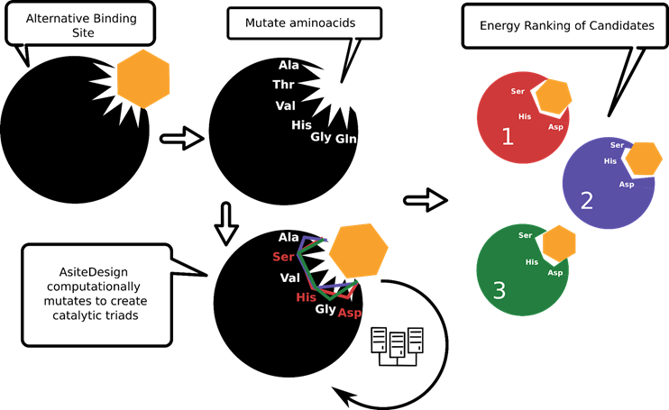
Figure 2. Simplified scheme of AsiteDesign workflow.

4. Results: Successful designs of PluriZymes
Currently, partners of the FuturEnzyme project already developed 4 PluriZymes. The first PluriZyme designed in the frame of FuturEnzyme by partners BSC, CSIC and UDUS was based on an ⍵-transaminase, allowing cascade reactions of interest. The selected enzyme was a class III ⍵-transaminase from an acidic beach pool on Vulcano island [39]. It was nominated to design multi-functional PluriZymes, because the availability of structural data and high expression level. An ester binding site was found with PELE around 20 Å of the main transaminase site and turned into a hydrolase active site by reusing the acid residue (317) and adding the nucleophile and base residues by mutating an Ala (residue 172) and a Gln (residue 173), respectively. Using this approach, we developed a PluriZyme, TR₂E₂ (see Figure 3), with efficient native transaminase (k_{cat}: 69.49±1.77 min⁻¹, for its best substrate, hexanal) and artificial esterase (k_{cat}: up to 3908 min⁻¹, for triglycerides) activities, integrated into a single scaffold. The new active site could hydrolyze around 50 ester substrates of an ester library of 96 compounds. Likewise, it was able to perform efficient transformations of different β-keto esters into β-amino acids. The crystal structures of TR₂ (7QYG) and the newly designed TR₂E₂ PluriZyme were solved (7QYF, 7QX3, 7QX0). For details see DOI: 10.1002/anie.202207344 in Zenodo Community.
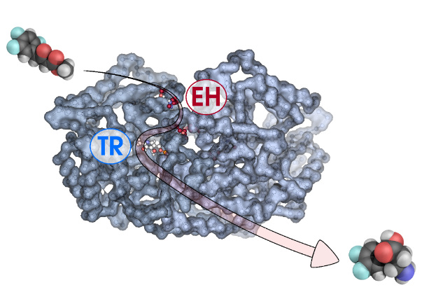
Figure 3. One becomes two: A PluriZyme with transaminase and esterase activities, TR₂E₂, was constructed by combining computational and laboratory design methods. The enzyme can perform cascade reactions in a single protein scaffold. Experimental proof is presented for the catalytic efficiency of both the native transaminase and the artificial esterase active site and their synergistic action to transform β-keto esters into enantiopure β-amino acids.

For the second PluriZyme designed, BSC and CSIC explored adding other types of catalytic dyads/triads, and thus, chemistries, by adding a Cys residue instead of a Ser. A first developed PluriZyme, designed prior to the inititation of the FuturEnzyme project (named, EH_{1AB1}) was used for this purpose, and the His residue of the artificial active site was reused to create a catalytic dyad by mutating a Leu (residue 24) to a Cys. This change granted protease activity to the serine esterase while preserving the other two active sites [40]. More in detail, using our PluriZyme EH_{1AB1}, we introduced protease activity by designing a single mutant, Leu24Cys, which was capable of recycling a histidine residue, His214, from an already existing catalytic triad in one of the most active and well-produced esterases, EH_{1AB1} (source: evaporite karstic lake Arreo in Spain (42°46'N, 2°59'W; altitude, 655 m). This enzyme was nominated to design multi-functional PluriZymes with proteolytic activity, because of the availability of structural data, and high expression level and performance. The newly designed PluriZyme, herein referred to as EH_{1AB1C}, included three potential sites. The first supports ester hydrolysis through a native catalytic triad (Ser161, Asp256 and His286) and an oxyanion hole (Gly88, Gly89 and Gly90), with Ser161 acting as a nucleophile. The second, also supporting ester hydrolysis, would employ an artificial catalytic triad (Ser211, Asp25 and His214) with Ser211 as the nucleophile and an oxyanion hole (Gly207, Tyr208 and Phe209). The third would support the protease activity through a catalytic dyad (Cys24 and His214). The resulting artificial enzyme, EH_{1AB1C} (Figure 4), efficiently hydrolysed (azo)casein at pH 6.5–8.0 and 60–70 °C. For details see DOI: 10.3390/ijms232113337 in Zenodo Community. These results demonstrate that active sites supporting proteolytic activity can be artificially introduced into an esterase scaffold. It is also possible to design artificial proteases with good production yields, in contrast to natural proteases, difficult to express.
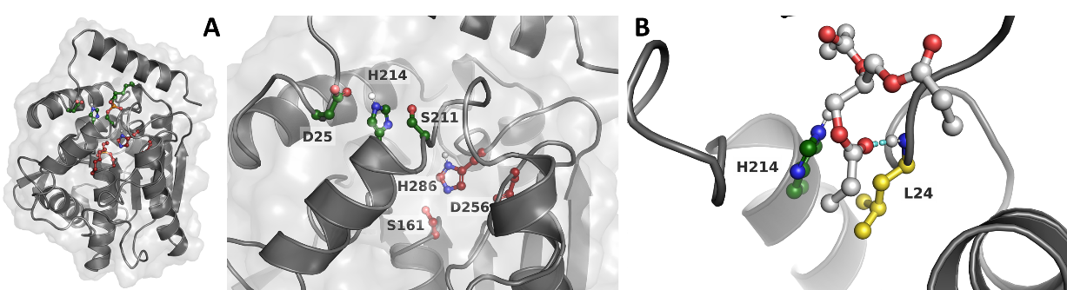
Figure 4. (A) Slice of the 3D structure of EH_{1AB1} representing the main and artificial active sites. The C atoms are stained in maroon and dark green in the main active site and artificial active site, respectively. (B) Representative binding pose of glyceryl tripropionate (with C atoms stained in gray) where we can see the position of Leu24. Leu24 (in yellow) forms a hydrogen bond with the carbonyl O atom in the ester bond by the NH group in the backbone (indicated by a cyan dashed line) and is close to the His214 residue.

For the thrid PluriZyme designed, BSC and CSIC explored the idea of adding feruloyl esterase activity in a xylanase from Pseudothermotoga thermarum, highly active and stable at 90°C, X11. It was nominated to design multi-functional PluriZymes because availability of structural data, and stability at temperatures as high as 80-90°C The xylan polymer contains ferulate radicals that slow down the depolymerization reaction, and adding the feruloyl esterase-specific activity to the xylanase enzyme could speed up the reaction [41]. By only inserting 2 mutations (L271S and K275H), we could add a hydrolytic site with experimentally measured K_{m} of 2.8 ± 0.6 mM and V_{max} of 1641 ± 10 units/g against methyl ferulate, which is in the range of best-performing esterases and lipases capable of degrading this substrate. Crystallographic analysis of the PluriZyme, X11-Mut1, confirms the existence of a catalytic site suitable for ester hydrolysis, and docking reaffirms the nature of the new catalytic center (PDB 8BBI). The intrinsic active center of the protein is formed by the Glu144 and Glu251 dyad, and the artificial active site consists of the catalytic triad Ser271 (nucleophile), Glu272 (acid) and His275 (base). The folding of X11-Mut1 is detailed as follows. Briefly, the crystal structure of mutant 1 of Xyn11 was obtained by X-ray diffraction at 2.1 Å. It shows a TIM barrel architecture typical of GH10 xylanases. The intrinsic xylanase active site, located at the axis of the barrel, is formed by the pair Glu144 and Glu251 and includes a trapped IPTG molecule. Using the software PELE allowed to create a second artificial catalytic site located on the surface of the protein at 27$Å$ and 31$Å$ from Glu251 and Glu144, respectively (Figure 5A). Mutagenesis experiments were performed to create the double mutant (X11-Mut1) L271S and K275H. The second artificial catalytic triad is formed by residues Ser271, Glu272 and His275, at the beginning of $α$7, and having esterase activity (Figure 5A). There are no significant structural differences upon superimposition of X11 onto the X11-Mut1 coordinates. However, as happened in the native crystal, X11-Mut1 crystals contain two molecules in the asymmetric unit that present some conformational differences at the artificial esterase catalytic triad. Thus, only chain B presents the Ser271-Glu272-His275 triad in a proper conformation that displays the expected hydrogen bonding pattern conserved in reported esterases (Figure 5B). In chain A, Arg133, from a symmetry related molecule, is making a hydrogen bond to Ser271 producing a shift in Glu272 and His275 side-chains.
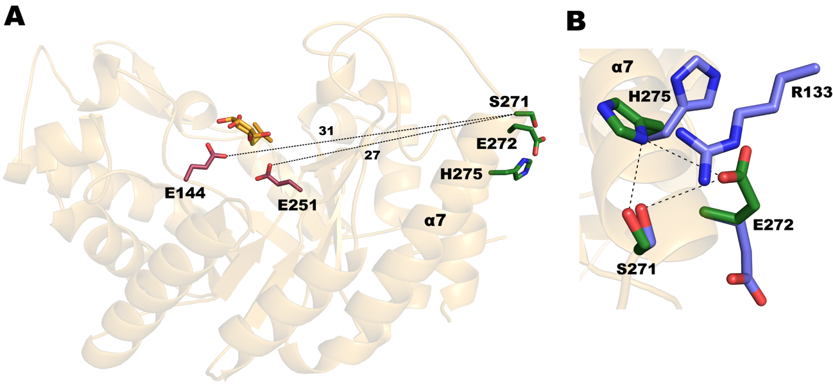
Figure 5. A) X11-Mut1 folding. The intrinsic xylanase catalytic pair is shown as raspberry sticks (Glu144 and Glu251) whereas the artificial secondary esterase triad is shown as green sticks (Ser271, Glu272 and His275). The trapped IPTG molecule is shown as orange sticks. B) Superimposition of chain A (blue) and chain B (green) at the artificial esterase secondary catalytic site. The catalytic triad of molecule B shows the proper hydrogen bond pattern conserved among esterases.

For the fourth PluriZyme designed, BSC and CSIC explored the possibility of enzymatically recycling polyethylene terephthalate (PET), particularly for the case of polyester (PES) fabrics and their macro-, micro- and nanosized particles, e.g., in waste streams during textile processing. Results on building additional sites to PETases are still not satisfactory enough, possibly indicating the difficulty to establish an open and large enough site to bind and degrade PET. Since the PluriZyme workflow, capable of building catalytic triads, can be implemented into any protein, we turned our efforts into adding triads into a protein that could trap nanoparticles of PET efficiently (Figure 6). For this, we chose the homo-octamer membrane biological assembly crystal structure of Fragaceatoxin C (FraC, PDB-ID 4TSY). We selected this protein scaffold for its pore dimensions, stability, and compartmental localization in membranes. We introduced esterase catalytic activity in two newly designed active sites and finally checked that they could be applied for PET nanoparticles degradation.

Figure 6. Example of a PluriZyme design for polymer degradation. The addition of a new active site with different biochemistry to the WT enzyme scaffold can release new products of interest.

The first active designed mutant (FraC_{m1}) located the triad in the alpha helix N terminal domain, where non-conserved polar residues face the channel cavity of the pore. We rationally inserted two mutations, K20H and T21S, in the eight monomers, creating a new enzymatic complex with eight potential different active sites. In addition, the preexistence of two acidic residues, at positions 17 and 24, increased the number of possible combinations of catalytic triad formations. The second active designed mutant (FraC_{m2}) located the triad in an area where several acidic residues—Asp38, Glu40, and Glu173— are located; in this case, there is also a native histidine, His175; PELE simulations revealed that the Asp38Ser variant could generate a catalytic triad. Moreover, we wanted to add a mutation that could act as an oxyanion hole to stabilize the negative charge that appears during hydrolysis: Glu173Gln. Finally, a double mutant (FraC_{m3}) combining the mutations in FraC_{m1} and FraC_{m2} was designed, which since contains two active sites can be referred to as a PluriZyme. As shown in Figure 7, one could imagine that any nanoparticle (or nanoparticle protuberance such as the one shown in Figure 7, that was obtained from molecular dynamics simulations) that gets stacked in the pore will have 8 scissors pointing at it and ready to cut the ester bonds. As a result, our FraC variants achieve one order of magnitude higher degradation rates than the current best PETases, when operating on PET nanoparticles. In addition, our constructs also hydrolyze multiple esters substrates.
Figure 7. Graphical representation of a schematic coupling between the pore and the PET particle polymer. The artificial sites 1 (FraC_{m1}) and 2 (FraC_{m2}) are color coded.

5. Conclusions
Based on the results presented in this deliverable, PluriZymes seem a promising approach to engineer enzymes to bring them a broader substrate specificity, improved catalytic performance or even incorporating new activities. In addition PluriZymes, offer also additional benefits, the first obvious one being the fact that it reduces overall protein cost. It facilitates expression costs and the necessity of optimizing different enzymes to the harsh industrial conditions. Similarly, it helps in unifying operating conditions such as optimal pH and temperature. Moreover, it can ensure that both catalytic active sites are nearby, potentially accelerating the total reaction rate through substrate channeling. Interestingly, most PluriZymes tend to be more stable than the native proteins. Mutations seek to introduce hydrogen bonds which can easily introduce some additional stability. Overall, we believe that PluriZymes could significantly impact the functionalization of enzymes for biotechnological applications that are targeted by the FuturEnzyme project, but also for other ones. This is why the information provided in this deliverable provides an exhaustive description of the design recipes to the FuturEnzyme consortium, so different labs can experiment with them and establish new limits. With modest computational resources and with help from the recipe herein details, any laboratory can manage to design PluriZymes. We will continue designing PluriZymes with single or multiple applications, that could have value for preindustrial validations within the consortium.

6. References
- Lovelock, S.L.; Crawshaw, R.; Basler, S.; Levy, C.; Baker, D.; Hilvert, D.; Green, A.P. The Road to Fully Programmable Protein Catalysis. Nature 2022, 606, 49–58.
- Roda, S.; Santiago, G.; Guallar, V. Mapping Enzyme-Substrate Interactions: Its Potential to Study the Mechanism of Enzymes. Adv. Protein Chem. Struct. Biol. 2020, 122, 1–31.
- Dauparas, J.; Anishchenko, I.; Bennett, N.; Bai, H.; Ragotte, R.J.; Milles, L.F.; Wicky, B.I.M.; Courbet, A.; de Haas, R.J.; Bethel, N.; et al. Robust Deep Learning-Based Protein Sequence Design Using ProteinMPNN. Science 2022, 378, 49–56.
- Pavelka, A.; Sebestova, E.; Kozlikova, B.; Brezovsky, J.; Sochor, J.; Damborsky, J. CAVER: Algorithms for Analyzing Dynamics of Tunnels in Macromolecules. IEEE/ACM Trans. Comput. Biol. Bioinform. 2016, 13, 505–517.
- Richter, F.; Leaver-Fay, A.; Khare, S.D.; Bjelic, S.; Baker, D. De Novo Enzyme Design Using Rosetta3. PLoS One 2011, 6, e19230.
- Labrou, N.E. Random Mutagenesis Methods for in Vitro Directed Enzyme Evolution. Curr. Protein Pept. Sci. 2010, 11, 91–100.
- Agresti, J.J.; Antipov, E.; Abate, A.R.; Ahn, K.; Rowat, A.C.; Baret, J.-C.; Marquez, M.; Klibanov, A.M.; Griffiths, A.D.; Weitz, D.A. Ultrahigh-Throughput Screening in Drop-Based Microfluidics for Directed Evolution. Proceedings of the National Academy of Sciences 2010, 107, 4004–4009.
- Jakočiūnas, T.; Pedersen, L.E.; Lis, A.V.; Jensen, M.K.; Keasling, J.D. CasPER, a Method for Directed Evolution in Genomic Contexts Using Mutagenesis and CRISPR/Cas9. Metab. Eng. 2018, 48, 288–296.
- Anishchenko, I.; Pellock, S.J.; Chidyausiku, T.M.; Ramelot, T.A.; Ovchinnikov, S.; Hao, J.; Bafna, K.; Norn, C.; Kang, A.; Bera, A.K.; et al. De Novo Protein Design by Deep Network Hallucination. Nature 2021, 600, 547–552.
- Burke, A.J.; Lovelock, S.L.; Frese, A.; Crawshaw, R.; Ortmayer, M.; Dunstan, M.; Levy, C.; Green, A.P. Design and Evolution of an Enzyme with a Non-Canonical Organocatalytic Mechanism. Nature 2019, 570, 219–223
- Lu, H.; Diaz, D.J.; Czarnecki, N.J.; Zhu, C.; Kim, W.; Shroff, R.; Acosta, D.J.; Alexander, B.R.; Cole, H.O.; Zhang, Y.; et al. Machine Learning-Aided Engineering of Hydrolases for PET Depolymerization. Nature 2022, 604, 662–667.
- Mazurenko, S.; Prokop, Z.; Damborsky, J. Machine Learning in Enzyme Engineering. ACS Catal. 2020, 10, 1210–1223.
- Amrein, B.A.; Bauer, P.; Duarte, F.; Janfalk Carlsson, Å.; Naworyta, A.; Mowbray, S.L.; Widersten, M.; Kamerlin, S.C.L. Expanding the Catalytic Triad in Epoxide Hydrolases and Related Enzymes. ACS Catal. 2015, 5, 5702–5713.
- Hong, N.-S.; Petrović, D.; Lee, R.; Gryn’ova, G.; Purg, M.; Saunders, J.; Bauer, P.; Carr, P.D.; Lin, C.-Y.; Mabbitt, P.D.; et al. The Evolution of Multiple Active Site Configurations in a Designed Enzyme. Nat. Commun. 2018, 9, 1–10.
- Petrović, D.; Risso, V.A.; Kamerlin, S.C.L.; Sanchez-Ruiz, J.M. Conformational Dynamics and Enzyme Evolution. J. R. Soc. Interface 2018, 15, doi:10.1098/rsif.2018.0330.
- Roda, S.; Robles-Martín, A.; Xiang, R.; Kazemi, M.; Guallar, V. Structural-Based Modeling in Protein Engineering. A Must Do. J. Phys. Chem. B 2021, 125, 6491–6500.
- Santiago, G.; Martínez-Martínez, M.; Alonso, S.; Bargiela, R.; Coscolín, C.; Golyshin, P.N.; Guallar, V.; Ferrer, M. Rational Engineering of Multiple Active Sites in an Ester Hydrolase. Biochemistry 2018, 57, 2245–2255.
- Carballares, D.; Morellon-Sterling, R.; Fernandez-Lafuente, R. Design of Artificial Enzymes Bearing Several Active Centers: New Trends, Opportunities and Problems. Int. J. Mol. Sci. 2022, 23, doi:10.3390/ijms23105304.
- Alonso, S.; Santiago, G.; Cea-Rama, I.; Fernandez-Lopez, L.; Coscolín, C.; Modregger, J.; Ressmann, A.K.; Martínez-Martínez, M.; Marrero, H.; Bargiela, R.; et al. Genetically Engineered Proteins with Two Active Sites for Enhanced Biocatalysis and Synergistic Chemo- and Biocatalysis. Nat. Catal. 2020, 3, 319–328.
- Roda, S.; Fernandez-Lopez, L.; Benedens, M.; Bollinger, A.; Thies, S.; Schumacher, J.; Coscolín, C.; Kazemi, M.; Santiago, G.; Gertzen, C.G.W.; et al. A Plurizyme with Transaminase and Hydrolase Activity Catalyzes Cascade Reactions. Angew. Chem. Int. Ed Engl. 2022, 61, e202207344.
- Díaz-Caballero, M.; Navarro, S.; Nuez-Martínez, M.; Peccati, F.; Rodríguez-Santiago, L.; Sodupe, M.; Teixidor, F.; Ventura, S. pH-Responsive Self-Assembly of Amyloid Fibrils for Dual Hydrolase-Oxidase Reactions. ACS Catal. 2021, 11, 595–607.
- Bos, J.; Browne, W.R.; Driessen, A.J.M.; Roelfes, G. Supramolecular Assembly of Artificial Metalloenzymes Based on the Dimeric Protein LmrR as Promiscuous Scaffold. J. Am. Chem. Soc. 2015, 137, 9796–9799.
- Zhou, Z.; Roelfes, G. Synergistic Catalysis in an Artificial Enzyme by Simultaneous Action of Two Abiological Catalytic Sites. Nat. Catal. 2020, 3, 289–294.
- Palomo, J.M. Nanobiohybrids: A New Concept for Metal Nanoparticles Synthesis. Chem. Commun. 2019, 55, 9583–9589.
- Filice, M.; Marciello, M.; del Puerto Morales, M.; Palomo, J.M. Synthesis of Heterogeneous Enzyme–metal Nanoparticle Biohybrids in Aqueous Media and Their Applications in C–C Bond Formation and Tandem Catalysis. Chem. Commun. 2013, 49, 6876–6878.
- Benavente, R.; Lopez-Tejedor, D.; del Puerto Morales, M.; Perez-Rizquez, C.; Palomo, J.M. The Enzyme-Induced Formation of Iron Hybrid Nanostructures with Different Morphologies. Nanoscale 2020, 12, 12917–12927.
- Benavente, R.; Lopez-Tejedor, D.; Palomo, J.M. Synthesis of a Superparamagnetic Ultrathin FeCO3 Nanorods–enzyme Bionanohybrid as a Novel Heterogeneous Catalyst. Chem. Commun. 2018, 54, 6256–6259.
- Zhao, L.; Cai, J.; Li, Y.; Wei, J.; Duan, C. A Host–guest Approach to Combining Enzymatic and Artificial Catalysis for Catalyzing Biomimetic Monooxygenation. Nat. Commun. 2020, 11, 1–11.
- Jumper, J.; Evans, R.; Pritzel, A.; Green, T.; Figurnov, M.; Ronneberger, O.; Tunyasuvunakool, K.; Bates, R.; Žídek, A.; Potapenko, A.; et al. Highly Accurate Protein Structure Prediction with AlphaFold. Nature 2021, 596, 583–589.
- Sastry, G.M.; Adzhigirey, M.; Day, T.; Annabhimoju, R.; Sherman, W. Protein and Ligand Preparation: Parameters, Protocols, and Influence on Virtual Screening Enrichments. J. Comput. Aided Mol. Des. 2013, 27, 221–234.
- Bochevarov, A.D.; Harder, E.; Hughes, T.F.; Greenwood, J.R.; Braden, D.A.; Philipp, D.M.; Rinaldo, D.; Halls, M.D.; Zhang, J.; Friesner, R.A. Jaguar: A High‐performance Quantum Chemistry Software Program with Strengths in Life and Materials Sciences. Int. J. Quantum Chem. 2013, 113, 2110–2142.
- Acebes, S.; Fernandez-Fueyo, E.; Monza, E.; Lucas, M.F.; Almendral, D.; Ruiz-Dueñas, F.J.; Lund, H.; Martinez, A.T.; Guallar, V. Rational Enzyme Engineering Through Biophysical and Biochemical Modeling. ACS Catal. 2016, 6, 1624–1629.
- Lecina, D.; Gilabert, J.F.; Guallar, V. Adaptive Simulations, towards Interactive Protein-Ligand Modeling. Sci. Rep. 2017, 7, 1–11.
- Campbell, S.J.; Gold, N.D.; Jackson, R.M.; Westhead, D.R. Ligand Binding: Functional Site Location, Similarity and Docking. Curr. Opin. Struct. Biol. 2003, 13, 389–395.
- Kua, J.; Zhang, Y.; McCammon, J.A. Studying Enzyme Binding Specificity in Acetylcholinesterase Using a Combined Molecular Dynamics and Multiple Docking Approach. J. Am. Chem. Soc. 2002, 124, 8260–8267.
- Rauer, C.; Sen, N.; Waman, V.P.; Abbasian, M.; Orengo, C.A. Computational Approaches to Predict Protein Functional Families and Functional Sites. Curr. Opin. Struct. Biol. 2021, 70, 108–122.
- Roda, S., Terholsen, H., Meyer, J-R-H., Guallar, V., Bornscheuer, U., & Kazemi, M. AsiteDesign: A semi-rational algorithm for automated enzyme design. The Journal of Physical Chemistry B. 2023. 127, 2661-2670.
- Chaudhury, S.; Lyskov, S.; Gray, J.J. PyRosetta: A Script-Based Interface for Implementing Molecular Modeling Algorithms Using Rosetta. Bioinformatics 2010, 26, 689–691.
- Coscolín, C.; Katzke, N.; García-Moyano, A.; Navarro-Fernández, J.; Almendral, D.; Martínez-Martínez, M.; Bollinger, A.; Bargiela, R.; Gertler, C.; Chernikova, T.N.; et al. Bioprospecting Reveals Class III ω-Transaminases Converting Bulky Ketones and Environmentally Relevant Polyamines. Appl. Environ. Microbiol. 2019, 85, doi:10.1128/AEM.02404-18.
- Fernandez-Lopez, L.; Roda, S.; Gonzalez-Alfonso, J.L.; Plou, F.J.; Guallar, V.; Ferrer, M. Design and Characterization of in-One Protease-Esterase PluriZyme. Int. J. Mol. Sci. 2022, 23, 13337.
- Wang, W.; Zheng, D.; Zhang, Z.; Ye, H.; Cao, Q.; Zhang, C.; Dong, Z.; Feng, D.; Zuo, J. Efficacy of Combination of Endo-Xylanase and Xylan-Debranching Enzymes in Improving Cereal Bran Utilization in Piglet Diet. Anim Biosci 2022, 35, 1733–1743.

Annex -QR codes
FE_BSC-CSIC_TR2E2

