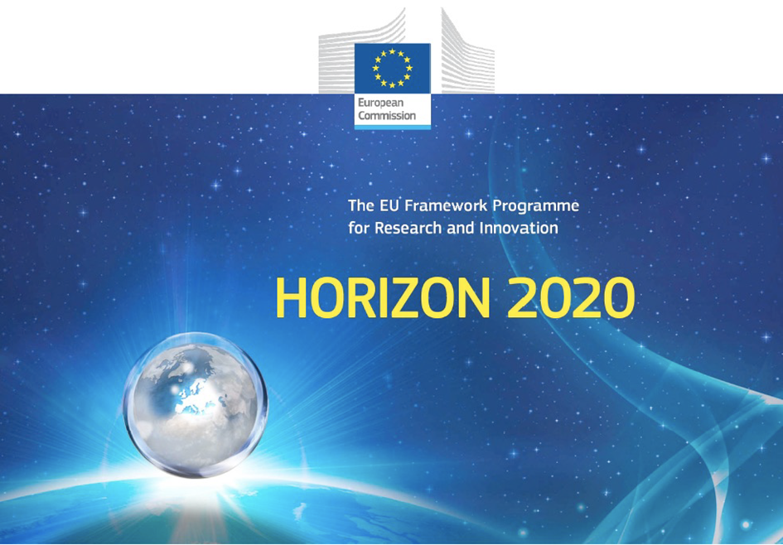

Horizon 2020 Work programme
Food Security, Sustainable Agriculture and Forestry, Marine, Maritime and Inland Water Research and the Bioeconomy
Call
H2020-FNR-2020: Food and Natural Resources
Topic name
FNR-16-2020: ENZYMES FOR MORE ENVIRONMENT-FRIENDLY CONSUMER PRODUCTS

FuturEnzyme:
Technologies of the Future for Low-Cost Enzymes for Environment-Friendly Products
Final ID: 101000327

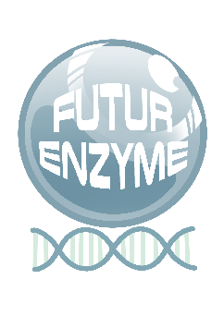
INSERT DATE
Name of WP Leader responsible for deliverable validation
name of the institution
Address)
Title 1
deliverable number eg.D1.1

Document information sheet

Work package: | e.g. WP8, Communication, Dissemination and Exploitation
Authors: | e.g. Consorzio Italbiotec (Sara Daniotti, Ilaria Re)
Document version: | e.g. 1
Date: | XXX
Starting date: | e.g. 01/06/2021
Duration: | e.g 48 months
Lead beneficiary: | e.g. Consorzio Italbiotec (ITB)
Participant(s): | e.g. CSIC
Dissemination Level: | e.g. Confidential, only for consortium's members (including the Commission Services)
Type | Report
Due date (months) | 3
Contact details: | Ilaria Re, ilaria.re@italbiotec.it

Summary
1
Document information sheet 2
Title 4
1.Title 1 (SCOPE of DELIVERABLE) 4
2. Title 2 4
3. Title 3 4
4. Title 4 4
5. Title 5 4

Title

1.Title 1 (SCOPE of DELIVERABLE)

Max 5,000 characters

2. Title 2

3. Title 3

4. Title 4

5. Title 5

