Horizon 2020 Work programme
Food Security, Sustainable Agriculture and Forestry, Marine, Maritime and Inland Water Research and the Bioeconomy
Call
H2020-FNR-2020: Food and Natural Resources
Topic name
FNR-16-2020: ENZYMES FOR MORE ENVIRONMENT-FRIENDLY CONSUMER PRODUCTS

FuturEnzyme:
Technologies of the Future for Low-Cost Enzymes for Environment-Friendly Products
Final ID: 101000327

30/11/2022
wolfgang streit
uham
Mittelweg 177, Hamburg 20148, Germany
Report on public, intraconsortium, and interconsortia 18-months events
D8.9

Document information sheet

Work package: | WP8, Communication, Dissemination and Exploitation
Authors: | UHAM (Wolfgang Streit, Jennifer Chow), CSIC (Manuel Ferrer, Patricia Molina)
Document version: | 1
Date: | 30/11/2022
WP starting date: | 01/06/2021
WP duration: | 48 months
WP lead beneficiary: | CSIC
WP participant(s): | CSIC as main contributor and all partners for providing feedback and suggestions for implementation
Deliv lead beneficiary: | UHAM
Dissemination Level: | Confidential, only for members of the consortium (including the Commission Services)
Type | Report
Due date (months) | 18
Contact details: | Wolfgang Streit (wolfgang.streit@uni-hamburg.de), Jennifer Chow (Jennifer.Chow@uni-hamburg.de), Manuel Ferrer (mferrer@icp.csic.es), Patricia Molina (patricia.molina@icp.csic.es)

Summary

REPORT ON PUBLIC, INTRACONSORTIUM, AND INTERCONSORTIA 18-MONTHS EVENTS 4
1. Scope of deliverable 4
2. Introduction 4
3. Public events 5
Webinar Fantastic enzymes: Where and How to find them 5
CLIB Forum Catalysing Alliances for Greener Products 7
4° ESO+Company 8
4. Intra-consortium events 8
Exploitation and Innovation Task Force workshop 8
5. Cluster Enzymes for Greener Products (FNR-16-H2020) events 10
Kick-Off Meeting 10
Policy Working Group 11
Newsletter 11
6. Upcoming events 11
7. Other events 12
8. Annex 15

REPORT ON PUBLIC, INTRACONSORTIUM, AND INTERCONSORTIA 18-MONTHS EVENTS

1. Scope of deliverable
This deliverable will consist in a report listing all public, intra-consortium, and inter-consortia events organized until month 18 with indication of assistance, outcomes, communication and dissemination efforts, etc. This material will be available through the website. Public events will include workshops, courses and other public events. Intra-consortia events will include internally organized exploitation workshops, with indication of assistance, and outcomes. Upcoming exploitable results will be monitored in intra-consortium exploitation workshops by providing questionaries to partners, the results of which will be evaluated and summarized in this deliverable as a report. The exploitation workshops will consist in 1 h meeting after the general annual meetings. Questions will include at least the following: i) identification of potential users of the results inside or outside the consortium; ii) Identification of authors of a result (Should co-ownership be applied?); iii) which enzymes are interesting? (are they published?; are there any genetic modifications that allow us to patent or protect them?; iv) If an interesting enzyme or results is found, which could be the next steps before publishing/protecting?; v) What additional steps would be needed so that the enzyme can be applied / manufactured industrially?; vi) do the enzyme/results has other applications different to those initially thought for the Project?; vii) Have we achieved the proposed objective of the Exploitation Plan?; viii) Is there something similar published or patented? Is the enzyme/result easy to copy? etc. Inter-consortia events will include online and face-to-face meetings with partners of other consortia.

2. Introduction
In this report, an update on the events carried out by the consortium is exposed. In Table 1 are detailed all the events proposed (Proposal Part B, Table 6), indicating changes and comments if any, and date if already conducted. The latter are fully described in the following sections. Inter-consortia events and others at which FuturEnzyme members have participated are also indicated. Last a list of the upcoming events is depicted.
All events that are not meant for general public or do not need general advertising, are disseminated while in process or right after they occur, in the social media accounts of the project (LinkedIn and Twitter) and the project’s website. All the partners do their best to collaborate in dissemination with the tools that each of them have available (institutions’ social media accounts and websites, mailing lists, etc.).
Table 1. Details of the proposed events (Part B, Table 6).
Event number | Event name | Due Date (month) | Where | Date | Comments
1-3 | Series of 3 online webinars, "Enzymes for more environment-friendly consumer products" via online tools | 12  24  36 | Online | 12: 06.09.2022  24: Pending  36: Pending | 12: Fantastic enzymes: Where and How to find them  24: Pending  36: Pending
4 | Workshop, "Summer School on Metagenomics 2021" | 12 (postponed to month 24) | Hamburg | Pending | None
5 | A consortia-wide industry-oriented workshop to evaluate market needs and provide training in the development and pitching of business ideas | 12 (forwarded to month 7) | Madrid (changed to online) | 10.12.2022 | Catalysing Alliances for Greener Products
6 | Workshop on RRI issues (e.g., how to take stakeholder and public views to direct R&D towards societal and market needs) | 24 | Dusseldorf | Pending | None
7 | A theoretical-experimental course on "Engineering enzymes for consumer products of higher environmental quality" | 24 | Barcelona | Pending | None
8 | Workshop and roundtable on "How to find enzymes that will serve the present and future industrial and consumer demands and habits" | 24 | Madrid | Pending | None
9 | Inter-consortia workshop to support good practices exchange between participants | 24 | To be defined | Pending | None
10 | An international biotech/bioeconomy conference | 36 | Dusseldorf | Pending | None
11 | A public event, "European Green Deal Aligned with Rights, Ethics, Equality" in the frame of the International Day of Women and Girls in Science | 36 | Madrid | Pending | None
12 | Inter-consortia workshop focused on fostering the dissemination and exploitation of results of all projects/initiatives | 36 | To be defined | Pending | None
13-14 | 4° ESO+Company | 36: Forwarded to month 11  48: Pending | CSIC | 36: 5-7.04.2022  48: Pending | None
15 | A professional event and roundtable on "Market Place and Policy" to show representatives of authorities, associations, policymakers, industries and end-users the FuturEnzyme results and products with pre-market value | 40 | Milan | Pending | None
16 | Inter-consortia policy event | 44 | Madrid | Pending | None
17-20 | Intra-consortium exploitation workshop | 12  24  36  48 | 12: Madrid  24  36  48 | 12: 01.06.2022  24  36  48 | 12: 01.06.2022  24: Pending  36: Pending  48: Pending

3. Public events

Webinar Fantastic enzymes: Where and How to find them
This webinar corresponds to event number 1, inside the designation Series of 3 online webinars, "Enzymes for more environment-friendly consumer products", via online tools. It was organised by CLIB and CSIC with ITB’s support, and took place on 6 September 2022.
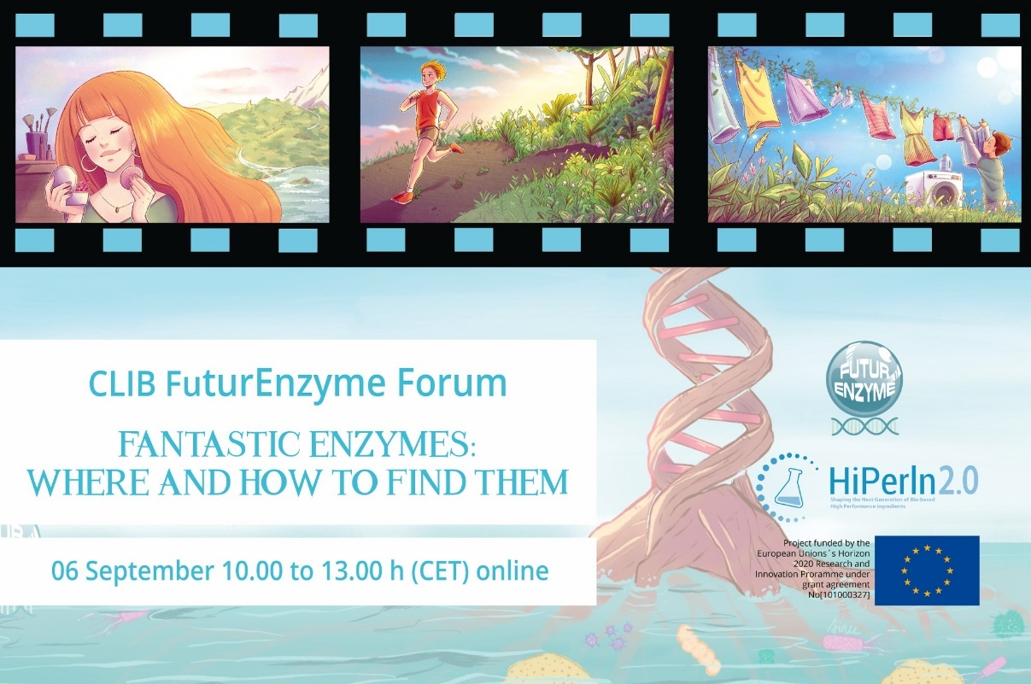
Fig. 1. Image created for the advertising of the webinar Fantastic enzymes: Where and How to find them.
It consisted in 3 talks by FuturEnzyme members which comprehend the general aim and methodology of our project (see agenda in Annex). The speakers and talk titles were:
- Manuel Ferrer (CSIC): Enzymes wanted, reason: the bioeconomy, the climate change and the consumer demands
- Sergi Rodà Llordés (BSC): In silico toolkit for enzyme bioprospecting and engineering: a current view
- Jennifer Chow (UHAM): Mining the microbial diversity for esterases, lipases and plastic degrading enzymes
It was conceived to a broad audience, including researchers, academia, stakeholders, policy makers, funding bodies, investors, consumers, and general public. To advertise it, CLIB prepared a registration form and a banner image (Fig. 1), and the consortium spread the announce by different channels:
- CLIB contacts (email)
- FuturEnzyme’s Partners members (email) and Advisory Board members (email)
- Cluster Enzymes for greener products coordinators (FNR-16-H2020 sister projects) (email)
- BioSC (Bioeconomy Science Center) Symposium, Bonn, Germany (along Manuel Ferrer’s talk)
- SEBBM (Spanish Society of Biochemistry and Molecular Biology) members (email)
- CIB-CSIC (Biological Research Centre Margarita Salas) members (email)
- UEM (European University of Madrid) students/teachers (email)
- FuturEnzyme account in LinkedIn post
- FuturEnzyme account in Twitter post
- FuturEnzyme, ICP-CSIC, CLIB, and MedLife’s websites
The online platform used was Teams (CLIB). Along the webinar and for a better organization, a poll using Slido was made available for the audience to ask questions, and the Teams chat was used for technical issues. After the webinar, a networking time was scheduled using the Wonder platform.
Regarding the audience, the webinar was followed from a wide variety of countries, of which Germany, Spain and United Kingdom were the top three. Besides, the webinar also had public from eastern Europe, such as Serbia and Slovakia and from countries outside of Europe, such as India, Brazil, Japan, Russia and Argelia (Fig. 2A). The sectors amongst which the webinar rose interest were also assorted: academia and researchers in its majority, but also companies such as Novozymes, BASF or Procter&Gamble, and bioeconomy and circular economy institutions (Fig. 2B).
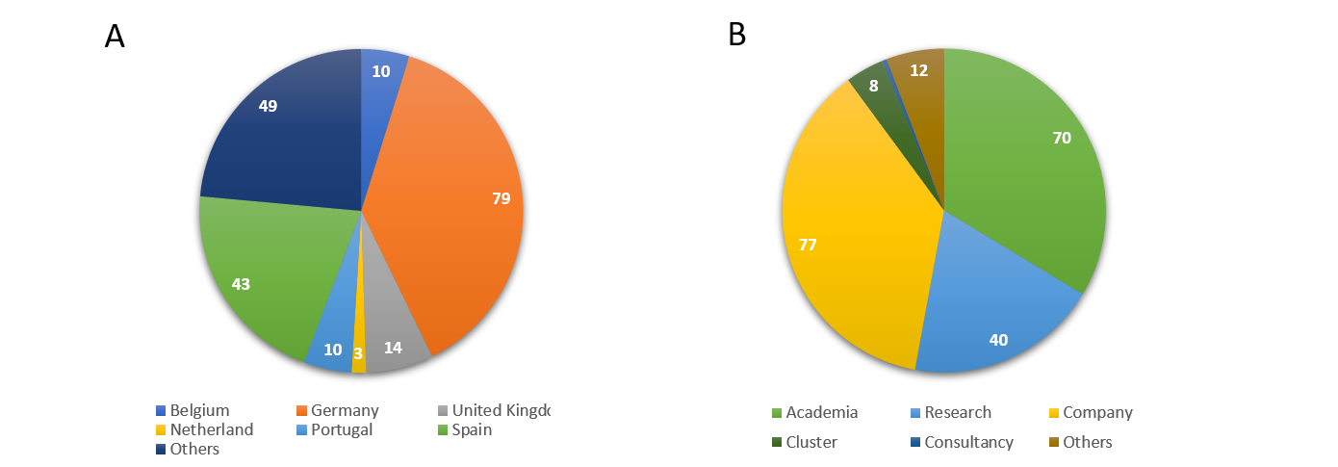
Fig. 2. Attendants to the webinar Fantastic enzymes: Where and how to find them by country (A) and sector (B).

The total registrations’ number was 295, of which 202 attended (which is a 31.5 % of no-show rate, in the average for webinars). The gender ratio of the audience was 46% female and 53% male, with 1 diverse and 2 unknown.

CLIB Forum Catalysing Alliances for Greener Products
This forum corresponds to event number 5, inside the designation “A consortia-wide industry-oriented workshop to evaluate market needs and provide training in the development and pitching of business ideas”. This inter-consortia event was initially thought to be an in-person event in Madrid on month 12, but we decided to organize it earlier online, in the frame of CLIB’s HiperIn2.0. The 4 project sisters from the FNR-16-H2020 conforming the Cluster Enzymes for Greener Products intervened (see agenda in Annex; for more information on the Cluster, see section 5). CLIB was in charge of the organization, with CSIC’s support, and took place on 10 December 2021 (month 7). After an introduction by Markus Müller (CLIB) the interventions were:
- Gro Bjerga (NORCE - Norwegian Research Centre), OXIPRO’s coordinator: Harnessing the power of novel oxidoreductases for greener consumer products
- Marco Fraaije (University of Groningen), OXIPRO’s partner: Computational and structure-inspired engineering of thermostable enzymes
- Manuel Ferrer (CSIC), FuturEnzyme’s coordinator: FuturEnzyme - project overview
- Nazanin Ansari (Schoeller Textiles), FuturEnzyme’s partner: Introducing Schoeller Textiles as industry partner for textile processing in the project FuturEnzyme
- Carolina Peñalva Lapuente (AITIIP Technological Centre), EnXylaScope Coordinator: EnXylaScope - Unleashing Xylan's Potential with Enzymes for a Scope of Consumer Products
- Lalitha Gottumukkala (CELIGNIS), EnXylaScope’s partner: Unleashing Xylan's Potential with Enzymes for a Scope of Consumer Products
- Aurelio Hidalgo (UAM - University Autonoma of Madrid), RADICALZ’s Coordinator: RADICALZ - harnessing enzymes for bio-based, greener consumer products
- Stephan Heijl (BIOP - BIO-PRODICT), RADICALZ’s partner: Combining AI and Bio-Prodict’s 3DM - Shaping the future of Protein Engineering
It was conceived for a specialized audience, focused on industry sectors. To advertise it, CLIB prepared a registration form and a banner image (Fig. 3), and the consortium spread the announce by different channels:
- CLIB and EnXylaScope’s websites
- FuturEnzyme account in LinkedIn post
- FuturEnzyme account in Twitter post
- Colombe Warin account in Twitter post
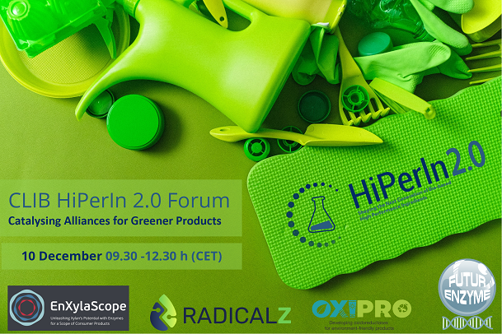
Fig. 3. Image created for the advertising of the CLIB Forum Catalysing Alliances for Greener Products.
The online platform used was Teams (CLIB). After the webinar, a networking time was scheduled using the Wonder platform.
Regarding the audience, the forum was followed mainly by European countries.
In total we had 92 attendants, and the gender ratio was 41% female and 55% male, with 5 unknown.

4° ESO+Company
This workshop corresponds to event 13, and was organized in the frame of the homonymous program from the Madrid Community (Spain). The aim of this extra-scholar activity is that voluntary students of around 15 years-old come close to the real laboral world, by a short stay in a company (a research laboratory in our case). This event was initially thought for month 36, but the opportunity came sooner, so it was decided to be forwarded to month 11, precisely the days 5-7 April 2022. ICP (CSIC) took in 5 students (all female) from the IES José Luis Sampedro (Tres Cantos, Madrid) who spent 3 days learning (with hands on when appropriated) basic techniques that are commonly used in our project to discover, develop and characterize enzymes to be employed to better our lives and the environment.

4. Intra-consortium events

Exploitation and Innovation Task Force workshop
This workshop corresponds to event number 17, inside the designation “Intra-consortium exploitation workshop”. It took place taking advantage of the gather-together that the 12-month General Assembly meeting of the project (31 May -1 June 2022) offered, in 1 June 2022. It was a hybrid (online and in-person) meeting in Madrid, organised by CSIC and CLIB. It was conducted by Markus Müller (CLIB) and Manuel Ferrer (CSIC).
The participants were all the presents in the General Assembly meeting, whether in-person or on-line. In total 43 consortium members (53% female and 47% male) attended, of which 25 were in-person, representing all the partners of the project with the exception of CNR because of last time travelling issues.
All attendants were encouraged to actively participate on the workshop, also by using Slido polls.
The general idea was to briefly discuss how exploitable results will be monitored, and present the Preliminary Exploitation Plan (deliverable 8.6, month 12 - May 2022). Different Key Exploitable Results (KERs) were listed, together with the possible exploitation routes. The 2 questionnaires that will be produced by the consortium (one intra-consortium, and one public for consumers) were discussed. For this purpose, a brainstorming with the aim to identify key impacts and exploitable results was launched by using Slido. The questions and answers were:
- What target groups for questionnaires could you think of?
  - Consumers (clearly higher number of answers)
  - Companies
  - Industry
  - Industrial partners
  - Enzyme producers
  - Spin-off
- How could your organisation profit from FuturEnzyme-specific questionnaires on any target group?
  - End of life cycle management
  - Engineered Enzymes appropriate to the current machineries in the production unit
  - Apply enzymes to new products
  - Influencing govt funding bodies
  - Adapt characterization experiments to real demands
  - Spending behaviour of the consumer for more sustainable products
  - New ideas for projects and products
  - Market trends
  - More sustainable production
  - Consumer trends
  - Search for new enzyme classes
  - Selecting new targets
  - To know industry needs
  - Design process
  - Opening the possibility to stabling new projects or patents
  - New ideas
  - Market need
  - Measuring market trends
  - Software needs
- What distribution channels could you offer for any type of questionnaire?
  - Social media (clearly higher number of answers)
  - In-house e-mail list
  - Conferences
  - Focus group organization
  - Focus group
  - Current spin-off clients
  - IP manager units to target industry
  - Project website
  - Final product brands, using our textiles
  - Henkel: Consumer Testcenter (tbc if feasible)
  - LinkedIn
  - E-mail, newsletters

Moreover, a previous brainstorm suggested a number of questions, that included:
- Identification of authors of a result: should co-ownership be applied?
- Identification of potential users of the results: inside or outside the consortium?
- Which enzymes are interesting? Are they published? Are there any genetic modifications that allow us to patent or protect them?
- Is there something similar published or patented? Is the enzyme/result easy to copy?
- If an interesting enzyme or result is found, which could be the next steps before publishing/protecting?
- What additional steps would be needed so that the enzyme can be applied / manufactured industrially?
- Which of the described exploitation routes would apply for the enzyme / product / process of interest?
- Do the enzyme/results have other applications different to those initially thought for the project?
- Have we achieved the proposed objective of the Exploitation Plan?
- Which end-users or third parties are willing to invest in its full development and commercialisation if the proposed TRL is reached at the end of the Exploitation Plan?
- What potential impact will the new TRL have on improving the transfer of such technology?
- A certain milestone/deliverable after the start of the Exploitation Plan may involve reassessing the protection of these new results and filing a patent application (technology not initially patented) or be a reason to decide to extend the previously filed patent and continue with the next phase. Which transfer partner can already be approached?
- Who and how will the consortium decide if new parties want to participate / a spin-off, will be continuously evaluate, including during the Exploitation workshops.
The results of these questionnaires will be evaluated and discussed in exploitation workshops organized after following General Assembly meetings.
Some ideas for the next workshop were proposed, including short presentation of a manufacturer, a presentation about: i) requirements on enzymes for industrial use (type/activity of enzyme, amount, stability, other requirements), and ii) what does a lab result need to fulfil to be interesting for industry partners?
Other issues that were addressed were how do we know which enzymes may be of interest to others, how do we reach others, and how do we supply the enzymes. For that, it was proposed to produce a web questionnaire and distribute it to interested parties through newsletter and publications, e.g. asking for:
- Enzyme family of interest
- Reaction of interest
- Substrate of interest
- Preferred option to obtain the enzyme (e.g. obtain mg quantities from supplier, get sequence information only, get a license for the expression plasmid…)
- Supply options: i) sequences/plasmids: difficult to protect, maybe an option for academic labs; ii) supply of enzyme preparations in screening grade/quantities; iii) In Eucodis experience, commercial customers don’t want to produce the enzymes themselves but want to obtain mg/gram quantities for initial screenings; iii) we could assemble screening kits of interesting consortium enzymes (no the selected hits), Eucodis could produce and supply them to customers, and share the profit with the consortium partners/providers of the enzymes.
Finally, we also discussed about how do we protect IP and ensure commercial success. Some suggestions were setup:
- Distributing sequences or giving access to consortium libraries to third parties ensuring secrecy and protection of our interests: i) individual agreements/contracts with third parties – difficult and maybe a lot of work; ii) general agreement on website, access after agreeing and after confirmation of contact details
- Distribution via Eucodis: i) Eucodis could sell the kits to interested academic and commercial third parties; ii) general Terms and Conditions do not allow reverse engineering, and offer at least some protection; iii) consortium partners would participate in the revenues and get their share.

5. Cluster Enzymes for Greener Products (FNR-16-H2020) events
This Cluster is composed of the 4 sister projects in the H2020 work programme FNR-16-2020: Enzymes for more environment-friendly consumer products (call Food and Natural Resources), and was organised in cooperation with the REA (Unit B3 “Biodiversity, Circular Economy and Environment”) with the aim to join efforts for a higher efficiency and impact. The other 3 projects are EnXylaScope (Grant Agreement no 101000831), OXIPRO (Grant Agreement no 101000607) and RadicalZ (Grant Agreement no 101000560). The Cluster has different joint actions and has organised several calls since its foundation in October 2021.

Kick-Off Meeting
Celebrated online on 14 October 2021, it gathered the Coordinators and Project Managers of the 4 projects plus the 2 Project Officers (Colombe Warin and Ruska Kelevska) and members of the EU Research Executive Agency (REA; Evdokia Achilleos - Head of Sector of the REA Unit B3 “Biodiversity, Circular Economy and Environment”- and Paloma Mallorquín - Policy Officer of the Unit B1 “Circular Economy & Biobased Systems”). In this meeting, the cluster settled the basis of the project’s actions, which include a newsletter, a policy brief, scientific and divulgative publications, a common open science platform, round tables, and webinars-forums (see section 3 for the joint event “CLIB Forum Catalysing Alliances for Greener Products” – not included in this section since it has already been mentioned in the part referring to public events included in the proposal), amongst others.

Policy Working Group
Each project assigned 2-4 members to be part of this group. All the meetings so far have been held online. The first meeting was celebrated on 22 April 2022, and settled the following actions regarding policy to be taken. On 30 June 2022, the group gathered together to start with the preparation of a joint policy brief. In the next meeting, on 3 November 2022, the policy brief draft was discussed, ideas for its improvement were provided, policy events were proposed, policies, strategies, action plans and directives were listed, and key messages were suggested. All of this is integrated and always available (for consultation and updates) for all the members of the group in a shared document. The final draft is meant to be ready for the end of 2022.

Newsletter
Other relevant action that the Cluster is very active on is the newsletter, named “The Active Site”, launched every 3 months. In this case, RadicalZ leads the action, with an intense collaboration of the rest of the Cluster members. We prepare periodic online meetings at which the Coordinator, Project Managers and WP leader of Communication and Dissemination attend. The first one took place on 10 March 2023, and served to establish the appearance, sections and name of the newsletter. On 20 October 2022, the group met again to bring up to date the outcome of the newsletter in terms of subscribers, clicks, etc., and to organize and distribute the work to produce the next years’ numbers.

6. Upcoming events
The events listed in Table 2 are already under preparation for next year. The Thermophiles Conference has recently been included in the frame of FuturEnzyme. The Workshop Summer School on Metagenomics 2021 was conceived as an activity linked to ESSIB 2022, but because of COVID-19 pandemic this congress was postponed to 2023. The congress is already being prepared by UHAM, and it has also been linked to our General Assembly meeting: 5th ESSIB will take place on 3-6 July 2023, and FuturEnzyme’s 24-month General Assembly meeting on 6-7 July 2023. In this way, FuturEnzyme members will participate in ESSIB as speakers too (the agenda is currently being settled).

Table 2. List of upcoming events under preparation for 2023.
Event number | Event name | Due Date (month) | Where | Date
2 | Series of 3 online webinars, "Enzymes for more environment-friendly consumer products" via online tools | 24 | Online | Pending
4 | Workshop, "Summer School on Metagenomics 2021" | 12 (postponed to month 24) | Hamburg | 03.07.2023 (tentative date)
6 | Workshop on RRI issues (e.g., how to take stakeholder and public views to direct R&D towards societal and market needs) | 24 | Dusseldorf | Pending
7 | A theoretical-experimental course on "Engineering enzymes for consumer products of higher environmental quality" | 24 | Barcelona | Pending
8 | Workshop and roundtable on "How to find enzymes that will serve the present and future industrial and consumer demands and habits" | 24 | Madrid | Pending
9 | Inter-consortia workshop to support good practices exchange between participants | 24 | To be defined | Pending
18 | Intra-consortium exploitation workshop | 24 | Hamburg | 07.07.2023
- | Thermophiles Conference |  | Bangor | August 2023

7. Other events
Besides those events organized in the frame of and for the project, the members of our consortium have actively participated in other 27 events, covering a broad spectrum of audiences to increase FuturEnzyme’s reach, which are listed in Table 3.
Table 3. Details of the events in which FuturEnzyme members have participated outside those organized for the project.
Nr | Type | Partner | Name of the event | Date | Audience*
 |  |  |  |  | Type | (%) | (%) | Total
1 | Talk | CSIC | La Nanotecnología llega al instituto ¡Nos vamos zumbando! | 14.06.2021 | Teenage students | 35 | 65 | 20
2 | Talk | CSIC | VII Simposio de Jóvenes Investigadores del IQFR-CSIC | 18.06.2021 | PhD students and scientists | 43 | 57 | 21
3 | Talk | CSIC | Technical Workshops TW3-TW4, Marie Curie ITN ImplantSens (H2020-MSCA-ITN-2018-813006) | 28.06.2021 | Marie Curie PhD student | 50 | 50 | 12
4 | Conference | CLIB, Henkel, Evonik, UDUS, Inofea | CLIB International Conference | 29.06.2021 | Academia, SME, Industry | 53 | 47 | 97
5 | Invited Lecture | UDUS | 3rd Aachen Protein Engineering Symposium AcES2021 | 01.09.2021 | Scientific | - | - | -
6 | Webinar | IST-ID | International Microorganism Day 2021 @Tecnico | 17.09.2021 | Academic, students from elementary to high school, general public | - | - | -
7 | Conference | CLIB | ECAB/ECCE (online) | 20.-23.09.2021 | Academia, SME, Industry | - | - | -
8 | Networking event | CLIB, Henkel, Evonik, UDUS, Inofea | CLIB Networking Day | 30.09.2021 | Academia, SME, Industry | 33 | 67 | 77
9 | Conference | CLIB | EFIB | 06.-08.10.2021 | Academia, SME, Industry | - | - | -
10 | Invited seminar | CSIC | Seminar at Biotechnology Degree (Francisco de Vitoria University) | 16.10.2021 | Degree students | 57 | 43 | 93
11 | Workshop | CSIC | Jornadas de puertas abiertas, Semana de la Ciencia en el ICP | 03-04.11.2021 | Teenage students | 54 | 46 | 197
12 | Seminar | CLIB | PhD Symposium novo nordisk | 04.11.2021 | PhD students | 35 | 65 | 23
13 | Forum event | CLIB, Inofea | Enzymes, the Multitool of Biotechnology | 17.11.2021 | Academic, companies, etc | 34 | 60 | 146
14 | Webinar | CSIC | Enzymes wanted, reason: the environment | 15.12.2021 | Academic | - | - | 43
15 | Conference | CLIB, Evonik, Henkel, UDUS, Inofea | CLIB International Conference | 01.-02.02.2022 | Academia, SME, Industry | 44 | 56 | 200
16 | Talk | CSIC | Mujeres científicas: ¡en la sombra nunca más! | 14.02.2022 | Teenage students | 48 | 52 | 44
17 | Networking event | CLIB, Eucodis | European Chemistry Partnering | 16.-18.02.2022 | SME, Industry | - | - | -
18 | Talk | CSIC | Mujeres científicas: ¡en la sombra nunca más! | 15.03.2022 | Teenage students | 44 | 56 | 34
19 | Conference + Talk | UHAM | VAAM (Vereinigung für Allgemeine und Angewandte Mikrobiologie), online congress | 23.02.2022 | Scientific | 55 | 45 | 600
20 | Conference | CLIB | Conference on CO₂-based Fuels and Chemicals | 23.-24.03.2022 | SME, Industry | - | - | -
 | Conference | BSC | NextGenBiocat 2022, Delft | 25-26.04.2022 | Scientific | - | - | -
21 | Conference | CLIB | Renewable Materials Conference | 10.-12.05.2022 | SME, Industry | - | - | -
22 | Conference | CLIB | DECHEMA Himmelfahrtstagung on Bioprocess Engineering | 23.-25.05.2022 | Academia, Industry | - | - | -
23 | Seminars | BSC | 14th Girona Seminars | 31.05-3.06.2022 | Scientific | - | - | -
24 | Guest talk | CLIB | OXIPRO General Assembly | 09.06.2022 | Project consortium | - | - | -
25 | Invited lecture | UDUS | Invited lecture applied biotechnology | 15.06.2022 | Undergraduate students of Biotechnology | 50 | 50 | 40
26 | Conference | BSC | "EFB Biocatalysis Division and the EFB Biobased Materials Division", Biocatalysis for the Biological Transformation of Polymer Science | 27.06.2022-01.07.2022 | Academia and industry | - | - | -
27 | Conference | IST-ID | One Sustainable Ocean, side event of the United Nations Ocean Conference | 27.06-01.07.2022 | Academia and industry | - | - | -
28 | Conference talk | UDUS | Biocatalysis for the Biological Transformation of Polymer Science | 28.06.2022 | Scientific | - | - | -
29 | Workshop | BSC | Barcelona International Youth Science Challenge (BIYSC) | 04-15.07.2022 | Teenage students (16-18 years) | 50 | 50 | 4
30 | Conference + Talk + Poster | UHAM | Biocat conference, Hamburg | 28.07-01.08.2022 | Scientific | 40 | 60 | 800
31 | Open Day | UDUS | Tag der Neugier (“Day of curiosity”) | 21.08.2022 | General, in particular families | - | - | 600
32 | Conference talk | CSIC | BioSC Symposium | 23.08.2022 | Scientific | - | - | -
33 | Conference poster | UDUS | 10th International Congress on Biocatalysis (Biocat) | 29.08.2022 | Scientific | - | - | -
34 | Inner IST-ID congress | IST_ID | Inner IST-ID congress | September 2022 | Scientific | - | - | -
35 | Congress | BSC | SEBBM2022, Malaga | 07-09.09.2022 | Scientific | - | - | -
36 | Open Day | CLIB, UDUS | Jülich Biotech Day | 23.09.2022 | Scientific, Industry | - | - | -
37 | Networking event | CLIB, Evonik, Henkel, UDUS | CLIB Networking Day | 17.10.2022 | Academia, SME, Industry | 33 | 67 | 62
38 | Talk | UHAM | Wetter.Wasser.Waterkant.2022  Educational program for schools | 04.09.2022 | Teenage students, teachers | 50 | 50 | 70
39 | Conference - poster + oral presentation | Bangor | 13th International Congress on Extremophiles, Loutraki-Greece | 18-22.09.2022 | Scientific | - | - | -
40 | Invited lecture | CSIC | Biotechnology Degree (Francisco de Vitoria University) | 21.10.2022 | Degree students | - | - | -
41 | Workshop | CSIC | Jornadas de puertas abiertas, Semana de la Ciencia en el ICP | 07-08.11.2022 | Teenage students | 50 | 50 | 206
42 | Conference | CLIB | EFIB | 25.-27.10.2022 | SME, Industry | - | - | -
* Non-binary is not included, since there were none participants identifying themselves with this gender.

8. Annex
Annex 1. Agenda for the Webinar Fantastic enzymes: Where and How to find them.
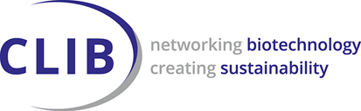
CLIB forum event
Fantastic enzymes: Where and how to find them
Tue, 06 Sep 2022 10.00 h – 13.00 h CET
10:00 h | Welcome & Introduction to HiPerIn2.0 and FuturEnzyme  Markus Müller, CLIB – Cluster Industrial Biotechnology & Patricia Molina, CSIC - Consejo Superior de Investigaciones Científicas | 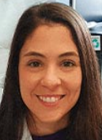
10:10 h | Enzymes wanted, reason: the bioeconomy, the climate change and the consumer demands  Manuel Ferrer, CSIC - Consejo Superior de Investigaciones Científicas | 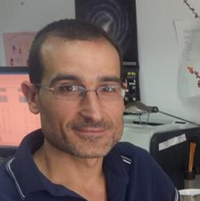
11:00 h | Short break
11:20 h  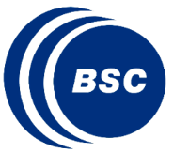 | In silico toolkit for enzyme bioprospecting and engineering: a current view  Sergi Rodà Llordés, BSC – Barcelona Supercomputing Center
12:10 h | Mining the microbial diversity for esterases, lipases and plastic degrading enzymes  Jennifer Chow, University of Hamburg
13:00 h | Final discussion

Prof. Manuel Ferrer
“Enzymes wanted, reason: the bioeconomy, the climate change and the consumer demands”
Our understanding of enzymes has demonstrated that they help circular economy and keeping climate change issues from rising. In the context of the circular bioeconomy, the solution is simple: to obtain an enzyme that can be added directly to, or at one of the stages of the production process of, products to make them more sustainable and environmentally friendly. However, the challenges of replacing chemical counterparts with enzymes are manifold, and constant innovation is demanded. In here, innovations to access enzymatic diversity with which to generate products demanded by industry and consumers will be described. In addition, an overview to what extend new enzymes contribute to the circular bioeconomy while also contributing fighting climate change and global warming, and meeting consumer demands will be provided.

Sergi Rodà
“In silico toolkit for enzyme bioprospecting and engineering: a current view”
Enzymes are a workhorse for facing climate change and other problems society faces. For enzymes to enter the market, they must outperform conventional inorganic catalysts with higher efficiencies and lower costs. The starting point to getting a competitive biocatalyst is to find something novel, not already explored by others. Once a novel enzyme is discovered, protein engineering can further enhance its properties. The recent developments in computational tools for bioinformatics and structural biology will allow us to find good starting points and improve them to our needs. Here, I would like to present our recent in silico enzyme bioprospecting and engineering efforts to ease the experimental workload and obtain better biocatalysts.

Dr. Jennifer Chow
“Mining the microbial diversity for esterases, lipases and plastic degrading enzymes”
Microorganisms harbor a vast biocatalytic potential, being able to live under the most hostile conditions and to degrade the most complex compounds. Using a combination of functional screening and sequence-based mining, we are unlocking this potential to search for new enzymes that can be used in white biotechnology and for circular bioeconomy. We have built large toolboxes of functional esterases, lipases and PET-hydrolases. By characterizing these enzymes biochemically and structurally, we lay the foundation for future industrial processes, e.g. to improve the effectiveness of detergents and better facilitate the circular use of plastics.

FuturEnzyme will develop advanced innovative solutions to discover, design, optimise and formulate low-cost enzymes for economically viable consumer products. The products include a textile containing elastane, a liquid detergent, and a hyaluronic acid-based cosmetic, will be targeted. The project will issue a high-tech enzyme development platform using big biodata mining, disruptive machine learning, activity-based bioprospecting, protein engineering, nano-biotechnology, upscale fermentation and down-stream processing systems. |  | Prof. Manuel Ferrer  (mferrer@icp.csic.es)  He graduated in Chemical Sciences from the University of Granada (Spain) in 1994. In the same year, he began his scientific career at the Institute of Catalysis of CSIC, where he obtained his PhD in 1999. In January 2001 he started a postdoctoral stay at the Helmholtz Centre for Infection Research in Germany, after which he returned to the Institute of Catalysis. He is currently Research Professor, and is the head of the "Systems Biotechnology" group, whose activity is mainly focused on enzymes as green catalysts in multiple sectors.
Sergi Rodá  (sergi.rodallordes@bsc.es)  is a late PhD student in the Electronic and Atomic Protein Modeling group led by Víctor Guallar at BSC. He got his BSc degree in Biochemistry at the Autonomous University of Barcelona. He also graduated from his MSc studies in Bioinformatics at the same university. He recently published a paper on Angewandte Chemie about the design of a biocatalyst that can perform both transaminase and hydrolase reactions. He is currently involved in several projects related to PluriZymes and more conventional computational study and rational design of enzymes. |  | Dr. Jennifer Chow  (Jennifer.Chow@uni-hamburg.de)  She develops her work in the Streit lab in the University of Hamburg, where she contributes with her strong background in molecular biology, metagenomics, and biochemistry and has published >20 mostly peer reviewed articles. Dr. Chow also worked on the development of novel expression hosts and has excellent skills in bacterial genetics and genomics, metagenomics and protein expression. She is an expert on in vitro technologies.
The event is supported by

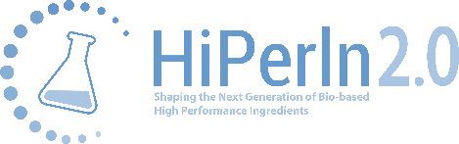
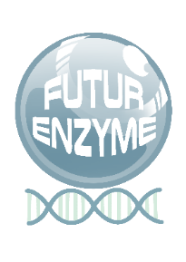 | This project is supported by the European Union’s Horizon 2020 research and innovation programme under grant agreement No 101000327.

Annex 2. Agenda for the CLIB Forum Catalysing Alliances for Greener Products.
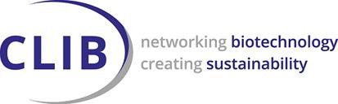

CLIB forum event
Catalysing Alliances for Greener Products
Fri, 10 Dec 2021 09.30 h – 12.30 h CET
09:30 h | Welcome & Introduction  (Markus Müller, CLIB – Cluster Industrial Biotechnology)
09:45 h | OXIPRO - Harnessing the power of novel oxidoreductases for greener consumer products  (Gro Bjerga, NORCE – Norwegian Research Centre)  Computational and structure-inspired engineering of thermostable enzymes  (Marco Fraaije, University of Groningen)
10:15 h  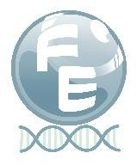 | FuturEnzyme - project overview  (Manuel Ferrer, CSIC)  Introducing Schoeller Textiles as industry partner for textile processing in the project FutureEnzyme  (Nazanin Ansari, Schoeller Textiles)
10:45 h | Short break
10:55 h  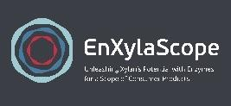 | EnXylaScope - Unleashing Xylan's Potential with Enzymes for a Scope of Consumer Products  (Carolina Peñalva Lapuente, AITIIP Technological Centre)  Unleashing Xylan's Potential with Enzymes for a Scope of Consumer Products  (Lalitha Gottumukkala, CELIGNIS)
11:25 h | RADICALZ: harnessing enzymes for bio-based, greener consumer products  (Aurelio Hidalgo, UAM - University Autónoma of Madrid)  Combining AI and Bio-Prodict’s 3DM: Shaping the future of  Protein Engineering  (Stephan Heijl, BIOP - BIO-PRODICT)
11:55 h | Final discussion
12:15 h | Networking @Wonder
12:30 h | End of event

Oxidoreductases are versatile enzymes that contribute to creating value from waste, replacing harmful oxidisers, and enhancing the appearance, quality, and durability of consumer products. OXIPRO will use efficient computing and the newest biotechnology to reduce time-to- market for enzyme solutions. Some of the platform technologies will be outlined at this event | RADICALZ aims at the development of novel enzymes, new formulations and ingredients for more environment- friendly and healthier consumer products by i) developing new droplet microfluidic tools and ii) user-friendly software solutions based on machine learning (ML) to develop suitable enzymes for consumer products. Our case studies will be the development of enzymes, glycosides, bio-based thickeners, natural antioxidants and fragrances for application in washing, nutraceuticals and cosmetics.
EnXylaScope will discover novel enzymes for debranching xylan, a highly abundant polymer in plants. Productions systems for these enzymes will be optimised and the enzymes will be applied to produce a debranched (water-insoluble) form of xylan that has properties which make it suitable as ingredients in a scope of consumer products. In total 3 types of enzymatically modified xylan will be made and will be application tested for 6 consumer products. These products span 3 sectors (cosmetics, personal care and nutraceuticals). | FuturEnzyme will develop advanced innovative solutions to discover, design, optimise and formulate low- cost enzymes for economically viable consumer products. The products include a textile containing elastane, a liquid detergent, and a hyaluronic acid-based cosmetic, will be targeted. The project will issue a high-tech enzyme development platform using big biodata mining of both public and internal databases and bio-resources, disruptive machine learning, activity- based bioprospecting, protein engineering, nano-biotechnology, upscale fermentation and down- stream processing systems.
The event is supported by
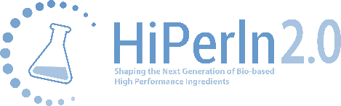

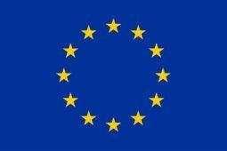
The Projects OXIPRO, FuturEnzyme, EnXylaScope, and RADICALZ are supported by the
European Union’s Horizon 2020 research and innovation programme.

