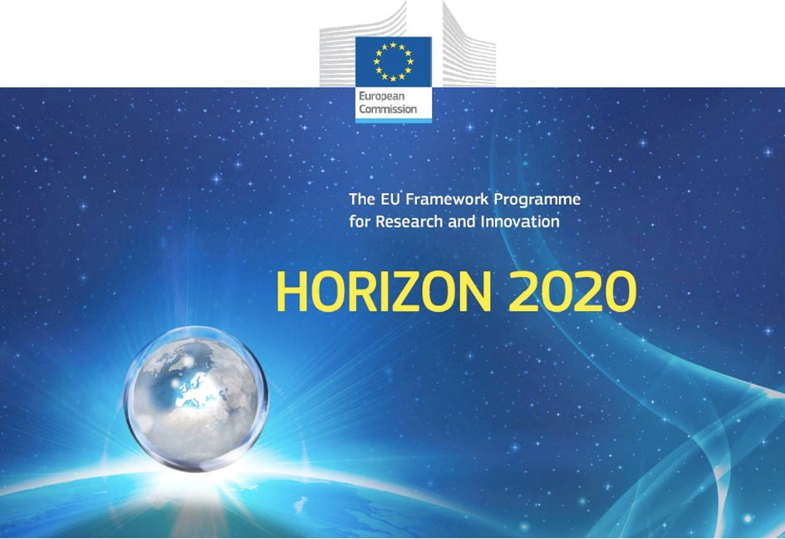

Horizon 2020 Work programme
Food Security, Sustainable Agriculture and Forestry, Marine, Maritime and Inland Water Research and the Bioeconomy
Call
H2020-FNR-2020: Food and Natural Resources
Topic name
FNR-16-2020: ENZYMES FOR MORE ENVIRONMENT-FRIENDLY CONSUMER PRODUCTS

FuturEnzyme:
Technologies of the Future for Low-Cost Enzymes for Environment-Friendly Products Final ID: 101000327

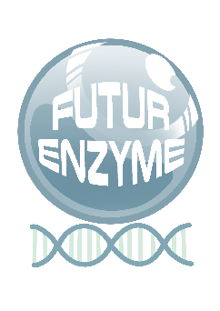
06/08/2021

VISUAL IDENTITY GUIDELINES
DELIVERABLE NUMBER D8.2

MANUEL FERRER
CSIC
Marie Curie 2, 28049, Cantoblanco, Madrid, Spain

Document information sheet

Work package: | WP8, Communication, Dissemination and Exploitation
Authors: | Consorzio Italbiotec (ITB) (Sara Daniotti, Ilaria Re), CSIC (Manuel Ferrer, Patricia Molina)
Document version: | 1
Date: | 06.08.2021
Starting date: | 01/06/2021
Duration: | 48 months
Lead beneficiary: | CSIC
Participant(s): | ITB, CSIC
Dissemination Level: | Public
Type | Websites, patents filing, etc.
Due date (months) | 3
Contact details: | Manuel Ferrer, mferrer@icp.csic,es; Patricia Molina, patricia.molina@icp.csic.es

Summary
VISUAL IDENTITY GUIDELINES 4
- Scope of Deliverable 4
- Logo 4
- Fonts and colours 5
- Templates 5
- Original Visual Identity Pictures for FuturEnzyme 8
- Partners’ images used for the project 11
- Short movie and comic 13

VISUAL IDENTITY GUIDELINES

Scope of Deliverable

A visual identity is composed of visual elements that will provide a tangible manifestation of the project identity and define how FuturEnzyme will be presented to the target audience. The FuturEnzyme graphical identity will include logo, fonts, colours, text, promotional materials, and templates for presentations, posters, and deliverables. The guidelines will assist the partners in designing and producing compelling communications both for web and printed material and contribute to developing a strong and recognisable FuturEnzyme brand. Therefore, it is important to follow the visual identity strategy since good use will help to consistently communicate and disseminate the project. Guidelines and templates will also save time and effort for the members of the consortium since no further design work will be necessary. These materials will be provided by CSIC. A short presentation of this material is also available in D8.3 "Plan for using, communication, and disseminating project information and knowledge".

Logo

As logo for FuturEnzyme project, a crystal ball was designed representing the predictive character of the tools to be developed, which settles in a double stranded DNA chain. There are two versions of the logo (Image 1), in order to use the most suitable in every case in sake of clearness.
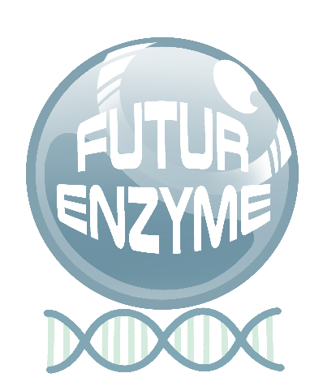
Image 1. FuturEnzyme’s logos.

The preferred logo is the one on the left, with the full FuturEnzyme name. It will be preferably used for the online and offline communication materials, on posters and on any official project documents. The one on the right, with the initials of the project (FE) will be employed for small-size logo when the full project name would not be clearly understandable. It is used, for instance, in the upper part of the browser window when visiting the webpage (Image 2).
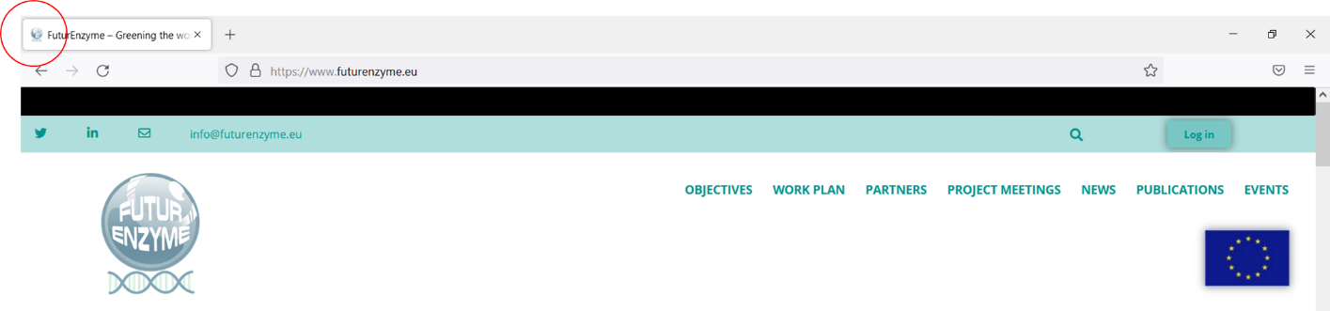
Image 2. Example of the use of the logo with the initials of the project.

Fonts and colours

Fonts

Depending on the material to be prepared, the type of font can be selected among the following: In the texts as in Deliverables, Milestones or reports, Calibri 11 will be used as a general rule.
In presentations, Franklin Gothic Book can be selected.

Corbel is a font that can be used in case of more artistic material.

Colours

The following colours and their Pantone/RGB codes are used in templates, logo and webpage. They will be preferentially used in general in all material produced for the project, such as in leaflets, posters, etc. They were selected to match the project’s logo and to represent the environmental purpose of FuturEnzyme, gathering the idea of a green world with a clean blue ocean.

Pantone 00968f RGB 0, 150, 143

Pantone 6f94a5 RGB 111, 143, 165
Pantone 82a2b0 RGB 130, 162, 1760

Pantone a4bbc5 RGB 164, 187, 197

Templates

The templates for deliverables and power point presentations (see below) have been prepared to be used for internal communications among partners. The same template for deliverables will be used to compile the minutes (to be produced by the project manager) of all internal project meetings and the reports for milestones, if needed. All of them include the EU logo.

The templates generated for compiling and describing the bioresources include the following heading on the left part of every sheet (modified with the name of each type of material):

Deliverable template:
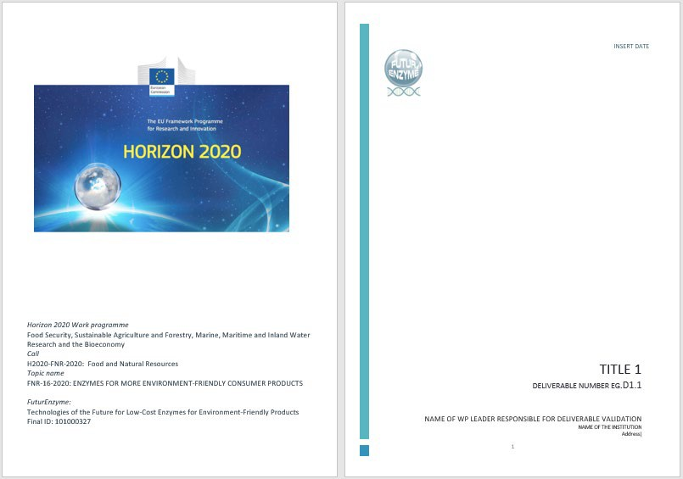
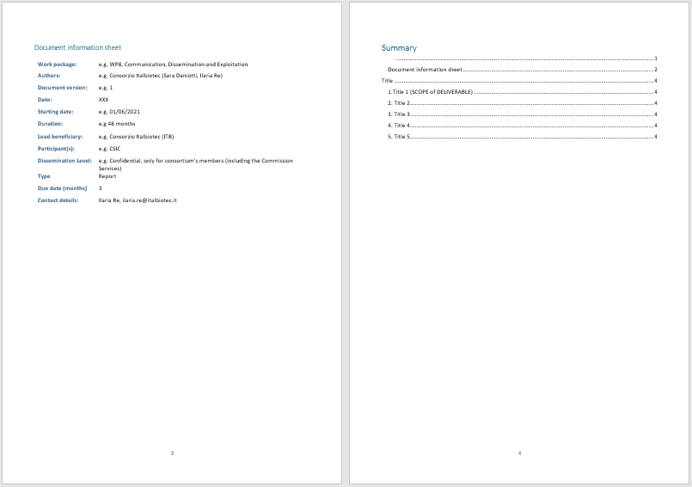

Power point presentation template:

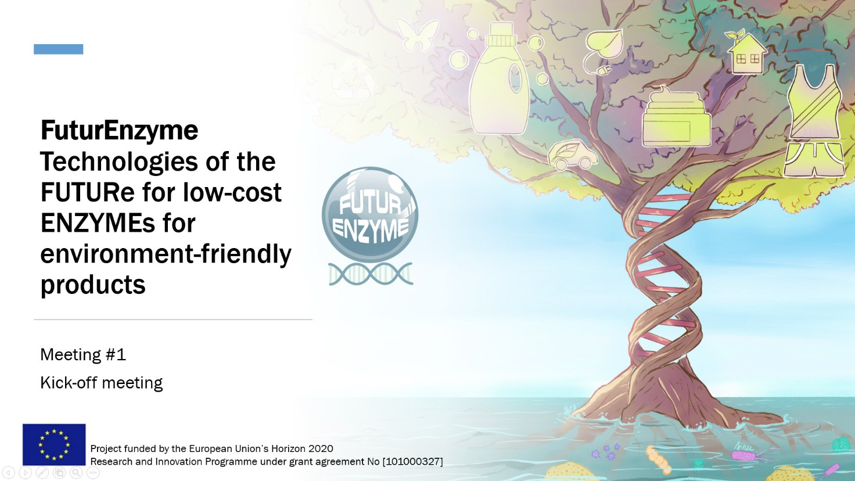

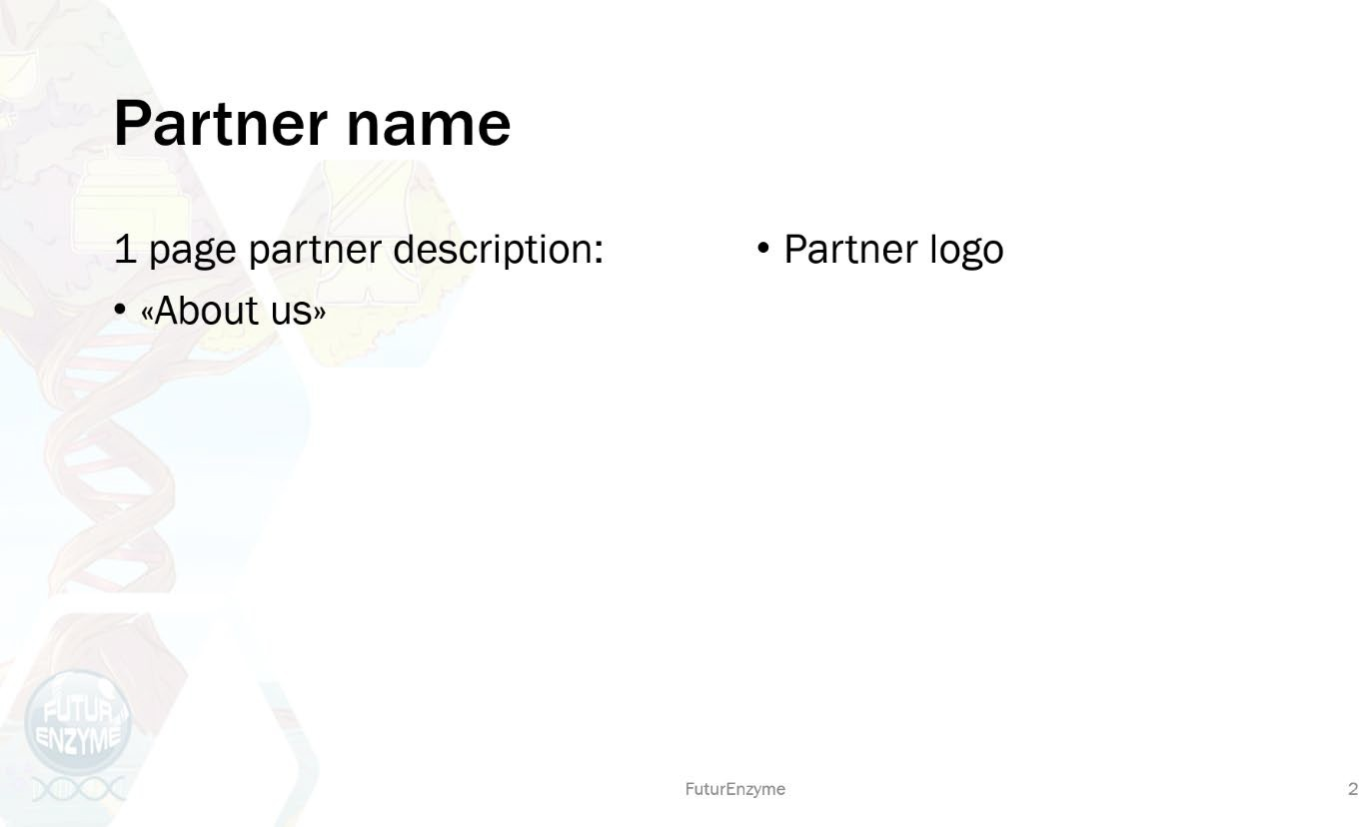

Original Visual Identity Pictures for FuturEnzyme

The five images below have already been created by CSIC with the help of a professional illustrator (Ainhoa Quirós) as major visual project identity pictures (Images 1-5). All of them include the EU logo in the low-left part of the image. These have been included on the website (www.futurenzyme.eu), in which they are also available for the partners to use in the private area, and in other communication activities that have already been published:
- Twitter posts https://twitter.com/futurenzyme
- LinkedIn posts https://www.linkedin.com/company/futurenzyme
- Press releases for the beginning of FuturEnzyme: https://www.clib-cluster.de/de/futurenzymes- project-starts-01-june-2021-technologies-of-the-future-for-low-cost-enzymes-for-environment- friendly-products/; https://icp.csic.es/the-icp-csic-coordinates-a-european-project-to-produce- sustainable-detergents-textiles-and-cosmetics-with-enzymes/; https://www.linkedin.com/feed/update/urn:li:activity:6806117480008949760; https://www.linkedin.com/posts/christian-degering-a0267984_togethercreatingacleanerworld- henkel-futurescience-activity-6807944279063969792-c6_P/ etc.).
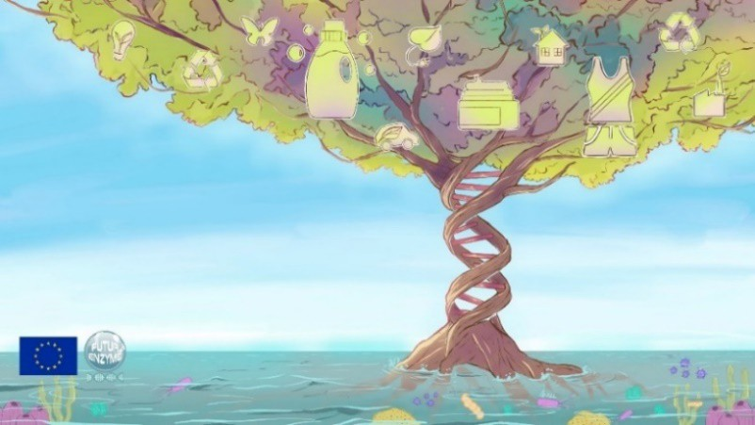
Image 1. Enzymes for driving a greener planet for tomorrow: this image represents the expansive nature of FuturEnzyme. Based on natural DNA resources (depicted as the root of the tree) and applying to them new smart and advanced technologies, disruptive enzymes with enhanced performances and reduced load to the environment will be discovered, designed, optimised, supplied, and formulated, leading to innovative and greener detergents, bio-processed textiles, and bio-processed cosmetic ingredients. FuturEnzyme will also bring to fruition the enormous potential of enzymes via a novel, high-tech platform to yield other greener, more valuable, and sustainable products depicted as multiple branches of the tree.
Image 2. Enzymes for driving greener detergents for tomorrow: this image is related to liquid detergents, showing a detergent from which we are going to remove chemical compounds by replacing them with enzymes. The consumer would use a new greener detergent with less or zero chemical additives in a washing machine, which would produce cleaner clothes. At the same time the washing machine would use less water and energy. In the image, the plants are climbing and growing around the clothes washed with the most ecological and innovative detergent made by FuturEnzyme, representing that the washing process is more eco-friendly. Sparkling around clothes represents the fact that the detergent not only cares for nature, but also leaves the clothes cleaner than a standard detergent.

Image 3. Enzymes for driving greener cosmetics for tomorrow: the following image show a cosmetic whose main ingredient is produced with zero-pollutants and which is beneficial for the environment because, in the production process, it avoids the use of toxic solvents and saves energy and greenhouse gases. At the same time, when using the new cosmetic consumers would have a better "look". Therefore, the image shows a user whose hair is part of the natural landscape, thus expressing that she/he is nature and that by using cosmetics to be produced in FuturEnzyme, she/he, in turn, takes care of both her/himself and nature.
Image 4. Enzymes for driving greener textiles for tomorrow: this image is related to textiles, showing a sportswear that is going to be more innovative (for example, breathable or waterproofing, etc.) using compounds with lower toxicity and less energy during the production process. It shows a runner that, by wearing clothes created more ecologically and functionally by FuturEnzyme, leaves a trail of steps in which vegetation grows, symbolizing that wherever she/he runs, nature feels appreciated.

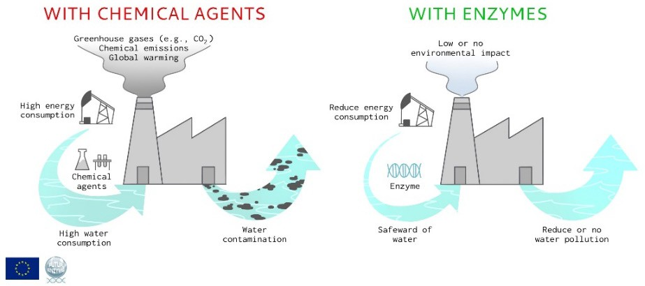
Image 5. Advantages of enzymes vs. chemical agents for the development of more sustainable detergents, textiles and cosmetics. The image summarizes the high environmental impact of consumer products produced with chemical agents and how it can be considerably minimized with the use of enzymes following circular economy criteria.

In addition to the above pictures, two main visual identity images have been designed for the Twitter and LinkedIn accounts (Images 6-7).
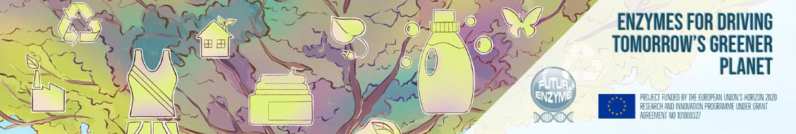
Twitter account.
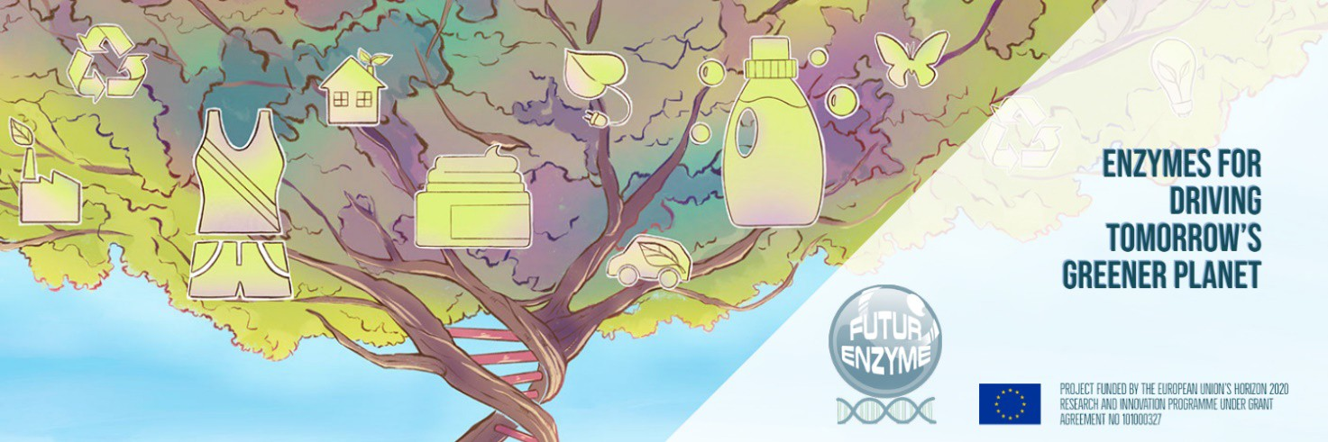
LinkedIn account.

An image has been also designed as a part of the visual identity of the project, used in the Twitter post for the launching of FuturEnzyme’s website (https://twitter.com/futurenzyme/status/1419618385575432202). A number of similar images will be designed along the project.

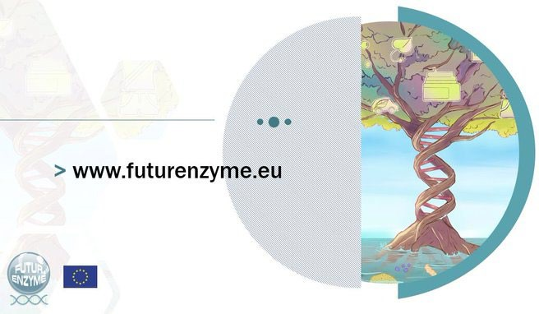
Image 8. Image designed for the Twitter post for the launching of FuturEnzyme’s website.

Other images will be prepared and included on the website as the project progresses. These images will represent the main results of the project in a simple graphic form so that they are easily communicated to both the general and the specific public.

Partners’ images used for the project

The partners put at the service of the project a variety of images and pictures related to the project. Some of them have been selected for the webpage and press releases (images 9-13).

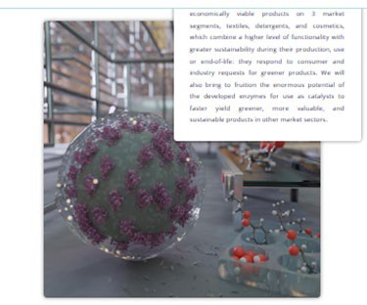
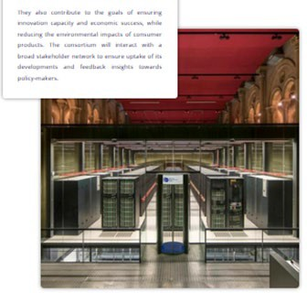
Image 9. Two partners’ pictures in the FuturEnzyme’s website homepage. Left, a representation of immobilized enzymes surrounded by a protective shield, one of the technologies to be used in the project. Right, the Mare Nostrum supercomputer, able to perform more than eleven thousand trillion operations per second.

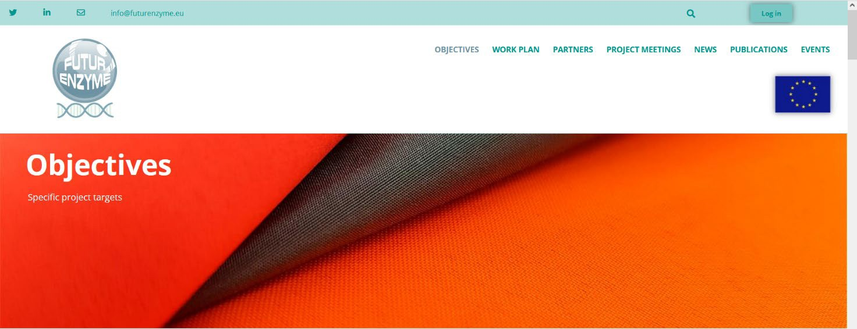
Image 10. Different advanced textiles.

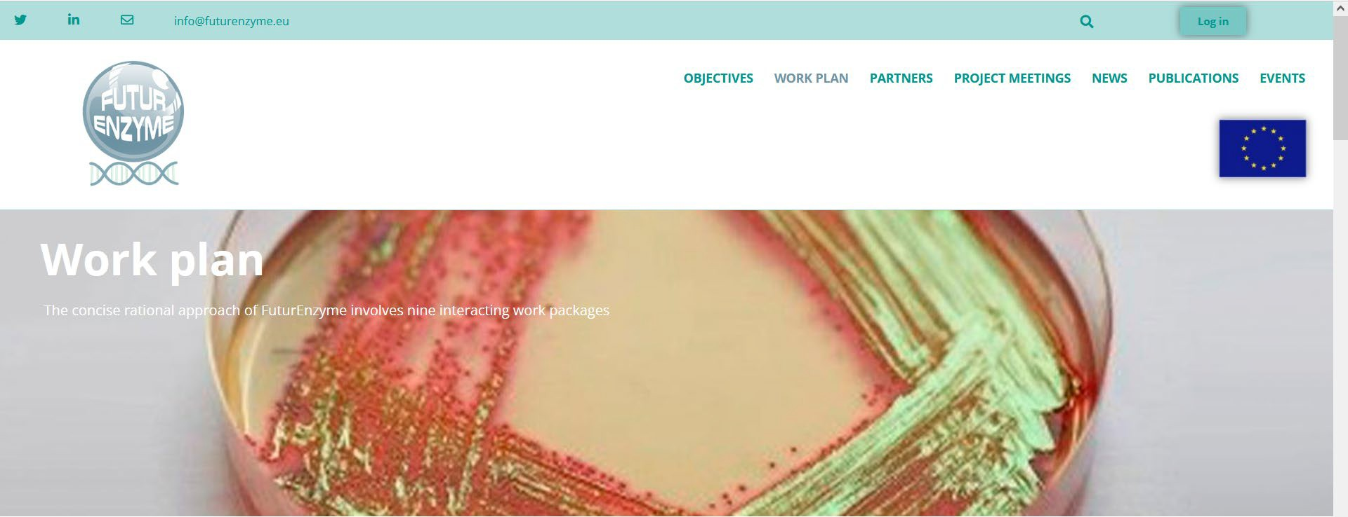
Image 11. A petri plate with a culture of microorganisms of interest to obtain outstanding enzymes which will be used for preparing greener and more sustainable detergents and the bioprocessing of textiles and cosmetic ingredients.

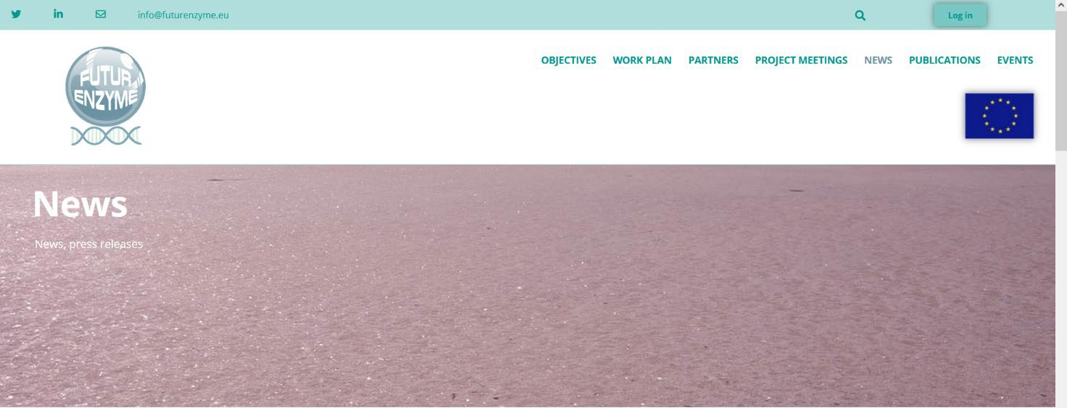
Image 12. A hypersaline extreme environment, selected as an example of extreme environment to be targeted for searching enzymes and microorganisms by metagenomics or conventional microbiology.
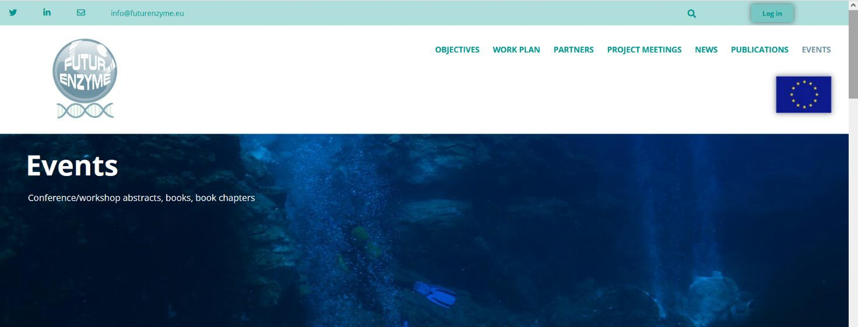

Short movie and comic

During the project lifecycle, a short film and a comic will be developed by CSIC, focused on the innovative research aspects and socio-economic potential of the FuturEnzyme Project in the frame of deliverable 8.12 (month 24).
Both, the video and the comic, will be in English and include the project and EU logos and a clear reference to the H2020 financial support (credits at the beginning or the end include an explicit mention "With the contribution of the Horizon 2020: the EU framework programme for Research and Innovation").
The video will have a duration of 15 minutes and adopt a user-friendly language, in order to explain the objectives, strategies and project impacts. It will be available on the project website and will be disseminated through social network campaigns on LinkedIn, Twitter, and YouTube.
The comic, also in English, will show the whole process from an initial idea, to how to organize the search for new enzymes, how these can be produced and used based on circular economy criteria for the design of new greener and more sustainable consumer products, and, finally, how consumers and the environment will benefit from this project. It will be available on the project website and will be disseminated through social network campaigns on LinkedIn and Twitter.
The objective of these materials is to maximize the FuturEnzyme dissemination, exploitation and communication impact towards a broader audience, helping to create and boost conscience about climate change and the protection of our planet.

