Horizon 2020 Work programme
Food Security, Sustainable Agriculture and Forestry, Marine, Maritime and Inland Water Research and the Bioeconomy
Call
H2020-FNR-2020: Food and Natural Resources
Topic name
FNR-16-2020: ENZYMES FOR MORE ENVIRONMENT-FRIENDLY CONSUMER PRODUCTS

FuturEnzyme:
Technologies of the Future for Low-Cost Enzymes for Environment-Friendly Products
Final ID: 101000327
15 November 2021
PATRICIA MOLINA
CSIC
Calle Marie Curie 2, 28049, Cantoblanco, Madrid, Spain
6-MONTH EXECUTIVE COMMITTEE MEETING

Document information sheet

Work package: | -
Authors: | CSIC (Patricia Molina, Manuel Ferrer)
Document version: | 1
Date: | 15/11/2021
Starting date: | 01/06/2021
Duration: | 48 months
Lead beneficiary: | -
Participant(s): | CSIC, BSC, BANGOR, UHAM, UDUS, IST-ID, ITB, FHNW, CLIB, HENKEL, EUCODIS
Type | Minutes
Due date (months) | 6
Contact details: | Manuel Ferrer (mferrer@icp.csic.es), Patricia Molina (patricia.molina@icp.csic.es)

Summary
6-MONTH EXECUTIVE COMMITTEE MEETING 4
1. Introduction 4
2. Participants 5
3. The meeting 6
4. The actions 8
5. Photo 8
6. Agenda 9

6-MONTH EXECUTIVE COMMITTEE MEETING

1. Introduction
As stated in the Consortium Agreement Section 6, “the Executive Committee is the supervisory body for the execution of the Project which shall report to and be accountable to the General Assembly and it shall pay special attention to the progress in deliverables and achieving Project milestones in a timely fashion”. This body is formed by the Coordinator, who chairs the meetings, and the Work Package (WP) leaders (table 1). It will meet twice a year (one usually in the frame of the General Assembly annual meeting). Any other person from the participating partners is also invited to attend the meetings.
Table 1. Partners leaders for Work Packages.
Partner number | WP lead | Affiliation | Name | e-mail
1 | 1, 9 | CSIC | Manuel Ferrer | mferrer@icp.csic.es
2 | 2 | BSC | Víctor Guallar | victor.guallar@bsc.es
3 | 3 | BANGOR | Peter Golyshin | p.golyshin@bangor.ac.uk
4 | 4 | UHAM | Wolfgang R. Streit | wolfgang.streit@uni-hamburg.de
8 | 5 | ITB | Ilaria Re | Ilaria.re@italbiotec.it
9 | 6 | FHNW | Patrick Shahgaldian | patrick.shahgaldian@fhnw.ch
10 | 7 | CLIB | Tatjana Schwabe | schwabe@clib-cluster.de
16 | 8 | Eucodis | Jan Modregger | modregger@eucodis.com

The tasks of the Executive Committee are:
- prepare the meetings, propose decisions and prepare the agenda of the General Assembly;
- seek a consensus among the Parties;
- be responsible for the proper execution and implementation of the decisions of the General Assembly;
- monitor the effective and efficient implementation of the Project with special attention to the progress in deliverables and achieving Project milestones in a timely fashion;
- collect information at least every 6 months on the progress of the Project, examine that information to assess the compliance of the Project with the Consortium Plan and, if necessary, propose modifications of the Consortium Plan to the General Assembly;
- support the Coordinator in preparing meetings with the Funding Authority and in preparing related data and deliverables;
- prepare the content and timing of press releases and joint publications by the consortium or proposed by the Funding Authority in respect of the procedures of the Grant Agreement Article 29;
- in the case of abolished tasks as a result of a decision of the General Assembly, advise the General Assembly on ways to rearrange tasks and budgets of the Parties concerned.
The 6-month Executive Committee was agreed to take place online on 8th November 2021 using CSIC’s platform Conecta. The room specifically created for FuturEnzyme was used. The meeting was recorded and can be followed in this link.
These minutes, after approval by the Executive Committee, will be shared to all the Consortium members, and will be made available at the intranet of the Project’s website.

2. Participants
Besides the 8 Work Package leaders (including the Coordinator) who are the members of the Executive Committee, other Consortium members and the Project Officer, Colombe Warin, attended to the meeting (table 2). Up to 23 participants were connected:
Table 2. Full list of participants from the different partners.
Partner number | WP lead | Affiliation | Name | e-mail
1 | 1, 9 | CSIC | Manuel Ferrer  Patricia Molina  Cristina Coscolín  Laura Fernández | mferrer@icp.csic.es  patricia.molina@icp.csic.es  cristina.coscolin@csic.es  l.fernandez.lopez@csic.es
2 | 2 | BSC | Víctor Guallar  Sergi Rodà | victor.guallar@bsc.es  sergi.rodallordes@bsc.es
3 | 3 | BANGOR | Peter Golyshin  Olga Golyshina  Alexander Yakunin  Tatjana Chernikova | p.golyshin@bangor.ac.uk  o.golyshina@bangor.ac.uk  a.iakounine@bangor.ac.uk  t.chernikova@bangor.ac.uk
4 | 4 | UHAM | Wolfgang R. Streit  Jennifer Chow | wolfgang.streit@uni-hamburg.de  Jennifer.Chow@uni-hamburg.de
5 | - | UDUS | Alexander Bollinger | a.bollinger@fz-juelich.de
6 | - | IST-ID | Carla de Carvalho | ccarvalho@tecnico.ulisboa.pt
8 | 5 | ITB | Ilaria Re  Sara Daniotti | Ilaria.re@italbiotec.it sara.daniotti@italbiotec.it
9 | 6 | FHNW | Patrick Shahgaldian  Giada Sabatino | patrick.shahgaldian@fhnw.ch
10 | 7 | CLIB | Tatjana Schwabe  Tobias Klement | schwabe@clib-cluster.de  klement@clib-cluster.de
14 | - | Henkel | Christian Degering | christian.degering@henkel.com
16 | 8 | Eucodis | Jan Modregger | modregger@eucodis.com
- | - | Project Officer (REA) | Colombe Warin | Colombe.WARIN@ec.europa.eu

3. The meeting
The participants are welcomed by the Coordinator, Manuel Ferrer (CSIC), who shortly comments the agenda.
Manuel Ferrer informs about the meeting held on 14th October 2021 with the other Coordinators from the FNR-16 topic that form the Cluster Enzymes for greener products and members of the REA (minutes available soon). In this meeting, the actions to be taken to boost, maximise and optimise the reach of the 4 projects were discussed and agreed. Colombe Warin, FuturEnzyme’s Project Officer, takes the word to indicate that the idea of the Cluster is to find synergies amongst the projects so our results can be channelled to their hierarchy in order to be able to obtain more financing for future calls. She also remarks that this is also important at a policy level for the European Commission. Manuel Ferrer informs that the minutes of the meeting, plus a short report and a roadmap summarising the actions and events are under preparation. He also mentions that efforts will be done in this sense not only to target and reach European but also non-European and Eastern Europe audiences.
Then, he summarises the work done during months 1-6 for WP1 Management and Coordination and remarks the importance of WP9 Ethics, and which deliverables are due for the current 6th month. In this sense, he encourages the partners to look at the Access and Benefit-Sharing Regulation about utilisation of genetic resources (Nagoya Protocol). Finally, he stresses the immediate actions that have to be tackled by the partners: send asap documents for deliverables for Ethics and consider the decision of the Cluster Enzymes for greener products. He further reminds that any question that the partners may have for the Project Officer have to be communicated through the Coordinator (directly or via the Project Manager).
Regarding WP2, Víctor Guallar (BSC), Manuel Ferrer, and Jennifer Chow (UHAM) put together the work done so far for Machine learning enzyme bioprospecting integrated into an industrial context. In the context of HMM, Guallar suggests that CSIC and BSC have a larger list of sequences in fasta that they can send UHAM to upgrade the model, which Chow sees as a good improvement. Manuel Ferrer asks if it is possible to add to the HMM pipeline a rule that considers if a sequence is similar to other already experimentally tested that, for instance, is not well expressed, so it can be discarded. Chow thinks it is not, since just one amino acid can produce drastic changes. Guallar also proposes to create workflows that go to Elixir repositories to take advantages of their versatility and analysis capacities. This could be something useful to share with the Cluster. He proposes to CSIC to experimentally try a GH16 family sequence that they have pointed out as candidate for hyaluronic acid treatment. Jan Modregger from EUCODIS asks if it is possible to include in the predictive tool from BSC a biphasic system since working with lipases implies that there is an aqueous phase interacting with lipids. This could help modelling the active site, or helping to orient the enzyme in a more appropriate manner. This can also help for the detergent application since the stain is on the fabric. At this, Guallar says that they can see diffusion of molecules, but there is a limit of 3-4 proteins that they can include and they cannot go to a macromolecular level. Modregger wants to know if liposomes would be possible, at which Guallar answers that with molecular mechanics it is not possible.
For WP3 Activity-based bio-prospecting for enzymes, Peter Golyshin (Bangor) presents the work done. Ferrer wants to clarify two points. First, since there are a lot of bio-resources, it could be adequate that the partners have a fast test to determine if the candidate is good for the real implementation, for instance, in the washing liquid, so it can be properly transferred to WP2 and WP4. Second, in this WP there are also many genomes and metagenomes, and it could be convenient for the partners to have access to this data to make HMM or Blast search for the identification of more candidates, maybe through the intranet or the BSC repository.
Jennifer Chow, Manuel Ferrer and Carla de Carvalho (IST-ID) resume the activities carried out in the frame of WP4 Small-scale enzyme production and characterisation. About the lactonases that UHAM have, Manuel Ferrer clarifies that this type of enzymes is not a priority for the Project’s industries, but that can be kept as a secondary option. About the esterases found, Guallar suggests that CSIC can send BSC the sequences to begin with Alphafold runnings (each structure takes around 5 hours). To this issue, Ferrer comments that we have to elaborate a system to help the interrelation between partners and WPs, through the intranet or BSC repository as mentioned, so when a partner has a prospect to be transferred, the sequence can be easily picked for other partners to feed the WPs from, for instance, a fasta file. Also, this pipeline can include for the partners to see the current work, characterised enzymes, their activities and properties, etc. Jan Modregger offers expressions systems such as Pichia, Bacillus, Aspergillus or Corynebacterium for expressing enzymes that other partners found of interest but their expression level is low. Patrick Shahgaldian (FHNW) proposes (via public chat) a meeting/chat with BSC to discuss the docking of catalytic inhibitors for metamorphosis activities.
WP5 Enhancing enzymes through innovative engineering work is briefed by Manuel Ferrer. Sergi Rodá (BSC) asks that since UDUS tested a PETase that is pretty active in the washing liquor and also transaminases are active, maybe the PluriZyme could work. Ferrer answers that this is something that needs to be discussed with UDUS, because in this particular case there is a constrain regarding stability and the activity levels.
Then WP8 Communication, Dissemination and Exploitation is skipped to his point for the Project Officer, Colombe Warin, to be present (the meeting was behind the scheduled time). Sara Daniotti from ITB gives an overview of the actions taken in this regard. Manuel Ferrer points out the fact that efforts will also be made to reach non-European and Eastern countries. Colombe Warin asks about the face-to-face planned events and suggests that one newsletter is launched for the 4 projects in the Cluster Enzymes for Greener Enzymes to strengthen the reach of this action, since this type of actions are time-consuming are the reach is not too high. She also wants to know the perspective of the videos that are going to be created for the Project. To the first point, Ferrer says that the face-to-face events may be feasible from next year but it has to be decided and confirmed as they approach, regarding COVID situation and availability issues, of course with all the necessary security protocols. For the newsletter, he agrees with Warin, and adds that maybe besides the common one, also a newsletter for each project could be interesting, since we can have different outcomes. About the video, Ferrer explains that we are looking for the best company to prepare the animation video, showing how enzymes are obtained, and how they are processed, tested, and then how they work in the real-life products. It has to be short (no more than 2 minutes) because of the cost and because longer videos are not interesting for the public. He says that besides this initial video explaining what the Project does, another one at the end is planned to show the results of what we have done. Modregger says that this point of view is more and more demanded by customers and it is also interesting from an educational/training and general public point of view. Ferrer stresses the expensiveness of this type of videos. Warin suggests that we can have a very short video and a larger one to be used at convenience. Modregger also suggests that the video can be structured in blocks for the same reason, to be showed depending on the context and public. Ferrer thanks Warin for her comments and for being present at our meeting.
Back to the technical part of the meeting, WP6 Development and supply of best enzyme prototypes is summarised by Jan Modregger (EUCODIS). He talks about the mentioned system that could be applied to make a rapid decision flow, where the partners can upload their candidates (sequences, characterisation, properties, etc), for other work packages to consult and take the lead for their activities. Also, information about the commercialisation of the candidates or about the industrial partners preferences, etc. can be added. In this way, every partner is at any time aware of the ongoing of the activities of the project. This can be done through the intranet. Maybe every time a new candidate is produced, an automatic notification can be delivered to the interested partners through this system. This can also clarify the activities every partner has to do at any time. Ferrer comments about the convenience of this system and that this is going to be discussed also with the web designer. Tatjana Schwabe from CLIB, via public chat, agrees in the advantages of this system also for exploitation issues.
WP7 Formulation and manufacturing of consumer products is resumed by Manuel Ferrer, with backup from Tatjana Schwabe (CLIB).
With this, Manuel Ferrer thanks all the participants the assistance and the meeting is dismissed.

4. The actions
Numerous ideas were put on the table by all the WP leaders and assistants based on which a number of immediate actions or initiatives to be undertaken were considered, among the most important ones highlighted below:
- To circulate among BSC, CSIC and UHAM the list of reference sequences for HMM in fasta format (WP2);
- To consider a way to deposit all genomes and metagenomes generated (WP3) in the intranet of BSC repository, so that partners can access them;
- To organize a meeting/chat FHNW-CSIC-BSC to discuss the docking of catalytic inhibitors for metamorphosis activities (WP4/5);
- To design a web protocol (WP4/6) that could be applied to make a rapid decision flow, where the partners can upload the enzyme candidates (sequences, etc.) and their characteristics, so that every time a new candidate is produced, an automatic notification can be delivered to the interested partners through this system. This tool will be beneficial for selecting best targets, for the commercialisation of the candidates or about the partner preferences, and for exploitation issues;
- To prepare one newsletter for the 4 projects in the Cluster Enzymes for Greener Enzymes to strengthen the reach of this action (WP8); and
- To prepare an animation video (WP8).

5. Photo
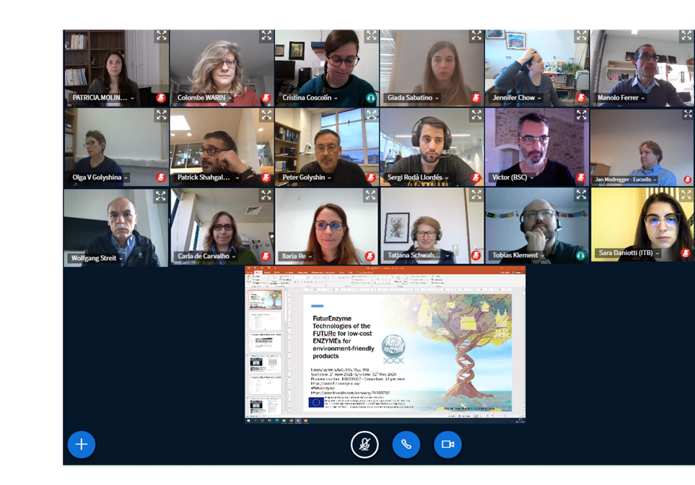

6. Agenda

9:30-9:35 Welcome to the 6-month Executive Committee meeting
Manuel Ferrer (CSIC): Project Coordinator and Chair of the 6-month Executive Committee meeting
Patricia Molina (CSIC): Project Manager
9:35-9:50 FuturEnzyme: general resume
Manuel Ferrer (CSIC): FuturEnzyme Project Coordinator and Chair of the 6-month Executive Committee meeting
Content: The coordinator will briefly summarize the outcomes of the dissemination, communication, and meetings with other coordinators and project officers of the other 3 funded projects. He will also clarify other actions.
9:50-10:10 CSIC as leader of WP1 and 9
Manuel Ferrer
Content: M. Ferrer will stress the attention to Ethical issues with an important deliverable in November, as well as point the status of budget issues.
10:10-10:30 BSC as leader of WP2
Víctor Guallar
Content: V. Guallar will discuss the status of the bioinformatics and computational effort done by UHAM and BSC, and others. Please, ask partners for a short summary (one or few slides per partner).
10:30-10:50 Bangor as leader of WP3
Peter Golyshin
Content: P. Golyshin will discuss the status of the functional screens and sequencing effort done by WP3 partners. Please, ask partners for a short summary (one or few slides per partner).
10:50-11:10 UHAM as leader of WP4
Jennifer Chow
Content: J. Chow will discuss the status of the effort regarding expression and characterization of enzymes by WP4 partners. Please, ask partners for a short summary (one or few slides per partner).
11:10-11:30 FHNW as leader of WP5
Patrick Shahgaldian
Content: P. Shahgaldian will discuss the status of the effort regarding the supramolecular engineering and suicide inhibitor-based enzyme metamorphosis. Please, ask partners for a short summary (one or few slides per partner).
11:30-11:50 Eucodis as leader of WP6
Jan Modregger
Content: Although too early to discuss about scale up production, it will be nice to discuss about steps to proceed once a good enzyme candidate is identified.
11:50-12:10 CLIB as leader of WP7
Tobias Klement
Content: Although too early to discuss about application tests and transfer, it will be nice to discuss about steps for preparing the Exploitation Plan and other actions to be taken in relation to WP7.
12:10-12:30 ITB as leader of WP8
Ilaria Re
Content: I. Re will discuss the status of the dissemination and communication efforts.
12:30-13:00 Conclusion, remarks, and future plans
Manuel Ferrer

