Horizon 2020 Work programme
Food Security, Sustainable Agriculture and Forestry, Marine, Maritime and Inland Water Research and the Bioeconomy
Call
H2020-FNR-2020: Food and Natural Resources
Topic name
FNR-16-2020: ENZYMES FOR MORE ENVIRONMENT-FRIENDLY CONSUMER PRODUCTS

FuturEnzyme:
Technologies of the Future for Low-Cost Enzymes for Environment-Friendly Products
Final ID: 101000327
27 June 2022
PATRICIA MOLINA
CSIC
Calle Marie Curie 2, 28049, Cantoblanco, Madrid, Spain
FE_Minutes 12M General Assembly meeting_FINAL
31 May – 1 June 2022

Document information sheet

Work package: | WP1, Management and Coordination (Task 1.1_Technical, administrative and financial management)
Authors: | CSIC (Patricia Molina, Manuel Ferrer)
Document version: | 1
Date: | 08/06/2022
Starting date: | 01/06/2021
Duration: | 48 months
Lead beneficiary: | CSIC
Participant(s): | CSIC, BSC, BANGOR, UHAM, UDUS, IST-ID, CNR, ITB, FHNW, CLIB, INOFEA AG, BioC_Chem, SCHOELLER , HENKEL, EVO, EUCODIS
Type | Report
Due date (months) | 12
Contact details: | Manuel Ferrer (mferrer@icp.csic.es); Patricia Molina (patricia.molina@icp.csic.es)

Summary
1. Introduction 4
2. Participants 4
3. The meeting 6
Day 1 6
Welcome, WP1_Management and Coordination, WP9_Ethics requirements, and general remarks (CSIC) 6
WP2_Machine learning enzyme bio-prospecting integrated into an industrial context (BSC) 6
WP3_ Activity-based bioprospecting for enzymes (Bangor) 7
WP4_Small-scale enzyme production and characterisation (UHAM) 8
WP5_ Enhancing enzymes through innovative engineering (FHNW) 10
WP8_Communication, Dissemination and Exploitation (ITB) 10
Gender, Rights and Ethical Task Force 10
Final comments 10
Day 2 11
WP6_ Development and supply of best enzyme prototypes (Eucodis) 11
WP7_ Formulation and manufacturing of consumer products: sustainability and environmental assessments (CLIB) 11
Exploitation and Innovation Task Force workshop 11
Conclusions, remarks, and future meetings and events 12
4. Links 12
5. Agenda 12
6. Photos 14
ANNEX I 15

1. Introduction
According to the Consortium Agreement section 6.2.2, the General Assembly (composed of at least one representative of each partner) celebrated its annual meeting the days 31th of May and 1st of June 2022, corresponding to the 12th month of the Horizon 2020 FuturEnzyme project. This document represents the minutes of this meeting (Consortium Agreement, section 6.2.5), prepared by the Coordinator (CSIC), reviewed and approved by all the members of the General Assembly.
In this context, the annual meetings of the Exploitation and Innovation Task Force and the Gender, Rights and Ethical Task Force were also conducted.
In this occasion, due to the lessen of the COVID-19 global health emergency, all the partners decided to hold the meeting in a hybrid attendance model, both in person and online, depending on the personal situation and current restrictions in each country and organisation. It took place in Chamartín The One hotel, Madrid (Spain), and was hosted by CSIC.
It was scheduled for 2 days. The first one included a welcome, resume of the project and general comments by Manuel Ferrer (FuturEnzyme Project Coordinator), the statement of WP1, 2, 3, 4, 5, 8 and 9, and the Gender, Rights and Ethical Task Force meeting. The second day consisted in the statement of WP6 and 7, the Exploitation and Innovation Task Force meeting, and final conclusions and remarks. Unfortunately, FuturEnzyme’s Project Officer, Colombe Warin, was not able to attend.
The total number of participants was 43, with representation of all the partners of the project with the exception of CNR because of last time travelling issues. Yet, all their information was exposed by other competent partners.
In this document, relevant issues and discussions are detailed. For further information on the ongoing of the project and the exposition of the WPs, see the presentation slides available in the intranet of the project’s website, shared material section. In addition, a brief was prepared for the Advisory Board and the Project Officer, also available on the same intranet’s section.

2. Participants
Partner number | WP lead | Affiliation | Name | Attendance | e-mail
1 | 1, 9 | CSIC | Manuel Ferrer¹ | In person | mferrer@icp.csic.es
1 | 1, 9 | CSIC | Patricia Molina | In person | patricia.molina@icp.csic.es
1 | 1, 9 | CSIC | Cristina Coscolín | In person | cristina.coscolin@csic.es
1 | 1, 9 | CSIC | Laura Fernández | In person | l.fernandez.lopez@csic.es
1 | 1, 9 | CSIC | David Almendral | In person | d.almendral@csic.es
1 | 1, 9 | CSIC | Paula Vidal | In person | p.vidal.ramon@csic.es
1 | 1, 9 | CSIC | Julia Sanz | On-line | xjulia@iqfr.csic.es
1 | 1, 9 | CSIC | Isabel Cea | In person | icea@iqfr.csic.es
2 | 2 | BSC | Víctor Guallar | In person | victor.guallar@bsc.es
2 | 2 | BSC | Rubén Muñoz¹ | In person | ruben.munoz@bsc.es
2 | 2 | BSC | Ana Robles | On-line | arobles@bsc.es
2 | 2 | BSC | Sergi Rodà | On-line | sergi.rodallordes@bsc.es
3 | 3 | BANGOR | Peter Golyshin¹ | In person | p.golyshin@bangor.ac.uk
3 | 3 | BANGOR | Alexander Yakunin | On-line | a.iakounine@bangor.ac.uk
3 | 3 | BANGOR | Olga Golyshina | In person | o.golyshina@bangor.ac.uk
3 | 3 | BANGOR | Tatyana Chernikova | On-line | t.chernikova@bangor.ac.uk
3 | 3 | BANGOR | Anna Khusnutdinova | On-line | a.khusnutdinova@bangor.ac.uk
4 | 4 | UHAM | Wolfgang R. Streit | On-line | wolfgang.streit@uni-hamburg.de
4 | 4 | UHAM | Jennifer Chow | On-line | Jennifer.Chow@uni-hamburg.de
4 | 4 | UHAM | Pablo Pérez¹ | In person | pablo.perez.garcia@uni-hamburg.de
4 | 4 | UHAM | Lena Preuß | In person | lena.preusz@web.de
4 | 4 | UHAM | Marno Gurschke | In person | marno.gurschke@uni-hamburg.de
5 | - | UDUS | Karl-Erich Jaeger | On-line | k.-e.jaeger@fz-juelich.de
5 | - | UDUS | Stephan Thies¹ | In person | s.thies@fz-juelich.de
5 | - | UDUS | Fabienne Hilgers² | In person | f.hilgers@fz-juelich.de
6 | - | IST-ID | Carla de Carvalho¹ | In person | ccarvalho@tecnico.ulisboa.pt
6 | - | IST-ID | Patricia Gómez | On-line | patgomvil@gmail.com
8 | 8 | ITB | Ilaria Re¹ | In person | Ilaria.re@italbiotec.it
8 | 8 | ITB | Sara Daniotti¹ | In person | sara.daniotti@italbiotec.it
9 | 5 | FHNW | Patrick Shahgaldian¹ | In person | patrick.shahgaldian@fhnw.ch
9 | 5 | FHNW | Philippe Corvini | In person | philippe.corvini@fhnw.ch
10 | 7 | CLIB | Markus Müller¹ | In person | mueller@clib-cluster.de
10 | 7 | CLIB | Tobias Klement | In person | klement@clib-cluster.de
10 | 7 | CLIB | Annika Thamm | On-line | thamm@clib-cluster.de
11 | - | Inofea | Anne Timm | On-line | anne.timm@inofea.com
11 | - | Inofea | Rita Correro | On-line | rita.correro@inofea.com
12 | - | BioC_Chem | Fabrizio Beltrametti | In person | fbeltrametti@bioc-chemsolutions.com
13 | - | Schoeller | Nazanin Ansari | In person | nazanin_ansari@schoeller-textiles.com
13 | - | Schoeller | Rainer Roesch | On-line | rainer_roesch@schoeller-textiles.com
14 | - | Henkel | Christian Degering | On-line | christian.degering@henkel.com
14 | - | Henkel | Susanne Wieland | On-line | susanne.wieland@henkel.com
15 | - | Evonik | Moniec van Logchem | On-line | moniec.van-logchem@evonik.com
16 | 6 | Eucodis | Jan Modregger¹ | On-line | modregger@eucodis.com
¹Speakers of each entity
²Not attendance for personal reasons

3. The meeting

Day 1

Welcome, WP1_Management and Coordination, WP9_Ethics requirements, and general remarks (CSIC)
The meeting began at due time, 09:30 h CEST, with 24 participants present (all listed in section 2 with the exception of Fabienne Hilgers because of personal reasons) and 13 online.
The in person attendants presented themselves.
The Project Officer could not be present nor connect because of agenda issues. The same happened for the Advisory Board, with the exception of Luisa Crisigiovanni, but finally couldn’t connect either because of IT problems. For all of them, these minutes will be available, together with a brief of the meeting, and the possibility to hold a call to discuss any doubts they may have.
Manuel Ferrer, FuturEnzyme’s Coordinator (CSIC) welcomed all attendants, both in person and online. Then he summarised the objectives and aim of FuturEnzyme.
He signalled the brochures that have been produced for the project (Deliverable 8.7_FuturEnzyme project leaflet and brochure, due to month 12, May 2022). ITB was the partner leading this action and they brought several printed copies of the A5 format brochures. Four brochures have been produced in English, two for consumers, one for academia, and one for stakeholders and industries, and have been translated to Spanish, Italian, and German. Ferrer indicated that every partner can pick them to distribute them as they find convenient. They were circulated by email amongst the partners and are also available in the project’s intranet in printable and online versions for the partners to use them.
Then, he continued with the description and update of WP1_Management and Coordination and WP9_Ethics requirements, and summarised the deliverables and milestones achieved within this first 12 months of project. He highlighted the relevance of the coming reporting period in 6 months (November 2022) and, that if there are any important issues to comment related to concerns or changes for instance in the budget, we need to communicate it as soon as possible to the Project Officer (no later than October). Finally, he made some remarks about aspects such as events participations, open access publications, QR codes, and other general aspects to bear in mind for the well development of the project. The next Executive Committee meeting was suggested and agreed to be held online in November 2022, and the next General Assembly meeting was suggested and agreed to be in Hamburg (Germany) in July 2023 (in the frame of the ESSIB – European Summer School on Industrial Biotechnology).

WP2_Machine learning enzyme bio-prospecting integrated into an industrial context (BSC)
Rubén Muñoz (BSC) led the exposition of WP2_Machine learning enzyme bio-prospecting integrated into an industrial context. Ferrer, Pablo Pérez (UHAM), Peter Golyshin (Bangor), and Muñoz exposed their tasks.
In Ferrer’s turn, Víctor Guallar (BSC) asked how many sequences CSIC has already expressed from those computationally analysed at BSC. Ferrer points that after curating all the sequences proposed by BSC, they have tested more than 80 up to the date. Ferrer pointed that not all the suggested sequences were expressed, and that the order was restricted to the synthesis of those whose catalytic events are higher, so the probability of having a functional enzyme is increased.
In UHAM’s intervention, Ferrer asked Pérez about the HMM tool and if they have run it to search for enzymes others than hyaluronidases. He answered that not yet. Guallar wondered how many sequences are needed for a medium/good HMM profile. Pérez responded that the more the better. They can also work with negative models of non-active sequences. Guallar suggested UHAM to use Biocontainers for their tools, at which they agree but said they are not that far in the process (they said this can be discussed later together with Ferrer); he asked if this tool uses Python code, at which Pérez answered that they use Bash Script. Guallar also wanted to know if their tools are free of use at which Pérez said they can be consulted with license. Ferrer asked about the predictive HMM tool, how the output will be and how confident one can be about the suitability of the selected sequence for encoding an enzyme with the desired purpose. The standard E value will be around 10⁻¹⁰ and they can go up to 10⁻⁵⁰. For this, the negative models mentioned before can also help. Olga Golyshina (Bangor) asked if there are particular groups of Bacteria or Archaea that they have observed that show bias. Pérez answered that for instance that can happen when you have an input of sequences from Pseudomonas.
Then, Muñoz continued with BSC participation. Ferrer commented that sometimes a curated sequence is synthesised but is not expressed in Escherichia coli. Is it possible to include this result in the model so it predicts that sequences similar to that non-expressed one might not be expressed either? Muñoz and Guallar said that this can be done. Pérez commented that these sequences are sometimes so overexpressed that the cell is killed, so those can be precisely the ones that one might be interested on, so the cell-free expression system (detailed in WP4) can be a solution. All this can be used for further machine-learning, Guallar added. Ferrer suggested to discuss later how to pass the information from experimental to predictions, besides using the datasets.
In the public chat of the online meeting, Sergi Rodà (BSC) asked: “the HMM could not be done if they are from different protein families, right? Because Hyaluronidases have different EC numbers”. Guallar and Pérez answered that this is correct. Rodà intervened: he remarked that a concern is to use HMM for a hyaluronidase but you have for instance a hydrolase sequence and a lyase sequence, which are from different families. Pérez answered that simulations can be done for domains, since it is always positive to have the more possible training for the model (the more data you get, the better). Ferrer pointed out that when a winner arises from WP4, they can be used for HMM and sent to BSC.
Guallar mentioned that they will need the biochemical results of the tested sequences in 1-2 weeks for deliverable 2.4_Set of 180 enzymes for experimental focus, due for July. Ferrer informed that they have already began to compile all the information, so soon it will be sent to BSC.

WP3_ Activity-based bioprospecting for enzymes (Bangor)
Before the beginning of this presentation, participants online introduced themselves.
Golyshin started to summarize WP3, followed by Stephan Thies (UDUS). Ferrer commented about the strains with hyaluronidase activity that Michail Yakimov (CNR) identified, and he wanted to know which hyaluronic acid did UDUS use for testing the activity. Thies said that they used a commercial one (Sigma-Aldrich), since they began the experiments before the material from Evonik arrived. Ferrer also wondered if they are testing other activities such as esterases, including polyesterases, at which Thies responded it is also being analysed. Last, Ferrer commented about the use of enzymes for the textiles (oil removal, surface modification, degradation of the garment, etc.) and the relevance of testing the enzymes, especially PETases (such as cutinases and others), with the real materials that Schoeller provided. Thies agreed. Nazanin Ansari (Schoeller) wanted to know if the enzymes will be handled to them once the hits are identified, at which Thies and Ferrer answered that they will. Guallar wondered how the strains’ genomes are analysed. Ferrer and Thies answered that the positive strains are sequenced and that as soon as the genomes are available the sequences will be transferred to BSC.
Golyshin followed the WP3 brief by resuming CNR activities (not attending because of agenda issues). Ferrer commented that Yakimov sent to CSIC 1 mL of the positive hyaluronidase cultures to check by HPLC the hyaluronic acid size they produce, since the relevant issue here is to focus on obtaining the precise desired size. Soon the results will be available; he remarked that if the cloning in E. coli is not possible (probable, since the sequences come from an Archaea), CSIC will consider asking CNR or BioC_Chem to homologously produce the enzymes in larger scale (around 20-30 L). Yakimov sent to BSC the genomes of the positive strains, where the sequence for the enzyme of interest was identified; then it was synthesised and checked as correct by CSIC.
In this moment, Carla de Carvalho resumed IST-ID activities in WP3. Ferrer pointed out IST-ID and CNR having such a good number of hyaluronidases, and he offered CSIC to analyse the product profile of the reactions’ outcome. He commented on the importance of setting the process for the material transfer, for instance, IST-ID produce a sufficient amount of culture (some mL) that can be sent to CSIC, as in the case of CNR. This can also be interesting for lipases. De Carvalho informed that they are waiting for the permissions (requested months ago) to collect new samples in Graciosa island (UNESCO’s biosphere reserve). Ferrer asked if the strains tested positive with hyaluronic acid have always activity with both Hyacare and Hyacare 50, or depending on the strain with both or just one. De Carvalho answered that, usually, with both of them. Guallar wanted to know about the output of the experiments to characterise hyaluronic acid, and Ferrer asked that by HPLC they compare the profiles obtained having as control the reaction with a commercial hyaluronidase.
Ferrer continued with CSIC’s part in WP3. About the temperature at which CSIC tests lipases, Golyshin question, Ferrer said that at 37˚C.
Golyshin kept going with the WP3 update.
Pérez explained UHAM part in WP3. Ferrer wondered about how they did the isolation of the samples taken in the “street sofas” and if they are testing them also for textile degradation. Pérez said that, so far, they are only focused on the foam but they have samples of the textiles to check that too.
Golyshin continued the WP3 reporting. Ferrer wanted to know if the new samples from the last campaign are already being tested. Golyshin answered that Yakimov has already started and they will complete the characterisation of the enzymes from Ischia. Ferrer also asked if they are testing the enzymes in the Henkel’s detergent washing liquor, at which Golyshin answered that they are. Actually, Ferrer comments that Cristina Coscolín (CSIC) has tested IS12 in the washing liquor, where it lost activity, but the remaining was maintained for around 3 months, and that maybe is a good candidate to be transformed into a lipase in WP5. Golyshin stated that IS12 and IS10 have been tested as polyesterases. They commented the suitability of looking for homologous of this enzyme to search for high stability, and that it can also be passed to BSC to suggest some mutations for this purpose. Patrick Shahgaldian (FHNW) suggested that this could be even performed in parallel to the shielding of the enzyme. Ferrer proposed to test the peroxidases available at Bangor for the removal of ethoxylated fatty alcohol from textiles. He and Golyshin agreed on interchanging the material to do the trials. Guallar commented: during the screening of genomes (of micro-organisms with specific activities) for specific enzymes it is also possible to search for other types of enzymes.

WP4_Small-scale enzyme production and characterisation (UHAM)
Pérez led the exposition of WP4. Ferrer suggested to prepare a list compiling the sequences regarding activity/non-activity in washing liquor, maybe detailing domains or motifs. Ferrer commented on the cell-free expression system that UHAM described and that it is impressive, and wanted to know more about it: is it preferred to the classical production protocol? Pérez: depends, the kit is homemade, they mix the different components, and the limiting factor is the cost, so it can be produced by cells if it is less expensive; Ferrer: if a partner wants to try it with an enzyme of interest, can it be transferred to UHAM? In which way? Pérez: they need the sequence, and then they can do the cloning as needed; Ferrer: which are the expression levels that can be achieved? Pérez: some micrograms. Ferrer also wanted to know if some of the best candidates, such as the lactonases, are being bared in mind to be transferred to WP5. In this regard, they agreed in having a meeting between all the partners involved after the minutes of this General Assembly call are prepared to discuss this issue.
Ferrer continued with CSIC’s involvement in WP4. Guallar said that it is difficult to bind anything on the catalytic center of a protease, so maybe it is easier to insert a catalytic triad in a peptide-binding protein. Ferrer stated that the initial idea was to transform an esterase into a protease by using the mentioned inhibitors, which they have seen is not as “easy” as to transform an esterase into an oxidase. Shahgaldian agreed that this can be tried although it is not included in the initial proposal. Rodà wanted to ensure if when the specific activity of lipases is measured, the double mutant for Lip5 is getting very high activities with big triglycerides; besides, CSIC is trying hyaluronidases tested with esters, is it to test promiscuity? Ferrer answered to the former that yes, the mutant strategy used in this case turned out to be very effective; and to the latter, that surprisingly the hyaluronidases that they are referring to also degrade esters (tripropionin, tributyrin, etc.). Pérez asked about the Lip9 PET performing, at which Ferrer explained that PET is degraded to the dimer but mostly to the two monomers. Pérez answered back that in their case, PET is degraded to MHET or terephthalic acid, so CSIC’s results are unexpected to him. Rodà saw it reasonable since the catalytic triad is solvent-exposed. The crystal structures of EH0, EH1, EH3 and EH7 are solved, Ferrer informed. Ansari wondered what will happen to the enzymes at 80-100˚C, temperatures at which Schoeller performs some of their processes; Ferrer responded that some enzymes can stand these high temperatures, but others won’t, and then might be subjected to engineering. Guallar said that a 15˚C is the increase in thermal stability that can be usually achieved. Ferrer said that according to his experience it is easier to find a highly active enzyme in real substrates and then achieve thermal stability rather than the opposite.
UDUS implication in WP4 was shown by Stephan Thies. Ferrer asked if the experiments were performed in real substrates (clothes stained with beef fat, for instance) or a commercial substance; Thies informed that the latter. Christian Degering (Henkel) wanted to know if the tests that UHAM performed are made in their washing liquor. Thies responded that initially it is performed in aqueous solution to test the bests activities and then go for the washing liquor. Degering also wanted to know if the experimental volume is the same for all the tests; Thies answered that yes, it is. And last, Degering wondered about the standard deviation for activity measurements, at which Thies said that since this is a screening, there are no replicas of the experiments, so no standard deviation.
Next was the turn of IST-ID, presented by de Carvalho. Ferrer was curious about how they perform the experiments, if by using cell culture, or lyophilised, etc. De Carvalho said that both washed cells and enzymes in the supernatant were tested for activities.
In FHNW’s time for WP4, Shahgaldian exposed their part. The question arose about the stability of the enzymes with the coupled inhibitor in the, for instance, washing liquor. Shahgaldian informed that the second coordination sphere is relevant for the activity so it can lose selectivity or/and activity.
Last for this WP4, Jan Modregger from Eucodis, took the word. He reminded the consortium that they can always ask them for alternative expression systems in the case of having expression level issues. Pérez wanted to know if the Pichia pastoris used by Eucodis is the wild type or a commercial one; at Eucodis they employ the wild type to avoid IP issues, but they have engineered plasmids for themselves. Ferrer stressed out the fact about the P. pastoris protocols already prepared so they can shorten the list of candidates to move on. Modregger added that from their experience there is not one perfect expression system, but several can always be tested, and sometimes, depending on the enzyme, the host can be elucidated.

WP5_ Enhancing enzymes through innovative engineering (FHNW)
Shahgaldian presented WP5. Muñoz continued explaining BSC’s work in this WP. Ferrer remarked the success with Lip5 mutant, which has a wider channel and better performance towards bigger substrates. Guallar asked about the stability of this variant; it will be tested soon, according to Ferrer. Guallar hypothesised it will be lower. Ferrer continued with CSIC’s contribution. After this, Shahgaldian completed his exposition of their involvement in WP5. He pointed out that, for the optimisation of the shielding, they usually need 10-100 mg of protein. Actually, if purification of a His-tagged protein and immobilization are carried out simultaneously, the process is optimized and a higher amount of protein is obtained, so it is more optimum if the partners send them the crude from the fermentations, even better if lyophilised. Ferrer asked Shahgaldian about how the stability can be increased: it is to be tested soon, but with a laccase the thermostability was doubled after shielding, and the chemical layer was stable. In addition, Ferrer wanted to know if the enzymes will still work after the shielding with complex substrates. Shahgaldian responded that it can be achieved by controlling the layer composition. Ferrer wondered if, in the application, do the particles stay in suspension or do they sink. Shahgaldian said that it is a challenge that Inofea is approaching. Ansari wondered if they do the treatment of textile substrates with shielded immobilised enzymes and Shahgaldian informed they don’t.

WP8_Communication, Dissemination and Exploitation (ITB)
Sara Daniotti (ITB) and Ferrer exposed all the activities and achievements of WP8. Regarding events, CLIB’s conference for 2023 is confirmed by Markus Müeller for February. Ferrer pointed out that the report on events which is due to the last month of the project should be prepared sooner, and better if it is constantly updated; the Project Officer, Colombe Warin, stressed out the convenience of having the reports, especially for policy, much sooner. Ferrer added that at the end of the projects of the H2020 FNR-16 call, an altogether policy meeting will take place. He also commented about the videos that the project is going to produce, suggesting one now briefing the project and one at the end resuming our outcome. ITB and CLIB can help to choose a company to produce the video because of their expertise. The idea is to have it prepared after summer; CSIC will send a script to the rest of the partners soon with in brief key points that the video should cover at least. He commented on the brochures, and that he distributed them in Saudi Arabia in a conference he attended at a few days ago. In addition, more images will be prepared for the project, so ideas are welcome.

Gender, Rights and Ethical Task Force
The annual meeting of Gender, Rights and Ethical Task Force was conducted by Ilaria Re (ITB). Ferrer commented about the clear differences shown in the average annual consumer expenditure on apparel by gender. He asked Re if she thinks that the new greener products that FuturEnzyme is going to develop can help to balance these differences. Re answered that a recent study showed that men prefer more expensive personal care products with a focus on their natural condition and the use of enzymes on the goods. She confirmed the increasing interest in sustainability and the impact of the products, in special for those which are daily used. Ferrer reminded that whenever a partner participates in an equality event (or any other event) they can send CSIC the information to add it to our list of actions, the website and the social media.

Final comments
The agenda for the next day was slightly changed: the Exploitation and Innovation Task Force annual meeting is forwarded and the Conclusions, remarks, and future meetings and events will take place the last.
Modregger suggested that an advantageous point would be to have kits available of FuturEnzyme’s enzymes. If they are commercially offered to users in research, academia, companies, etc., they can purchase them and use them. For instance, when someone needs a lipase usually goes for CalB because it is there, easy to purchase. So we can offer our enzymes for such purposes.
The session for this first day was dismissed.

Day 2
The meeting began at 09:40 h CEST (after some IT issues), with 24 participants present and 10 online.

WP6_ Development and supply of best enzyme prototypes (Eucodis)
The activities of this WP have not yet begun, so Jan Modregger (Eucodis) shortly briefed the work to be done and emphasised the need to determine as soon as possible a workflow for the selection of candidates to be produced a higher scale: how and who will select them from WP4 and 5 and how they will be transferred to Eucodis or other partner/s for WP6. A solution would be to create a form in the website. Ferrer fully agreed: CSIC will design the process, share it with the partners, and implement it together with the web developer online. Another solution can be to have short meetings when enzyme candidates are produced, listed, and datasets filled.

WP7_ Formulation and manufacturing of consumer products: sustainability and environmental assessments (CLIB)
Markus Müller (CLIB) led the WP7 summary. Most of the activities of this WP will begin in month 20, so he focused in LCA. Ferrer asked about the composition showed by ITB for the benchmark detergent’s LCA; Daniotti informed that it is an average composition which is more detailed that the provided by Henkel. Degering agreed in general with the use of the mentioned information, but will check it and give feedback if needed, as will do Schoeller and Evonik. It was agreed to run short meetings between CLIB and the 3 large industries to discuss relevant LCA doubts. Ferrer suggested to add to the LCA the degradation of the textiles (not included in the initial proposal of the project), at which Ansari and Re agreed. Müller proposed to include Inofea and Eucodis in the 6-month periodical “Formulation meetings”. Ferrer agreed and remarked the need for feedback for the report due to November about LCA implementation.

Exploitation and Innovation Task Force workshop
The annual meeting for the Exploitation and Innovation Task Force workshop took place, conducted by CLIB. Müller encouraged all attendants to actively participate on the workshop, also by using the Slido polls they prepared (see results in Annex I).
Ferrer stressed out the relevance of having a patentability study from the beginning of the project.
Golyshin showed his concerned about the further process of the commercialisation of an enzyme. When the material enters industrial steps the track is lost, and it would be good to have such information.
The target groups (Slido poll revealed that the majority of the participants suggested consumers, see Annex I) and content for the questionnaires will be defined in the coming weeks. In the following weeks, CSIC will send the rest of the partners a draft of the questionnaires to be revised and to add entries that anyone may think of relevance. The results of these questionnaires will be discussed in the future Exploitation and Innovation Task Force workshops (the next one will be in June 2023). Müller requested to name one contact per partners for the follow up of information and activities in the coming days.
Tobias Klement (CLIB) reminded that CLIB is open to help to any partner who has any concerns about exploitation or other IP issues.

Conclusions, remarks, and future meetings and events
Ferrer expressed his conformity with the outcome of the meeting, he added it was very productive. The minutes will be prepared by CSIC together with a short summay of the meeting for the Project Officer and the Advisory Board. He reminded about communicating enough in advance any budget changes that may be necessary before the reporting period next November. He informed that in February will be a meeting in Brussels in which our project will be presented, with representation of all the WP leaders and PIs. Finally, Ferrer thanked all the assistants both online and in person for attending to this FuturEnzyme’s 12-month meeting.
With this farewell the meeting was concluded.

4. Links
Day 1
https://balanbbb.corp.csic.es/playback/presentation/2.0/playback.html?meetingId=73c45220ca9d919ea5a88862837074915e4db82d-1653982279331
Day 2
https://balanbbb.corp.csic.es/playback/presentation/2.0/playback.html?meetingId=73c45220ca9d919ea5a88862837074915e4db82d-1654069014721

5. Agenda
12-month GENERAL ASSEMBLY meeting (31st May - 1st June 2022)
Technologies of the Future for Low-Cost Enzymes for Environment-Friendly Products

On-line link:
https://conectaha.csic.es/b/pat-1d3-guk-x6v

Agenda
Tuesday, 31st May
9:30-9:40 Welcome to the 12-month General Assembly meeting
Manuel Ferrer (CSIC): Project Coordinator
Patricia Molina (CSIC): Project Manager
9:40-10:00 FuturEnzyme: general resume on the activities along the first year of the project
Manuel Ferrer (CSIC): FuturEnzyme Project Coordinator
10:00-10:15¹ CSIC as leader of WP1 and 9
Manuel Ferrer
10:15-11:10¹ BSC as leader of WP2
Víctor Guallar

11:10-11:40 Coffee break

11:40-12:35¹ Bangor as leader of WP3
Peter Golyshin
12:35-13:30¹ UHAM as leader of WP4
Pablo Pérez

13:30-14:30 Lunch

14:30-15:00¹ FHNW as leader of WP5
Patrick Shahgaldian, Philippe Corvini
15:00-15:45¹ ITB as leader of WP8
Ilaria Re, Sara Daniotti
15:45-16:15² Gender, Rights and Ethical Task Force annual meeting
Ilaria Re, Sara Daniotti, Manuel Ferrer

20:30 -------> Project dinner (Sky Bar & Restaurant Picalagartos, Gran Vía 21)

Wednesday, 1st June
09:30-10:00¹ Eucodis as leader of WP6
Jan Modregger
10:00-10:30¹ CLIB as leader of WP7
Markus Müller
10:30-11:00³ Conclusions, remarks, and future meetings and events
All, Manuel Ferrer, Patricia Molina

11:00-11:30 Coffee break

11:30-12:30⁴ Exploitation and Innovation Task Force annual meeting
Markus Müller and Manuel Ferrer

¹The idea is that each of the WP leaders make a presentation, 30-50 min, to briefly summarize the work done by the partners involved in their WP and the following steps
²The idea is to briefly give an overview on how the gender, rights and ethical issues will be managed, and how collection of statistics, etc., will be considered
³WPs, deliverables and milestones will be discussed as a whole, and then a focus on next 6-months actions will be done, so that project activities are well planned
⁴The idea is to briefly discuss how exploitable results will be monitored; the preliminary exploitation plan due to month 12 (May 2022) will be presented. Since 2 questionnaires have to be produced (one intra-consortium, and one public for consumers), we will also discuss their questions and the distribution/advertising of the public one. The results of these questionnaires will be evaluated and discussed in exploitation workshops organized after following general assembly meetings.
For the list of participants, see section 2.

6. Photos
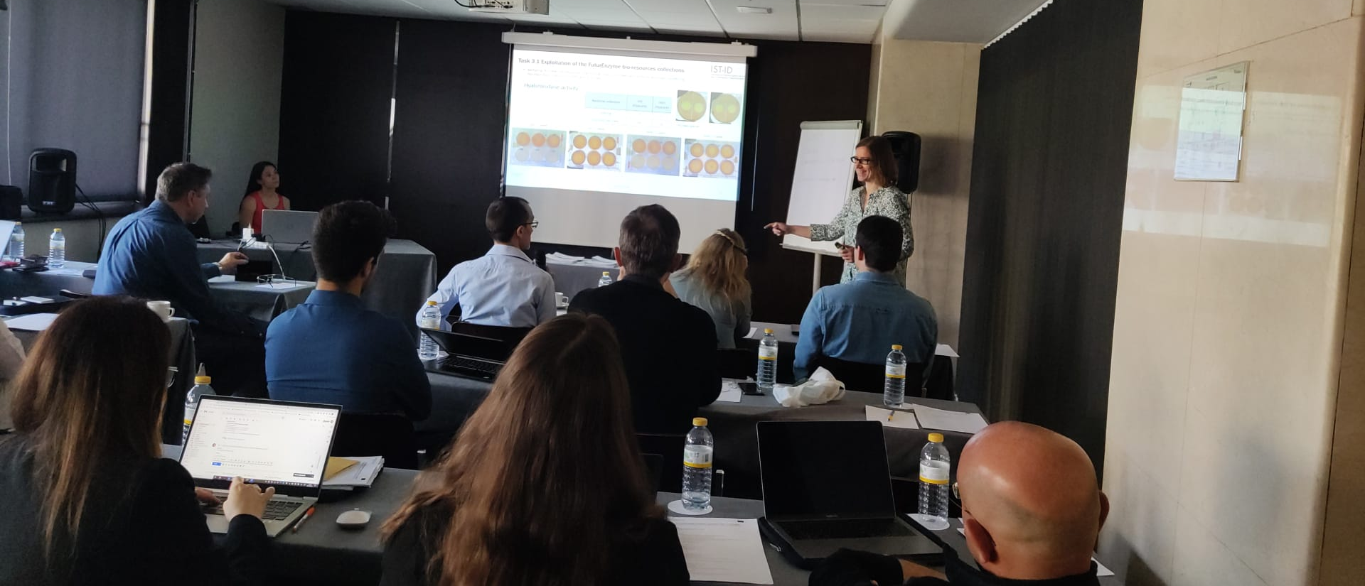
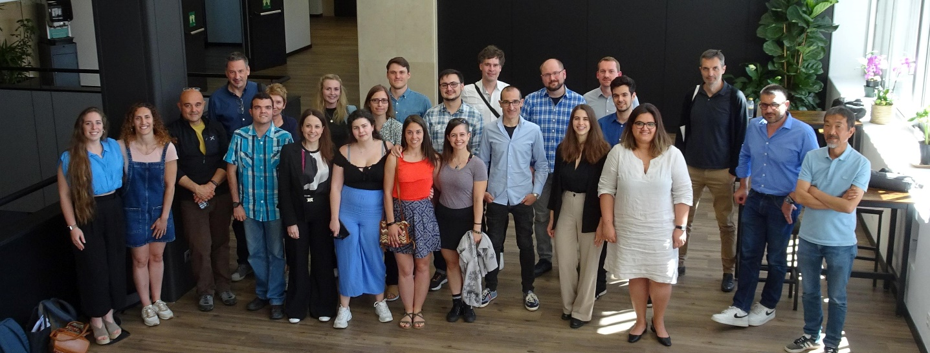
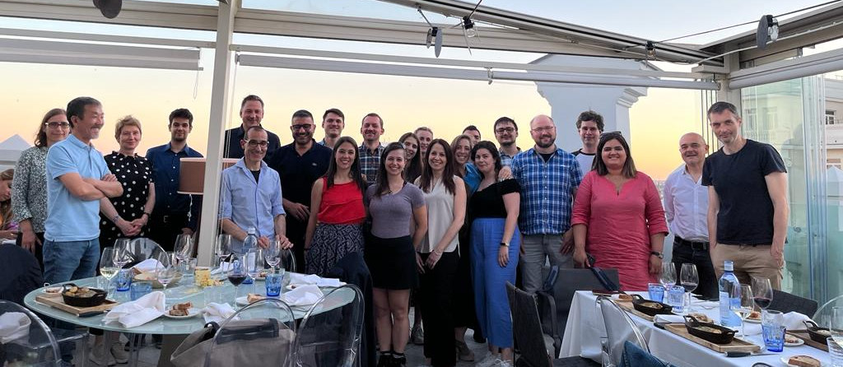

ANNEX I
Exploitation and Innovation Task Force workshop: Slido polls

