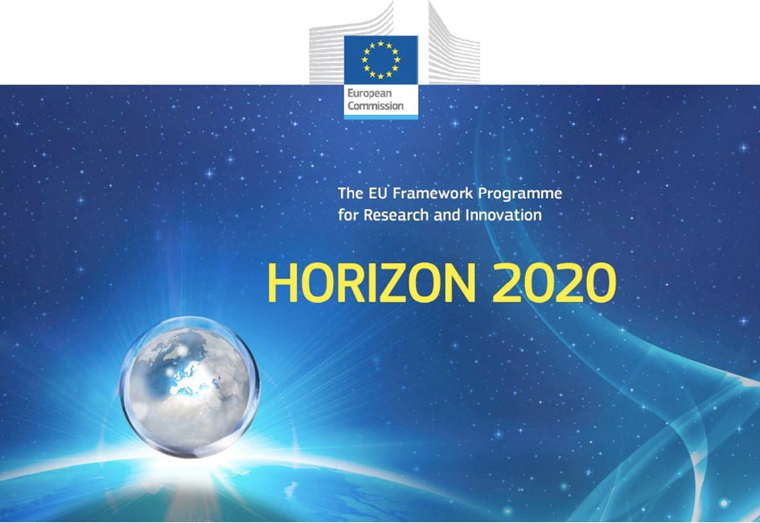

Horizon 2020 Work programme
Food Security, Sustainable Agriculture and Forestry, Marine, Maritime and Inland Water Research and the Bioeconomy
Call
H2020-FNR-2020: Food and Natural Resources
Topic name
FNR-16-2020: ENZYMES FOR MORE ENVIRONMENT-FRIENDLY CONSUMER PRODUCTS

FuturEnzyme:
Technologies of the Future for Low-Cost Enzymes for Environment-Friendly Products Final ID: 101000327

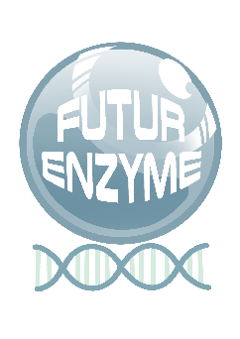
20/07/2021

FUTURENZYME WEBSITE
DELIVERABLE NUMBER D8.1

MANUEL FERRER
CSIC MARIE CURIE 2, 28049 MADRID, SPAIN

Document information sheet

Work package: | WP8, Communication, Dissemination and Exploitation
Authors: | CSIC (Manuel Ferrer, Patricia Molina)
Document version: | 1
Date: | 20/07/2021
Starting date: | 01/06/2021
Duration: | 48 months
Lead beneficiary: | CSIC
Participant(s): | CSIC as main contributor and all partners for providing feedback and suggestions for implementation
Dissemination Level: | Public
Type | Websites, patents filling, etc.
Due date (months) | 2
Contact details: | Manuel Ferrer, mferrer@icp.csic.es; Patricia Molina, patricia.molina@icp.csic.es

Summary
FuturEnzyme website 4
- Introduction 4
- Objectives 4
- Contents 5
- Outcome measure 6
- Screenshots 7

FuturEnzyme website

Introduction
This deliverable consists in the creation of an open website to assure communication towards the outside world, under the URL http://futurenzyme.eu. It is going to be maintained and regularly updated throughout the project in terms of publications, events, members, project meetings, news, etc. The website is going to serve as the main interface for distributing project information and results elaborated in all WPs. In this regard, it contains a private area that serves as repository for all the data sets, deliverables, templates, visual identities, links, videos or any other material of interest for the FuturEnzyme’s Consortium.

Objectives
The website's primary function is to disseminate information about the project activities and results, its achievements, scientific knowledge and list of publications. It is also a platform from which to promote, disseminate and communicate the activities and results of the project and the EU's environmental research efforts. The website, fully in English, contains general information of the project such as objectives, project meetings, events (e.g., conferences, workshops, info days, etc.), videos, reports, information on the members and their corresponding websites, as well as also including all communication materials (project leaflet, brochures, consumer briefs, link to publications, seminars invitations, etc.) which will be open and easily downloadable (when the information is public) for the website visitors.
The website also contains a contact form and email address (info@futurenzyme.eu) where visitors will post requests, interacting and exchanging ideas with the Consortium members and project stakeholders. We will also include a public, non-confidential questionnaire to interested industrial parties throughout the EU to deposit interest into enzyme families and communicate non-confidential requirements. After collecting all the information, a protocol to evaluate and summarize the outcome will be designed in order to define how our project can help solving these requirements and also how we can adapt our strategies to take into consideration relevant needs.
Aside from providing factual and practical information about the project, the website serves also as a secure central file exchange platform and a facility for internal communication and project management: therefore, a part of the website is reserved as an internal workspace for the partners with the aim to share contacts, databases, reports and scientific materials, allowing a strong relationship between partners fitting the current COVID-19 situation and also reducing the environmental impact of extensive travel.
The user-friendly layout format includes the project logo as to create a distinctive and recognisable identity for the publication.
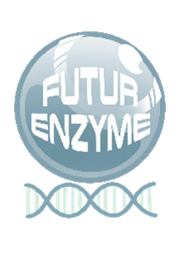
The site is also accessible via QR Code report on all materials produced by the project (intra-Consortium when confidential, public when not). A QR code has been attached to the URL that can be used for all the Consortium members to add in posters, presentations, brochures, etc. TO BE CREATED UPON WEB RELEASE

To drive traffic to FuturEnzyme’s website, the partners will provide a link to the project’s webpage on their organisation's web.

The first draft of the project website was designed and circulated internally on 30/06/21 (the corresponding milestone [MS29] was submitted) and is online since 26/07/21. It has been set up by CSIC and will be managed, maintained, and updated for the duration of the project and for at least 1 year after the completion of the project.

Contents
The sitemap has the following pages structure (for Screenshots, see Section 5):
  - Home (images 1 and 2): i) Project challenge and general context, accompanied by images from the partners; ii) logo and three visual images related to the products to be developed in the project (cosmetics, detergents and textiles); iii) EU logo, seen at first sight, with the following sentence “This project has received funding from European Union’s Horizon 2020 research and innovation programme under grant agreement No 101000327”; iv) Highlights with the three more recent important entries of the web.
  - Objectives (image 3): Specific project targets, accompanied by a scheme representing the FuturEnzyme concept in the context of innovations and goals, and more information about the reasons why FuturEnzyme is a necessary project in the actual climate emergency situation.
  - Work Plan (image 4): Detailed project work packages. A graphical representation of the FuturEnzyme components and how they interrelate is showed.
  - Partners (image 5): Logo of each FuturEnzyme partner. The Read more button opens a full page dedicated to every partner with information of the institution, their involvement in the project and all the members that are a part of FuturEnzyme, with a picture, a short CV and links/contact details. Links to their websites, ORCID and contacts are included.
  - Project Meetings (image 6): Regular Consortium and project-related meetings. The kick-off meeting and several calls held to set and clarify the beginning of the activities are already posted. This section will be constantly updated with a picture of the meeting (on-line or face-to-face), a title and a short description. The newest meetings appear first.
  - News (image 7): Media-gallery, promotion of events, news, press releases, etc. This section will be constantly updated with a title, short description, an image and the necessary links, media material, or documents. The newest entries appear first.
  - Publications (image 8): This page includes three sections: scientific publications, divulgative publications and patents, that will be accompanied of the necessary links and representative images. The more recent publications appear first.
  - Events (image 9): Description of public events (workshops, courses, conferences, etc.) conducted in the frame of the project; description of public events such as demonstration events, science festivals, open days, exhibitions, tours, conferences, workshops, and social events organized outside the consortium and in which project activities are presented. The more recent events are shown first.
All the pages (except the Home that has its own structure) are designed with an image which presides the background while scrolling down. These images belong to the partners and are closely related with the project activities.
Other entries and sections of the webpage are:
  - Networking and Links: (in Homepage) Logo, social media and link to other relevant European projects within the call, such as EnxylaScope, OXIPRO and RadicalZ; other links of interest, such as

European Commission H2020, Paris Climate Conference, European Green Deal, Sustainable Development Goals, EU Policy relevant to FuturEnzyme, Equality Plans of the Partners.
  - Advisory board: (in footpage, image 2) Scientific Advisory Board, Stakeholder, Policymakers, Consumer Organizations, including their web links and social media accounts.
  - Contact details: Coordinator/Project Manager (in footpage, includes a contact form), all members (in the Partners page) and Advisory Board (in footpage).
  - Social Media: (in headline and footpage) LinkedIn, Twitter.
  - Intranet (image 10): internal repository through password for data storage, data and material exchange between partners, etc. It is divided in 4 sections: i) Private data storage (members of the Consortium can upload documents, such as those detailing results, with a password which can only be opened/downloaded by themselves; other partners can see that the document is there but cannot open/download it); ii) shared data (documents from the private storage can be disclosed and transferred to this section, or documents such as data sets can be included with access to all the Consortium); iii) shared material (interesting material from and for all the partners can be included, such as videos, links and minutes of meetings, deliverables, logos, photos, visual identities images, etc.); and iv) shared templates (for deliverables, power point presentations, data sets, etc.). Information of the Partners and documents uploaded is also detailed (All accounts, All profiles).
  - Visitors to website: overall/daily number of website visitors (image 2).
  - Slogans: (Home and others) The slogan or slogans the Consortium wants to mention.
  - Legal information: Cookie policy, privacy policy, and basic information on data protection legal notice (image 2).

All these sections/pages are interconnected between them and redirections to outside links are constantly integrated. For instance, while visiting the partners, one can click on the WP and go directly to the Work plan page to obtain more information, in the Partners page you can find the links to their institutions and groups, in the News section, Press releases, one can by one click go directly to every press note, etc.

Outcome measure
The website activity is going to be monitored by a statistical analyser (Google Analytics) to analyse website hits, page views, downloads and other important indicators to evaluate the website performance and impact.
Comments received, request for information received, or number of specific webpages dedicated to the project on partners' website are also factors to be assessed.

Screenshots
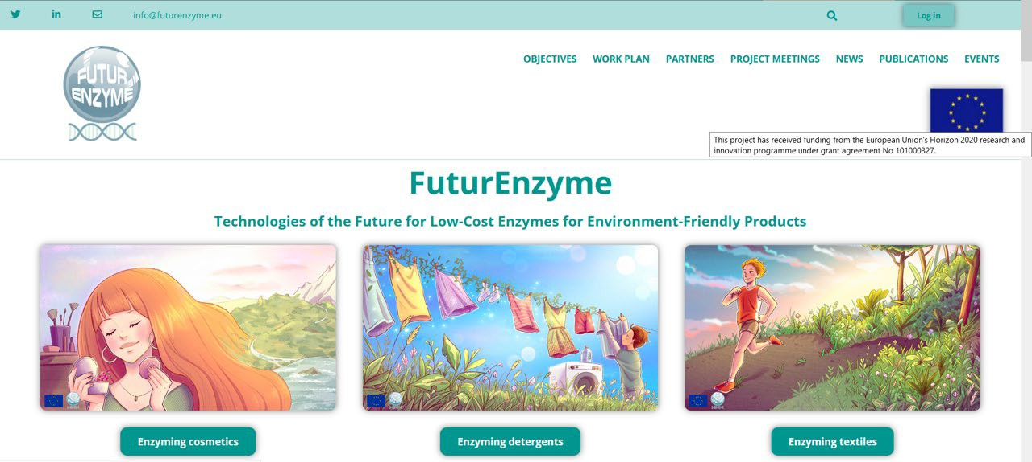
Image 1. FuturEnzyme’s Home webpage. The project logo, 3 visual images related to the products to be developed (cosmetics, detergents and textiles) and the EU logo are seen at first sight. In the upper part, the Log In, Search, contact email and social media can be found.

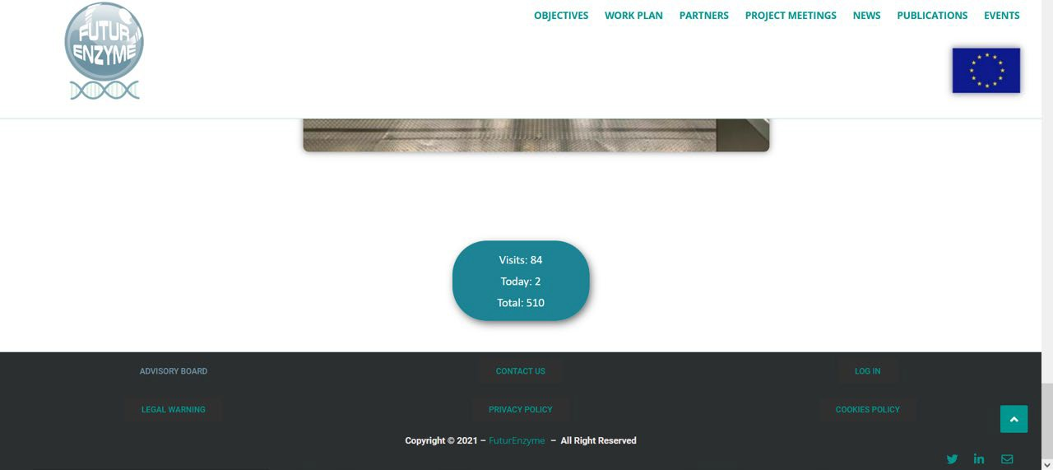
Image 2. Footpage of the website. The links to legal information, Advisory Board, Contact details and Log In pages are located at the end of the main pages. In the Home, also a visitor counter is showed.

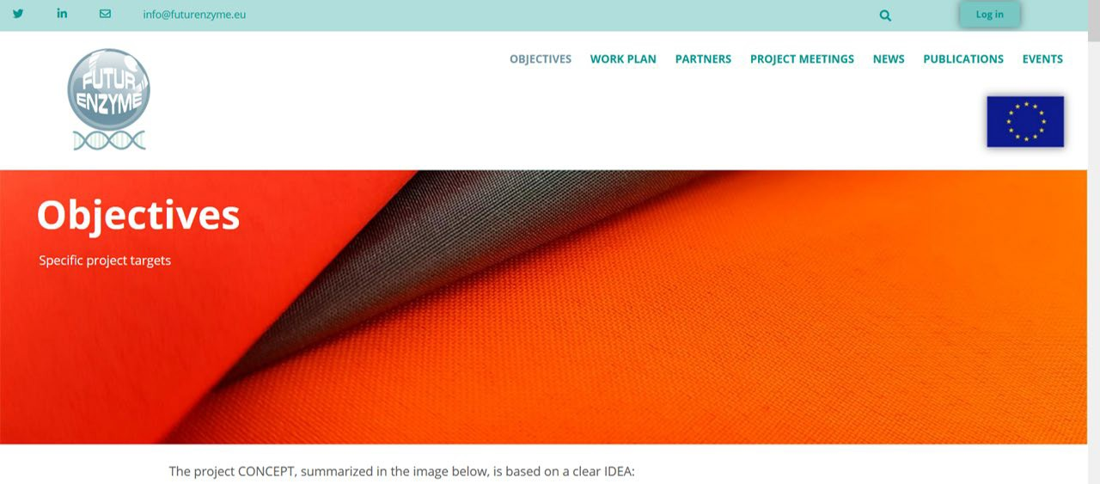
Image 3. FuturEnzyme’s Objectives page.

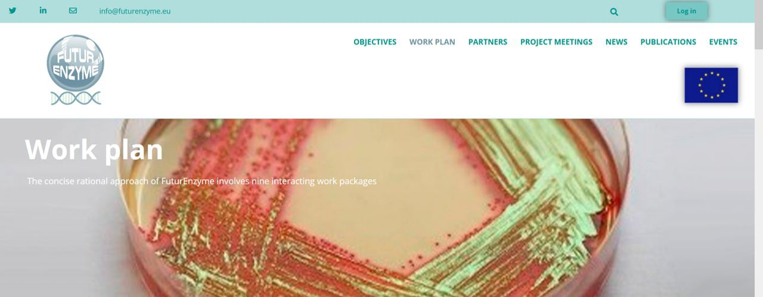
Image 4. FuturEnzyme’s Work Plan page.

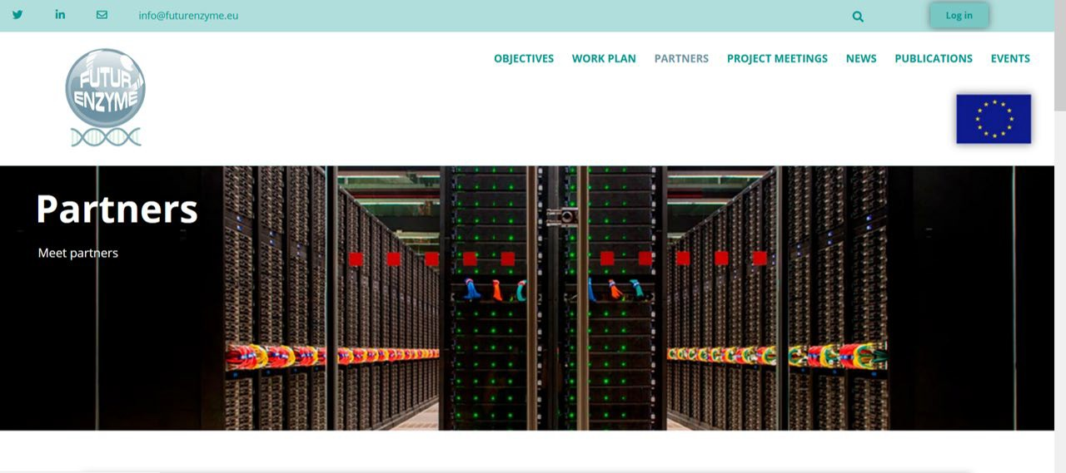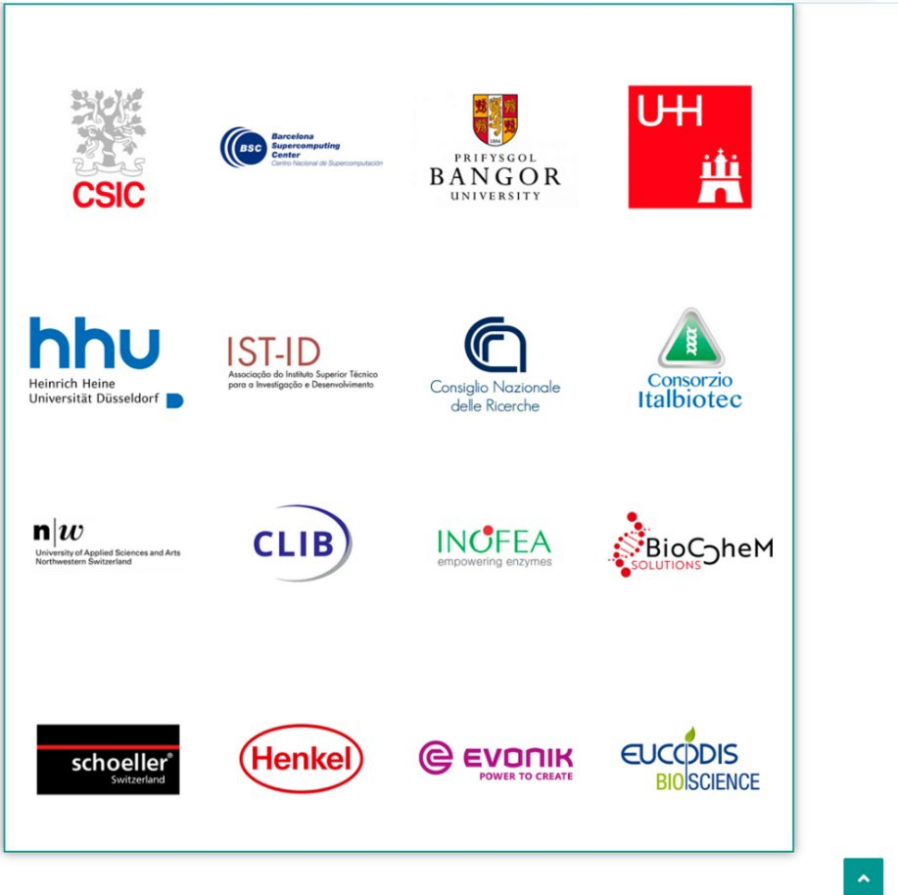
Image 5. FuturEnzyme’s Partners page.

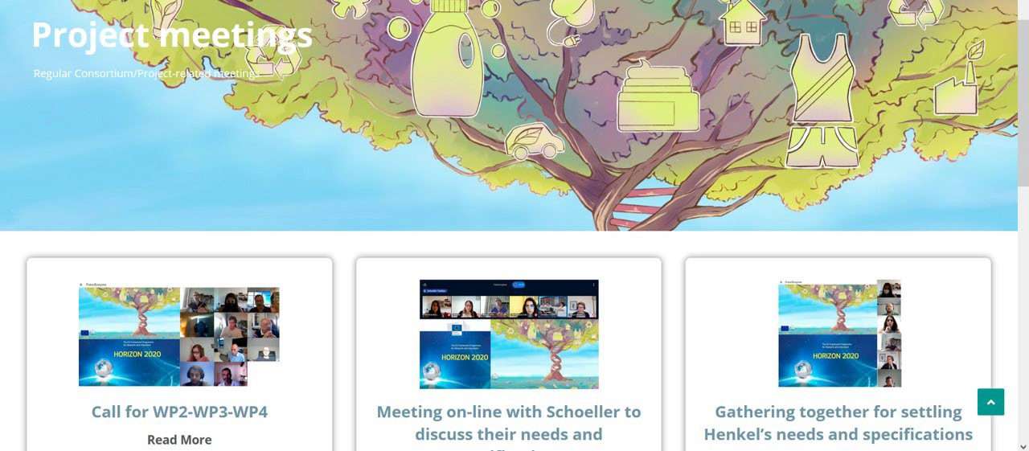
Image 6. FuturEnzyme’s Project Meetings page.

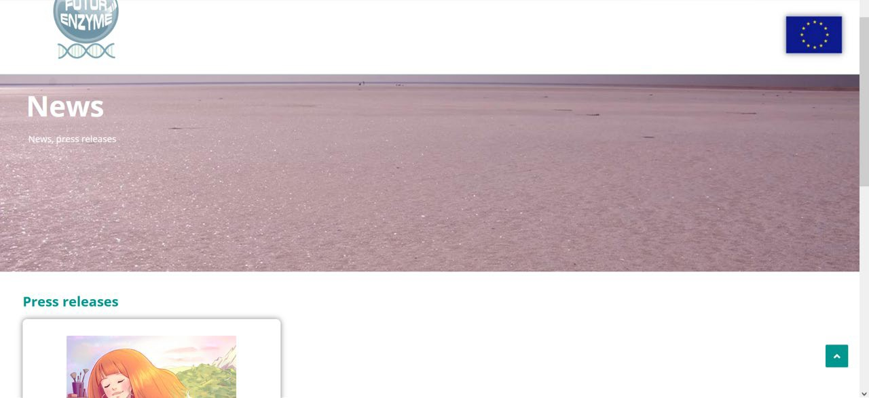
Image 7. FuturEnzyme’s News page.

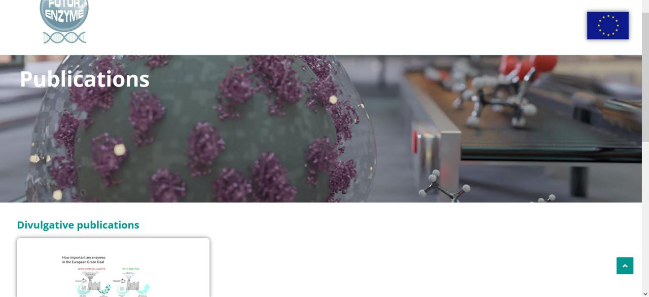
Image 8. FuturEnzyme’s Publications page.

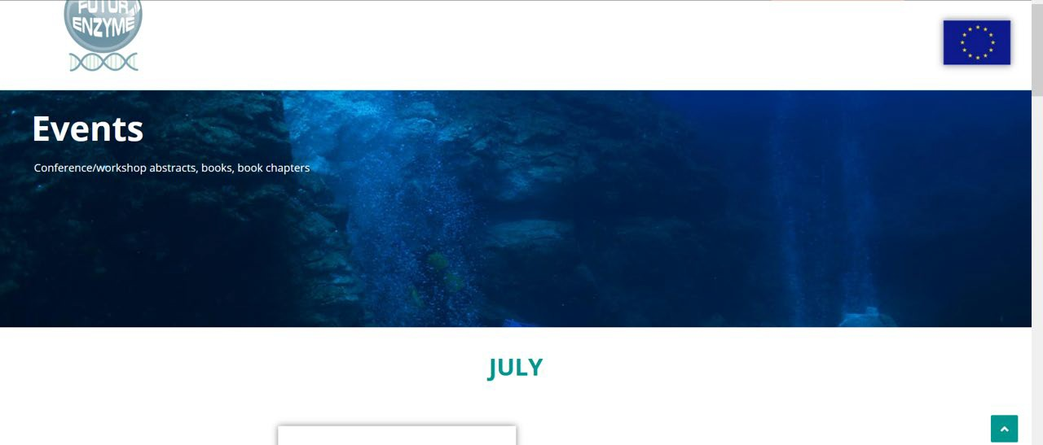
Image 9. FuturEnzyme’s Events page.

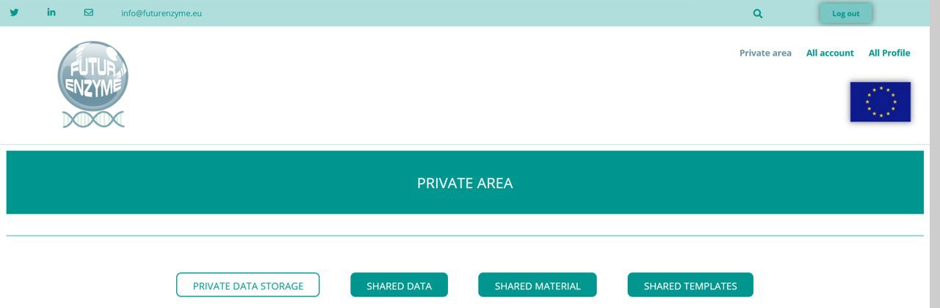
Image 10. FuturEnzyme’s Private area page.

