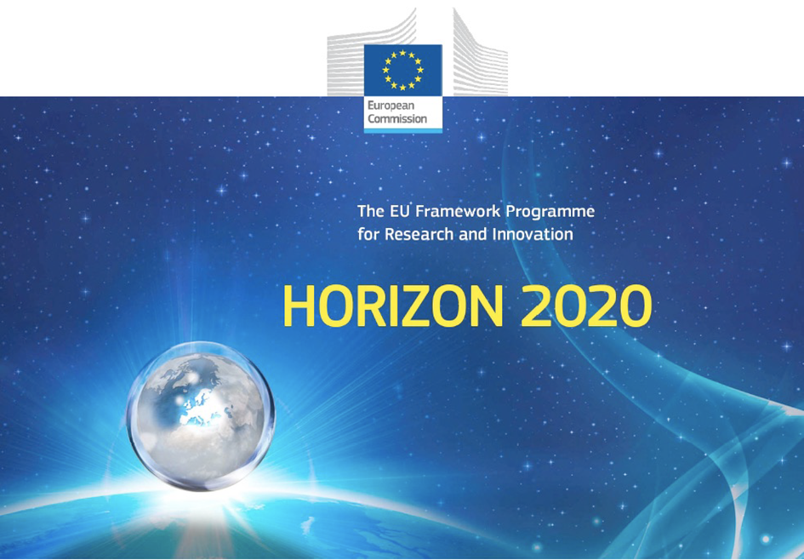

Horizon 2020 Work programme
Food Security, Sustainable Agriculture and Forestry, Marine, Maritime and Inland Water Research and the Bioeconomy
Call
H2020-FNR-2020: Food and Natural Resources
Topic name
FNR-16-2020: ENZYMES FOR MORE ENVIRONMENT-FRIENDLY CONSUMER PRODUCTS

FuturEnzyme:
Technologies of the Future for Low-Cost Enzymes for Environment-Friendly Products
Final ID: 101000327

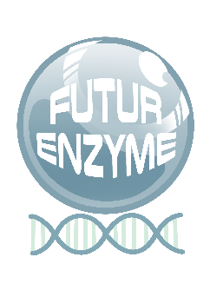
INSERT DATE
Stephan Thies
UDUS
Forschungszentrum JülichWilhelm Johnen Straße, Bldg 15.8, 01/303, 52428Jülich, Germany
Characteristics, first 180 enzymes (WP2-top ones)
MS14

Document information sheet

Work package: | WP4, Small-scale enzyme production and characterisation
Authors: | UDUS (Stephan Thies), CSIC (Manuel Ferrer, Patricia Molina)
Document version: | 1
Date: | XXX
Starting date: | 01/06/2021
Duration: | 40 months
Lead beneficiary: | UHAM
Participant(s): | CSIC, Bangor, UDUS, IST-ID, CNR, FHNW, Bio_Ch, Eucodis
Dissemination Level: | -
Type | -
Due date (months) | 12
Contact details: | Stephan Thies, s.thies@fz-juelich.de; Manuel Ferrer, mferrer@icp.csic.es

Summary
1
Document information sheet 2
Title 4
1.Title 1 (SCOPE of DELIVERABLE) 4
2. Title 2 4
3. Title 3 4
4. Title 4 4
5. Title 5 4

CHARACTERISTICS, FIRST 180 ENZYMES (WP2-TOP ONES)

1.SCOPE of DELIVERABLE

Data available – this milestone will attest the realisation and availability of the characteristics of the 180 enzymes selected as prioritary targets

2. Title 2

3. Title 3

4. Title 4

5. Title 5

