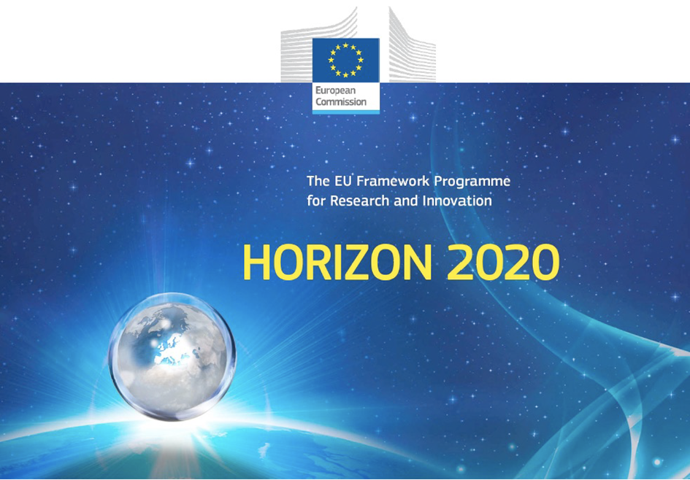

Horizon 2020 Work programme
Food Security, Sustainable Agriculture and Forestry, Marine, Maritime and Inland Water Research and the Bioeconomy
Call
H2020-FNR-2020: Food and Natural Resources
Topic name
FNR-16-2020: ENZYMES FOR MORE ENVIRONMENT-FRIENDLY CONSUMER PRODUCTS

FuturEnzyme:
Technologies of the Future for Low-Cost Enzymes for Environment-Friendly Products
Final ID: 101000327

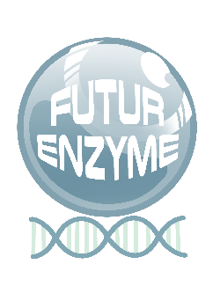
23/11/2021
Peter Golyshin
bangor
College Road, Bangor LL57 2DG, United Kingdom
First round of sequencing completed
MS10

Document information sheet

Work package: | WP3, Activity-based bio-prospecting for enzymes
Authors: | Bangor (Peter Golyshin), CSIC (Manuel Ferrer)
Document version: | 1
Date: | 23.11.2021
Starting date: | 01/06/2021
Duration: | 36 months
Lead beneficiary: | Bangor
Participant(s): | CSIC, Bangor, UHAM, UDUS, IST-ID, CNR
Dissemination Level: | -
Type | Report, materials
Due date (months) | 6
Contact details: | Peter Golyshin (p.golyshin@bangor.ac.uk), Manuel Ferrer (mferrer@icp.csic.es)

Summary

FIRST ROUND OF SEQUENCING COMPLETED 4
1. Scope of the Milestone 4
2. Methodology and Results 4

FIRST ROUND OF SEQUENCING COMPLETED

1. Scope of the Milestone
Data available – this milestone will attest to the realisation of the sequencing of the first selected bioresources found to be positive in the screen tests.

2. Methodology and Results
By applying a number of protocols extensively described in the deliverable D3.2, a number of bio-resources (enzymes, clones, microbes, microbial communities) were selected for sequencing. In details:
382 new bio-resources (strains: 191; clones: 3; pure enzymes: 188) were found positive for activities:
- Hydrolases (esterase/lipase/cutinase): 134
- Hydrolases (proteases): 48
- Hyaluronidases: 3
- Oxidoreductases: 58
- Others (proteases, amylases, etc.): 139
Sequence datasets have been generated/available for:
- Positive strains Thermoleophilum album (hydrolase +)
- Positive strain Halorhabdus sp. SivX81 (hyaluronidase +)
- Positive strain Xylanivirga thermophile (hydrolase +)
- >250 Gbp data available from microbiomes of plastic colonisers
- 180 Mbp data available from microbiomes of surface seawater
- 200 Gbp sequencing data of microbiomes from anaerobic bioreactors
- Sequencing data from biogas microbiome
Currently, the sequences are available at the laboratories of the partners performing the selection and sequencing, and soon will be made available at the intranet’s project website and the intranet’s repository at the Barcelona Supercomputing Center (BSC).

