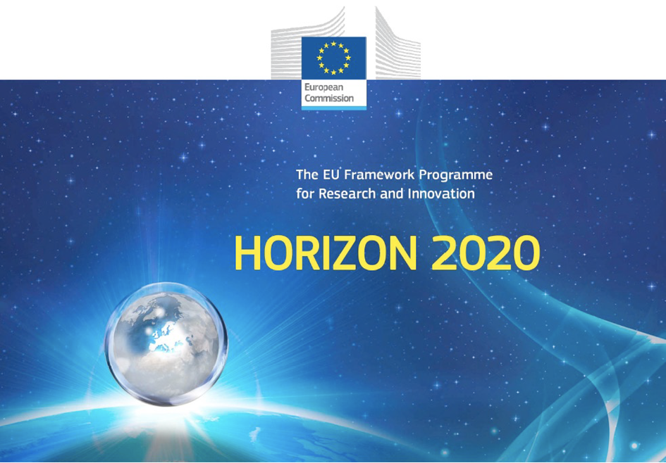

Horizon 2020 Work programme
Food Security, Sustainable Agriculture and Forestry, Marine, Maritime and Inland Water Research and the Bioeconomy
Call
H2020-FNR-2020: Food and Natural Resources
Topic name
FNR-16-2020: ENZYMES FOR MORE ENVIRONMENT-FRIENDLY CONSUMER PRODUCTS

FuturEnzyme:
Technologies of the Future for Low-Cost Enzymes for Environment-Friendly Products
Final ID: 101000327

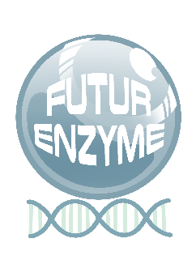
30/05/2023
manuel ferrer
csic
marie curie 2, 28049 Cantoblanco, Madrid, Spain
FE_CSIC_D8.12_Short promo video or comic
D8.12

Document information sheet

Work package: | WP8, Communication, Dissemination and Exploitation
Authors: | CSIC (Manuel Ferrer, Patricia Molina)
Document version: | 1
Date: | 30/05/2023
WP starting date: | 01/06/2021
WP duration: | 48 months
WP lead beneficiary: | ITB
WP participant(s): | CSIC as main contributor and all partners for providing feedback and suggestions for implementation
Deliv lead beneficiary: | CSIC
Dissemination Level: | Public
Type | Websites, patents filling, etc.
Due date (months) | 24
Contact details: | Manuel Ferrer (mferrer@icp.csic.es), Patricia Molina (patricia.molina@icp.csic.es)

Summary

Short promo video/ comic 4
1. Scope of deliverable 4
2. The making of 4
2.1. Video 4
2.2. Comic 5
3. Conclusion 7

Short promo video/ comic

1. Scope of deliverable
This deliverable consists in at least one short promo video and a comic to maximize the FuturEnzyme dissemination, exploitation and communication impact towards a broad audience. This material will be available through the website, as well as through all communication and dissemination channels established during the project.

2. The making of
The idea is to produce divulgative materials in which we present FuturEnzyme’s moto, workflow and targets. This deliverable has suffered a slight delay of around two months, according to our estimation. In the case of the video, it was complicated to find to fit the budget with the idea we want for the video. Finally, we have found a nice solution that combines quality and a suitable price (so that to respect the principle of best value for money when outsourcing this service). The idea of adjusting the budget was also considered with the idea of producing several videos over the life of the project. Regarding the comic, agenda issues have prevented us to start sooner. In both cases, a script was set months ago.

2.1. Video
Our aim is to produce a realistic animated video. After a thorough search we have found Design Cells, who create very realistic and science-precise videos with an impressive relation quality/price. The work has officially started, with the first part approved for high-resolution production.
The video is meant to last 2 minutes, divided in 5 parts that can be later combined separately, for instance, to make posts in social media. The tentative script of the video, which can be revised during the production process or after the first draft has been finalised and reviewed by the partners, is as follows:
Part I. Intro ̴25 seconds
Today’s world: climate change. Images of contaminated water with industry/household spills, mountains of disposed textiles, plastics, fabrics contaminating. Images of wash machines were we add some amount of liquid detergent which after used are disposed to water circuit.
Text/voice: How to revert this while keeping our way of life? One essential solution is the use of enzymes.
Images of environmental sites from which microorganisms can be isolated, their genomes sequenced and analysed by supercomputers to identify the enzymes we search for, which can be later synthesized, produced and tested. After that, arrows pointing to their application in the three sectors: textiles, detergents, cosmetics.
Text/voice: Enzymes are natural macro-molecules capable of performing all the amazing reactions that allow life, so we can learn from them to “pamper” our planet Earth.

Part II. Textiles ̴25 seconds
Note: For textile, the utilization of enzymes in the textile production unit can have an effective impact to save energy, time and water and reduce CO₂ emissions in three steps, namely, the removal of the spinning oils during the solvent cleaning step, the removal of the dyes after the dyeing/fixing of the textile materials, and the degradation of textile waste after the end-use. The textile’s complexity, in the base material used and different oils & dye recipes & variants in color, make it quite complex to find only one enzyme in their removal and discoloration and neutralization of the wastewater.

Transition with text/voice: come with us to see how we can help to make the world green again
Zooming from a textile production unit to the textile image into the clothes: an enzyme that once dissolved in water can remove the spinning oils and dyes that remains in the surface of the textile materials during the different processing steps. Then, it is showed how at the end of life of the garment, our enzymes can degrade the textiles to avoid their accumulation in the environment.

Part III. Detergents ̴25 seconds
Note: For detergent, developing new and improved enzymes, such as lipases, which help to remove fatty stains at low wash temperatures (20-30°C) give the consumers new opportunities to reduce the carbon footprint and the energy needed for heating the water during laundry. However, it is very challenging to a) identify new enzyme candidates, which bring new and promising properties, and b) to evaluate if these wild type enzymes are applicable for our target.

Zooming from the detergents image into the washing machine’s drum/tub: an enzyme “eating” grease dirt that easily gets out of the fabrics and disappears. Showing that the water temperature is low and that with enzymes, the amount of chemicals used in the final composition are reduced, delivering cleaner water to the environment.

Part IV. Cosmetics ̴25 seconds
Note: For cosmetic, enzymes (hyaluronidases) can have an effective role in hydrolyzing the long hyaluronic acid in a short-defined molecule that is key to the production of anti-ageing cosmetics. However, it is not so easy to find an enzyme that cuts this very long molecule into small pieces of a defined size with highest anti-ageing properties. The complexity of the products to be implemented together with the bottlenecks in selecting the best enzymes from all the millions available in nature are the biggest challenges.

Zooming from the cosmetics image into the hyaluronic acid’s cream container: big hyaluronic acid polymer being cut by enzymes into smaller hyaluronic acid polymers (explaining by text or voice that other sizes are not so effective or can produce immune responses). Then zooming again from the cosmetics image into epithelial cells. A short hyaluronic acid molecule penetrating into the interstitial space (other bigger hyaluronic acid molecules try unsuccessfully) where it can be seen the beneficial effect of this active principle in the skin and how it unwrinkles the skin (hyaluronic acid retains water in a percentage of thousands-fold its weight, helping to rebuild the fibres that sustain the skin tissues; hyaluronic acid occupies the space that leaves the lost collagen and stimulates its production).

Part V. Final scene ̴20 seconds
Transition with text/voice: we aim at implement our awesomenzymes in these everyday products and carry them to the edge of biotechnology to be applied in industrial processes
FuturEnzyme’s world: by the use of our enzymes in everyday products, factories throw clean fumes, rivers are clear, no trash everywhere, nature is “happy”.
Final image: FuturEnzyme’s tree image with the slogan Greening the world through enzymes (it can also be accompanied by voice). The partners, the funding.

2.2. Comic
The chosen illustrator is Ainhoa Quirós. She already produced visual materials for us, such as the project’s logo and 5 images that we use in the brochures, website, and other materials (see Deliverable D8.2_Visual identity guidelines).
The length of the comic is around 15 strips. It is meant to be spread mostly by digital media. It will be designed in such a way that different parts can be used separately as in the case of the video. Some of the comic characters are going to be inspired by the image of some of the members of the consortium (already have agreed for their image to be used with this purpose). The tentative text accompanying the comic strips is:

Introduction
There are products on the market whose daily consumption contributes globally to worsening climate change and pollution. As example, the world average temperature has risen more than 1°C in only the last two decades! Some industries are continuously working to make their products more efficient and environmentally friendly. This requires collaboration between research centers, universities, industries and consumers, to continue pursuing a 100% sustainable model.
An essential innovation for this goal is the use of enzymes, proteins found in all living beings. They are eco-ingredients and we have learned to extract, improve and use them in multiple sectors and products that are key in circular economy. In fact, today, thousands of enzymes are available on the market, the global production of which reaches 117 kilotons per year.
But we need more enzymes, better than those available on the market, with which to develop products that meet increasingly stringent environmental and quality standards. Come with and learn how we can green the world through enzymes.
Research
1.1_Our planet is dwelled by 1 trillion (10¹²) microbial species, living in very diverse environments, some of them really extreme. So…we have work to do! First, we take samples from extreme environments, such as deep sea, salty, sulfurated or volcano surroundings, always being very careful not to damage the place!
Bubble: “Got you!” o “Gotcha!”
1.2_From these samples, we can analyze the microorganisms on them, but also the metagenome, fragments of genetic material (DNA) belonging to the living microscope living beings on them.
1.3_Making use of advanced computational methods, we can obtain the enzymes coded in the metagenome sample. Moreover! We can use these disruptive technologies to obtain our enzymes of interest from databases containing millions of such sequences. Another possibility is to improve them by predicting beneficial variations for the application in mind.
1.4_Once we have integrated all this knowledge, we can infer from it some enzyme candidates, that we check on the lab: we produce the enzymes using our favourite expression microorganism and test their activities for the target application.
Bubble: This is science, not magic, so sometimes we try and try… and in the end… we disclose our hit!
2.1_Now is time to produce our hits in bigger amounts, so they can be tested in real processes. We use fermenters of several liters that produce our enzymes at gram scale.
Bubble: grams can seem like a small quantity, but in our body we have less than 1 kg of enzymes performing thousands of functions!
2.2_Cosmetic industry can incorporate enzymes, for instance, in the production of very precise size molecules, such as hyaluronic acid (HA). In this way, the process is greener and the efficiency of the HA is improved to make our skin glow.
2.3_A very spread application of enzymes in households is laundry detergents. Enzymes can replace other contaminant chemicals in the formulation and allow the use of cold water for efficient cleaning.
Bubble: Check your laundry detergent bottle, for sure you find enzymes in the ingredients list!
2.4_Textiles, we cannot live without them! Introducing enzymes in their manufacturing can for instance diminish the amount of water used in their production, or provide them with interesting properties.
Bubble: Enzymes can also “eat” the garments once they are disposed so they can be recycled!
The performance of our hits in the real application can be satisfactory or not. In the latter case, the manufacturers provide information of the problem to all the previous phases, so we can keep improving our enzymes. With this positive feedback we ensure the best possible results.
Application
3.1, 3.2, 3.3_And, finally, you can enjoy your daily use products as always. Well, wait, not as always! With enzymes involved, consumer products and other goods can gain is innovation while reducing the damage to nature. Other industries that can benefit from enzymes are automotive sector, energy (biofuels for example), agriculture and forestry, and building, chemical (bioplastics for example), pharma, and food and beverage industries.

3. Conclusion
In sight of the delay to accomplish this deliverable on time, we contacted in advance with the Project Officer via the Communication section of the EU portal to let her know. After providing the explanations listed in this document, the delay was allowed. We believe that this small postponement will not have negative consequences on the project and will give us the possibility to make several videos throughout the project as we have found more economical and high-quality graphic options.

