Horizon 2020 Work programme
Food Security, Sustainable Agriculture and Forestry, Marine, Maritime and Inland Water Research and the Bioeconomy
Call
H2020-FNR-2020: Food and Natural Resources
Topic name
FNR-16-2020: ENZYMES FOR MORE ENVIRONMENT-FRIENDLY CONSUMER PRODUCTS

FuturEnzyme:
Technologies of the Future for Low-Cost Enzymes for Environment-Friendly Products
Final ID: 101000327

31/03/2023
First set of lead enzymes
at multi-gram scale
MS20
jan modregger
eucodis
Viehmarktgasse 2 A 2
OG Campus Vienna Biocenter II, Wien 1030, Austria

Document information sheet

Work package: | WP6, Development and supply of best enzyme prototypes
Authors: | Eucodis (Jan Modregger)
Document version: | 1
Date: | 31.03.2023
Starting date: | 01/09/2022
Duration: | 32 months
Lead beneficiary: | Eucodis
Participant(s): | Eucodis, CSIC, IST-ID, ITB, CLIB, Inofea, Bio_Ch
Dissemination Level: | Confidential, only for consortium's members (including the Commission Services)
Type | Report
Due date (months) | 22
Contact details: | Jan Modregger (modregger@eucodis.com)

Summary

First set of lead enzymes at multi-gram scale 4
1. Introduction and brief summary of outcomes 4
2. Methodological set-up 4
2.1 Lead candidates for heterologous expression in Pichia 4
2.2 Secreted expression in Pichia 4
2.3 Production of lead enzymes in native hosts 5
3. Results 5
3.1 Activity tests after heterologous expression in Pichia 5
3.2 SDS-PAGE analysis after heterologous expression in Pichia 6
3.3 Production of lead enzymes in native hosts 7
4. Summary: Secreted expression in Pichia 7
5. Next step 7

First set of lead enzymes at multi-gram scale

1. Introduction and brief summary of outcomes
Report available – this milestone attests the realization of the first production batches at gram scale for lead enzymes to be used for pre-industrial validations. Different deliverables have been accomplished from which the present milestone nourishes. To be mentioned the Deliverable 5.1 that detailed the best enzymes nominated for WP5 (genetic and supramolecular engineering), WP6 (large scale production) and WP7 (pre-industrial validations). Among the priority candidates, a number of those, for which information has been provided verifying compliance with Nagoya protocol, were selected for expression in Pichia pastoris and first production batches at gram scale. Based on the results gathered by the partners and summarized in the present document, Milestone 20 “First set of lead enzymes at multi-gram scale”, can be considered achieved.
In summary, expression systems in P. pastoris has been done for 8 lead enzymes, that included the following steps: gene design and synthesis, sequence/codon optimization for P. pastoris, addition of secretion signals, cloning into Eucodis plasmids, transformation into P. pastoris cells and selection of zeocin plates for multiple integration events. After expression activity tests confirmed the presence of enzyme activity. For that we used 24-well expression systems, induction with methanol and actvitiy based screening with appropiated substrates. Finally, expression analysis by SDS-PAGE was done. To date, expression systems in P. pastoris are available for 8 lead enzymes, and others are in progress. In addition to that, enzyme samples of the two native strains containing lead hyaluronidases are being produced 2L-fermentation cultures.

2. Methodological set-up

2.1 Lead candidates for heterologous expression in P. pastoris
Highest priority enzymes cloned into P. pastoris are listed in Table 1.
Table 1. Highest priority enzymes cloned into P. pastoris for their expression and production at large.
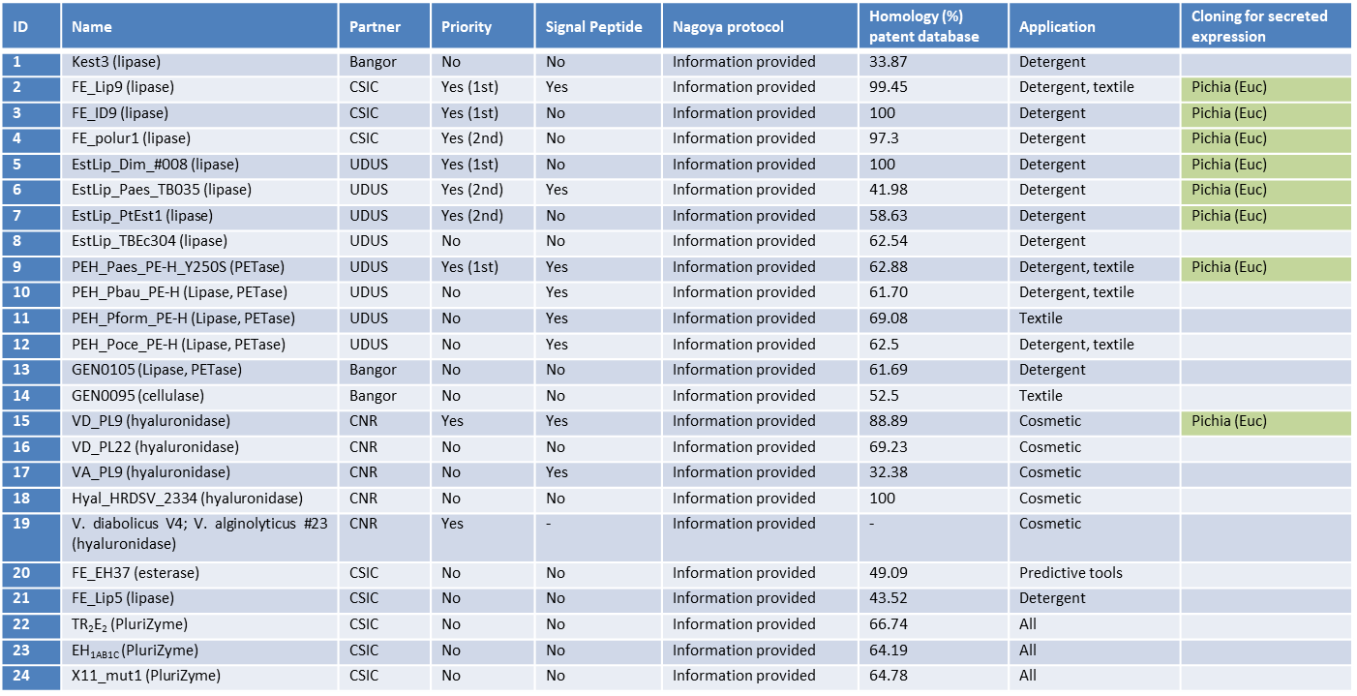

2.2 Secreted expression in P. pastoris
Pichia pastoris was used, by partner Eucodis, to produce at gram scale the lead enzyme candidate. For that, the following steps were considered:
- Gene design and synthesis
- Sequence/codon optimization for P. pastoris
- Addition of secretion signals (used for 1st round: α-mating factor, OST1)
- Synthesis of genes at external provider, cloning into Eucodis plasmids (pPichia57ost1)
- Transformation into P. pastoris cells
- Selection of zeocin plates for multiple integration events
- Lipase activity screening:
- 24-well expression
- Induction with methanol
- Activity based screening with pNP-butyrate
- Expression analysis:
- Expression analysis by SDS-PAGE

2.3 Production of lead enzymes in native hosts
Apart from the lead enzymes detailed in 2.1 and 2.2 sections, two additional native strains found to contain hyaluronidases with lead characteristics were cultivated at large, so produce enzyme materials to be shared with consortium partners. Below the strains and cultivation conditions are detailed.
Cultivation conditions for two HA-positive halo(natrono)philic prokaryotes:
- Neutro-halophilic haloarchaeon Natronarchaeum sp. Hhyl (98.98% 16S rRNA gene identity to Natronarchaeum rubrum). Genome sequenced, annotated and curated (one chromosome and three plasmids).
The NaCl base medium, pH 7.4, containing (g L⁻¹): NaCl – 240; KCl – 5, K₂HPO₄ – 2; NH₄Cl – 0.5 was used for cultivation of Natronarchaeum sp. Hhyl. After sterilization in autoclave, the basic media were supplemented with 1 mM MgCl₂ x 6H₂O, 1 ml L⁻¹ of acidic trace metal solution and vitamin mix 1 mL L⁻¹ of alkaline Se/W solution and 50 mg L⁻¹ of yeast extract. Hyaluronic acid (35KDa) from Evonik and cellobiose (CB) both 0.2% w/w and/or only 0.2% hyaluronic acid (35KDa) from Evonik was used as the carbon and energy source (c). Cultivation was performed in microbial incubator at 37°C with permanent shaking (100 rpm) for at least two weeks.
- Neutro-halophilic alphaproteobacterium Paracoccus sp. AB-hyl4. Genome is not yet sequenced, but will be done soon.
Paracoccus sp. AB-hyl4 is not a halophilic archaeon, but rather is a pure soda bacterium. Its optimum for growth is 1 M Na⁺ in a purely carbonate medium with pH 9.5. So, to prepare the optimized haloalkaline medium with total salinity of 160 g L⁻¹, two stock solution were initially made:
SOLUTION 1 (0.6M Na⁺): pH 9.5 containing (g L⁻¹): Na₂CO₃ – 15; NaHCO₃ - 20; NaCl – 3; K₂HPO₄ – 1.
SOLUTION 2 (2M Na⁺): pH 9.5 (containing g L⁻¹): Na₂CO₃ – 62; NaHCO₃ - 46; NaCl – 18; K₂HPO₄ – 1; HCl (50%) – 2.5 ml L⁻¹.
After sterilization, both solutions 1 and 2 were mixed in ration 7:3, respectively, and the prepared alkaline medium was further supplemented with 1 mM MgCl₂ x 6H₂O, 1 ml L⁻¹ of acidic trace metal solution and vitamin mix, 1 mL L⁻¹ of alkaline Se/W solution and 100 mg L⁻¹ of yeast extract. Hyaluronic acid (35KDa) from Evonik and cellobiose (CB) both 0.2% w/w and/or only 0.2% hyaluronic acid (35KDa) from Evonik was used as the carbon and energy source (c). Cultivation was performed in microbial incubator at 37°C with permanent shaking (100 rpm) for at least two weeks.

3. Results

3.1 Activity tests after heterologous expression in P. pastoris
Up to date, individual clones screened in p-nitrophenyl butyrate (pNP-butyrate) assay. As shown in Figure 1, all lead lipases except FE-ID9 show good to excellent activity in the supernatant (time course of pNP release shown).
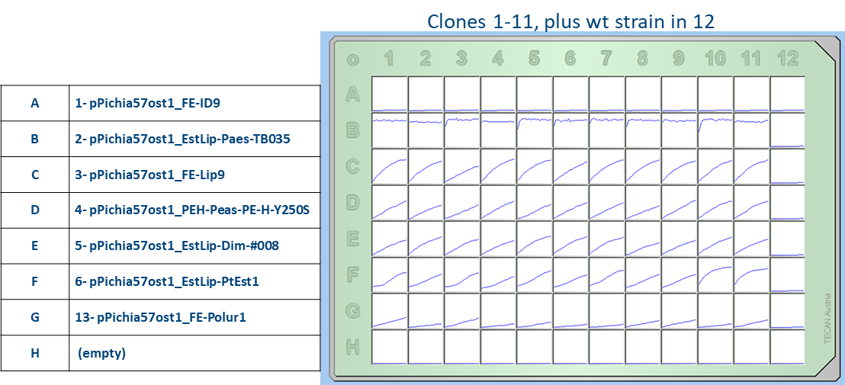Figure 1. Time course of pNP release from pNP-butyrate when supernatants of selected 11 expression systems were tested.

3.2 SDS-PAGE analysis after heterologous expression in Pichia
A sub-set of 2-3 clones of each construct (see Figure 1) were analyzed for expression. For that, supernatants were 10x concentrated via 10 kDa cut-off, and 10 µL of the resulting concentrated solutions were loaded into a 12% TGX-Gel. A shown in Figure 2 and Figure 3, positive expression was achieved in most cases.
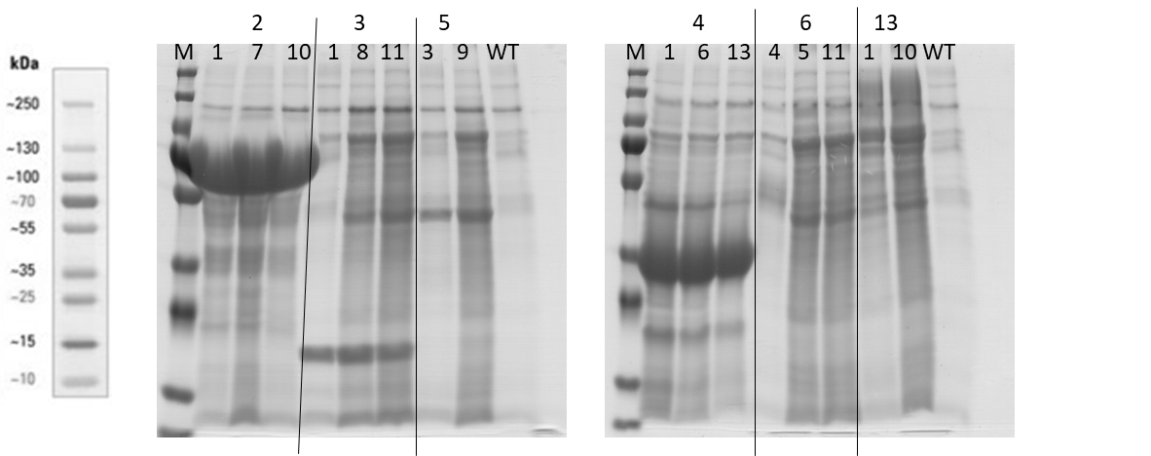Figure 2. SDS-PAGE analysis of supernatant of each construct. Lane 2, pPichia57ost1_EstLip-Paes-TB035 (~ 56 kDa); lane 3, pPichia57ost1_FE-Lip9 (~ 22 kD); lane 4, pPichia57ost1_PEH-Peas-PE-H-Y250S (~30 kDa); lane 5, pPichia57ost1_EstLip-Dim-#008 (~ 43 kD); lane 6, pPichia57ost1_EstLip-PtEst1 (~ 39 kDa); lane 13, pPichia57ost1_FE-Polur1 (~ 67 kDa).

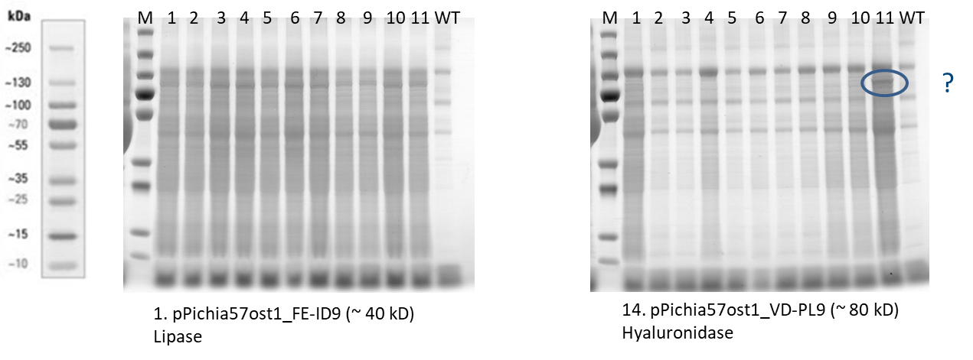Figure 3. SDS-PAGE analysis of supernatant of each construct. Left gel, pPichia57ost1_FE_ID9 (~ 40 kDa); right gel, pPichia57ost1_VD-PL9.

3.3 Production of lead enzymes in native hosts
Currently, partner CNR setup 2L-fermentation cultures of the neutro-halophilic haloarchaeon Natronarchaeum sp. Hhyl and neutro-halophilic alphaproteobacterium Paracoccus sp. AB-hyl4. Once the fermentation is completed, the supernatant will be concentrated in an Amicon chamber with low molecular weight cut-off, so that to provide a concentrate enzyme sample to consortium partners. Note, that these two strains have been recently selected as lead hyaluronidase-containing native strains.

4. Summary: secreted expression in P. pastoris
Based on the experimental setup and the results obtained, briefly summarized in this document, basically all lipases except FE_ID9 can be expressed well into the supernatant, and we will start now with fermentations of those. The lipase FE_ID9 does not express in P. pastoris with the OST1 signal peptide, so we will test different signal peptides. The hyaluronidase VD_PL9 seems to show some expression, one clone also a bit stronger, so that we will look at some more clones there. Activity screening of supernatant will be performed to confirm the presence of hyaluronidase activity. Table 2 summarizes the enzymes tested and successfully expressed in P. pastoris. In addition, enzyme samples of two native strains (neutro-halophilic haloarchaeon Natronarchaeum sp. Hhyl and neutro-halophilic alphaproteobacterium Paracoccus sp. AB-hyl4) producing lead hyaluronidases are being produced in 2L-fermentation cultures.
Table 2. List of enzymes successfully expressed in P. pastoris.
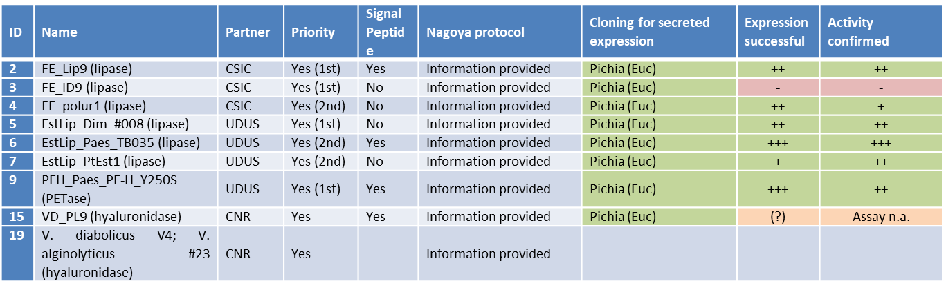

5. Next step
For all lead lipases tested active, fermentation in 1 L scale will be undertaken and the lipase samples will be provided to consortium partners. For the VD_PL9 hyaluronidase, more clones will be tested to confirm expression and through the establishment of assays in house best expression clones will be selected to supply enzyme samples to consortium partners. Finally, enzyme samples of the two native strains containing lead hyaluronidases will be completed and send to consortium partners.

