Horizon 2020 Work programme
Food Security, Sustainable Agriculture and Forestry, Marine, Maritime and Inland Water Research and the Bioeconomy
Call
H2020-FNR-2020: Food and Natural Resources
Topic name
FNR-16-2020: ENZYMES FOR MORE ENVIRONMENT-FRIENDLY CONSUMER PRODUCTS

FuturEnzyme:
Technologies of the Future for Low-Cost Enzymes for Environment-Friendly Products Final ID: 101000327

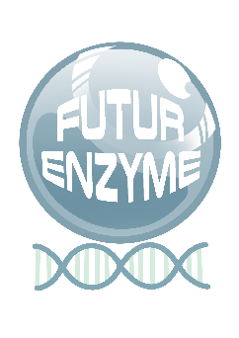
29/07/2021

BIO-RESOURCES PREPARED AND
EXCHANGED
DELIVERABLE NUMBER D3.1

PETER N. GOLYSHIN
BANGOR GWYNEDD, LL57 2DG, UNITED KINGDOM

Document information sheet

Work package: | WP3, Activity-based bio-prospecting for enzymes.
Authors: | BANGOR (Peter Golyshin, Alexander Yakunin, Olga Golyshina, Tatyana Chernikova), UHAM (Wolfgang R. Streit, Jennifer Chow, Pablo Pérez García), CSIC (Manuel Ferrer, Patricia Molina), UDUS (Karl-Erich Jaeger, Stephan Thies, Alexander Bollinger, Rebecka Molitor), CNR (Michael Yakimov), IST-ID (Carla de Carvalho, Pedro Fernandes)
Document version: | 1
Date: | 29/07/2021
Starting date: | 01/06/2021
Duration: | 36 months
Lead beneficiary: | BANGOR
Participant(s): | BANGOR, UHAM, CSIC, UDUS, IST-ID, CNR
Dissemination Level: | Confidential, only for members of the consortium (including the Commission Services)
Type | Other
Due date (months) | 2
Contact details: | Peter N. Golyshin, p.golyshin@bangor.ac.uk

Summary
- Scope of Deliverable 4
- Bio-resources prepared 4
- Bio-resource exchange 7

Bio-resources prepared and exchanged

Scope of Deliverable
This deliverable enlists a set of bio-resources (isolates, clones, sequences, etc.) available within the consortium that will be exchanged/transferred by and to the partners for selecting those containing enzymes requested by manufacturers. All bio-resources will be barcoded through a QR code readable with a mobile phone. The QR code will detail, wherever possible or relevant, the origin, identity and culture conditions of the isolates, as well as the cloning system to produce the clone, the host, the vector, the inductor, the antibiotic resistance, the origin of the sample (GPS coordinates, microbe, environmental sample, etc.) and further processing and isolation and production of isolates and clone, production date, etc. The list of bio- resources and the QR code will be made available in the internal FuturEnzyme repository, and also as a report that will accompany this deliverable (the present document).

Bio-resources prepared
For month 2, a deliverable (D3.1) compiling all the bioresources available from the partners was prepared. These bio-resources were established by previous FP7, H2020, EraNet and national-funded projects. The bio- resources comprised 7 different types of products: 1) enzymes available; 2) isolates available (not yet screened for enzyme activities); 3) isolates with genomes available; 4) metagenomic libraries; 5) enrichment cultures; 6) isolates with proven activity; and 7) shotgun metagenome sequences. These resources available at CSIC, UHAM, UDUS, BANGOR, CNR and IST-ID originate from more than 200 geographically and biogeochemically diverse environments around the world (Figure 1).

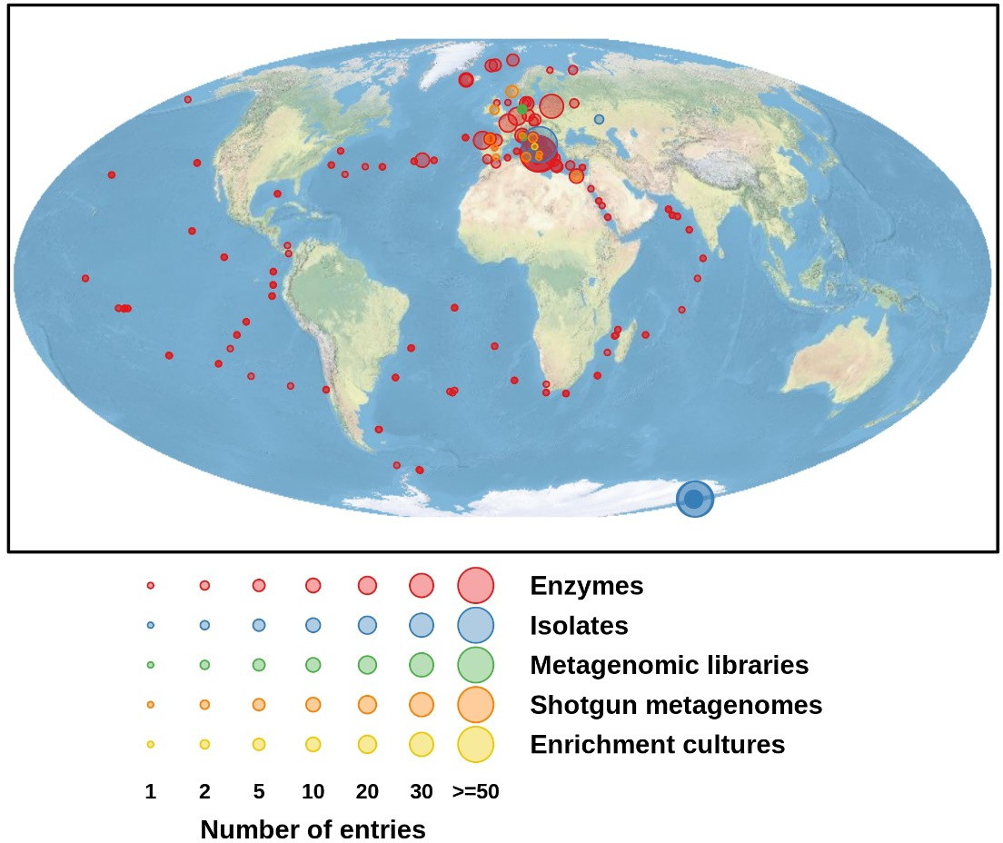

Figure 1. FuturEnzyme bio-resources: location and number of sampling sites.

Below is a full description of each type of bioresources. For every type, a PDF file was produced which was attached to a QR code by using the free web www.qr-me.com. The data provided in these documents and the corresponding QR codes are:

ENZYMES AVAILABLE
ID enzyme; amino acid sequence; phylum or domain; genera, order or family; screen system; GPS coordinates; latitude; longitude; depth (m); source or source organism (short ID); type of habitat; cloning or expression system; activity.
1353 entries, representing highly diverse enzymes relevant to FuturEnzyme, available in expression systems, from single (meta)genomes; the enzymes have been isolated and characterized for purposes others than those in FuturEnzyme, and will be now screened with project-relevant substrates and conditions.

ISOLATES AVAILABLE
Sample ID/Sequence accession; strain name (original); status genome; corrected strain name; taxonomy ID; domain; phylum; class; order; family; coordinates; isolation site; source.
1387 entries, representing psychrophilic, mesophilic, thermophilic, hyper-thermophilic, thermo-acidophilic, alcaliphilic, extreme halophilic, obligate anaerobic and facultative (micro)aerobic sulphur-respiring microorganisms. The collection includes strains growing at temperatures from 0° to 92°C, pH from 1.5 to 10.0, salinity up to 490 g/L, and pressure up to 50 Mpa.

ISOLATES WITH GENOMES AVAILABLE
Sample ID/Sequence accession; sequence and length of the 16S RNA; taxonomic information if available (gene; domain; phylum; class; order; family).
197 entries, representing genomes from isolates representing lineages of (non)-extremophiles growing from 0 to 92°C, pH from 1.5 to 9.0, salinity up to 492 g/L, pressure up to 50 MPa.

METAGENOMIC LIBRARIES
Libraries site/material; sampling date; GPS coordinates of the sampling site; number of clones and vector used to construct the library; GPS coordinates of the sampling site; accession number (if published); published in (journal); enrichment (substrate) or native community; further comments.
28 entries, representing DNA material from communities inhabiting extreme environments (low pH from 1.1 to 4.4; high pH of 9.3-9.6; high salinity from 200 to 490 g/L; pressure up to 300 MPa; temperature up to 98°C) and non-extreme environments, including contaminated sites (close to neutral pH, low to moderate salinity (up to 50 g/l), temperatures from 4 to 30°C, up to 10.1 MPa).

ENRICHMENT CULTURES
Starting material; sampling date; GPS coordinates; accession number; published in (journal); enrichment (substrate and medium); further comments including: sample ID; preliminary and validated strain (enriched) name; taxonomy ID; domain; phylum; class; order; family.
41 entries, derived from samples originated from multiple locations and representing enriched microorganisms of at least 16 different genera.

ISOLATES WITH PROVEN ACTIVITY
ID: activities tested: lipase 30⁰C; lipase 37⁰C; protease 30⁰C; protease 37⁰C; inulinase 30⁰C; inulinase 37⁰C; amylase 30⁰C; amylase 37⁰C; transaminase 30⁰C; published (doi).

55 entries.

SHOTGUN METAGENOME SEQUENCES
Sample description; BioSample/BioProject; GPS coordinates.
61 entries, corresponding to at least 16 different types of extreme and non-extreme environments.

These QR codes are confidential and available within the FuturEnzyme consortium. In order to increase the security, they have been blocked with a password (FuturEnzyme€01/06/2021). They will also be included in the private area of the FuturEnzyme website (www.futurenzyme.eu), in the section Shared material. This private area that serves as a repository for the project is accessible to the members of the consortium through user and password.

Bio-resource exchange
The bio-resources described in this deliverable and the QR codes and information detailed through them has been made available to, and exchanged between, the consortium members.

