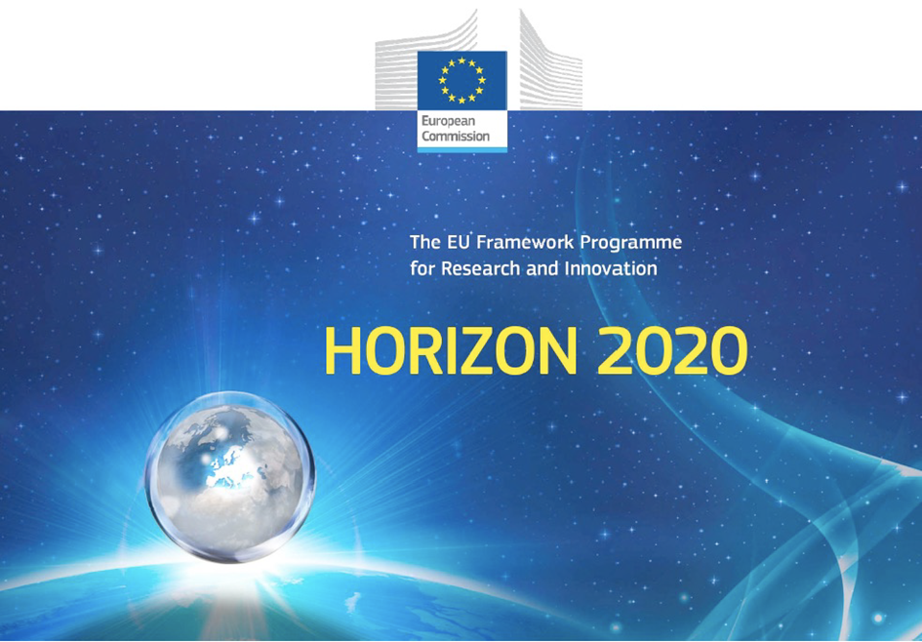

Horizon 2020 Work programme
Food Security, Sustainable Agriculture and Forestry, Marine, Maritime and Inland Water Research and the Bioeconomy
Call
H2020-FNR-2020: Food and Natural Resources
Topic name
FNR-16-2020: ENZYMES FOR MORE ENVIRONMENT-FRIENDLY CONSUMER PRODUCTS

FuturEnzyme:
Technologies of the Future for Low-Cost Enzymes for Environment-Friendly Products
Final ID: 101000327

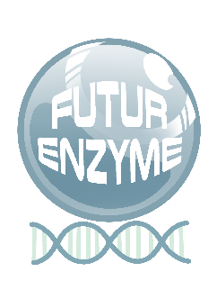
23/11/2021
victor guallar
bsc
Jordi Girona 31, Barcelona 08034,Spain
Set of 500 computational driven sequences selected
MS6

Document information sheet

Work package: | WP2, Machine learning enzyme bioprospecting integrated into an industrial context
Authors: | BSC (Víctor Guallar), CSIC (Manuel Ferrer)
Document version: | 1
Date: | 23.11.2021
Starting date: | 01/06/2021
Duration: | 48 months
Lead beneficiary: | BSC
Participant(s): | BSC, CSIC, Bangor, UHAM, UDUS, Schoeller, Henkel, Evonik
Dissemination Level: | -
Type | Report, materials
Due date (months) | 6
Contact details: | Víctor Guallar (victor.guallar@bsc.es), Manuel Ferrer (mferrer@icp.csic.es)

Summary

SET OF 500 COMPUTATIONAL DRIVEN SEQUENCES SELECTED 4
1. Scope of Milestone 4
2. Methodology: Source and selection of enzymes 4

SET OF 500 COMPUTATIONAL DRIVEN SEQUENCES SELECTED

1. Scope of Milestone
Report/sequences available - this milestone will consist in a fasta file containing 500 full-length candidate sequences encoding enzymes relevant to FuturEnzyme with high probability to fulfill manufacturer’ specifications based on computational predictions. The fasta file will be deposited in the FuturEnzyme internal repository.

2. Methodology: Source and selection of enzymes
Through a protocol extensively described in the deliverable D2.2, at least 3,152,857 sequences have been selected by in silico approaches and are available in the intranet’s project website:
- See intranet’s website File 1 (D2_2) in www.futurenzyme.eu -> login -> private-area -> shared-data

From them, a total of ca. 500 representing each of the clusters representing the enzymes identified, have been selected and and are available in the intranet’s project website:
- See intranet’s website File 2 (D2_2) in www.futurenzyme.eu -> login -> private-area -> shared-data
- See intranet’s website: File 3 (D2_2) in www.futurenzyme.eu -> login -> private-area -> shared-data

