Horizon 2020 Work programme
Food Security, Sustainable Agriculture and Forestry, Marine, Maritime and Inland Water Research and the Bioeconomy
Call
H2020-FNR-2020: Food and Natural Resources
Topic name
FNR-16-2020: ENZYMES FOR MORE ENVIRONMENT-FRIENDLY CONSUMER PRODUCTS

FuturEnzyme:
Technologies of the Future for Low-Cost Enzymes for Environment-Friendly Products
Final ID: 101000327
27 December 2022
wolfgang streit
uham
Department of Microbiology and Biotechnology, Ohnhorststrasse 18, 22609, Hamburg, Germany
Standard assays, analytics and calculations for monitoring enzymatic performance
D3.2

Document information sheet

Work package: | WP3, Activity-based bio-prospecting for enzymes
Authors: | UHAM (Wolfgang R. Streit, Jennifer Chow, Pablo Pérez García), CSIC (Manuel Ferrer, Patricia Molina), Bangor (Peter Golyshin, Alexander Yakunin, Olga Golyshina), UDUS (Karl-Erich Jaeger, Stephan Thies, Alexander Bollinger, Rebecka Molitor), CNR (Michael Yakimov), IST-ID (Carla de Carvalho,  Pedro Fernandes)
Document version: | 2
Date: | 27.12.2022
Starting date: | 01/06/2021
Duration: | 48 months
Lead beneficiary: | UHAM
Participant(s): | UHAM, CSIC, BANGOR, UDUS, IST-ID, CNR
Dissemination level | Confidential, only for members of the consortium (including the Commission Services)
Type | Report
Due date (months) | 2
Contact details: | Wolfgang Streit, wolfgang.streit@uni-hamburg.de; Manuel Ferrer, mferrer@icp.csic.es

Summary
Abbreviations 5
1. Scope of the Deliverable 6
2. Reasons for the update 6
3. Origin of the Deliverable 6
4. Protocols for DETERGENT APPLICATIONS 6
4.1. pH shift liquid protocols for quantifying esterase-lipase activity 11
4.1.1. Using Phenol Red (pH 8.0) as a pH indicator 11
4.1.2. Using p-nitrophenol (pH 7.0) as a pH indicator 12
4.1.3. Using nitrazine yellow as a pH indicator 12
4.1.4. Using fluorescein as pH indicator 13
4.2. Liquid protocol for quantifying esterase-lipase activity with chromogenic esters 13
4.2.1. Using short-medium α- or β-naphthyl and p-nitrophenol esters 13
4.2.2. Using short-large p-nitrophenol esters 13
4.2.3. Using medium-large p-nitrophenol esters 14
4.3. Liquid protocol for quantifying esterase-lipase activity with non-chromogenic esters 14
4.3.1. Using with fatty acid cholesterol esters 14
4.3.2. Using insoluble substrates (waxes and lipids) and pH-stat 14
4.4. Liquid protocol for quantifying esterase-lipase activity with chromogenic commercial kits 15
4.4.1. NEFA-HR(2) kit 15
4.5. Agar plate for screening esterase-lipase with α-naphthyl ester 16
4.6. Agar plate tributyrin screening esterase-lipase assay 17
4.7. Agar plate coconut oil screening lipase assay 17
4.8. Agar plate cocoa butter screening lipase assay 17
4.9. Agar plate olive oil lipase screening assay 18
4.10. Agar plate palm oil screening lipase assay 18
4.11. Agar plate egg yolk phospholipase assay 19
4.12. Liquid assay for investigating effect of laundry detergents 19
4.13. Protocol for preparing cell suspensions for activity assays 19
5. Protocols relevant for TEXTILE APPLICATIONS 19
5.1. Agar plate polyesterase screening assay with PET-nanoparticles 22
5.1.1. Protocol for the preparation of PET-nanoparticle solution 22
5.1.2. Preparation of PET-nanoparticle screening plates 22
5.2. Agar plate polyesterase screening assay with polylactic acid (PLA) emulsion 22
5.3. Agar plate polyesterase screening assay with PET or PLA polymers 23
5.4. Agar plate polyesterase screening assay with Impranil DLN 23
5.5. Agar plate polyesterase screening assay with polycaprolactone diol (PCDMn530) 23
5.6. Agar plate polyesterase screening assay with polycaprolactone (PCL) nanoparticles 23
5.7. Agar plate protease skim milk screening assay 24
5.8. Agar plate protease casein screening assay 24
5.9. Agar plate cellulase screening assay 24
5.10. Agar plate oxidoreductase (laccase/oxidase) screening assay 25
5.11. Liquid protocol for quantifying esterase-lipase activity with chromogenic commercial kits 25
5.11.1. NEFA-HR(2) kit 25
5.12. Liquid polyesterase quantification assay with polylactic acid (PLA) powder 27
5.13. Liquid polyesterase quantification assay using Impranil DLN-SD 27
5.14. Liquid protocol for the quantification of BHET or PET foil hydrolysis using UHPLC 27
5.15. Liquid oxidoreductase (laccase/oxidase) quantification assay 27
5.16. Liquid amylase quantification assay with chromogenic substrates 28
5.17. Liquid amylase quantification assay with polymeric substrates 28
5.18. Liquid proteolytic activity assays using FITC-labelled protein 28
5.19. Liquid proteolytic (alcalase) activity assays using p-nitroanalide chromophores 29
5.20. Liquid proteolytic (subtilisin) activity assays using p-nitroanalide chromophores 29
5.21. Liquid proteolytic activity assays using azocasein 29
5.22. Liquid hydrophilic and dyeability modification of fabrics 29
5.23. Liquid amino modification of polyamide fabrics 30
5.24. Dye liquid discoloration test 31
6. Protocols relevant for COSMETIC APPLICATIONS 32
6.1. Liquid colorimetric assay for hyaluronidase activity 32
6.1.1. DNS method 33
6.1.2. BSA method 33
6.1.3. BCA method 34
6.1.4. DMAB method 34
6.2. Liquid analysis of hyaluronic acid oligosaccharides by HPAEC-PAD 34
6.3. Liquid analysis of hyaluronic acid oligosaccharides by SEC-ELSD 34
6.4. Agar assay for the determination of hyaluronidase activity 35
Annex - List of esters successfully tested with pH shift assay 36

Abbreviations
4-AA, 4-aminoantipyrine
ε, Extinction coefficient
ABTS, 2,2′-Azinobis(3-ethylbenzthiazoline-6-sulfonate)
ACOD, Acyl-CoA oxidase
ACS, Acyl-CoA synthetase
AMP, adenosine monophosphate
ATP, adenosine 5-triphosphate
BCA, Bicinchoninic acid
BES, N,N-bis(2-hydroxyethyl)-2-aminoethanesulfonic acid
BHET, bis-(2-Hydroxyethyl) terephthalate
C12:0, Trilaurin
C14:0, Trimyristin
C16:0, Tripalmitin
C16:1, Tri-glyceryl palmitoleic acid
C17:0, Tri-glyceryl heptadecanoic acid
C18:0, Tristearate
C18:1, Triolein
C18:2, Trilinolein
CHES, N-Cyclohexyl-2-aminoethanesulfonic acid
CoA, Coenzyme A
CO, Cotton
DAS, 3-Amino-5-nitrosalicylic acid
DMAB, p-Dimethylaminobenzaldehyde
DMSO, dimethyl sulfoxide
DNS, 3,5-Dinitrosalicylic acid
EPPS, 4-(2-Hydroxyethyl)-1-piperazinepropanesulfonic acid
FITC, Fluorescein isothiocyanate
FRET, Fluorescence resonance energy transfer
GlcNAc, N-Acetyl-D-glucosamine
HAOS, Hyaluronic acid oligosaccharides
HEPES, 4-(2-Hydroxyethyl)-1-piperazineethanesulfonic acid ()
HPAEC-PAD, High performance anion exchange chromatography with pulsed amperometric detection
HPLC-SEC, High performance size exclusion chromatography with evaporative light scattering detector
LB, Luria Bertani
MEHA, 3-Methyl-N-Ethyl-N-(β-Hydroxyethyl)-Aniline
MHET, Mono-(2-hydroxyethyl) terephthalate
MWCO, Molecular weight cut-off
NEFA, Non-esterified fatty acid
PA, Polyamide fibres
PCD, Polycaprolactone diol
PCL, Polycaprolactone
PES, Polyester fibres
PET, Polyethylene terephthalate
PLA, Poly(DL)-lactide or polylactic acid
p-NP, p-Nitrophenol
Ppi, pyrophosphoric acid
RFU, Relative fluorescence units
TB, Terrific broth
TBS, Tris buffered saline
TNBS, Trinitrobenzenesulfonic acid
TPA, Terephthalic acid
WR, Working reagent

1. Scope of the Deliverable
This deliverable consists in a report detailing the customized multi-substrate and multi-condition screen protocols to be applied by partners to speed up the screening of bio-resources for enzymes, and further characterization of enzymes and their engineered variants, of interest for the purposes of FuturEnzyme’s objectives. On the basis of the activity level units, decisions are taken to pre-select those best matching industrial requirements to proceed with sequencing and characterisation. The protocols are available in the internal FuturEnzyme repository.

2. Reasons for the update
The first version of the Deliverable D3.2 was submitted in July 2021. This update is due to the fact that in these approx 18 months (from July 2021-original submission- to December 2022 -update submission), the partners have exchanged new materials for tests from the manufacturers and from commercial suppliers, and new protocols to evaluate enzymatic activity have been defined. In November 2022, the Coordinator (Manuel Ferrer) contacted the Project Officer (Colombe Warin) to explain these circumstances and ask her to re-open the submission of this deliverable (amongst others), at which she agreed.

3. Origin of the Deliverable
Along the already 18 months of project, one deliverable has been accomplished from which the present one nourishes. To be mentioned:
- D2.1: Manufacturers’ needs and specifications: protocol (August 2021, to be updated by December 2022)
In this deliverable, information about manufacturers’ needs, and enzymes and products specifications (working/storage conditions and stabilities, compositions, etc.) for implementing 3 innovative, real-life, and environment-friendly products (detergents, textiles and consumer care products) are detailed. They include:
Detergents: Enzymes for removing fatty oil stains
Cosmetic: Enzymes for degrading hyaluronic acid to size controlled products to be integrated into cosmetics
Textile: Enzymes for the removal of spinning additives and dyes

Based on these applications and needs detailed in D2.1, a series of protocols and assays have been established to help not only to identify enzymes or microorganisms that contain them, but also to assist in their detailed characterization in order to identify the best candidates. The following are the protocols and assays developed and used by the different partners during the project. Some of these protocols are part of prior knowledge, but others have been designed and adapted to the needs of the project.

4. Protocols for DETERGENT APPLICATIONS
As detailed in Deliverable D2.1, priority enzymes are those for removing fatty oil stains, that will include:
- True lipases (EC 3.1.1.3)
- Esterases (EC 3.1.1.1)
- Cutinases (EC 3.1.1.74) and related fatty-oil degrading hydrolases
The enzymes should be active and stable under conditions relevant to the wash cycle and to storage. Below, the key specifications are summarized:
- The enzymes should be stable for at least 2 to 3 months at 30˚C in the liquid detergent formulation provided by partner HENKEL (see details in Deliverable D2.1).
- The enzymes should be effective and stable at a washing temperature between 20 and 40˚C and at pH 7.0-8.5, at least during an operation time of a common wash cycle (120 min). Note: These stability and activity refer to that of the enzymes in a wash liquor mimicking the detergent-water mixture in a wash machine; this wash liquor consists in about 50 g liquid detergent per 20 L of water.
Therefore, it is a priority to adapt the screening and characterization methods to those enzymes and conditions. Below, a number of protocols are described which have been proven to successfully work in a number of buffers and conditions. As detailed in Deliverable D2.1, in general Henkel strongly recommends to concentrate on the screening methods which can be performed in a wash-liquor matrix (instead of standard buffers) as early as possible, since this affects the enzyme properties often quite strongly. It is similarly crucial to screen on real textiles as soon as possible, too, as they are more challenging than stains alone. Therefore, it is highly recommended that partners focus on, and adapt the screen methods to, (A) commercially available standard soils on textiles and (B) natural soils of interest with high consumer relevance detailed in Deliverable D2.1. Note: priority standard soil textiles recommended by Henkel, as detailed in Deliverable D2.1, have been ordered by CSIC by July 2021 and transferred to all partners (see Deliverable D2.1) involved in enzyme screening and characterization.

The following decision-taken strategy, once activity towards ester-like substrates is confirmed, has been undertaken.

Decision taken screen 1:
- Enzyme retaining some activity 5-10 min in wash liquor
Note: wash liquor is prepared by adding 50 g liquid detergent provided by partner Henkel per 20 L of water.
Decision taken screen 2:
- Active towards commercially available standard soils/stains on textiles and natural soils. They include, at least, cuff and collar, natural skin fat, butterfat, olive oil, frying fat, lard and tomato beef sauce, beef lard, pigment, oil, pigment, sebum, mayonnaise with carbon black, butterfat with colorant, lipstick, pink and make up.
Note: the following standard soils/stains on textiles and natural soils were selected by partner Henkel, which were requested to Center For Testmaterials, CFT: Pigment with oil on polyester/cotton (PC-09), Mayonnaise on cotton (C-S-05S), Lipstick, pink on polyester/cotton (P-S-16), Fluid make-up on cotton (C-S-17), High discriminative sebum BEY on polyester/cotton (PC-S-132), Beef fat on cotton (C-S-61) and Butterfat on cotton (C-S-10).

Decision taken screen 3:
- Enzyme retaining activity 120 min in wash liquor
- Enzyme stable in liquid detergent for few days
- Active against standard soils/stains on textiles.
Final requirements:
- Stable 2-3 months at 30˚C in the liquid detergent formulation
- Effective at conditions mimicking the wash cycle using wash liquor: 20-40˚C, pH 7.0-8.5, 120 min.
As a baseline or reference, a wash liquor made of “HENKEL® Liquid Laundry Detergent_A including enzymes” is used, so that the values obtained are compared with those obtained when the FuturEnzyme’s enzymes were added to a wash liquor made of “HENKEL® Liquid Laundry Detergent_A without enzymes”. Only enzymes, lipases, that behave similarly or better than the “HENKEL® Liquid Laundry Detergent_A including enzymes” are selected.
Below, the detergents provided by partner Henkel, and that were used for activity tests when appropriated, are detailed:
Detergents with and without enzymes
Sent to Bangor, CSIC, UDUS, UHAM, IST-ID, CNR in September 2021
- Density: 1,0855 - 1,0955 g/cm3
- pH: 7,8 - 8,2
- Viscosity: 210 - 310 mPa.s
Sample name | Batch No. | Dosage for wash liquor  (16.7 °dH water) | Ingredients | Gap [%] to be filled (last w water)
Detergent_A | WLHUL2161400 | 3.1 g/L | All ingredients included | -
Detergent_A_w/o | WLHUL2194600 | 3.1 g/L | Without enzymes | 2.5 %

Hazardous substances according to CLP (EC) No 1272/2008:
Hazardous substances  CAS-No | EINECS | REACH-Reg No. | Content | Classification
Benzenesulfonic acid, mono-C10-13-alkyl derivs., compds. with ethanolamine  85480-55-3 | 287-335-8 | * | >= 20- < 40 % | Acute toxicity 4 H302  Skin irritation 2 H315  Serious eye damage 1 H318  Chronic hazards to the aquatic environment 3  H412
Alcohols, C12-18, ethoxylated  68213-23-0 |  |  | >= 10- < 20 % | Acute toxicity 4 H302  Serious eye damage 1  H318  Chronic hazards to the aquatic environment 3  H412
Alcohols, C12-14, ethoxylated, sulfates, sodium salts  68891-38-3 | 500-234-8 | 01-2119488639-16 | >= 5- < 10 % | Skin irritation 2; Dermal H315  Serious eye damage 1  H318  Chronic hazards to the aquatic environment 3  H412
Tetrasodium (1-hydroxyethylidene)bisphosphonate  3794-83-0 | 223-267-7 | * | >= 1- < 5 % | Acute toxicity 4 H302  Serious eye irritation 2  H319
Sodium metaborate, anhydrous  7775-19-1 | 231-891-6 | * | >= 1- < 5,9 % | Toxic to reproduction 2 H361d  Serious eye irritation 2  H319
Protease  9014-01-1 | 232-752-2 | 01-2119480434-38 | >= 0,1- < 1 % | Acute hazards to the aquatic environment 1  H400  Chronic hazards to the aquatic environment 2  H411  Acute toxicity 4 H302 Specific target organ toxicity - single exposure 3 H335  Skin irritation 2 H315  Serious eye damage 1  H318  Respiratory sensitizer 1  H334
*exempted according to REACH article 2(7) and Annex V. Each starting material of the ionic mixture is registered, as required.

4.1. pH shift liquid protocols for quantifying esterase-lipase activity
The protocols are recommended for short-middle chain length carboxylesterases, and have been successfully applied for a variety of chemically and structurally diverse soluble and insoluble esters, including short-medium-large triglycerides (see Annex). The method allows using insoluble triglycerides.

4.1.1. Using Phenol Red (pH 8.0) as a pH indicator
Below the assay is described for 384-well plates, but can be adapted to 96-well plates or any other format (e.g. 1 mL cuvette).
- Prepare a concentrated ester stock solution¹ by dissolving each ester at a concentration of 100 mM in acetonitrile, dimethyl sulfoxide (DMSO), acetone or isopropanol, depending on its solubility (stock solutions can be prepared and maintained at -20°C until use).
- Fill a 384-well plate with 20 μL of 5 mM 4-(2-hydroxyethyl)-1-piperazinepropanesulfonic acid (EPPS) buffer pH 8.0², using a QFill3 microplate filler.
- Add 2 μL of each ester stock solution to each well using a PRIMADIAG liquid-handling robot.
- After the esters are added, fill the 384-well plate with 20 μL of 5 mM EPPS buffer pH 8.0, containing 0.912 mM Phenol Red (used as a pH indicator: from red to yellow color when pH is lowered) using a QFill3 microplate filler (the final ester concentration in each well is 4.5 mM, and the final concentration of Phenol Red is 0.45 mM).
- Add immediately 2 μL of enzyme solution, cell extract or cell suspension³ to each well using an Eppendorf Repeater M4 pipette.
- Follow the progress of the reaction at the desired temperature by monitoring the absorbance at 550 nm⁴, in continuous mode, in a microplate reader (reaction can be followed for up to 24 h, but we recommend continuous reading for up to 1-8 hours, depending on the enzyme activity).
- Activity (unit/mg protein) is calculated by determining the absorbance per minute from the slopes generated, and by applying the following formula:
$$Rate \left(\frac{μmol}{\min{mg prot./cells}}\right)=\frac{\frac{∆Abs}{min}}{8450 M-1cm-1}* \frac{1}{0.4 cm}*\frac{{10}^{6} μM}{1 M} * 0.000044 L*\frac{1}{mg prot./cells}$$

Extinction coefficient (ε) phenol red at 550 nm and pH 8.0: 8450 M⁻¹cm⁻¹
Total assay volume: 44 μL

¹This method has been proven efficient for a wide variety of chemically and structurally diverse esters, including long chain triglycerides and poly-aromatic esters.
²This method can be adapted to the use of wash liquor supplied by Henkel. Briefly, the 5 mM EPPS buffer pH 8.0, is substituted by one in which 0.5 g liquid detergent is added to 100 ml of 5 mM EPPS buffer pH 8.0. Alternatively, when using large triglycerides such as those based on C12:0 (trilaurin), C14:0 (trimyristin), C16:0 (tripalmitin), C16:1 (triolein), C17:0, C18:0, C18:1, and C18:2 (trilinolein), the 5 mM EPPS buffer pH 8.0, can be substituted by one containing 0.2% (w/w) arabic gum and 0.4% (w/v) sodium deoxycholate.
³Cell suspension can be prepared following optimal cultivation conditions. In case of Escherichia coli expressing enzymes of interest the following protocol is recommended. We do the cultivation in 96 well deep-well-plates, starting with 300 μL Terrific Broth (TB) medium with the required antibiotic. Wells get inoculated with a loop of the cryoculture or an single colony from an agar plate and grown over night at 37°C, 200 rpm, and sealed with a breathable membrane. The next day, 3 μL of each preculture are transferred to fresh 300 μL TB + antibiotic and grown for 3 h, 37°C, 200 rpm. Then cultures get induced with 1 mM IPTG (or other appropriate inducer) and grown over night at 30°C, 200 rpm. Next, the cultures are spun down in the plate, the media is removed and plates are covered with a fresh breathable membrane and frozen for at least 6 h at -30°C. Finally the plates get lyophilized overnight. For assays, the liophilized cells are re-suspended in 0.6 ml of 5 mM EPPS buffer pH 7.0 and 2 µl are used for activity tests
⁴The acid produced after ester bond cleavage by the hydrolytic enzyme induces a color change in the pH indicator that is measured spectrophotometrically at 550 nm. Absence of activity defined as at least a 2-fold background signal.

4.1.2. Using p-nitrophenol (pH 7.0) as a pH indicator
- Prepare the reaction mixture in 96-well microplates adding 150 μl of 2 mM N,N-bis(2-hydroxyethyl)-2-aminoethanesulfonic acid (BES) buffer pH 7.2 containing 0.45 mM p-nitrophenol
- Add 2 mM ester substrate (soluble aliphatic and aromatic esters, available from Merck/Sigma)¹
- Add 0.1-0.5 μg of purified protein or about 2 μL enzyme solution, cell extract or cell suspension to each well.
- Incubate the plates for 10 min at the desired temperature (e.g., 25-37°C).
- Monitore spectrophotometrically the hydrolytic activity by following absorbance of p-nitrophenol at 404 nm (ε = 17.3 mM⁻¹ cm⁻¹) (Janes L.E. et al., 1998, Chem. Eur. J., 4: 2324-2331).
- Activity (unit/mg protein) is calculated by determining the absorbance per minute from the slopes generated, and by applying the following formula:
$$Rate \left(\frac{μmol}{\min{mg prot./cells}}\right)=\frac{\frac{∆Abs}{min}}{17300 M-1cm-1}* \frac{1}{0.4 cm}*\frac{{10}^{6} μM}{1 M} * 0.00015 L*\frac{1}{mg prot./cells}$$

- Extinction coefficient (ε) p-nitrophenol at 404 nm and pH 7.2: 17300 M⁻¹cm⁻¹
- Total assay volume: 150 μL
¹A 100 mM stock solution of the esters can be prepared in acetonitrile, dimethyl sulfoxide (DMSO), acetone or isopropanol, depending on their solubility.

4.1.3. Using nitrazine yellow as a pH indicator
The method is adapted to handle insoluble substrates (semi-quantitative) and allows high concentrations of co-solvents.
Harvest the expression cultures by centrifugation, discard the supernatants, and resuspend the cells in 0.1 mL cell lysis solution containing polymyxin B (10 mM potassium phosphate buffer pH 7.2, 0.1 mg/mL Polymyxin B).
- Incubate for 1h at 37°C.
- For solvent tolerance assessment: mix in a 96 well plate 0.1 mL of the esterase-containing cell extracts with 0.1 mL of the respective solvent/water mix in a microplate to reach final solvent concentrations of 0%, 30%, and 50% (vol/vol) and incubate for 2 h at 30°C. During this pre-incubation, the microplate lid should be sealed with organic-solvent-stable tape to prevent evaporation.
- Combine in a 96 well plate 10 µL of the sample (cell extract or organic solvent pre-incubation mix) with 180 µL nitrazine yellow-containing assay buffer (5 mM potassium phosphate buffer pH 7.2, 20 µg/mL nitrazine yellow, and 0%, 30%, or 50% (vol/vol) of the respective organic solvent) and 10 µL of substrate solution (e.g. 200 mM tributyrin in acetonitrile) or 10 µL acetonitrile for the control. In the case of a color shift after the addition of the organic solvent and before substrate supplementation, the pH is titrated to neutral (blue color) with potassium hydroxide solution.
- Incubate the reaction mixture for 18 h at 30°C.
- Determine the activity by measuring the absorption at 450 and 600 nm. The quotient of the absorption values determined at both wavelengths is used to measure the pH shift. Correct each value by subtraction of the control which did not contain substrate before calculation of mean values and standard deviations. To reduce false positives, values in the range of the standard deviation of the empty vector control should be considered as not active.

4.1.4. Using fluorescein as pH indicator
The method is adapted to handle insoluble substrates (semi-quantitative) and allows usage of solid substrates.
- Prepare 2 mM potassium phosphate (KPi) buffer pH 7.0 or Tris-buffer pH 8.0 (this buffer can be adapted to specific requirement).
- Prepare working reagent; buffer + 5.0 µM Fluorescein (+ substrate dispersion, if applicable. For Impranil DLN, we use typically 5 µL/mL).
- Add 0.19 mL working reagent (and substrate) per well of a 96-well plate.
- Add 10 µL of enzyme solution to the wells (and 10 µL of the buffer as control).
- Follow the activity (= drop of fluorescence) at Excitation: 488 nm/Emission: 525 nm at the temperature of interest.
- If the measurement is performed longer than 15 min, add a cover to the plate to prevent evaporation.

4.2. Liquid protocol for quantifying esterase-lipase activity with chromogenic esters
The protocols are recommended for short-middle chain length carboxylesterases.

4.2.1. Using short-medium α- or β-naphthyl and p-nitrophenol esters
- Prepare the reaction mixture (200 μL) containing 50 mM Tris-HCl buffer pH 8.0 or N-cyclohexyl-2-aminoethanesulfonic acid (CHES) buffer pH 9.0-10.0, 1 mM substrate (naphthyl) acetate, butyrate, laurate, etc., and 4-nitrophenyl esters such as pNP-butyrate (C4), caprylate (C8), laurate (C12), palmitate (C16), and stearate (C18)], and 0.01-1.0 μg of purified enzyme or appropriated amount of cell extracts or cell suspensions.
- Incubate the reaction for 10 min at selected temperatures (from 15 to 50°C).
- Monitore spectrophotometrically the activity by following absorbance at 310 nm (for α- or β-naphthyl esters of fatty acids substrates) or 410 nm (for p-nitrophenyl (pNP) substrates).

4.2.2. Using short-large p-nitrophenol esters
- Prepare the substrate stock with 20 mM 4-nitrophenyl ester [pNP-butyrate (C4), caprylate (C8), laurate (C12), palmitate (C16), and stearate (C18)]) in acetonitrile.
- Prepare working reagent of 100 mM potassium phosphate buffer pH 7.2, 1 mM 4-nitrophenyl ester, 5% (vol/vol) acetonitrile from 20 mM substrate in acetonitrile stocks.
- Pipette 10 µL of enzyme solution (vol. sample) into the well of a 96 well plate.
- Add 190 μL of working reagent to each well (total vol. in microtiter plate (MTP) = 200 μL).
- Measure the increase of absorption at 410 nm at 30°C for 10 min.
- Calculate activity with
$$\frac{slope at 410 nm \left[\min^{-1}\right] * total vol. in MTP \left[ml\right] * dilution factor}{path length \left[cm\right] * ε \left[{mM}^{-1}{ * cm}^{-1}\right] *vol. sample \left[ml\right]}$$

and ε =10 mM⁻¹cm⁻¹

4.2.3. Using medium-large p-nitrophenol esters
- Prepare working reagent of 25 mM Tri-HCl buffer, pH 7.0, containing 0.1% (w/w) arabic gum and 0.2% (w/v) sodium deoxycholate at 37˚C. Add 4-nitrophenyl ester [pNP-butyrate (C4), caprylate (C8), laurate (C12), palmitate (C16), and stearate (C18)] to a final concentration of 1-8 mM.
- Pipette 190 µL of the working reagent into the well of a 96 well plate.
- Pipette 10 µL of enzyme solution (vol. sample) into the well of a 96 well plate.
- Measure the increase of absorption at 410 nm at 30°C for 10 min, and calculate the activity as above.

4.3. Liquid protocol for quantifying esterase-lipase activity with non-chromogenic esters

4.3.1. Using with fatty acid cholesterol esters
The protocols are recommended for short-middle-large chain length carboxylesterases.
- Prepare working reagent of 25 mM Tri-HCl buffer pH 7.0, containing 0.1% (w/w) arabic gum and 0.2% (w/v) sodium deoxycholate at 37˚C. Then, add cholesteryl oleate¹ to a final concentration of 1 mM.
- Pipette 190 µL of the working reagent into the well of a 96 well plate.
- Pipette 10 µL of enzyme solution (vol. sample) into the well of a 96 well plate.
- Keep reaction for 20 min and estimate the cholesterol released by a commercial enzymatic method (Boehringer).
- One unit of activity was defined as the amount of enzyme hydrolyzing 1 µmol of substrate per minute under the above conditions.
¹This method can be used for testing cholesteryl butyrate (C4:0), cholesteryl palmitate (C16:0), cholesteryl stearate (C18:0), cholesteryl oleate (C18:1) and cholesteryl linoleate (C18:2).

4.3.2. Using insoluble substrates (waxes and lipids) and pH-stat
The hydrolysis of tributyrin, triolein, cholesterol esters, and other waxes and lipids can be assayed titrimetrically at pH 7.0 and 25˚C in a pH-stat (Mettler, model DL50) using 0.1 M NaOH as titrant.
- Prepare a reaction mixture (20 ml) containing the substrate (50 mM) in the presence of 0.15 M NaCl and 5% (v/v) Genapol X-100. Introduce this mixture into a pH-stat.
- Pipette 10-100 µL of enzyme solution (vol. sample).
- Follow hydrolysis titrimetrically at pH 7.0 and 25˚C in a pH-stat using 0.1 M NaOH as titrant.
- Activity (unit/mg protein) is calculated by determining the slope of the line.
This protocol could be adapted to conditions mimicking those in a washing machine and can be adapted to any kind of insoluble substrate (wax, lipid, etc.). Instead of using commercial sufactants or dispersants such as arabic gum or Genapol X-100, the insoluble lipids are resuspended in a wash liquour mimicking the detergent-water mixture in a washing machine.
- Prepare a wash liquor containing 0.5 g liquid detergent (Henkel) per 200 mL of water.
- Prepare the reaction mixture by adding to the wash liquor the raw substrate (wax, lipid) to a final concentration of approx. 0.1-1.0 % (w/v).
- Take 20 mL of the wash liquid and incorporate it into the vial of the pH-stat.
- Pipette 10-100 µL of enzyme solution (vol. sample).
- Follow hydrolysis titrimetrically at pH 7.0 and 25˚C in a pH-stat using 0.1 M NaOH as titrant.
- Activity (unit/mg protein) is calculated by determining the slope of the line.

4.4. Liquid protocol for quantifying esterase-lipase activity with chromogenic commercial kits

4.4.1. NEFA-HR(2) kit
The NEFA-HR(2) kit (Waco, 517982 - Reagent 1 Set kit NEFA-HR(2) Assay, 517984 - Reagent 2 Set, kit NEFA-HR(2) Assay, 517954 - Standard, kit NEFA-HR(2) Assay), also referred to as ACS-ACOD method, is used for the quantitative determination of Non-Esterified Fatty Acids (NEFA). Non-esterified fatty acid (NEFA) in sample is converted to Acyl-CoA, adenosine monophosphate (AMP) and pyrophosphoric acid (PPi) by the action of Acyl-CoA synthetase (ACS), under coexistence with coenzyme A (CoA) and adenosine 5-triphosphate disodium salt (ATP). Obtained Acyl-CoA is oxidized and yields 2,3-trans-Enoyl-CoA and hydrogen peroxide (H₂O₂) by the action of Acyl-CoA oxidase (ACOD). In the presence of a peroxidase, the H₂O₂ formed yields a blue-purple pigment by quantitative oxidation condensation with 3-Methyl-N-Ethyl-N-(β-Hydroxyethyl)-Aniline (MEHA) and 4-aminoantipyrine (4-AA). Non-esterified fatty acids (NEFA) concentration is obtained by measuring absorbance of the blue-purple color.
Reagent preparation:
- R1: Prepare R1 by mixing one bottle of Color A and Solvent A. After preparing the R1, store at 2 - 10°C and use within 1 month.
- R2: Prepare R2 by mixing one bottle of Color B and Solvent B. After preparing the R2, store at 2 - 10°C and use within 1 month.
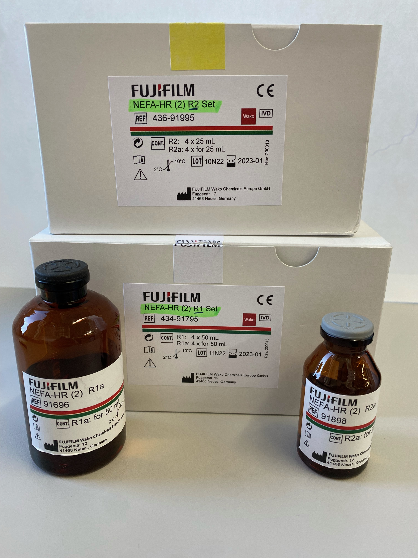
Protocol for stained clothes (adapted from the kit specifications):
- Incubate the enzyme (at different concentrations) with a small piece (4 mg) of a stained cloth (e.g. purchased from Center For Testmaterials, CFT), previoulsy cutted using a circle hole puncher (5 mm diameter) in 100 µL of 40 mM of the appropriated buffer (e.g. pH 7.0 HEPES buffer) or washing liquor (e.g. appropriated dilution from the detergent provided by Henkel) for 24h, at 30˚C and 950 rpm. Two “small wash tests” were performed: one with with HENKEL® Liquid Laundry Detergent without enzymes (2.5 g/L water), and one with HENKEL® Liquid Laundry Detergent_A including enzymes (3.1 g/L water).
- The reaction outcome is tested using the NEFA-Kit, following specifications:
  - Transfer 10 µL of the reaction solution + 100 µL of NEFA solution 1 to a 96 microplate well. Incubate 6 min at 37˚C.
  - Add 50 µL of NEFA solution 2. Incubate 6 min at 30˚C.
  - Measure sample’s absorbance at 550 nm using a microplate spectrometer (e.g. Synergy HT Multi Mode Microplate Reader, Agilent, Madrid, Spain).
A summary of the protocol is detailed, in a schematic manner, below:
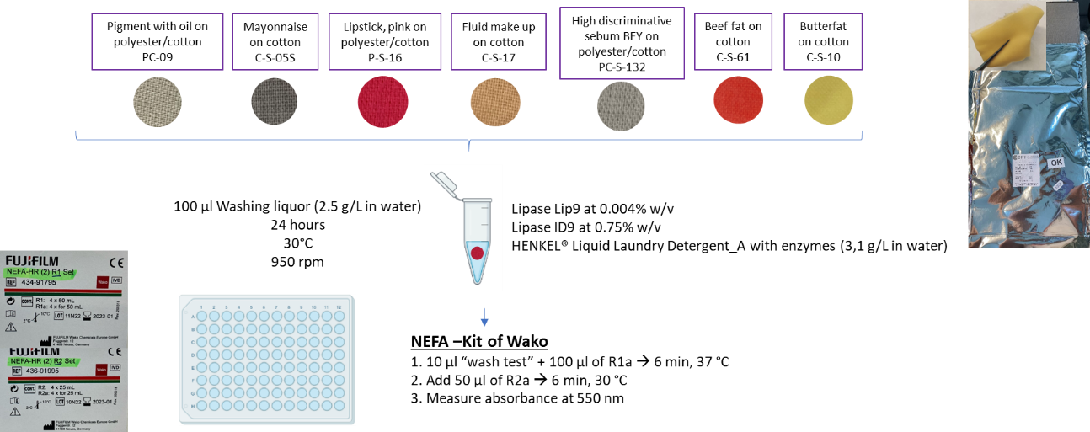
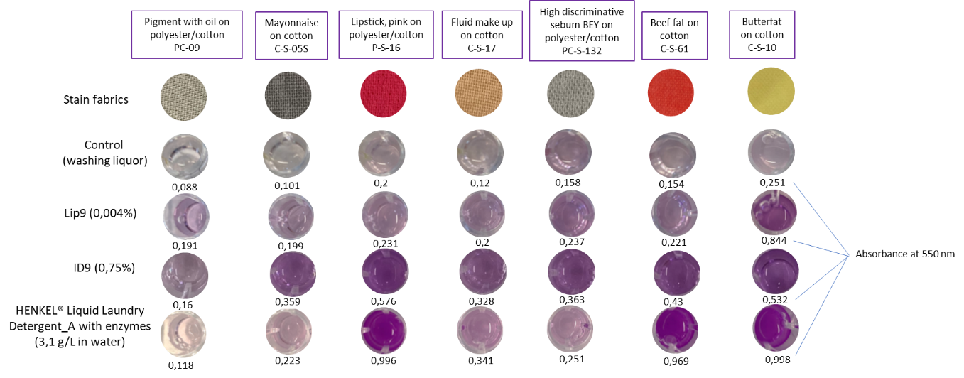

4.5. Agar plate for screening esterase-lipase with α-naphthyl ester
This protocol is based on the use of the substrate α-naphthyl acetate or laurate that is enzymatically hydrolyzed by esterases/lipases, liberating a free naphthol product. This then couples with a diazonium compound (Fast Blue RR solution), forming brown colored deposits; the positive clones will appear due to the formation of a dark brown precipitate.
- Prepare 40 mM 4-(2-hydroxyethyl)-1-piperazineethanesulfonic acid (HEPES) buffer pH 7.0 from 1 M stock (Note: any other buffer can be used). Add agar to a final concentration 0.4% and heat it in the microwave (defreeze position) to dissolve the entire agar. Cool down to ~50˚C.
- Prepare 40-80 mg/mL Fast Blue RR (Sigma-Aldrich/Merck) solution in DMSO (FBRR solution).
- Prepare 20 mg/mL α-naphtyl acetate or laurate (Sigma-Aldrich/Merck) solution in acetone (substrate solution).
- Add 320 μL of FBRR solution and 320 μL of SUBSTRATE solution to a Falcon tube containing 20 mL of HEPES/agar previously tempered, and mix by inverting the tube.
- Overlay the plates containing individual clones or microbial colonies with 10-15 mL of the mix.
- Positive clones will appear as dark brown colonies after 30 sec to 60 min and can be picked (no longer than 5 min, if colonies do not change to dark brown color.

4.6. Agar plate tributyrin screening esterase-lipase assay
The protocol is recommended for short-chain length carboxylesterases.
- Prepare a 50% (v/v) tributyrin (Applichem, Darmstadt, Germany) emulsion in sterile distilled water and add 50 g/L arabic gum (Carl Roth) (Jaeger and Kovacic, 2014). Arabic gum powder is used as an emulsifying agent for the triglyceride.
- Homogenize the mixture for at least 1 min to yield a stable emulsion, e.g. using an Ultra Turrax¹.
- Add 30 mL of tributyrin emulsion per 1 L of molten Luria Bertani (LB) agar and mix thoroughly, e.g. using an Ultra Turrax.
- Pour 25 mL medium portions into appropriate Petri dishes and allow the agar to solidify for at least 15 min.
- Plate bacterial clones and incubate at optimal growth temperature for the specific organism for at least 16 h.
¹Add the arabic gum powder to the respective volume of water. Filling water into a tube or a bottle with a layer of the powder at the bottom should be avoided because it will result in a hard-to-dissolve clot of gum.

4.7. Agar plate coconut oil screening lipase assay
The protocol is recommended for middle-chain length carboxylesterases.
- Melt coconut oil (Biozentrale Naturprodukte, Wittibreut - Ulbering, Germany) by incubation at 30-37°C. Pre-heat sterile distilled water to 60°C¹.
- Prepare a 50% (v/v) coconut oil (e.g., Sigma-Aldrich/Merck, ref. C1758-100G) emulsion in the pre-heated water containing 50 g/L arabic gum (Carl Roth) and 0.35 g/L rhodamine B (Sigma-Aldrich/Merck, Darmstadt, Germany). Homogenize the mixture for at least 1 min to yield a stable emulsion^{2,3}.
- Add 20 mL of coconut oil emulsion per 1 L of molten LB agar and mix thoroughly, e.g. using an Ultra Turrax.
- Pour 25 mL medium portions into appropriate Petri dishes and allow the agar to solidify for at least 15 min.
- Plate bacterial clones and incubate at optimal growth temperature for the specific organism for at least 16 h to develop fluorescent halos/fluorescent colonies.
¹Heating the water in advance should avoid a drop of temperature below 30°C during the preparation of the emulsion in the next step and therefore prevent a partial hardening of the coconut oil which will hamper successful emulsification
²Add the arabic gum powder to the respective volume of water. Filling water into a tube or a bottle with a layer of the powder at the bottom should be avoided because it will result in a hard-to-dissolve clot of gum.
³This method can be adapted to the use of wash liquor supplied by Henkel. Briefly, the 50% (v/v) cocoa butter triglycerides emulsion containing 50 g/L arabic gum (Carl Roth) and 0.35 g/L rhodamine B (Sigma-Aldrich/Merck, Darmstadt, Germany), could be substituted by one 50% (v/v) cocoa butter triglycerides emulsion containing 0.25 g liquid detergent supplied by Henkel per 100 ml water.

4.8. Agar plate cocoa butter screening lipase assay
The protocol is recommended for middle-large chain length carboxylesterases.
- Melt cocoa butter triglycerides (Sigma-Aldrich/Merck, ref. IRMM801-5G) by incubation at 30-37°C. Pre-heat sterile distilled water to 60°C¹.
- Prepare a 50% (v/v) cocoa butter triglycerides emulsion in the pre-heated water containing 50 g/L arabic gum (Carl Roth) and 0.35 g/L rhodamine B (Sigma-Aldrich/Merck, Darmstadt, Germany). Homogenize the mixture for at least 1 min to yield a stable emulsion^{2,3}.
- Add 20 mL of cocoa butter triglycerides emulsion per 1 L of molten LB agar and mix thoroughly, e.g. using an Ultra Turrax.
- Pour 25 mL medium portions into appropriate Petri dishes and allow the agar to solidify for at least 15 min.
- Plate bacterial clones and incubate at optimal growth temperature for the specific organism for at least 16 h to develop fluorescent halos/fluorescent colonies.
¹Heating the water in advance should avoid a drop of temperature below 30°C during the preparation of the emulsion in the next step and therefore prevent a partial hardening of the coconut oil which will hamper successful emulsification
²Add the arabic gum powder to the respective volume of water. Filling water into a tube or a bottle with a layer of the powder at the bottom should be avoided because it will result in a hard-to-dissolve clot of gum.
³This method can be adapted to the use of wash liquor supplied by Henkel. Briefly, the 50% (v/v) cocoa butter triglycerides emulsion containing 50 g/L arabic gum (Carl Roth) and 0.35 g/L rhodamine B (Sigma-Aldrich/Merck, Darmstadt, Germany), could be substituted by one 50% (v/v) cocoa butter triglycerides emulsion containing 0.25 g liquid detergent supplied by Henkel per 100 ml water.

4.9. Agar plate olive oil lipase screening assay
The protocol is recommended for long-chain length carboxylesterases.
- Prepare a 50% (v/v) olive oil¹ emulsion in water containing 50 g/L arabic gum (Carl Roth) and 0.35 g/L rhodamine B (Sigma-Aldrich/ Merck, Darmstadt, Germany).
- Homogenize the mixture for at least 1 min to yield a stable emulsion.
- Add 20 mL of olive oil emulsion per 1 L of molten LB agar and mix thoroughly, e.g. using an Ultra Turrax.
- Pour 25 mL medium portions into appropriate Petri dishes and allow the agar to solidify for at least 15 min.
- Plate bacterial clones or specific organism and incubate at optimal growth temperature for at least 16 h to develop fluorescent halos/fluorescent colonies.
¹This method can be use also for oils such as sunflower oil, coconut oil, cocoa butter, etc.

4.10. Agar plate palm oil screening lipase assay
The protocol is recommended for long-chain length carboxylesterases.
- Prepare a 50% (v/v) palm oil¹ in water containing 50 g/L arabic gum (Carl Roth).
- Homogenize the mixture for at least 1 min to yield a stable emulsion.
- Add 20 mL of palm oil emulsion per 1 L of molten LB agar and mix thoroughly, e.g. using an Ultra Turrax.
- Pour 25 mL medium portions into appropriate Petri dishes and allow the agar to solidify for at least 15 min.
- Plate bacterial clones or specific organism and incubate at optimal growth temperature for at least 16 h, but preferably for 24-72 h.
- After cultivation, plates are overlaid with a 25 ml of a solution prepared as follows: 0.4% w/v of agar is added to a 5 mM EPPS buffer pH 8.0 containing 0.45 mM Phenol Red (used as a pH indicator) and 0.4% w/v of agar (Note: heat it in the microwave to dissolve the entire agar). After cooling down to ~40-50˚C, the plate is overlaid with this solution and yellow halo zones seen are considered as positive for lipase production.
¹This method can be used with any wax or lipid, including long chain triglycerides.

4.11. Agar plate egg yolk phospholipase assay
The protocol uses the phospholipids from egg yolk to detect phospholipase activity. Hydrolysis of phospholipids drives to the liberation of fatty acids. Calcium forms a complex with the free fatty acids resulting in the formation of a precipitation halo around the colonies. Colonies are grown in this medium.
- Add an egg yolk (~ 8% v/v) to each 500 mL of appropriate agar medium (e.g. LB agar) cooled to less than 40˚C after autoclaving. Then, add appropriate antibiotics and supplements such as inductors.
- Mix vigorously using a vortex before plating into Petri dishes (mix vigorously the bottle containing the agar medium before plating every 4-5 plates or as many times as necessary).
- Replicate the clones or microbial cells into egg yolk agar plates.
- Incubate the plates for 16 hours at 37˚C.
- Positive clones will appear as colonies surrounded by a halo.

4.12. Liquid assay for investigating effect of laundry detergents
Henkel will provide a detergent without enzymes.
- The detergent will be diluted in double distilled water to a final concentration of 2.5 mg/mL to simulate washing conditions. The enzyme is added to the reaction mix and incubated at 20-40°C for 30-120 min. Any of the method described above can be used.
- For stability tests, aliquots are taken at different time intervals and the residual activity is determined at 20˚C; the enzyme will be added to different amount in the liquid detergent and incubated for months at 20-40˚C. At different time frames, aliquots are taken and the activity evaluated using any of the methods described above.

4.13. Protocol for preparing cell suspensions for activity assays
In some cases, the presence of lipase activity or the analysis of substrate specificity can be evaluated by using cells containing presumptive lipase activity, not purified protein. The cell suspensions can be prepared following optimal cultivation conditions. In case of Escherichia coli expressing enzymes of interest the following protocol is recommended.
- Cultivate the cells in 96 well deep-well-plates, starting with 300 μL Terrific Broth (TB) medium with the required antibiotic.
- Wells get inoculated with a loop of the cryoculture or an single colony from an agar plate and grown over night at 37°C, 200 rpm sealed with a breathable membrane.
- After the overnight, 3 μL of each preculture are transferred to fresh 300 μL TB + antibiotic and grown for 3 h, 37°C, 200 rpm. Then cultures get induced with 1 mM IPTG (or other appropriated inducer) and grown over night at 30°C, 200 rpm.
- Then, the cultures are spin down in the plate, the media is removed and plates are covered with a fresh breathable membrane and frozen for at least 6 h at -30°C.
- Finally the plates get lyophilized overnight.
- For assays, the liophilized cells are re-suspended in 0.6 ml of a buffer with low ionic strenght and close to neutral pH; 2-10 µL are used for activity tests.

5. Protocols relevant for TEXTILE APPLICATIONS
As detailed in Deliverable D2.1, priority enzymes are those for textile fibres, that include cotton (CO), polyester fibres (PES), polyamide fibres (PA), and elastane (polyether-polyurea copolymer): Lipases and polymer-degrading enzymes (herein referred as polyesterases), cutinases, amidases, proteases (subtilisin, papain, alcalase and bromelain-type), polyurethanases, cellulases, amylases and bleaching and dye decolorizing enzymes (oxidoreductases). Among them, priority targets are lipases for removing residual spinning oils/sizing products that, if not eliminated, will otherwise generate emissions during the drying and fixation steps; priority textiles are those made of polyester (PES). Priority targets are also oxidoreductases (laccase-like) for supporting in the decolorization of dyes. Currently, these additives/preparation materials and residual dyes are removed by a water/surfactant process and reducing the rinsing steps/duration is the expected goal when adding enzymes into the cleaning processes, and enzymes are requested to support the elimination of those additives/preparation materials and residual dyes in water. Final priority target are polyesterases that can be applied in the biodegradation of the current textile materials in such a way that they can even be reused to produce new recycled textiles.

The following decision-taken strategy, once activity towards lipase and dye-related substrates is confirmed, has been undertaken.

Decision taken screen 1:
- Enzymes are capable of eliminating spinning oils/sizing products from raw fabrics provided by partner Schoeller, in buffer or water.
Note: As a control the pretreated fabrics from which the spinning oils / sizing products have been chemically and thermally removed, are used. No control enzyme can be used, as no lipases are used commercially for this purpose.
Decision taken screen 2:
- Enzymes are capable of eliminating dye products provided by partner Schoeller, in buffer or water.
Note: No control enzyme can be used, as no lipases are used commercially for this purpose.
Decision taken screen 3:
- Enzymes are capable of degrading polyester (PES) fabrics provided by partner Schoeller, in buffer or water.
Note: As a control, best performing PETases reported in the literature are used.
Below, the fabrics and dyes provided by partner Schoeller, and that were used as real substrates for activity tests when appropriated, are detailed:
Raw and pre-treated fabrics (to remove the spinning oils, sizing products, etc.)
Sent from Schoeller to CSIC, and CSIC distributed them to Bangor, IST-ID, UDUS, UHAM, and BioC_Chem (September 2021).
Variant | Type | Article No. | Based material | Available Status in stock | Comp.¹ / Weight
1 | Woven | 61488 | 61488Z | Raw | 92% PA, 8% EL 180 g/m²
 |  |  | 61488Z | Pre-treated
2 | Woven | 61988 | 61988F1 | Raw | 92% PA, 8% EL 280 g/m²
 |  |  | 61988F1 | Pre-treated
3 | Woven | 67007 | 67007 | Raw | 88% PA,12% EL 135 g/m²
 |  |  | 67007 | Pre-treated
4 | Woven | 3X58 | 3X58 | Pre-treated | 100% PES 100 g/m²
5 | Woven | 66299 | 5237/00 | Raw | 92% CO, 8% EL 240 g/m²
6 | Warp-knitted | E03130 | E03130 | Raw | 80% PA, 20% EL 160 g/m²
¹PA: Polyamide; EL: Elastane; PES: Polyester.

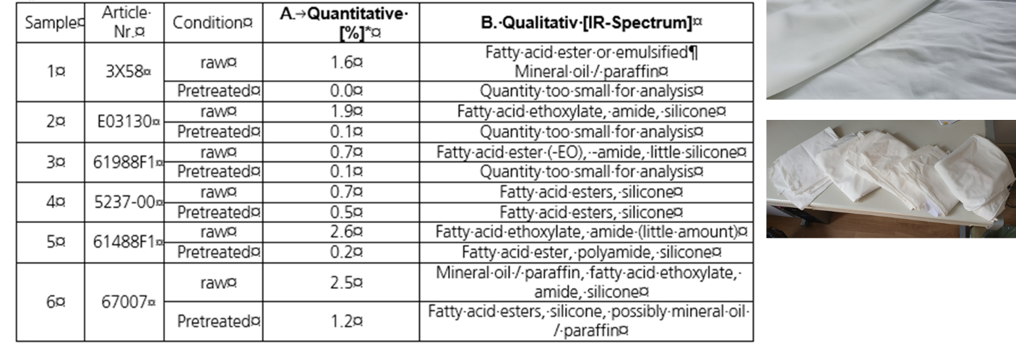
Dyeing baths and chemicals inside (to remove the dyes from it - decolorization)
Sent from Schoeller to CSIC, Bangor, IST-ID, Inofea (received on 15.11.2022)
Sent from CSIC to UDUS and (received on 24.11.2022)
Sent from Inofea to FHNW (received on 24.11.2022)
Schoeller Receipt Nr. 31964900
Proceedings (Verfahren): V-AN4SDNFPH4RFDI
Dyeing of materials on Noseda machinery with pH 4.5
Chemicals in the dyeing bath:
Chemicals | Amount (g/L) | Provider
Periwet WDP NEW | 0.4 | Petry Chemie
BIAVIN BPA | 2 | CHT
SARABID C14 | 0.65 | CHT
Ammoniumsulfate-LSG. 33% | 4 | Bilgram Chemie GmbH
Ameisesäure 85% | 0.6 | Bilgram Chemie GmbH
Dyeing material
BEMAPLEX SCHWARZ D.HF | 3.57 | CHT
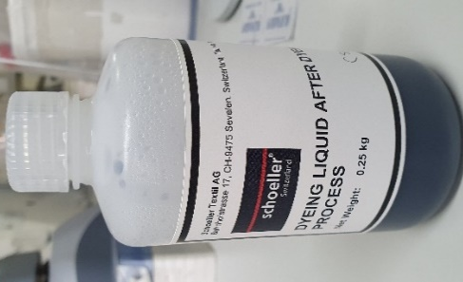

5.1. Agar plate polyesterase screening assay with PET-nanoparticles

5.1.1. Protocol for the preparation of PET-nanoparticle solution
- Dissolve completely 0.1 g polyethylene terephthalate (PET)¹ in 10 mL 1,1,1,3,3,3-hexafluor-2-propanole (Sigma-Aldrich/Merck) and pour it in a burette.
- Slowly transfer this solution (drop-by-drop) into a 100 mL ice-cold water containing beaker (in an ice bath), which is strongly agitated, to produce precipitated PET polymer.
- Remove the solvent¹ and part of the water by distillation, so that the 110 mL total volume is reduced to approx. 2-fold (approx. 50 mL final volume).
- The concentrated water solution containing precipitated PET-nanoparticles can be stored at 4°C for about 2 months. Usually we get a solution of about 0.8-1.6 mg/ml nanoparticles in water.

¹Any kind of plastic bottle can be used as source of PET. We used PET from fruit juice bottle of Granini.

5.1.2. Preparation of PET-nanoparticle screening plates
- Mix 50 mL medium (M9 minimal medium plus 1.8% (w/v) agar agar)² with the concentrated nanoparticle solution (~12 mL).
- Those plates can be stored for a maximum of 2 weeks at 4°C.
- Place bacterial³ or protein⁴ solution onto the plate.
- Usually we observe a lysis zone⁵ around the colonies after 2-3 days of incubation at 37°C, depending on the activity of the enzymes.

¹It is absolutely mandatory to completely remove the solvent prior to the incorporation of the nanoparticles into the plates (see below), otherwise the bacteria and enzymes are strongly growth-inhibited.
²This can be adapted to any other buffer and medium with appropriate antibiotic.
³Grow Escherichia coli expressing the enzyme of interest at 37°C on Luria Bertani (LB) agar medium, supplemented with an appropriate antibiotic. Pick a single colony to inoculate 1 mL of LB-antibiotic medium in a 2-mL Eppendorf and cultivate it at 37°C and 150 rpm during 6 h (OD_{600nm} ranging from 0.7 to 0.9). Afterwards, use 5 µL of this culture to inoculate the PET-nanoparticle plate, and incubate it at 37°C.
⁴If purified or cell extract of protein is available, use 5 µL of a concentrated protein solution to inoculate the PET-nanoparticle plate, and incubate it at the desired temperature.
⁵The diameter of the lysis zone is directly correlated to the hydrolytic enzyme activity; we observed diameters ranging from mm to 1 cm scale (low activity: ∅ < 1 mm; medium activity: ∅ 1-3 mm; high activity: ∅ >3 mm).

5.2. Agar plate polyesterase screening assay with polylactic acid (PLA) emulsion
- To prepare the PLA (poly(DL)-lactide, average Mw 2000 or higher, purchased from PolySciTech) emulsion (Teeraphatpornchai T. et al., 2003, Biotechnol. Lett., 25: 23-28), dissolve 2 g of analytical grade PLA in 40 mL of dichloromethane, mixed with 1 L of 50 mM Tris-HCl pH 8.0 containing 0.1 g of Triton X-100 as surfactant and subject it to sonication for 10 min.
- Heat the stable emulsion at 80°C for 2 h to remove the solvent; then mix it with 15 g of agarose or agar (1.5% final agarose, 2% final PLA) and pour it into Petri dishes.
- Cool to room temperature.
- Punch manually the well in the solidified agarose and load it with purified proteins (50 μL, 10-50 μg/well).
- Seal the plates and incubate them at 30°C for 1-3 days. The presence of PLA degrading activity is indicated by the formation of a clear halo around the wells. To compare polyesterase depolymerization activity of different enzymes, image analysis is conducted using the histogram tool on Adobe Photoshop software, and pixel counts are plotted on the graph with error bars representing measurements with varying pixel tolerance values.

5.3. Agar plate polyesterase screening assay with PET or PLA polymers
The protocol is based on Hajighasemi et al. (2016, 2018) and can be used with PET and PLA polymers as substrates.
- Dissolve 0.2% (or enough polymer to get a good contrast to visualise the halos) of polymer in 1-2 mL of solvent (acetone, chloroform or dichloromethane) (3PET dichloromethane, PLA acetone/chroloform)¹.
- Dissolve 1-1.2% agarose in 50 mM Tris-HCl pH 8.0. Microwave to dissolve agarose/agar and then keep solution at 50-60°C stirring. Add 0.1-0.01% Plysurf A210G (a surfactant; Daiichi Kogyo Seiyaku, Tokyo, Japan).
- Add solvent solution drop by drop in the aqueous solution while vigorously stirring.
- Sonicate at maximum power.
- Heat (stirring, under fume hood) at 80°C to remove the solvent.
- Pour in Petri dishes.
- Hydrolysis is observed by the appearance of a lysis zone.
¹Alternatively, prepare 2x solution of agarose/agar and 2x solution of aqueous phase + solvent and mix after evaporation of solvent.

5.4. Agar plate polyesterase screening assay with Impranil DLN
- Add 0.5% Impranil DLN-SD emulsion (COVESTRO, Leverkusen, Germany) per 1 L of sterile molten LB agar and mix thoroughly, e.g. using an Ultra Turrax.
- Pour 25 mL medium into appropriate Petri dishes and allow the agar to solidify for at least 15 min.
- Plate bacterial clones or specific microorganism at optimal growth temperature for at least 16 h.
- Hydrolysis is observed by the appearance of a lysis zone.

5.5. Agar plate polyesterase screening assay with polycaprolactone diol (PCDMn530)
- Prepare a 50% (v/v) PCD (average Mn 530 Da) emulsion: mix the PCDMn530 (Sigma-Aldrich/Merck) and 50 g/L arabic gum with sterile distilled water. Homogenize the mixture for at least 1 min to yield a stable emulsion, e.g. using an Ultra Turrax¹.
- Add 30 mL of PCDMn530 emulsion per 1 L of LB agar and mix thoroughly, e.g. using an Ultra Turrax.
- Pour 25 mL medium portions into appropriate Petri dishes and allow the agar to solidify for at least 15 min.
- Plate bacterial clones or specific microorganism and incubate at optimal growth for at least 16 h.
- Hydrolysis is observed by the appearance of a lysis zone.
¹Add the arabic gum powder to the respective volume of water. Filling water into a tube or a bottle with a layer of the powder at the bottom should be avoided because it will result in a hard-to-dissolve clot of gum.

5.6. Agar plate polyesterase screening assay with polycaprolactone (PCL) nanoparticles
The protocol derived from Jarrett et al. (1984).
- Prepare a 5 g/L PCL solution by completely solving PCL (average Mn ~10 000 by GPC, density 1.146 g/mL, Sigma-Aldrich/Merck) in pre-heated acetone at 50°C under continuous stirring. Pre-heat an appropriate volume of sterile water likewise to 50°C for the next step¹.
- Prepare a PCL particle suspension by slowly pouring the PCL solution drop by drop under continuous stirring into the water until a final acetone percentage of aprox. 10-15% is reached.
- Add 100 mL of the warm PCL suspension per 1 L of LB agar and mix thoroughly, e.g. using an Ultra Turrax.
- Pour 25 mL medium into appropriate Petri dishes and allow the agar to solidify for at least 15 min.
- Plate bacterial clones or specific microorganism and incubate at optimal growth temperature for at least 16 h.
- Hydrolysis is observed by the appearance of a lysis zone.
¹A turbid dispersion should be formed. Pour carefully, because too fast supplementation of PCL solution easily leads to the formation of tiny globular plastic particles instead of a homogenous suspension.

5.7. Agar plate protease skim milk screening assay
- Autoclave 3% skim milk in water and LB-Medium containing 3% Agar-Agar separately.
- Mix the above two solutions in a ratio of 1:1.
- Plate bacterial clone or specific microorganism¹ and incubate at optimal growth temperature for at least 16 h.
- Hydrolysis is observed by the appearance of a lysis zone.
¹It is recommended to place into the plates a volume of 10 μL of a pre-grown culture.

5.8. Agar plate protease casein screening assay
- Prepare a calcium caseinate agar plate following the protocol by Sigma-Aldrich/Merck (ref. 21065-500G). Autoclave.
- Plate bacterial clone or specific microorganism¹ and incubate at optimal growth temperature for at least 16 h.
- Hydrolysis is observed by the appearance of a lysis zone.
¹It is recommended to place into the plates a volume of 10 μL of a pre-grown culture.

5.9. Agar plate cellulase screening assay
This protocol is based on the use of the β-glucose polymer Avicel, and on the ability of the exo β-glucosidases to hydrolyze the polymer. That hydrolysis results in a clear halo formation surrounding colonies.
- Carry out the screening is carried out on solid medium containing 1.0% w/v Avicel (Sigma-Aldrich/Merck) partially hydrolysed¹. Then, maintain the plates up to 16-48 h at 37˚C. Positive activity is detected by the presence of a halo.
- Slowly add 10 mL of ice-cold 86.2% H₃PO₄ to the slurry with vigorous stirring so that the final phosphoric acid concentration is approx. 83.2%. Before adding the last 2 mL of phosphoric acid, mix evenly the cellulose suspension solution. The cellulose mixture turns transparent within several minutes, and stands for approx. an hour on ice with occasional stirring.
- Add approx. 40 mL of ice-cold water at a rate of around 10 mL per addition with vigorous stirring between additions, resulting in a white cloudy precipitate.
- Centrifuge the precipitated cellulose at ∼5000 g and 4°C for 20 min. Resuspend the pellet with ice-cold water, followed by centrifugation to remove the supernatant containing phosphoric acid four times. Add approx. 0.5 mL of 2 M Na₂CO₃ to neutralize the residual phosphoric acid, and then, use 45 mL of ice-cold distilled water to suspend the cellulose pellet.
- After centrifugation, resuspend the pellet in distilled water and centrifuge twice or until pH 5.0-7.0.

¹Hydrolyzed Avicel is prepared as follows (adapted from Biomacromolecule 2006 Feb;7(2):644-8): Approximately 0.2 g of microcrystalline cellulose is added to a 50 mL centrifuge tube, and 0.6 mL distilled water is added to wet the cellulose powder to form a cellulose-suspended slurry. The regenerated amorphous (homogeneous) cellulose slurry can be kept for a long time at ∼4°C, and used for activity screening at 1% w/v (see above).

5.10. Agar plate oxidoreductase (laccase/oxidase) screening assay
In order to screen purified proteins for oxidase activity against polymeric lignin, we designed a lignin-agarose plate screen, which is based on a polyester-agarose screen developed for screening purified proteins for polyesterase activity (Hajighasemi M. et al., 2016, Biomacromolecules, 17: 2027-2039):
- Load purified proteins (up to 50 μg) into small wells in 1.5% agarose containing low sulfonate kraft lignin or Indulin AT kraft lignin (0.025-0.25%) in 100 mM Tris-HCl buffer pH 7.0.
- Incubate overnight at 37°C.
- Stain the lignin-agarose plates with a mix (50/50) of 1% (w/v) potassium ferricyanide (K₃[Fe(CN)₆]) and 1% ferric chloride (FeCl₃) (a staining protocol developed for fungi (Mswaka A.Y., Magan N., 1998, Mycol. Res., 102: 1399-1404; Peterson R.A. et al., 2009, Lett. Appl. Microbiol., 48: 218-225), resulting in the formation of a green background. The development of green background involves two reactions: (1), generation of Fe²⁺ (from the oxidation of hydroxyl groups of lignin phenolic units by FeCl₃), which (2) reacts with K₃[Fe(CN)₆] generating green colored Prussian blue (KFe₃⁺[Fe²⁺(CN)₆]). The presence of lignin oxidase activity is detected as the formation of yellow halos around positive wells (due to the decrease in the content of phenolic-hydroxyl groups).
- Yellow halo areas are quantified in pixels obtained via image scanning as described previously (Hajighasemi M. et al., 2018, Environ. Sci. Technol., 52: 12388-12401).

5.11. Liquid protocol for quantifying esterase-lipase activity with chromogenic commercial kits

5.11.1. NEFA-HR(2) kit
In the first steps of a textile manufacture, the spinning oils used to produce the continuous thread or the yarn need to be eliminated. Traditionally, this step uses huge amounts of water. The oils can be removed by the action of enzymes to replace or highly reduce the water usage. To test this, the NEFA-HR(2) kit (Waco, 517982 - Reagent 1 Set kit NEFA-HR(2) Assay, 517984 - Reagent 2 Set, kit NEFA-HR(2) Assay, 517954 - Standard, kit NEFA-HR(2) Assay), also referred to as ACS-ACOD method, can be is used (quantitative determination of Non-Esterified Fatty Acids - NEFA). NEFA in sample is converted to Acyl-CoA, adenosine monophosphate (AMP) and pyrophosphoric acid (PPi) by the action of Acyl-CoA synthetase (ACS), under coexistence with coenzyme A (CoA) and adenosine 5-triphosphate disodium salt (ATP). Obtained Acyl-CoA is oxidized and yields 2,3-trans-Enoyl-CoA and hydrogen peroxide (H₂O₂) by the action of Acyl-CoA oxidase (ACOD). In the presence of a peroxidase, the H₂O₂ formed yields a blue-purple pigment by quantitative oxidation condensation with 3-Methyl-N-Ethyl-N-(β-Hydroxyethyl)-Aniline (MEHA) and 4-aminoantipyrine (4-AA). Non-esterified fatty acids (NEFA) concentration is obtained by measuring absorbance of the blue-purple color.
Reagent preparation:
- R1: Prepare R1 by mixing one bottle of Color A and Solvent A. After preparing the R1, store at 2 - 10°C and use within 1 month.
- R2: Prepare R2 by mixing one bottle of Color B and Solvent B. After preparing the R2, store at 2 - 10°C and use within 1 month.
Protocol for spinning oils removal from yarn (adapted from the kit specifications):
- Incubate the enzyme (at different concentrations) with a small piece (4 mg) of the yarn material (e.g. provided by Schoeller Textile), previoulsy cutted using a circle hole puncher (5 mm diameter), in 100 µL of 40 mM of the appropriated buffer (e.g. pH 7.0 HEPES buffer) for 24h, at 30˚C and 950 rpm.
- The reaction outcome is tested using the NEFA-Kit, following specifications:
  - Transfer 10 µL of the reaction solution + 100 µL of NEFA solution 1 to a 96 microplate well. Incubate 6 min at 37˚C.
  - Add 50 µL of NEFA solution 2. Incubate 6 min at 30˚C.
  - Measure sample’s absorbance at 550 nm using a microplate spectrometer (e.g. Synergy HT Multi Mode Microplate Reader, Agilent, Madrid, Spain).

A summary of the protocol is detailed, in a schematic manner, below:
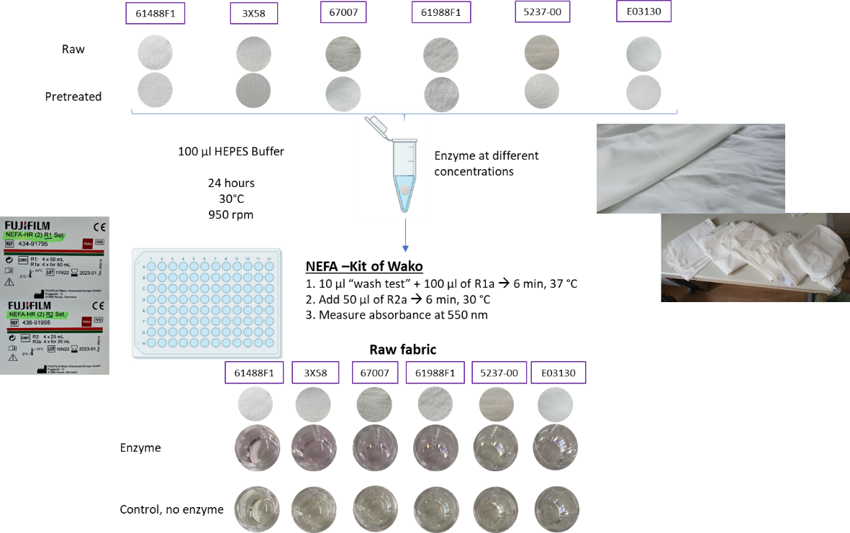

5.12. Liquid polyesterase quantification assay with polylactic acid (PLA) powder
- To determine PLA depolymerase activity against solid PLA, incubate small amounts of PLA powder (10-15 mg) in a reaction mixture (1 mL) containing 400 mM Tris-HCl buffer pH 8.0.
- Then, add 50 μg of protein with shaking at 35°C for 36 h.
- At different time intervals, take small samples and clarify them using centrifugal filters (Mw cut-off 10 kDa); measure free lactate using L- and/or D-lactate dehydrogenase (LDH) added in excess (0.5 mg/mL) which enables the detection of both D- and L-enantiomers of lactic acid (Babson A.L., Phillips G.A., 1965, Clin. Chim. Acta, 12: 210-215). The oligomeric PLA products in flow-through aliquots (90 μL) were converted to monomeric lactic acid after 5 min incubation at 95°C with 10 μL of 10 mM NaOH followed by LDH assay.

5.13. Liquid polyesterase quantification assay using Impranil DLN-SD
- Prepare a substrate solution by mixing 0.5 % (vol/vol) Impranil DLN-SD dispersion in 100 mM KPi pH 7.2.
- Pipette 10 µL of enzyme solution into each well of a 96-well plate (10 µL enzyme buffer as a control).
- Add 190 μL of substrate solution.
- Follow the clearing of the reaction (turbidity clearing) by measuring the absorbance at 580 nm.

5.14. Liquid protocol for the quantification of BHET or PET foil hydrolysis using UHPLC
- Prepare the enzyme reaction in 1.5 mL Eppendorf tubes. The reaction mixture is composed of 500 nM purified enzyme in 20 mM potassium phosphate buffer pH 7.4 with 20 % (v/v) DMSO in a total volume of 300 μL. As a substrate, add either 0.75 µL of 400 mM bis(2-hydroxyethyl) terephthalate (BHET; 95% purity, Sigma Aldrich) dissolved in DMSO or a circular piece of PET film (6 mm diameter) to each tube. A reaction without the addition of an enzyme is used as a control¹.
- Incubate the reaction for 48 h at 30°C, 800 rpm on a shaker.
- Stop the reaction by heat inactivation of the enzymes (e.g. 10 min at 80°C) or separate reaction products and enzymes by ultrafiltration (e.g. centrifugal filters with 10 kDa molecular weight cut-off (MWCO)).
- Quantify reaction products terephthalic acid (TPA), mono-(2-hydroxyethyl) terephthalate (MHET), and bis-(2-hydroxyethyl) terephthalate (BHET) via HPLC using pure standards.
- HPLC setup:
Acquity UPLC (Waters GmbH) equipped with an Acquity UPLC BEH C18 column (1.7 mm particle size).
HPLC program:
Mobile phase (A) 20 mM Na₂HPO₄ pH 2.5 (pH adjusted with H₂SO₄) and (B) methanol, the effluent was monitored at 240 nm. Column temperature set to 35°C. Flow rate 0.208 mL/min. Injection volume 4 µL. 75% (A) and 25% (B) for 1.28 min, followed by a linear gradient to 100% (B) in 2 min, hold 100% (B) for 3 min, linear gradient from 100 to 25% (B) in 1 min and hold 25% (B) until minute 8.28 is reached².
¹For standardized PET film substrate we recommend: (A) Polyethylene terephthalate Film ES301445, Thickness: 0.25 mm, Transparent, Amorphous, Goodfellow GmbH, order no. 518-097-996. (B) Polyethylene terephthalate Film ES301450, Thickness: 0.25 mm, Biaxially Oriented, Clear, Goodfellow GmbH, order no. 543-716-953.
²For MHET no commercial standard is available. A standard curve can be calculated from a series of hydrolysis reactions with BHET as a substrate and the quantified amounts of BHET and TPA.

5.15. Liquid oxidoreductase (laccase/oxidase) quantification assay
- Prepare reaction mixtures (200 μL) containing 100 mM Britton-Robinson buffer, optimal pH for each substrate (pH 2.0 - 9.0, see below), substrates (0.04 - 20 mM)
- Add 10 μg of enzyme (for preliminary screening, then adjust to 0.1-0.5 μg of protein).
- Incubate at 30°C in 96-well plates and measure the conversion at the appropiated wavelenght to each of the selected substrates.
2,2′-azinobis(3-ethylbenzthiazoline-6-sulfonate) (ABTS), pH 5.0 (ε = 36 mM⁻¹cm⁻¹, 420 nm)
Syringol, pH 7.0 (ε = 14.8 mM⁻¹cm⁻¹, 468 nm)
Guaiacol, pH 7.0 (ε = 6.4 mM⁻¹cm⁻¹, 436 nm)
p-phenylenediamine, pH 6.0 (ε = 14.7 nM⁻¹cm⁻¹, 487 nm)
3-hydroxyanthranilic acid (3-HAA), pH 6.0 (480 nm)
Gallic acid, pH 6.0 (480 nm)
Sinapic acid, pH 8.0 (480 nm)

5.16. Liquid amylase quantification assay with chromogenic substrates
- Prepare reaction mixture (200 μL) containing 50 mM buffer (HEPES-K pH 7.0; MOPS-K pH 6.5; MES-K pH 6.0), 1 mM substrate (p-nitrophenyl α-D-maltoside or β-D-maltoside, available from Sigma/Merck), 20 mM NaCl, 1 mM DTT, and 1-5 µg of purified protein.
- Measure substrate hydrolysis spectrophotometrically after 10 min incubation at 30°C (or room temperature) at 420 nm in a microplate reader.

5.17. Liquid amylase quantification assay with polymeric substrates
- Add 40 µL of starch (2 mg/mL) to 40 µL of 0.1 M HEPES-K buffer pH 7.0 in a microplate covered with a plastic film.
- Incubate the microplate for 30 min at 30-50°C.
- Stop the reaction by adding 20 µL of 1 M HCl followed by the addition of 100 µL of iodine reagent (5 mM I₂ and 5 mM KI).
- Measure activity by following color development at 580 nm using a plate reader (Xiao Z. et al., 2006, Anal. Biochem., 351: 146-148).
An alternative method consists in the detection of reducing sugars with a modified 3,5-dinitrosalicylic (DNS) method adapted to a 96-well microplate scale.
- Prepare the DNS solution: 10 g 3,5-dinitrosalicylic acid (DNS), 300 g sodium and potassium tartrate (Rochelle salt), 16 g NaOH and distilled water up to 1 L (Note: it takes some time until completely dissolved).
- In a microtiter plate or 1.5 mL Eppendorf, add 45 µL buffer, 5 µL reaction solution (see above) and 50 µL DNS solution.
- Incubate at 85˚C for 25 min (in these conditions, the reducing sugars allow the transformation of DNS into DAS (3-amino-5-nitrosalicylic acid) with the color change from yellow to dark brown).
- Add 100 µL water and read the absorbance at 540 nm.

5.18. Liquid proteolytic activity assays using FITC-labelled protein
- Prepare labelled protein stock in water (5 mg/mL), using Thermo Scientific Kit or self-made Fluorescein isothiocyanate (FITC) labelled protein.
- Prepare working reagent (WR) of 100 µg/mL labelled protein in Tris Buffered Saline (TBS) Buffer.
- Add 100 μL sample (or standard) to each well of a 96-well plate (use 37.5 μL/well for 384-well plate). In addition to the zero-standard, prepare a blank using a buffer similar to that used for the protease sample.
- Add 100 μL of WR (1:500) to all wells of a 96-well plate (use 37.5 μL/well for 384-well plate).
- Incubate for 5-60 min at room temperature.
- Measure fluorescence in a plate reader using a fluorescein excitation/emission filter set.
- Subtract the blank from each sample and standard measurement and then prepare a standard curve: for fluorescence resonance energy transfer (FRET), plot the change in relative fluorescence units (RFU) of the standards vs. protease concentration.

5.19. Liquid proteolytic (alcalase) activity assays using p-nitroanalide chromophores
Alcalase-like activity is measured in batch through a fluorometric assay, using a synthetic specific substrate (N-succinyl-l-alanyl-l-alanyl-l-ananyl-p-nitroanilide; available from Merck/Sigma). Incubate protein samples (purified protein, cell extract or cell suspensions) with a buffer solution (150 nM Tris-HCl pH 7.5, 200 nM NaCl, 10 uM ZnCl₂) and the substrate (1 mg/mg stock solution in DMSO) (portions 10:99:1, respectively). After incubation at desired temperature for up to 16 h, quantify the absorbance at 405 nm with a microtiter plate reader.

5.20. Liquid proteolytic (subtilisin) activity assays using p-nitroanalide chromophores
Alcalase-like activity is measured in batch through a fluorometric assay, using a synthetic specific substrate (N-succinyl-Ala-Ala-Pro-Phe-p-nitroanilide; available from Merck/Sigma). Protein samples (purified protein, cell extract or cell suspensions) are incubated with a buffer solution (150 nM Tris-HCl pH 7.5, 200 nM NaCl, 10 μM ZnCl₂) and the substrate (1 mg/mg stock solution in DMSO) (portions 10:99:1, respectively). After incubation at desired temperature for up to 16 h, the absorbance at 405 nm is quantified with a microtiter plate reader.

5.21. Liquid proteolytic activity assays using azocasein
- Mix 1.1 mL of 50 mM sodium phosphate buffer pH 7.6 (standard buffer) containing 10 μg of protein (or appropriated amount of cell extract or cell suspension) with 0.65% (w/v) of the substrate azocasein.
- After incubating the reaction mixture at 30°C for 30 min, add 900 μL of 110 mM trichloroacetic acid and incubate the mixture at 37°C for 30 min.
- To remove precipitant, centrifuge the mixture (12,000 g for 3 min at 4°C) and filter through a 0.45-μm filter.
- Mix the filtrate (500 μL) with 250 μL Folin & Ciocalteu’s phenol reagent and 1.25 mL of 500 mM sodium carbonate solution.
- After 30 min at 37°C, determine the OD₆₆₀ and calculate the enzyme activity based on an l-tyrosine standard curve.
- One unit of protease activity is defined as the activity required to produce 1 nmol of tyrosine equivalents released amino acids per min, per mg of protein at 30°C.

5.22. Liquid hydrophilic and dyeability modification of fabrics
Protocol adapted from Gao et al 2017 (Aiqin Gao, Hongwei Shen, Hongjuan Zhang, Guanchen Feng, Kongliang Xie, Journal of Cleaner Production 2017, 164, 277-287). This protocol can be used for proteases, lipases, cutinases and polyesterases.
- Prepare a buffer aqueous solution containing certain concentrations of lipase.
- Immerse the polyester, PLA, PET or polyamide fabric (5.0 g) in the solution (100 mL).
- Perform the treatment at the desired temperature and pH 7.5 for a certain time.
- After the enzymolysis reaction, increase the temperature to 100°C, hold for 15 min, and then cool, to inactivate the lipase.
- Determine the polyester hydrolysis degree from the quantities of terephthalic acid (TPA) derivatives (TPA, ethylene terephthalate, and mono(2-hydroxyethyl) terephthalate) released into the samples supernatant by measuring the absorbance at 241 nm. The possible hydrolysis products were TPA, ethylene terephthalate, and mono(2-hydroxyethyl) terephthalate. Use a TPA calibration curve to calculate the total amount of products released (all three products have the same molar absorption, arising from their carbonyl groups).
Calculate the activity by applyign the following equation:

A = -6.4690x10⁻⁴ + 75.1195 x C

where A is the absorbance at 241 nm and C is concentration of TPA (mg/mL).
Hydrolytic activity on polyester, PLA, PET or polyamide fabrics can be also measured by a titration method (protocol adapted from H.R. Kim and W.S Song (Fibers and Polymers 2010, 11, 67-71). This protocol can be used for proteases, lipase, cutinase, polyesterases.
- Cut each fabric sample into 4×4 cm pieces that weight approx. 0.1 g.
- Place each sample into a 20 mL vial bottle containing 8 mL of an appropriate buffer. Then, treat the polyester fabrics with different temperature, pH, treatment time, and concentrations of enzymes. All treatments are performed at 150 rpm using a shaking waterbath.
- After the treatments, transfer the test solutions to a 50 L Erlenmeyer flask, and add 20 mL ethanol to the test solution to inactivate its enzymes. Add four drops of 0.9% TPH indicator to the test solution. The test solution is titrated with 0.1 M NaOH into a light blue color. Then, recordthe volume of the 0.1 M NaOH used in the sample test.
Enzymatic hydrolytic activity can be also measured according to the method of SH Lee and SY Yeo (Fibers and Polymers 2016, 17, 1154-1161). This protocol can be used for proteases, lipase, cutinase, polyesterases.
- Mix a PLA fabric or other polymer-based fabric (0.5 g) with 50 mL of 0.1 M sodium phosphate buffer pH 7.0. Then, add 2 mM p-NP¹ as a yellow chromogen pH indicator.
- Place each sample into a 20 mL vial bottle containing 8 mL of an the above prepared solution.
- Then, treat the fabrics with different temperature, pH, treatment time, and concentrations of enzymes. All treatments are performed at 150 rpm using a shaking waterbath.
- Measure the hydrolytic activity by taken aliquots and following the absorbance at 405 nm. Calculate the hydrolytic activity of the enzyme on the basis of absorbance at 405 nm using the following equation: Hydrolytic activity = A405 after hydrolysis – A405 before hydrolysis.
¹p-nitrophenol (p-NP) could be substituted by 0.45 Phenol Red, and in this case, the buffer 100 mM sodium phosphate buffer(pH 7.0, need to be substituted by 5 mM EPPS buffer.

5.23. Liquid amino modification of polyamide fabrics
Protocol adapted from Kanelli et al (Maria Kanelli, Sozon Vasilakos, Spyridon Ladas, Emmanouil Symianakis, Paul Christakopoulos, Evangelos Topakas, Process Biochemistry 2017, 59, 97-103). This protocol can be used for proteases, amidases and lipases. The hydrolysis of polyamide model occurred as followed:
- Treat 50 mg of the model fabric with an appropriated amount of enzyme in 1.5 mL potassium phosphate buffer pH 8.0 and at appropriated temperature, overnight.
- Subsequently, filter the samples to obtain the soluble fraction of the hydrolysis and analyze them with the Trinitrobenzenesulfonic acid (TNBS) method. This method is based on the reaction of the primary amino groups with the sodium salt of TNBS leading to the formation of a complex that can be measured spectrophotometrically at 420 nm. Briefly, incubate 1 mL of the reaction’s supernatant with 25 μL of 30 mM aqueous TNBS for 30 min at 30°C. For the quantification of amino-groups that is indicative of the enzymatic hydrolysis of the PA model, the absorbance is read against the controls, one with model fabrics and buffer and one with enzyme and buffer at 420 nm in a spectrophotometer. Prepare a calibration curve using hexamethylenediamine as a standard solution in different concentrations.

5.24. Dye liquid discoloration test
- Prepare the reaction mixture in 96-well microplates by adding 20 μL of concentrated dye (provided by partner Schoeller), 10 μL of 2 mM mediator (ABTS) (for peroxidase screen prepare fresh 0.06% H₂O₂ add 100 uL to the reaction mixture), and water to 200 μL taking into account the enzyme volume (5-10 μg).
- (Control wells should a) not contain enzyme, but the elution buffer, b) contain enzyme and mediator, but no dye).
- Mix by pipetting (plate shaker alternatively for 10 min on 500 rpm).
- Add 5-10 μg of purified protein to fit in the final volume 200 μL.
- Mix by pipetting and read the 0 time point at 588 nm , save the data.
- Seal plate with adhesive seal and keep shaking for overnight at 30˚C, 500 rpm.
- Next day shortly spin down the plate and read at 588 nm.
- Subtract the ON data from the 0 time point read, taking into account the controls.
Notes:
For futher protocol optimization reaction volume may be considered to be decreased to 150 μL for better aeration and the concentration of mediatior may need optimization.
As shown in the Figure below, 588 nm was identified as maximal absorbance for the dying liquid cocktail from Schoeller, dye absorbance is distant from the ABTS absorbance (420 nm), if using different mediators, their extinction should be taken into account.
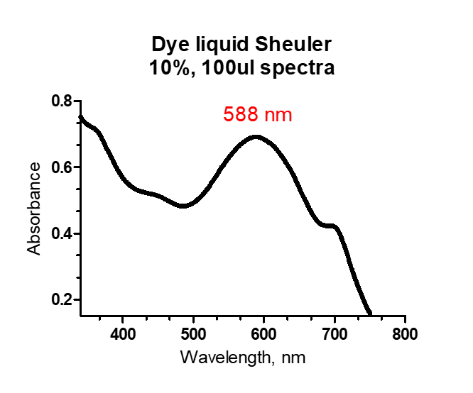

6. Protocols relevant for COSMETIC APPLICATIONS
As detailed in Deliverable D2.1, priority enzymes are those for processing hyaluronic acid:
- Heparanase (EC 3.2.1.166)
- Hyaluronate lyase (cd01083 – EC 4.2.2.1)
- Hyaluronidase (EC 3.2.1.35, EC3.2.1.36, pfam03662, pfam01630)
The idea is to identify hyaluronidase-like enzymes capable of degrading hyaluronic acid to small hyaluronic acid products with 1-2 k Dalton molecular weight (see figure below), at <37ºC, no solvents, and high viscosity solutions.
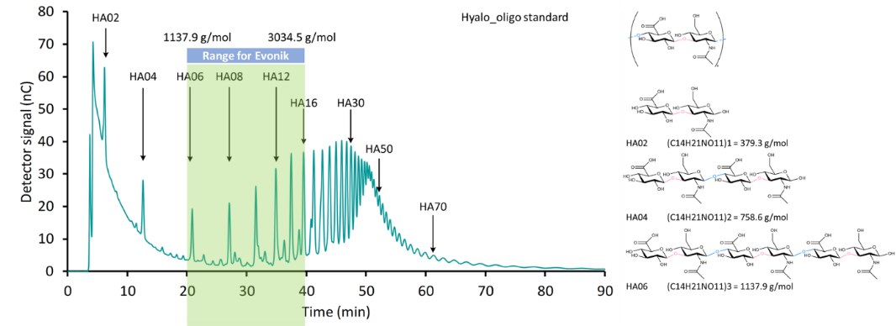
The following two real hyaluronic acid products were provided by partner Evonik for activity tests:
- Low molecular weight (50 kDa) hyaluronic acid HyaCare® 50
- Low molecular weight hyaluronic acid (<10 kDa), Hyalo-Oligo
This material was provided to CSIC directly by Evonik, and then distributed to Bangor, UDUS, UHAM, IST-ID, and CNR (September 2021).
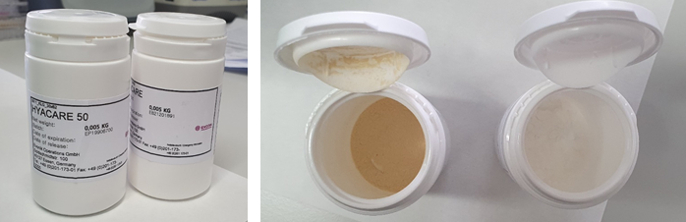

6.1. Liquid colorimetric assay for hyaluronidase activity
The hyaluronidase activity is determined by detection of reducing sugars with three different colorimetric methods. We may use hyaluronic acid, sourced from Sigma-Aldrich or provided by Evonik, as substrate and the calibration curve was performed with a N-acetyl-D-glucosamine (GlcNAc) solution of 3 mg/mL for the quantification of reducing sugars. One unit (U) of activity corresponded to the release of one μL of reducing sugars per minute.
- Prepare a 10 mL substrate solution by mixing 0.4-10.0 mg mL⁻¹ hyaluronic acid in 20 mM phosphate buffer solution pH 6.3 (dissolve 2.5 g of monobasic sodium phosphate, 1.0 g of anhydrous dibasic sodium phosphate, and 8.2 g of sodium chloride in water to make 1 L). Any other buffer can be used.
- Pipette 100 µL of enzyme solution into 9.9 mL substrate solution, into a close vial with vigorous mixing.
- Incubate at the desired temperature for 1-24 h.
- Take aliquots and measure the release of reducing sugars as follows.

6.1.1. DNS method
The activity of the hyaluronidase is determined by detection of reducing sugars with a modified 3,5-dinitrosalicylic (DNS) method adapted to a 96-well microplate scale.

- Prepare the DNS solution: 10 g 3,5-dinitrosalicylic acid (DNS), 300 g sodium and potassium tartrate (Rochelle salt), 16 g NaOH and distilled water up to 1 L (Note: it takes some time until completely dissolved).
- In a microtiter plate or 1.5 mL Eppendorf, add 45 µL buffer, 5 µL reaction solution and 50 µL DNS solution.
- Incubate at 85˚C for 25 min (in these conditions, the reducing sugars allow the transformation of DNS into DAS with the color change from yellow to dark brown).
- Add 100 µL water and read the absorbance at 540 nm.

6.1.2. BSA method
The hyaluronate lyase activity can be additionally determined by quantifying the unsaturated degradation product 2-acetamido-2-deoxy-3-O-(β-d-gluco-4-enepyranosyluronic acid)-d-glucosamine (ΔDi-HA) photometrically at 232 nm (adapted from Oettl M, Hoechstetter J, Asen I, Bernhardt G, Buschauer A. Comparative characterization of bovine testicular hyaluronidase and a hyaluronate lyase from Streptococcus agalactiae in pharmaceutical preparations. Eur J Pharm Sci. 2003 Mar;18(3-4):267-77):
- Prepare incubation mixture containing 300 μL of citrate–phosphate buffer citrate–phosphate (solution A: 200 mM Na₂HPO₄/100 mM NaCl, solution B: 100 mM citric acid/100 mM NaCl; solutions A and B are mixed in appropriate portions to adjust the required pH), 150 μL of water, 100 μL of BSA (0.2 mg BSA per mL of water=solution 1) and 250 μL of substrate (0.4-10 mg hyaluronic acid per mL; solution 3).
- After incubation at 37°C for 10 min, monitor the increase in absorbance at 232 nm.
- Calculate the velocity of the enzymatic reaction from the increase in absorbance (ΔA) at 232 nm per time (Δt) according to the following equation:

$$Rate \left(\frac{μmol}{\min{L}}\right)=\frac{Abs}{t l}$$
where ε=4550 L mol⁻¹ cm⁻¹. The molar absorptivity (ε₂₃₂) of hyaluronate unsaturated disaccharide (ΔDi-HA) was determined at 37°C by measuring the absorbance of a known concentration of ΔDi-HA (sodium salt, Calbiochem®, Bad Soden, Germany) at 232 nm under the conditions prevalent in the incubation mixture.

6.1.3. BCA method
The bicinchoninic acid (BCA) method is mainly used in protein quantification, but has also been adapted to measure reducing sugars. The reaction with reducing agents results in the reduction of Cu²⁺ to Cu⁺, followed by the chelation of one Cu⁺ with two BCA molecules, forming an intense purple color with an absorbance maximum at 562 nm. See Bicinchoninic Acid Kit for Protein Determination available from Merck/Sigma.

6.1.4. DMAB method
This colorimetric method is based on the Morgan-Elson reaction modified by Reising et al (see Takahashi T, Ikegami-Kawai M, Okuda R, Suzuki K. A fluorimetric Morgan-Elson assay method for hyaluronidase activity. Anal Biochem. 2003 Nov 15;322(2):257-63; J. Biol. Chem., 217 (1955), pp. 959-966). It is based upon the generation of a new reducing GlcNAc terminus with each cleavage reaction. Briefly, after reactions:
- Take 200 μL of reaction mixture.
- The Morgan–Elson color reaction was started by the addition of 50 μL of tetraborate reagent¹ and subsequent heating for 3 min in a boiling water bath.
- After cooling to room temperature, add 1.5 ml of p-Dimethylaminobenzaldehyde (DMAB) reagent¹ and incubate it at 37°C for 15 min.
- After centrifugation at 18,000 g at 4°C for 10 min to remove turbidity, measure the absorbance at 585 nm (or 450 and 650 nm) of the clear supernatant against that of a blank test, which was carried out in the absence of enzyme. Alternatively, the released reducing terminal GlcNAc in the supernatant can be detected by fluorescence (excitation, 545 nm; emission, 604 nm) in a fluorescence spectrophotometer, instead of absorbance at 585 nm.
In both the colorimetric and the fluorimetric methods, 1 unit of hyaluronidase activity is defined as the amount of enzyme required to produce 1 μmol of reducing terminal GlcNAc per minute under the specified conditions, using respective standard curves plotted with known concentrations of GlcNAc.

¹The Reissig method needs two solutions (Analytical Biochemistry293,53–59 (2001)): (i) the borate solution prepared by dissolving K₂B₄O₇ · 4H₂O at 0.8 M in Milli-Q water (Waters) and (ii) 0.1 g mL⁻¹ DMAB solution prepared by dissolving 5 g DMAB (Sigma D8904) in 6.25 mL hydrochloric acid, 12 N (Sigma H 7020), made up to a final volume of 50 mL with glacial acetic acid (Sigma A 6283). The latter solution was diluted 10-fold with glacial acetic acid just before use (and at least 15 min before use).

6.2. Liquid analysis of hyaluronic acid oligosaccharides by HPAEC-PAD
Commercial hyaluronic acid oligosaccharides can be used: Hyalo-Oligo, a low molecular weight hyaluronan oligosaccharide mixture with an average molecular weight below 10 KDa. It was kindly provided by Kewpie Corp. The mixture is analyzed by high performance anion exchange chromatography with pulsed amperometric detection (HPAEC-PAD) with a Dionex ICS3000. An anion exchange carbo-pack PA 100 column connected to a PA100 guard column is used at 30˚C.

6.3. Liquid analysis of hyaluronic acid oligosaccharides by SEC-ELSD
Hydrolysis of hyaluronic acid is analyzed by high performance size exclusion chromatography with evaporative light scattering detector (HPLC-SEC). We could study the hyaluronic acid consumption and the formation of the hyaluronic acid oligosaccharides (HAOS). A PolySep-P 4000 column (Phenomenex) is used at 30˚C. The analysis is performed at isocratic conditions using milliQ H₂O as mobile phase at 0.6 mL/min. The samples show a wide molar mass distribution. In SEC, the molar mass of the polysaccharides is estimated from a calibration curve, which is normally obtained from well-defined standards. However, we do not have different size HAOS standards.

6.4. Agar assay for the determination of hyaluronidase activity
The agar assay method is adapted from Patil & Chaudhari 2016 (J Basic Microbiol. 2017; 57: 358–361).
- Add hyaluronic acid (0.4-10.0 mg mL⁻¹) as a substrate and agarose/agar (1%) as a solidifying agent into the medium where microbes grow or into the buffer where enzymes function.
- Sterilize the medium/buffer i and pour it into Petri dishes up to a depth of 3-4 mm.
- Then, add 50 μL of 24 h old culture supernatant of microorganisms, or 50 μL of enzyme solution under investigation.
- Incubate the plates at 37°C (or any other temperature) for 1-24 h.
- Upon incubation, flood plates with Gram's iodine for 1 min in order to visualize the zones of clearance around the wells (see image below).
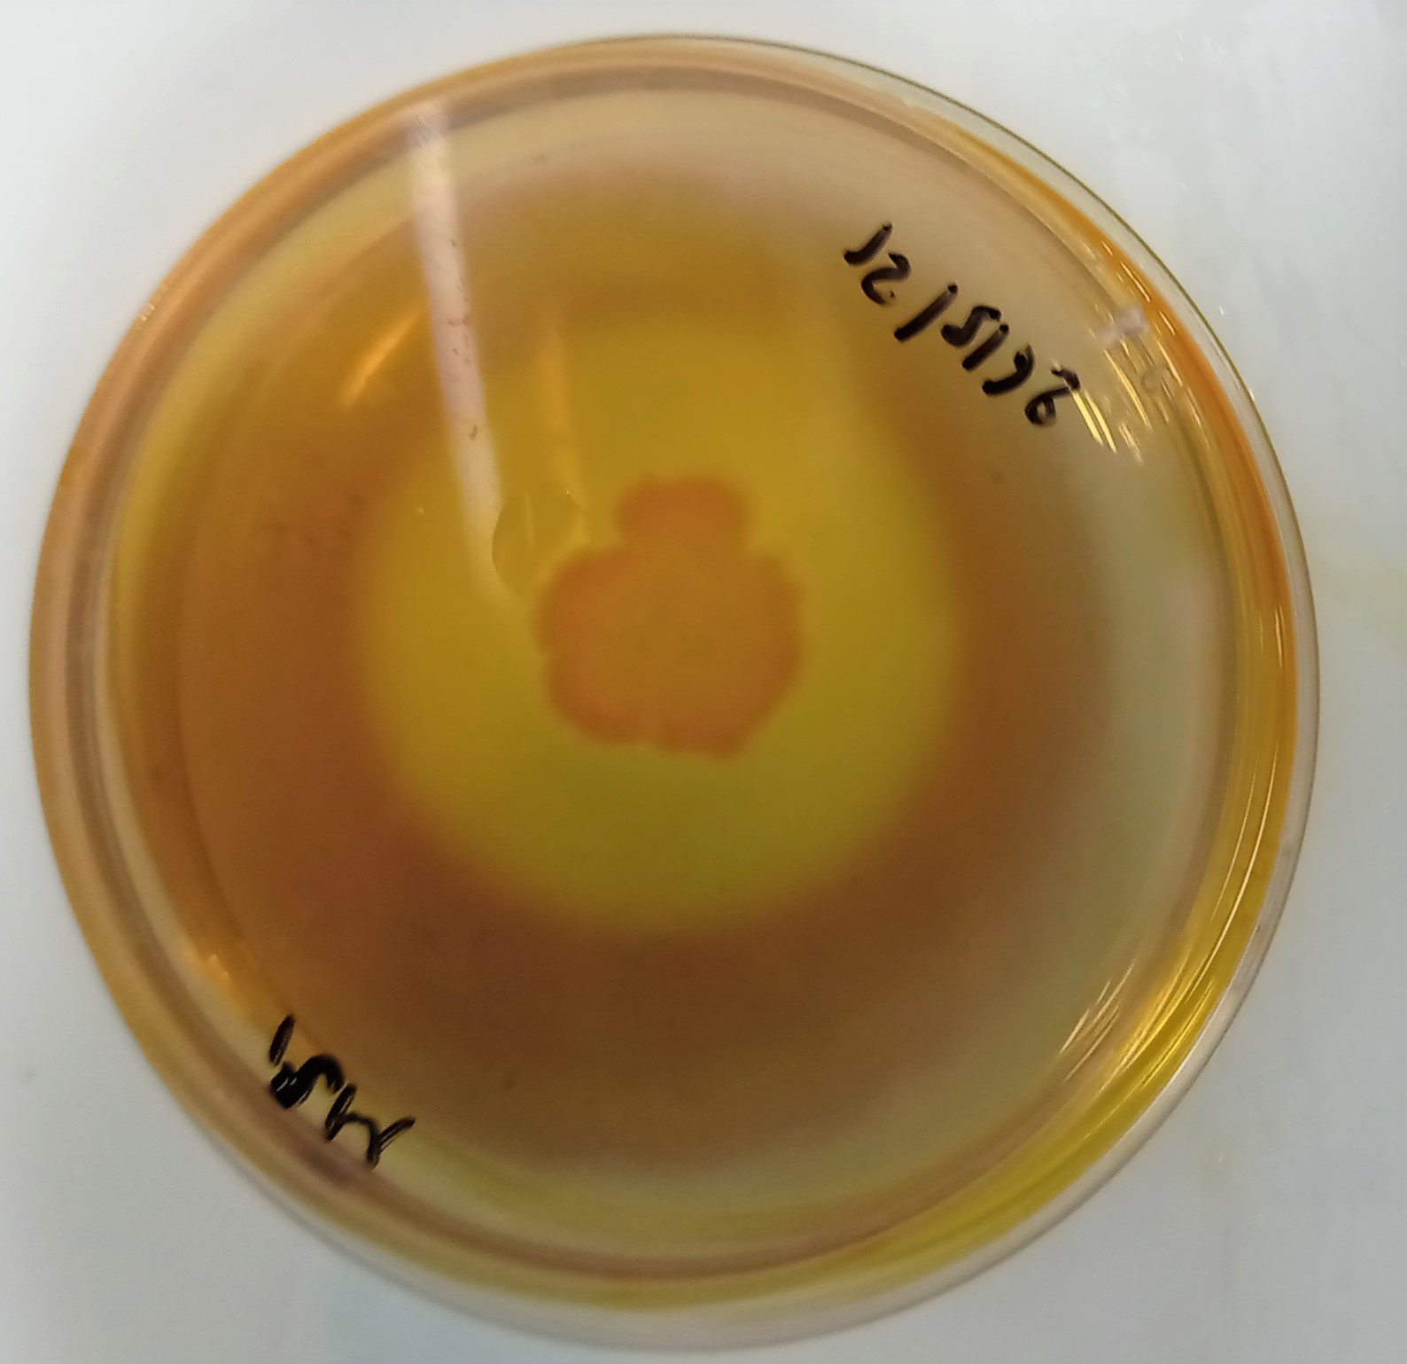

Annex - List of esters successfully tested with pH shift assay
Name | Chemical structure
(1R)-(-)-Dimenthyl succinate
1,10-Diacetoxydecane
1-Methyl L-Glutamate
1-Naphthyl butyrate
1-Napthyl acetate
2-(tert-Butylamino)ethyl methacrylate
2,2,3,3,4,4,5,5-Octafluoro-1,6-hexyl diacrylate
2,2,3,3,4,4,5,5-Octafluoropentyl acrylate
2,3,4,9-Tetrahydro-1h-b-carboline-3-carboxylic acid methyl ester
2,4-Dichlorobenzyl 2,4-dichlorobenzoate
2,4-Dichlorophenyl 2,4-dichlorobenzoate
2-Naphthyl acrylate
3-beta-Hydroxy-16-alpha-methyl-5-pregnen-20-one 3-acetate
3-Formylphenyl 3,5-dimethoxybenzoate
3-Iodo-1H-indazole-6-carboxylic acid methyl ester
4,6-Dimethyl-α-pyron
4-Glycylphenyl benzoate
6-Chloro-8-methyl-imidazo[1,2-a]pyridine-2-carboxylic acid ethyl ester
Allyl cyclohexanepropionate
Benzyl (R)-(+)-2-hydroxy-3-phenylpropionate
Benzylparaben
Bis(2-hydroxyethyl) terephthalate
Butyl acetate
Butylparaben
Citraconic acid dimethyl ester
Cyclandelate
Cyclohexyl butyrate
Dibenzyl terephthalate
Diethyl adipate
Diethyl ethoxymethylenemalonate
Diethyl furan-2,5-dicarboxylate
Diethyl sebacate
Diethyl succinate
Diethyl-2,6-dimethyl 4-phenyl-1,4-dihydro pyridine-3,5-dicarboxylate
Dimethyl 1,3-thiazolidine-2,4-dicarboxylate
Dimethyl 5-(2-amino-4-(methoxycarbonyl) phenoxy)isophthalate
Dimethyl terephthalate
Dodecanoyl acetate
Ethyl 2-(5-amino-3-tert-butyl-1H-pyrazol-1-yl)acetate
Ethyl 2,5-dibromofuran-3-carboxylate
Ethyl 2-chlorobenzoate
Ethyl 2-ethylacetoacetate
Ethyl 2-methylacetoacetate
Ethyl 3-(4-methoxyphenyl)-1-methyl-1H-pyrazole-5-carboxylate
Ethyl 3,5-dimethyl-1H-pyrazole-4-carboxylate
Ethyl 3-Aminopyridazine-4-carboxylate
Ethyl 3-oxohexanoate
Ethyl 4-(3,4-dimethoxybenzylamino)benzoate
Ethyl 4,4,4-trifluoro-2-butynoate
Ethyl 6-aminopyridazine-3-carboxylate
Ethyl acetate
Ethyl acetoacetate
Ethyl benzoate
Ethyl beta-morpholinocrotonate
Ethyl butyrate
Ethyl decanoate
Ethyl dodecanoate
Ethyl hexanoate
Ethyl myristate
Ethyl octanoate
Ethyl propionate
Ethyl propionylacetate
Geranyl acetate
Glucose pentaacetate
Glyceryl triacetate
Glyceryl tributyrate
Glyceryl trioctanoate
Glyceryl tripropionate
H-Asn-OtBu
Hexadecyl 3,5-Di-tert-butyl-4-hydroxybenzoate
Hexyl acetate
Hydroxyprogesterone caproate
Isobutyl cinnamate
Mannide monooleate
Massoia Lactone
Methyl 2,5-dihydroxycinnamate
Methyl 2-amino-5-iodo-4-(trifluoromethyl)benzoate
Methyl 2-fluoropyridine-4-carboxylate
Methyl 2-hydrazino-4-(trifluoromethyl)pyrimidine-5-carboxylate
Methyl 2-hydroxybenzoate
Methyl 2-methoxy-5-(methylsulphonyl)benzoate
Methyl 3-amino-5-bromo-2-methylbenzoate
Methyl 3-hydroxybenzoate
Methyl 4-bromo-1,2,5-thiadiazole-3-carboxylate
Methyl 4-hydroxy-1H-indole-6-carboxylate
Methyl 5-bromo-4-chlorosalicylate
Methyl 5-fluoronicotinate
Methyl 5-methylhex-2-enoate
Methyl 6-bromo-7-chloro-8-methyl-4-hydroxyquinoline-2-carboxylate
Methyl benzoate
Methyl butyrate
Methyl cinnamate
Methyl decanoate
Methyl dodecanoate
Methyl ferulate
Methyl glycolate
Methyl hexanoate
Methyl imidazo[1,2-b]pyridazine-6-carboxylate
Methyl myristate
Methyl octanoate
Methyl oleate
Moguisteine
n-Pentyl benzoate
Octyl acetate
Octyl gallate
Oxybutynin
Pantolactone
Pentabromophenyl acrylate
Pentadecyl acetate
Pentane-1,5-diyl diacrylate
Phenyl acetate
Phenyl propionate
Phenylethyl cinnamate
Phthalic acid diethyl ester
Phthalic acid diethyl ester
Polycaprolactone diol
Propyl acetate
Propyl butyrate
Propyl hexanoate
Propyl propionate
Propylparaben
Sec-Butyl methacrylate
Tetracaine
Tetramethyl 1,2,4,5-benzenetetracarboxylate
trans-4'-Cyano-[1,1'-biphenyl]-4-yl 4-ethylcyclohexanecarboxylate
Tri(propylene glycol) diacrylate, mixture of isomers
Vinyl acetate
Vinyl acrylate
Vinyl benzoate
Vinyl butyrate
Vinyl crotonate
Vinyl laurate
Vinyl myristate
Vinyl oleate
Vinyl palmitate
Vinyl propionate
α-Angelicalacton
γ-Dodecalactone
δ-Dodecalactone
ε-Caprolacton
ϒ-Valerolactone

